1. Write C program to print 1 to 10 number.

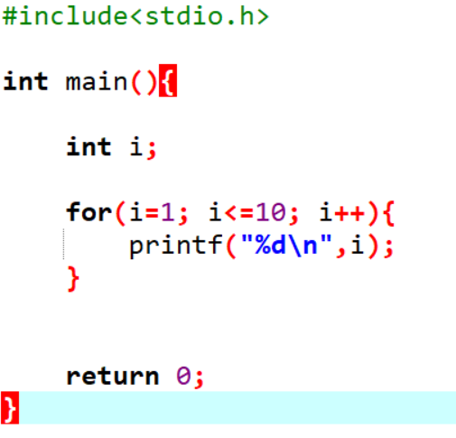 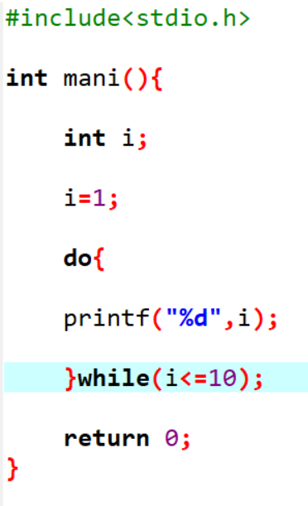

Output to for_loop :- Output to while_loop:- output to do_while_loop:-

  

1. Write C program to print 40 to 31 number.

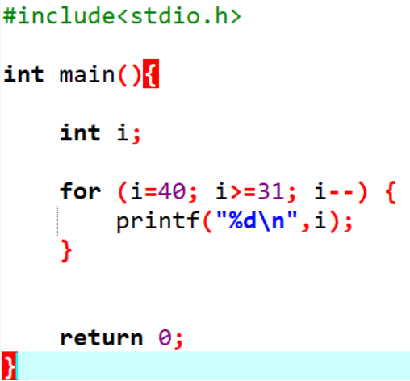Output:-



1. Write C program to print odd number from 80 to 100.

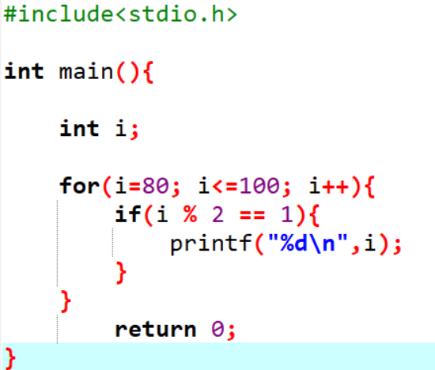

Output:-



1. Write C program to print number that are divisible by 5 from 25 to 50 number.

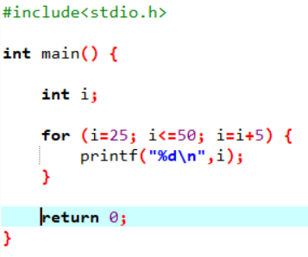

Output:-



1. Write C program to print to print A to Z character.

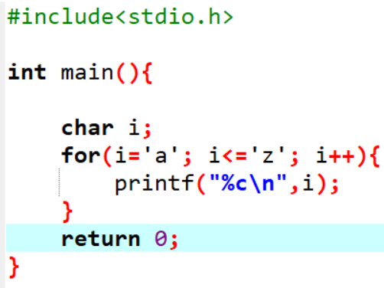

Output:-



1. Write C program to print multiplication table of any number.

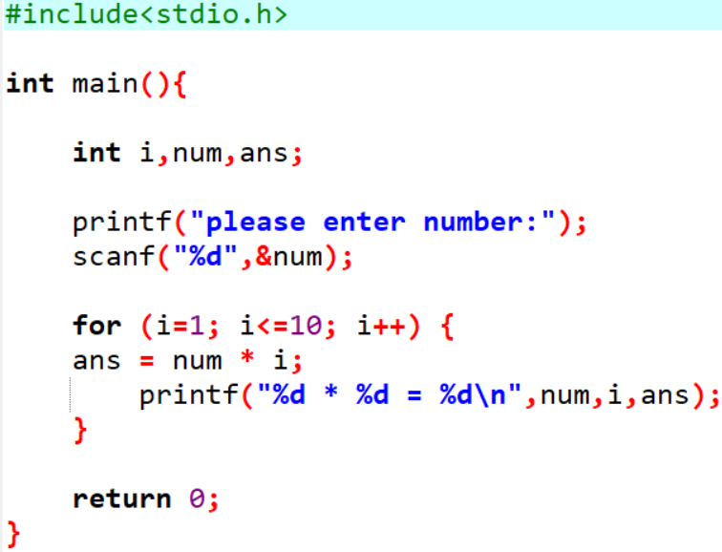

Output:-

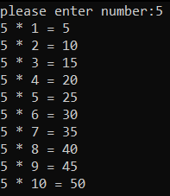

1. Write C program to count number of boys whose weight is less than 50kg and height is greater than 170cm.

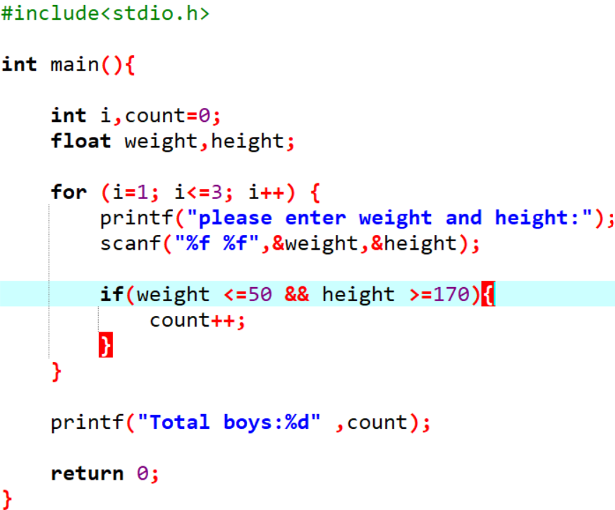

Output:-

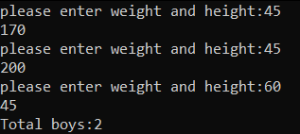

1. Write C program to find ratio of (a-b) and (c-d) of any three number. If c and d is equal than not to find ratio.

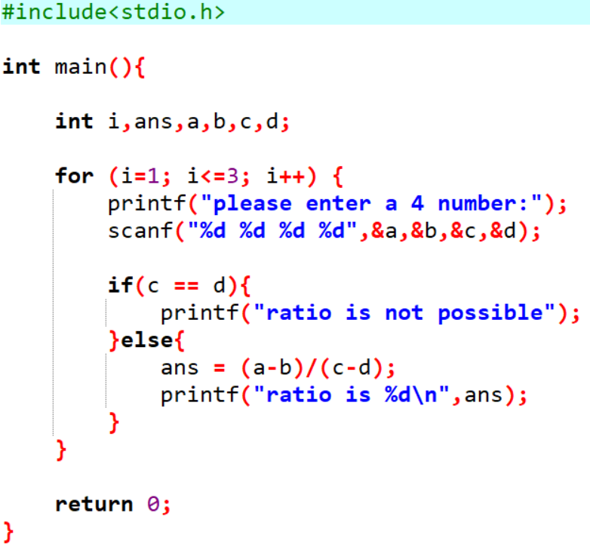

Output:-

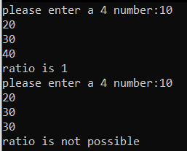

1. Write C program to calculate factorial of a number.

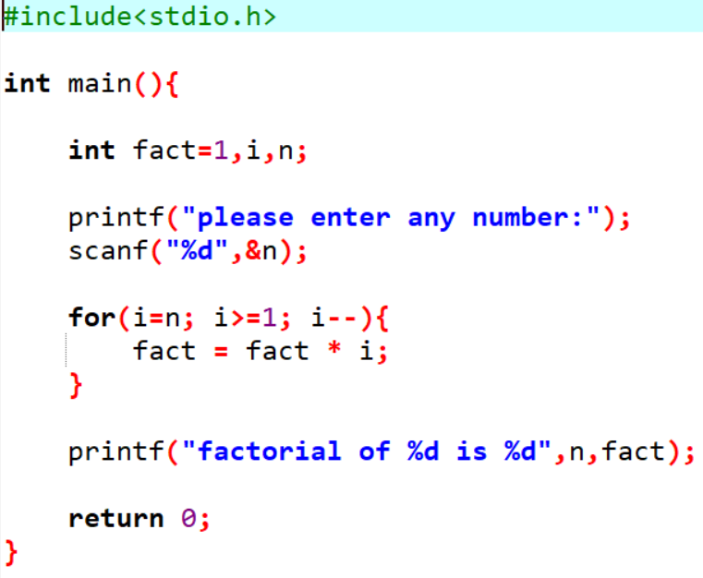

Output:-



1. Write C program to give sum of n numbers.

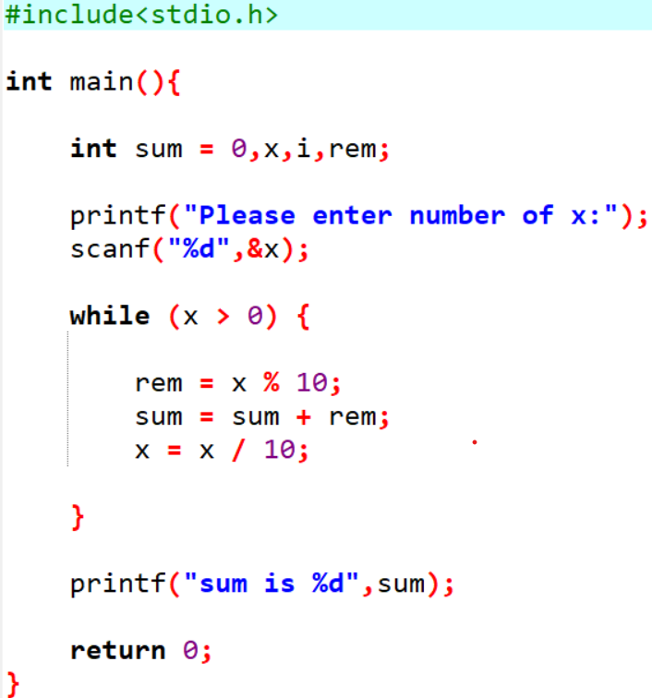

Output:-



1. Write C program to give average of n numbers.

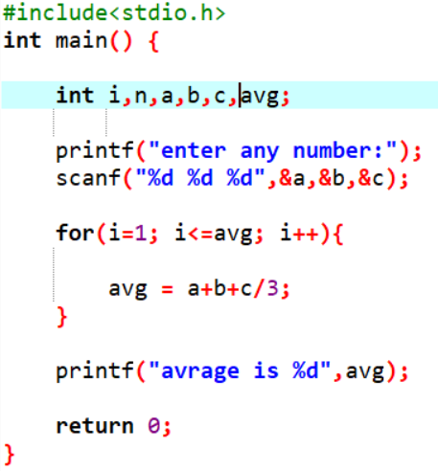

Output:-



1. Write C program to find a number that is divisible by 7 or 3 from n numbers.

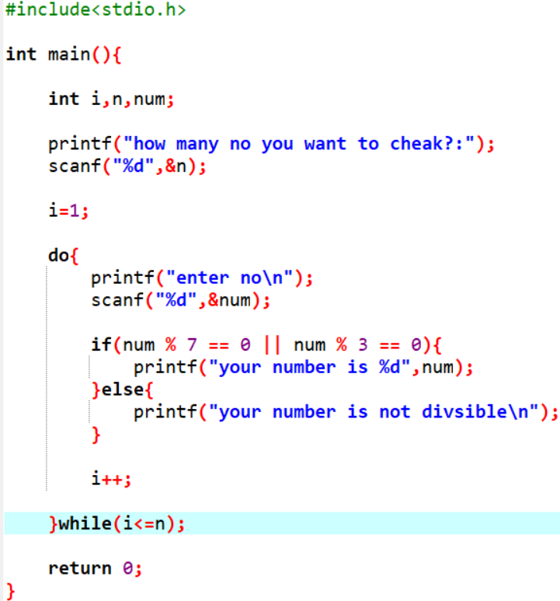

Output:-

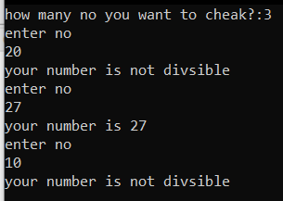

1. 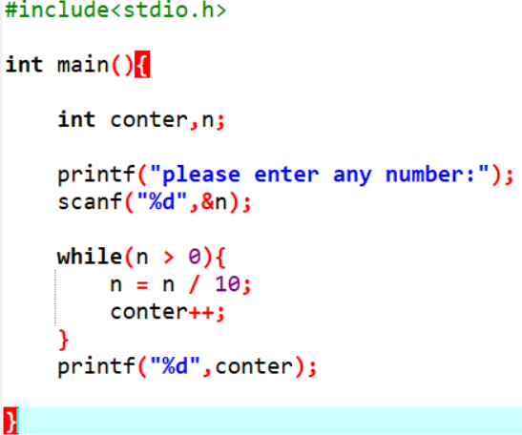Write C program to count number of digits in a number.

Output:-



1. Write C program to enter a number and print its reverse & check weather num is palindrome or not?

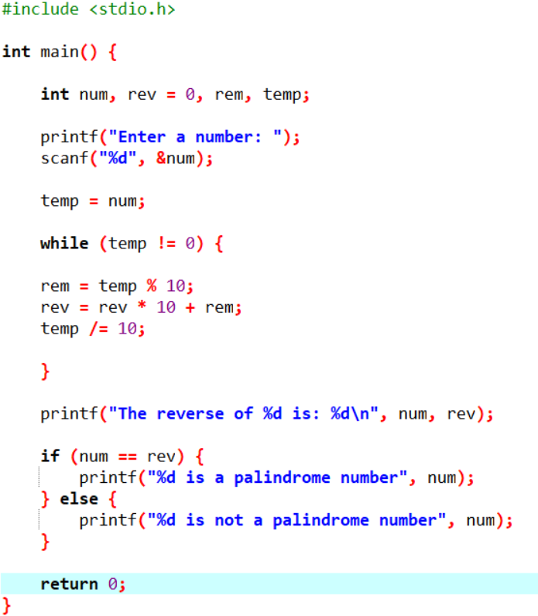

Output:-

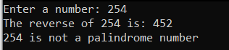

1. Write C program to check number is prime or not.

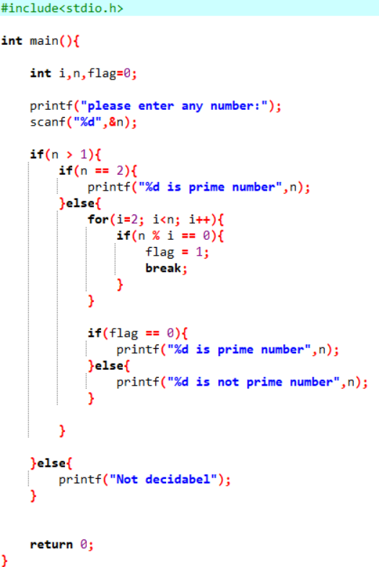

Output:-

 

16. Write C program to find class of the n students from their m marks.  
   Note: 1. You have to take student's roll number and 5 subject marks out of 100.   
              2. If total marks greater than 450 then grade will be A.  
                  If total marks greater than 350 then grade will be B.  
                  If total marks less than 350 then grade will be C.

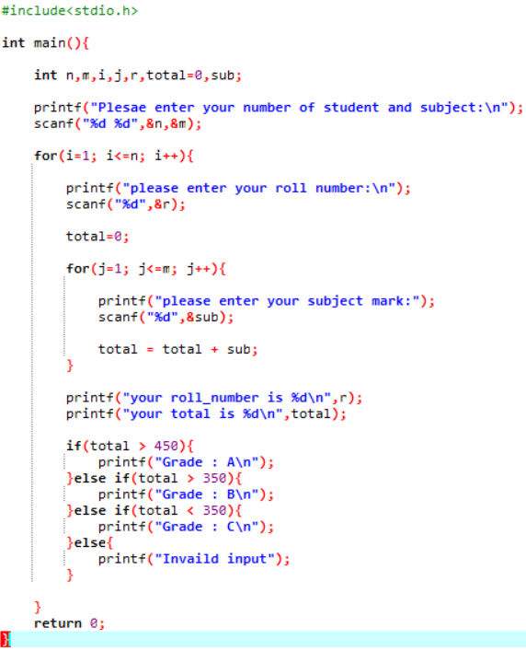

Output:-

× 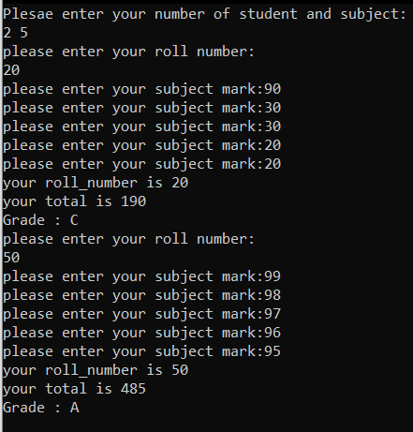

1. Write C program to find expenses of an organization from n month.  
   Note:   
    1. You have to ask expense of electricity, salary and marketing of each month.  
    2. You have to print Month number and total expense of each month.

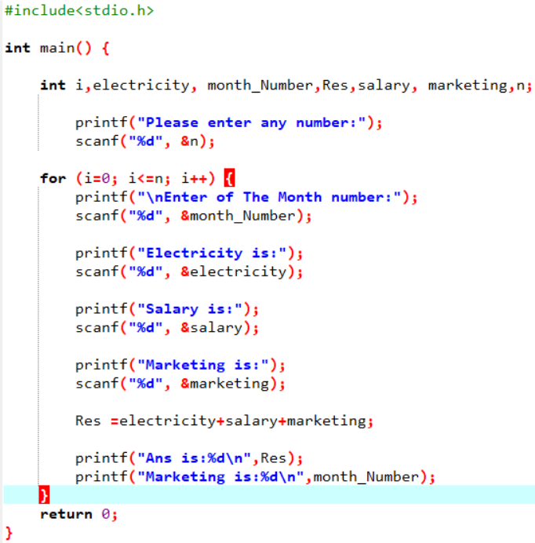

Output:-

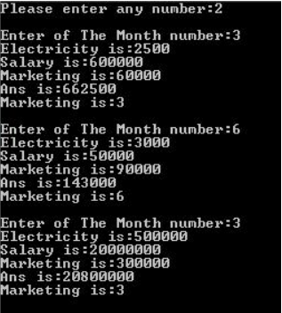

1. Write a program to calculate x power y.(when user input x is 2 and y is 3 then the result will be 8)

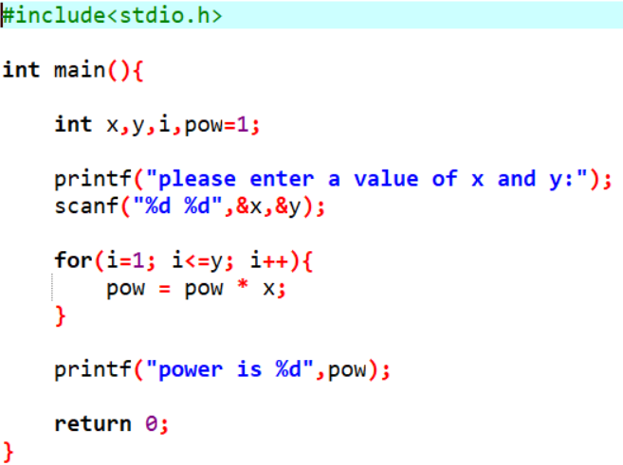

Output:-



1. Write a program to calculate sum of the digits of a given number.

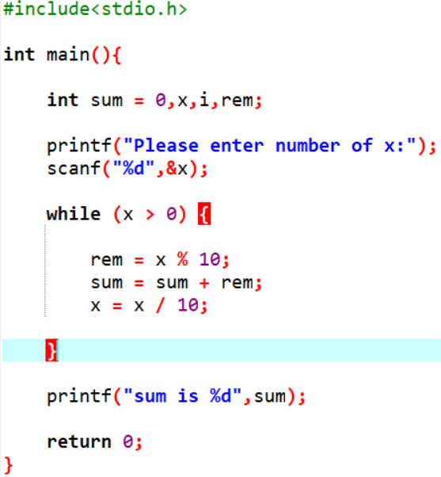

Output:-



1. Write a program to print all Armstrong numbers under 1000.

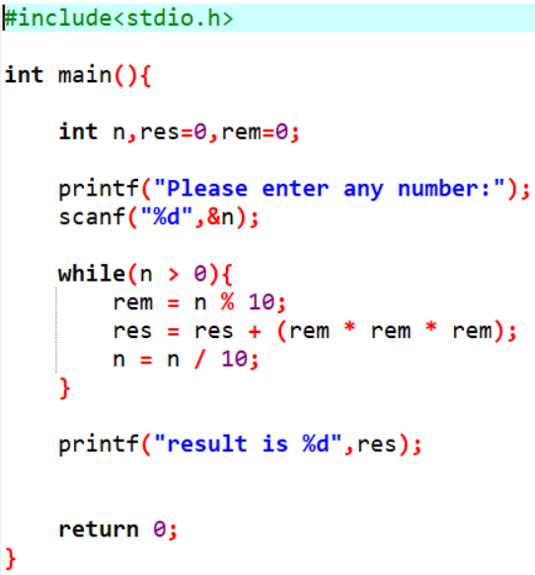

Output:-

 