1. Write a C program that demonstrate static string and add - (dash) after each character except last character.
2. Write a C program that demonstrate all string functions.

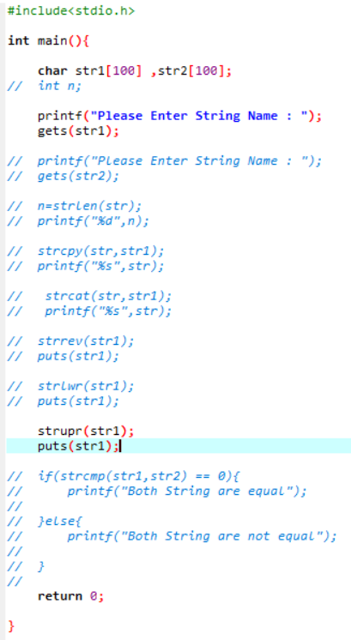

Output:-



1. Write a C program that remove white space from given string.

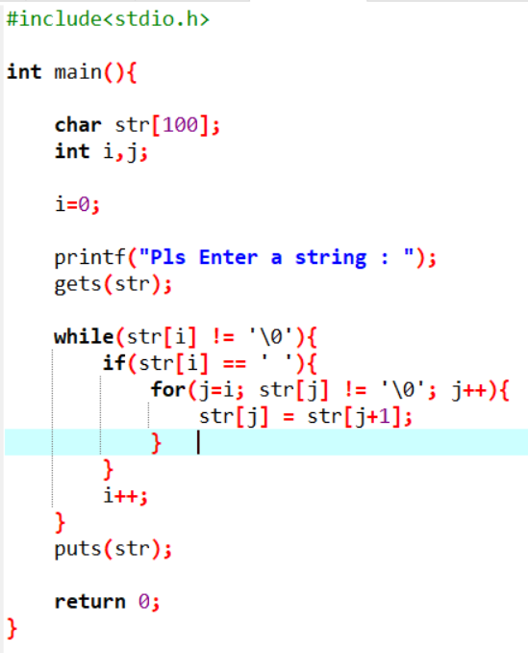

Output:-



1. Write a C program that remove repeated character from given string.

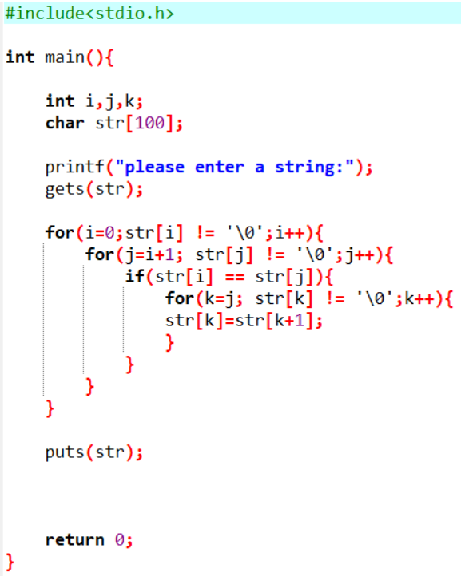

Output:-



1. Write any two C program that demonstrate string without string function.

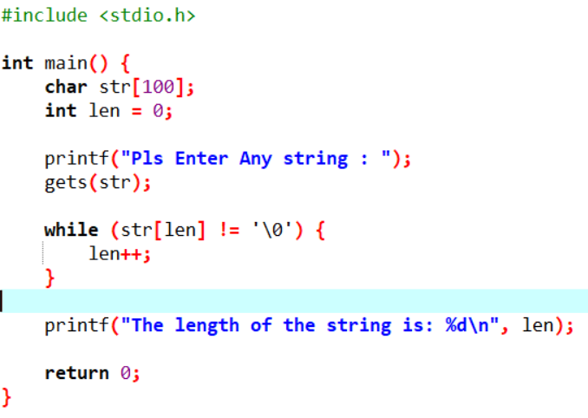

Output:-

