1. Write a C program to print your introduction using type-1 function.

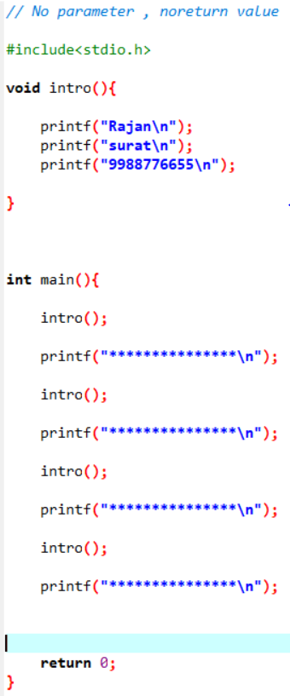

Output:-

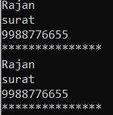

1. Write a C program to find area of circle using type-2 function.

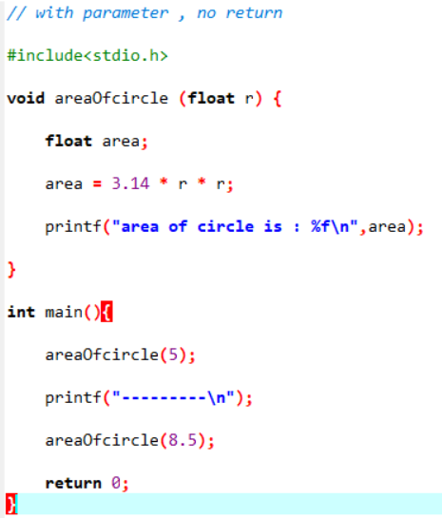

Output:-

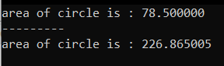

1. Write a C program to find area of rectangle using type-3 function.

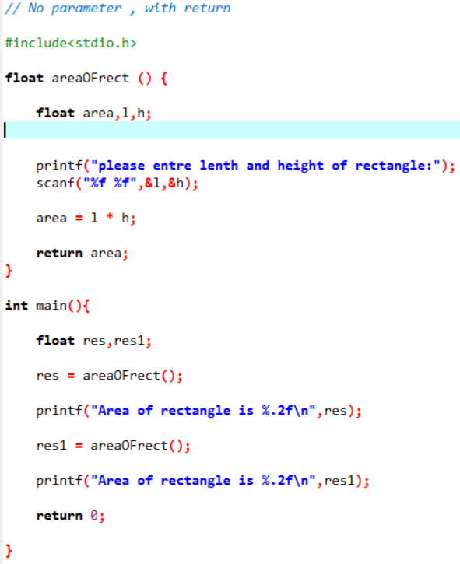

Output:-

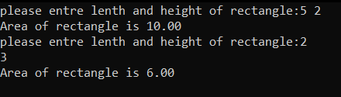

1. Write a C program to create a calculator using type-4 function.

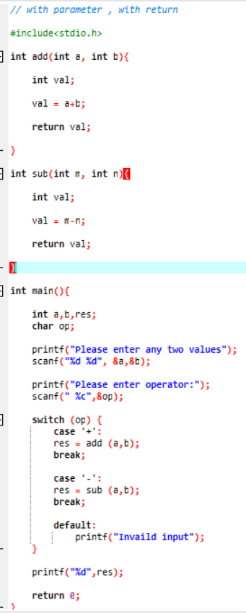

Output:-

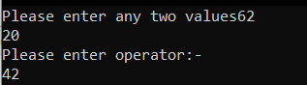

1. Write a C program to find number is even or odd using type-1 function.

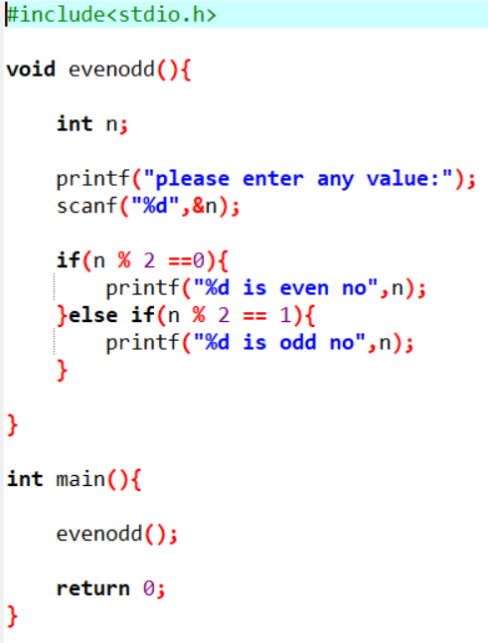

Output:-



1. Write a C program to find average of 4 numbers using type-2 function.

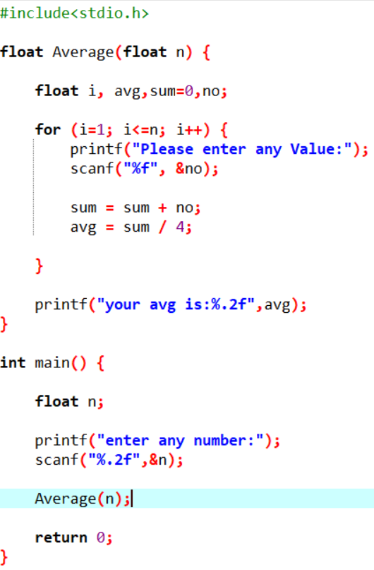

Output:-

1. Write a C program to find given number is prime or not using type-3 function.

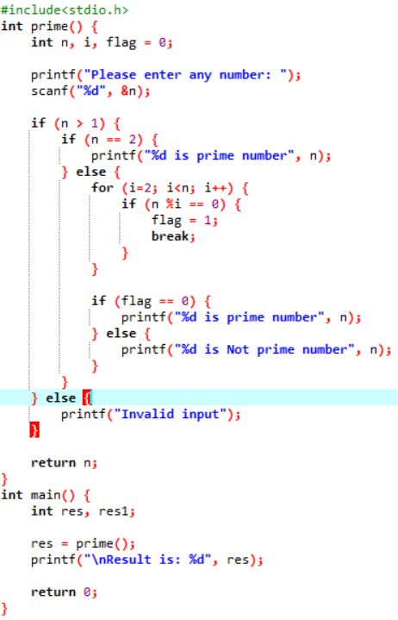

Output:-

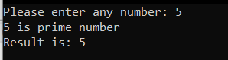

1. Write a C program to find given number is Armstrong or not using type-4 function.

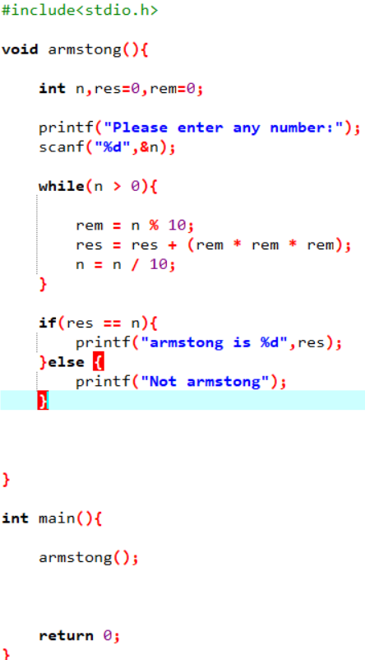

Output:-



9.Write a C program to find Sum of all Array Elements by passing array as an argument using User Define Functions.

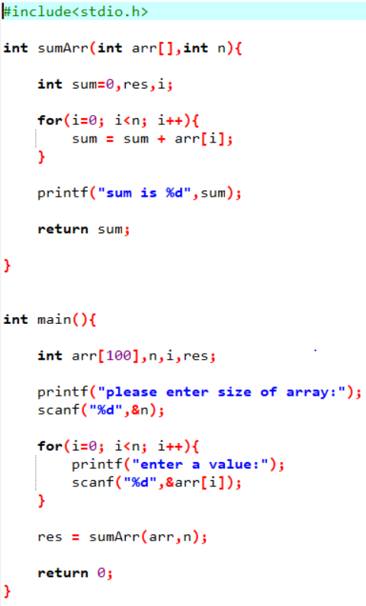

Output:-

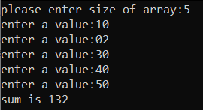

11. Write a C program to find factorial of number using recursion. 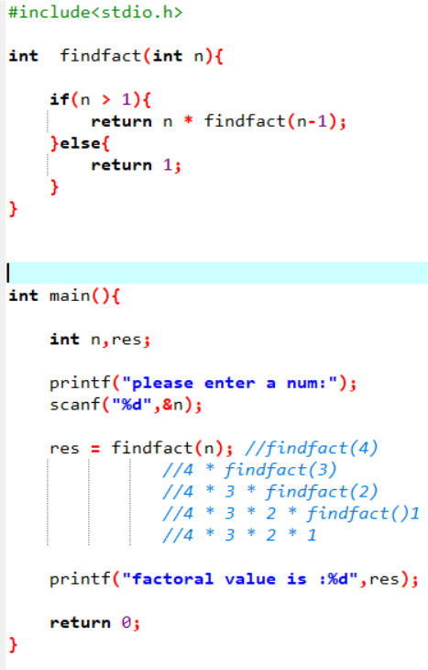

Output:-



12.mximum number find.

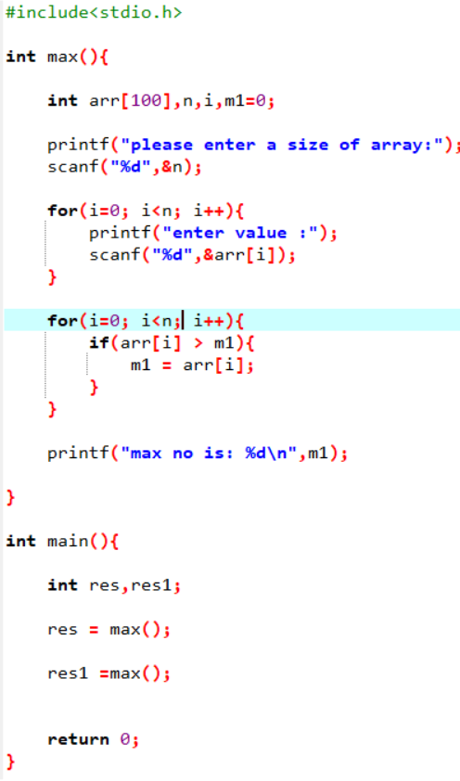

Output:-

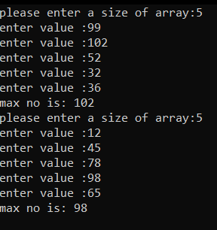

13. find a negative number.

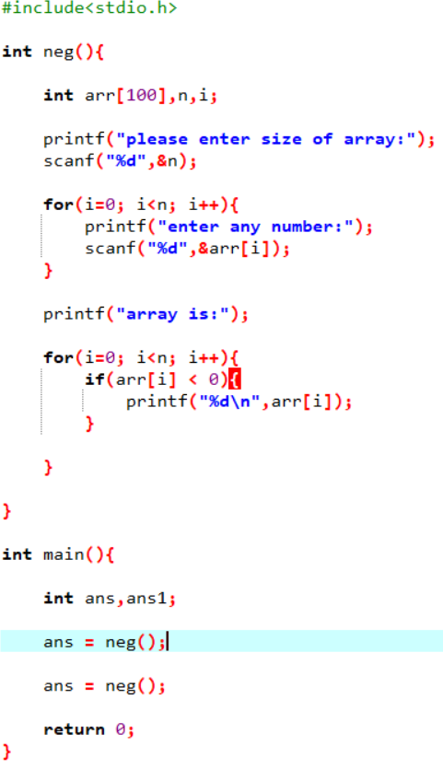

Output:-

