Smart Speakers
Once awake, the speaker will listen to your question, feed it through the system and respond. The virtual assistant will also learn the more you talk so that it can make better sense of your accent and vocabulary over time and give you better answers.

Alexa[Intelligent virtual assistant]:
- Alexa, an intelligent personal assistant developed by Amazon, is revolutionizing the way we interact with technology.
- With its voice-activated capabilities, Alexa can effortlessly play music, set alarms, provide weather updates, even order any products, set routines, make payments with just a simple command.
- Once awake, the speaker will listen to your question, feed it through the system and respond. The virtual assistant will also learn the more you talk so that it can make better sense of your accent and vocabulary over time and give you better answers.

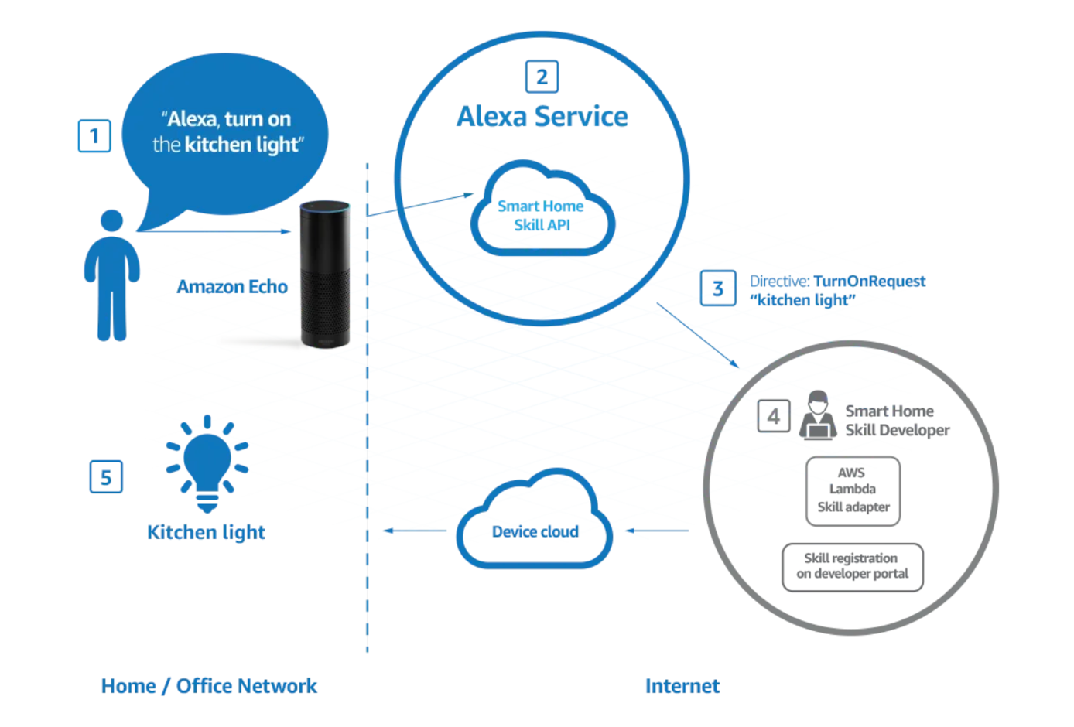
Signal Processing:
- Signal processing is one of the most important challenges in far-field audio.
- The idea is to improve the target signal, which means being able to identify ambient noise like the TV and minimize them. To resolve these issues, seven microphones are used to identify roughly where the signal is coming from so the device can focus on it. Acoustic echo cancellation can subtract that signal so only the remaining important signal remains.
- If the wake word is detected, the signal is then sent to the speech recognition software in the cloud, which takes the audio and converts it to text format. The output space here is huge as it looks at all the words in the English language, and the cloud is the only technology capable of scaling sufficiently.
- To convert the audio into text, Alexa will analyse characteristics of the user’s speech such as frequency and pitch to give you feature values.
- A decoder will determine what the most likely sequence of words is, given the input features and the model, which is split into two pieces. The first of these pieces is the prior, which gives you the most likely sequence based on a huge amount of existing text, without looking at the features, the other is the acoustic model, which is trained with deep learning by looking at pairings of audio and transcripts. These are combined and dynamic coding is applied, which has to happen in real time.”

Alexa Architecture:
Alexa’s architecture is divided into two main components:
- the Alexa Voice Service (AVS) and
- the Alexa Skills Kit (ASK).

- The interaction between a user and an Amazon Echo device begins with the user’s voice command,
- which is recorded by the device and sent to Amazon’s cloud servers.
- The request is then processed using a combination of natural language processing (NLP) and machine learning algorithms, allowing Alexa to decipher the user’s intent accurately.

ASK: [Alexa Skill kit]
The Alexa Skills Kit (ASK) is a software development framework that enables you to create content, called skills.
Skills are like apps for Alexa.
With an interactive voice interface, Alexa gives users a hands-free way to interact with your skill.
Users can use their voice to perform everyday tasks like checking the news, listening to music, or playing a game. Users can also use their voice to control cloud-connected devices. For example, users can ask Alexa to turn on lights or change the thermostat. Skills are available on Alexa-enabled devices, such as Amazon Echo and Amazon Fire TV, and on Alexa-enabled devices built by other manufacturers.

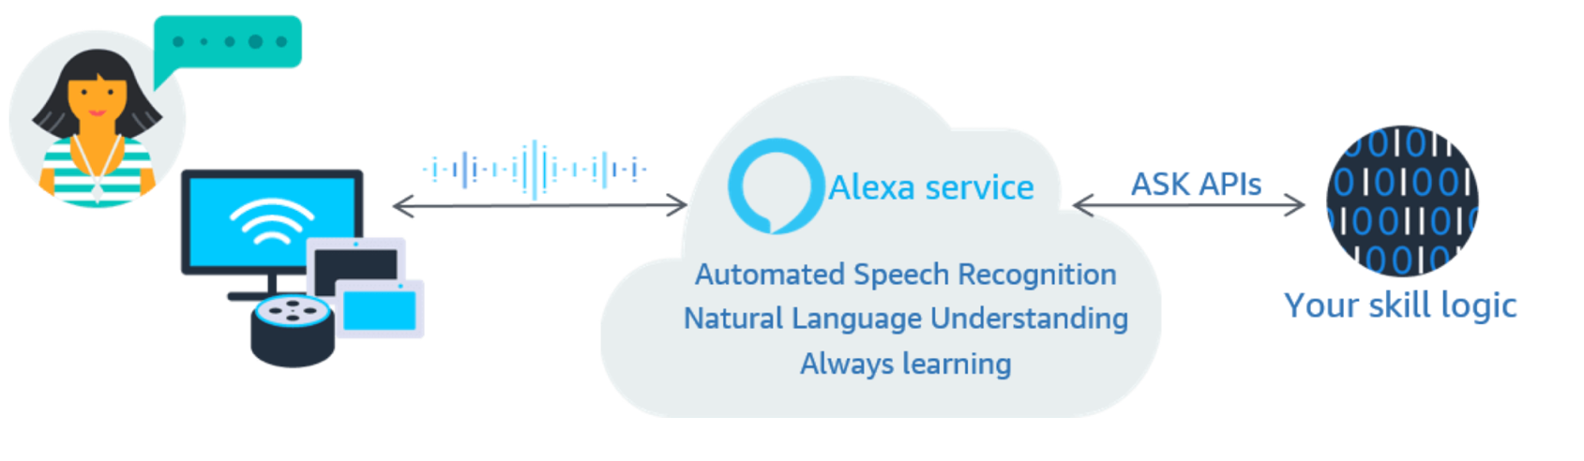

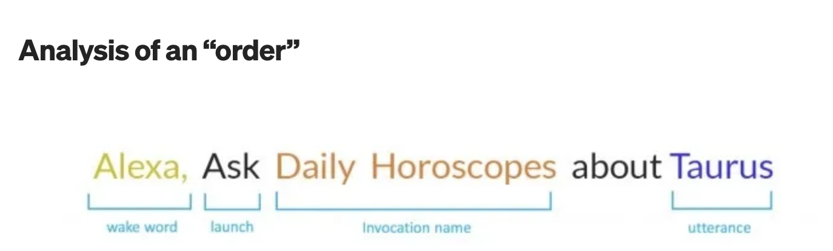
Wake word [invocation-kick start the alexa engine]
When users say ‘Alexa’ which wakes up the device. The wake word put the Alexa into the listening mode and ready to take instructions from users.
Invocation name [intent]
Invocation name is the keyword used to trigger a specific “skill”. Users can combine the invocation name with an action, command or question. All the custom skills must have an invocation name to start it.
Utterance [request]
‘Taurus’ is an utterance. Utterances are phrases the users will use when making a request to Alexa. Alexa identifies the user’s intent from the given utterance and responds accordingly. So basically the utterance decide what user want Alexa to perform.

After, Alexa enabled devices sends the user’s instruction to a cloud-based service called Alexa Voice Service (AVS).
AVS:[Alexa Voice services]
It’s a convergence of artificial intelligence and computational linguistics which handles interactions between machines and natural languages of humans in which computers are entailed to analyze, understand, alter, or generate natural language.
NLP:[Natural Language procession]
- NLP helps computer machines to engage in communication using natural human language in many forms, including but not limited to speech and writing.
- After, it converts them into Artificial language like speech recognition. Here we get the data into a textual form which NLU (Natural Language Understanding) process to understand the meaning.
- NLU[Natural Language Understanding] is actually a subset of the wider world of NLP

Today’s voice-first technologies are built with NLU, which is artificial intelligence centered on recognizing patterns and meaning within human language. Natural Language Processing with voice assistants as its proxy has already redefined how we interact with technology, in the home and otherwise
The most popular smart speaker brands include Amazon and Google, though you can also buy speakers made by the likes of Apple, Sonos, and Bose [own voice recognition technology]

