

|  |  |  |
| --- | --- | --- |
| **AWT PROJECT** | | |
| Project Name-Online Medical Store (CAREPOINT) | | |
| Group Members Name | | |
| **NAME** | **PRN** | DIV |
| RAJAN JHA | 1132210594 | A |
| NIKITA KUMARI | 1132210590 | A |
| RUTIKA ITHAPE | 1132210078 | A |
| CHIDERA CAROL OMIBIRE | 1132210760 | A |
| HARDIK PARMAR | 1132210578 | A |

**Introduction**

The main objective of the project on “CAREPOINT” is to manage the details of Customer, Medicine, Medicine Stock, Order, Customer.

The project is totally built at administrative end and thus only the administrative end thus only the administrator is guaranteed the access.

The purpose of the project is to build an application program to reduce the manual work for managing the customer, medicine Company, Payment, Medicine. It tracks all the details about the Medicine Stock, Order.

Our project aims at business process automation i.e. we have tried to computerize processes of CAREPOINT. In computer system the person has to fill the various forms & number of copies of the forms can be easily generated at a time.

In computer system, it is not necessary to create the manifest but we can directly print it, which saves our time.

To assist the staff in capturing the effort spent on their respective working areas.

To utilize resources in ab efficient manner by increasing their productivity through automation.

The system generates types of information that can be used for various purposes. It satisfies the user requirement.

Be easy to understand by the user and operator Be easy to operate

Have a good user interface Be expandable Delivered on schedule within the budget.

**Screen Shot**

Figure 1Home Page



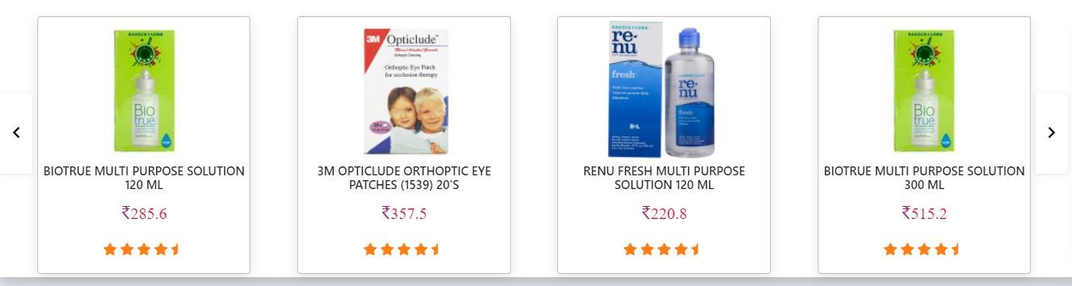

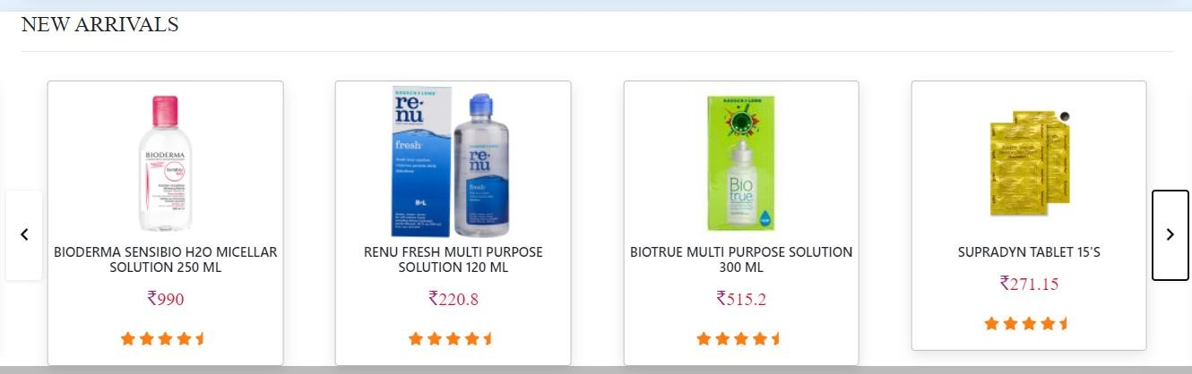

Figure 2Register Page

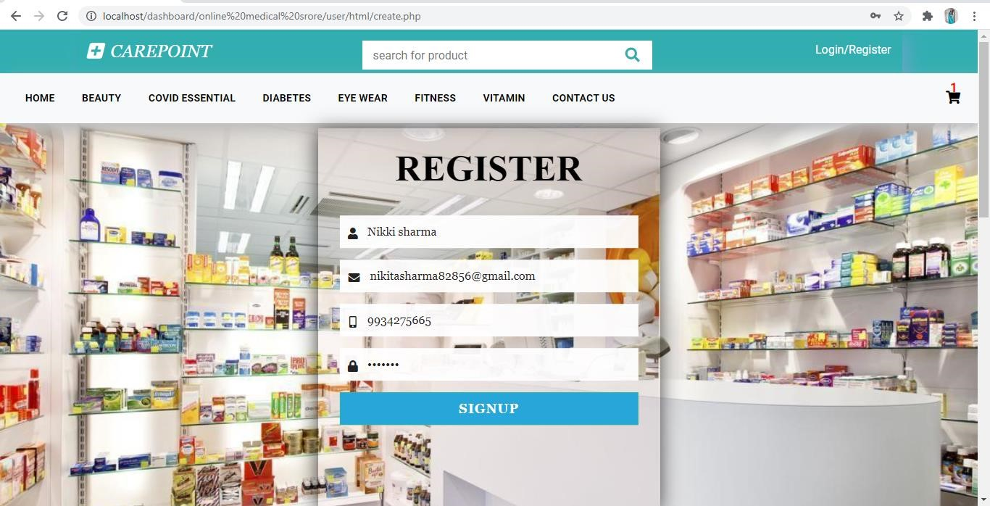

Figure 3Login Page

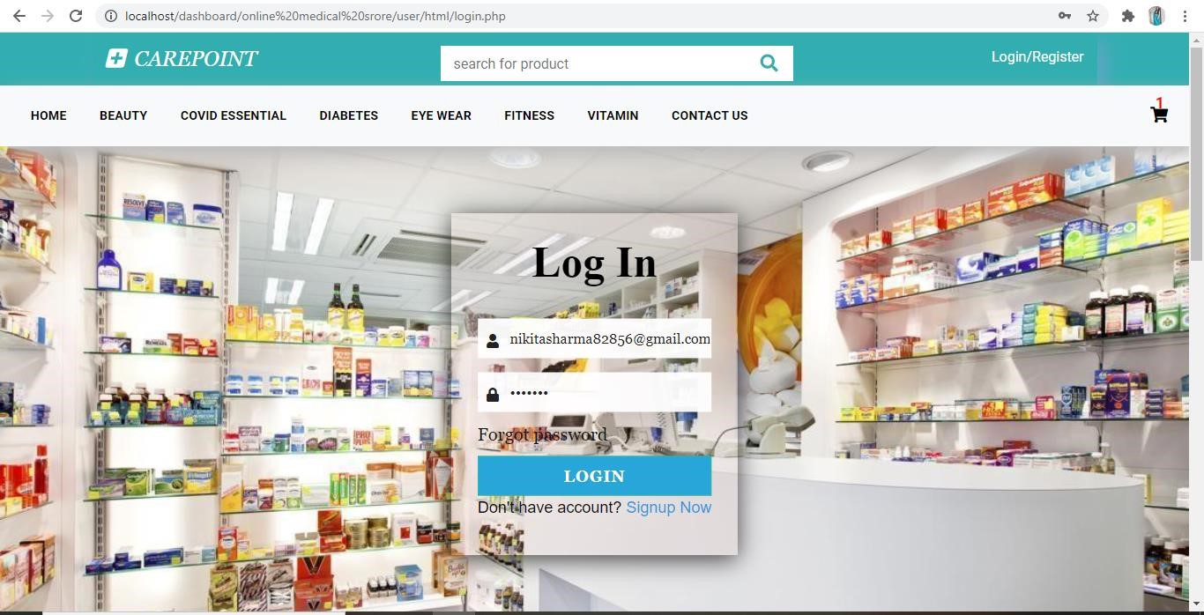

Figure 4Customer details Page

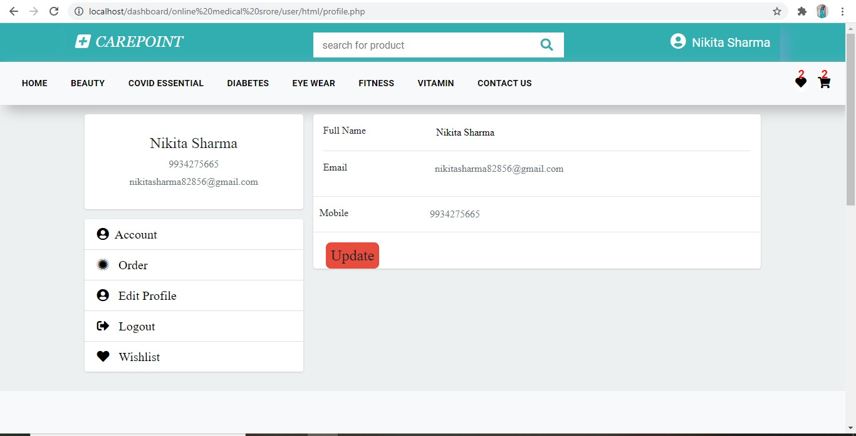

Figure 5categories page

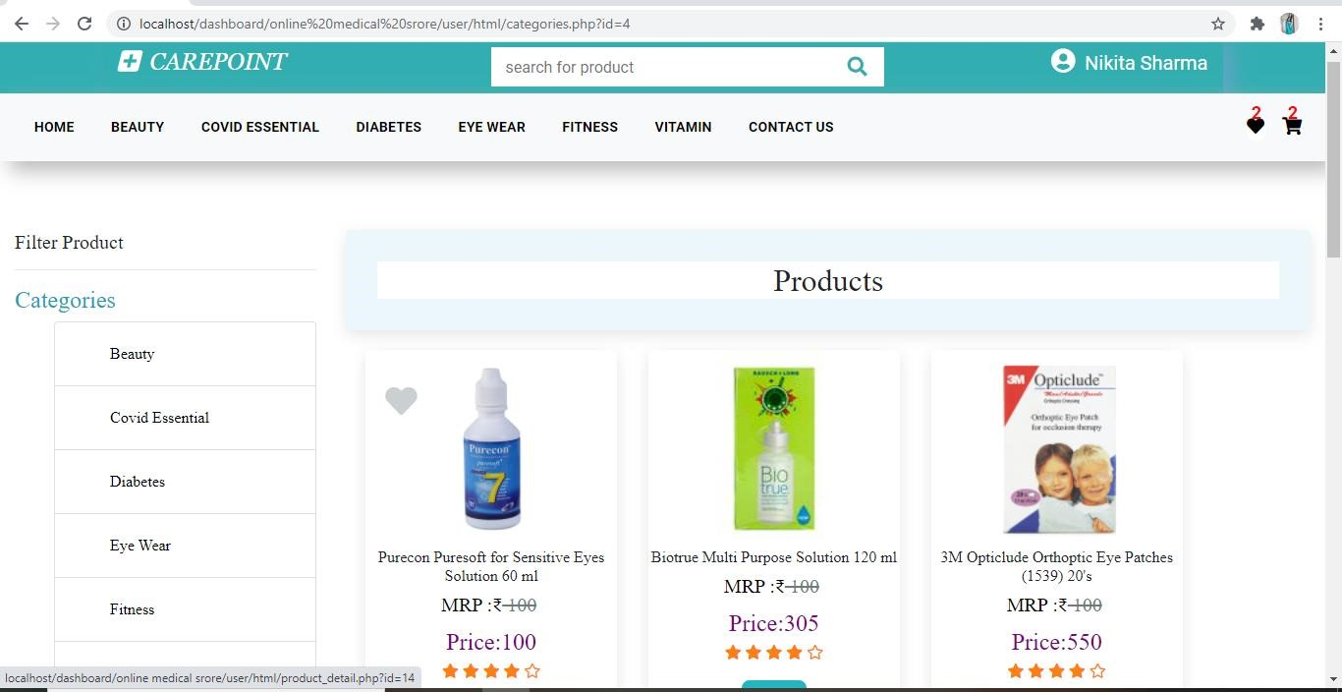

Figure 6Product details page

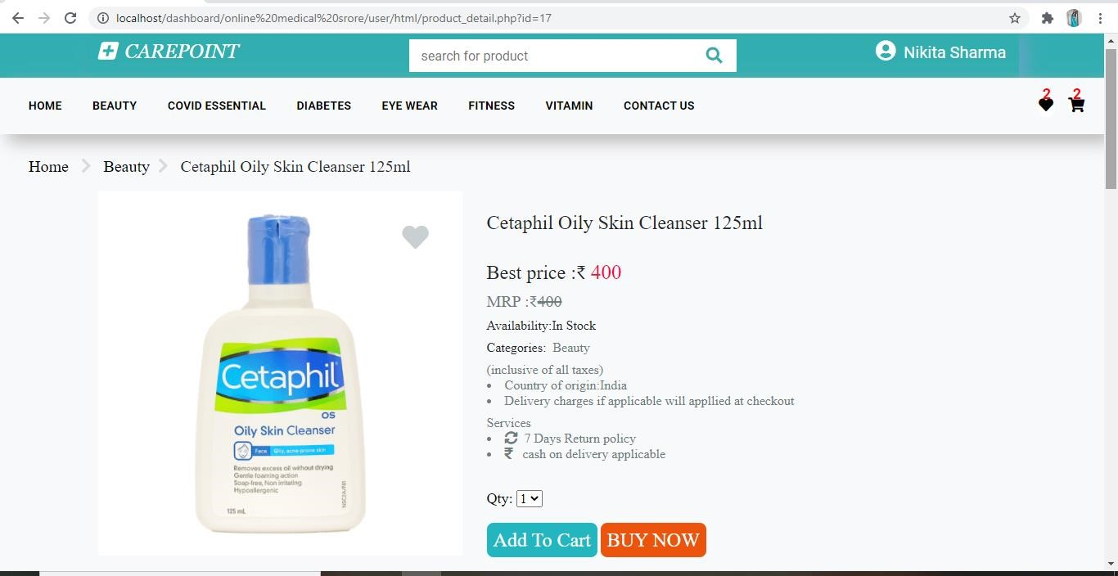

Figure 7Wishlist Page

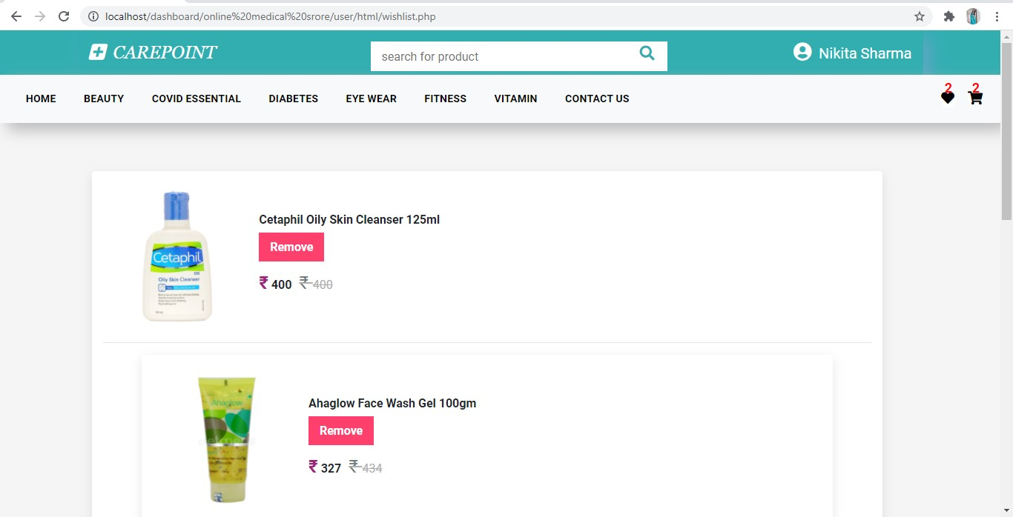

Figure 8Cart page

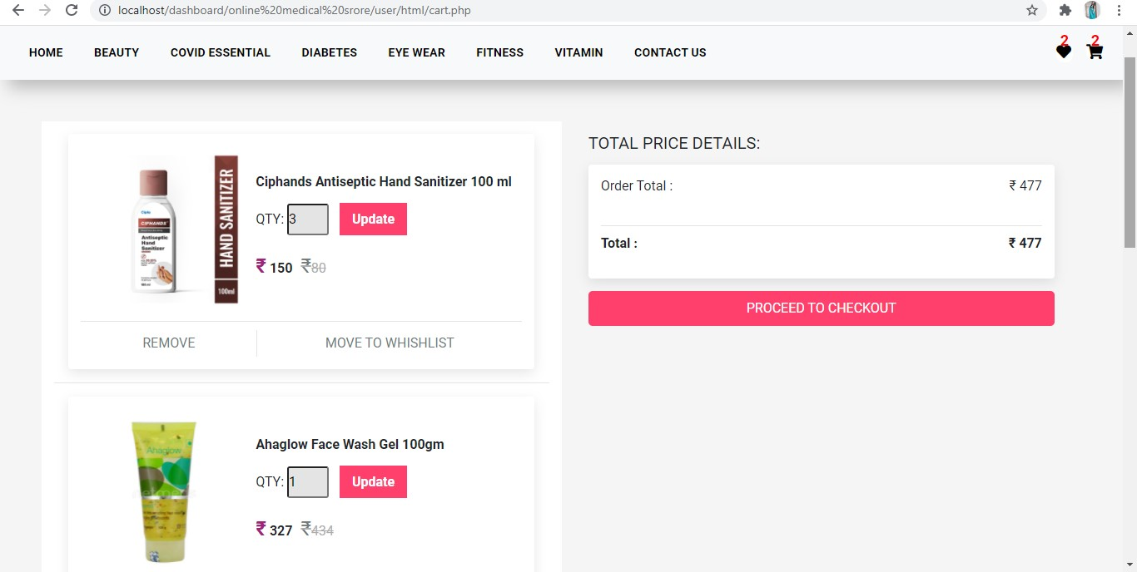

Figure 9CheckOut page

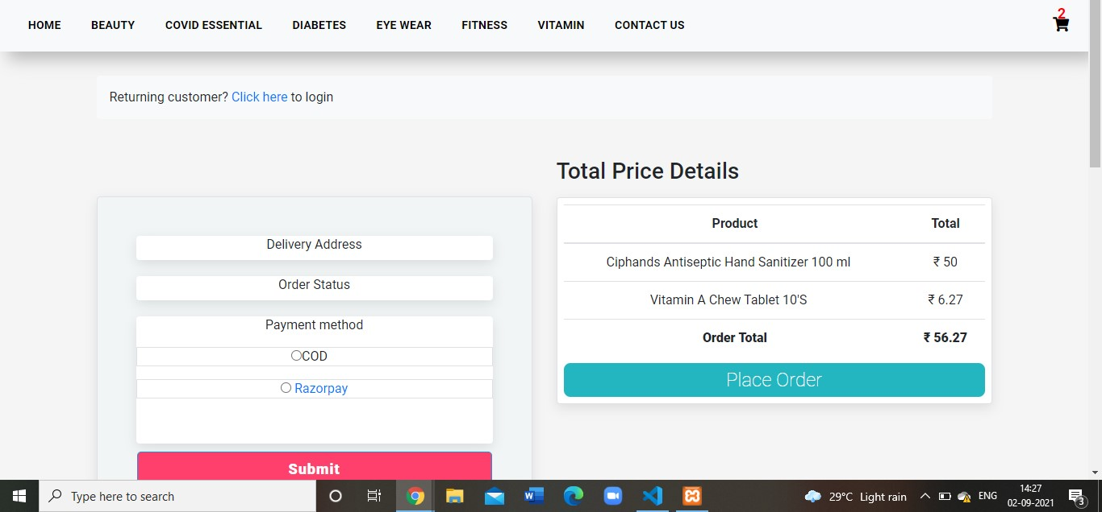

Figure 10 Admin Categories Page

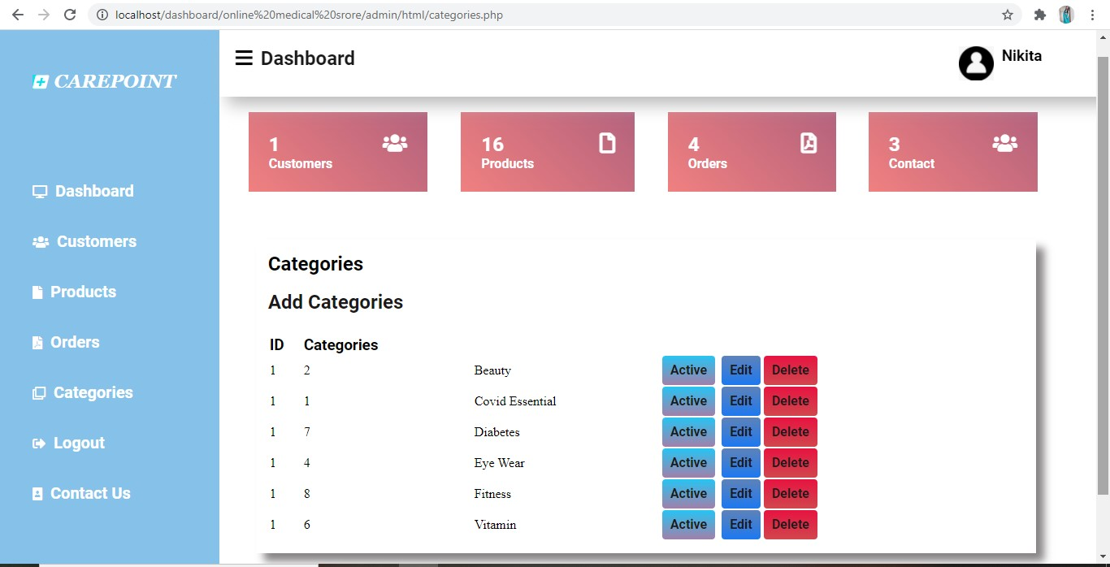

Figure 11 Admin Order

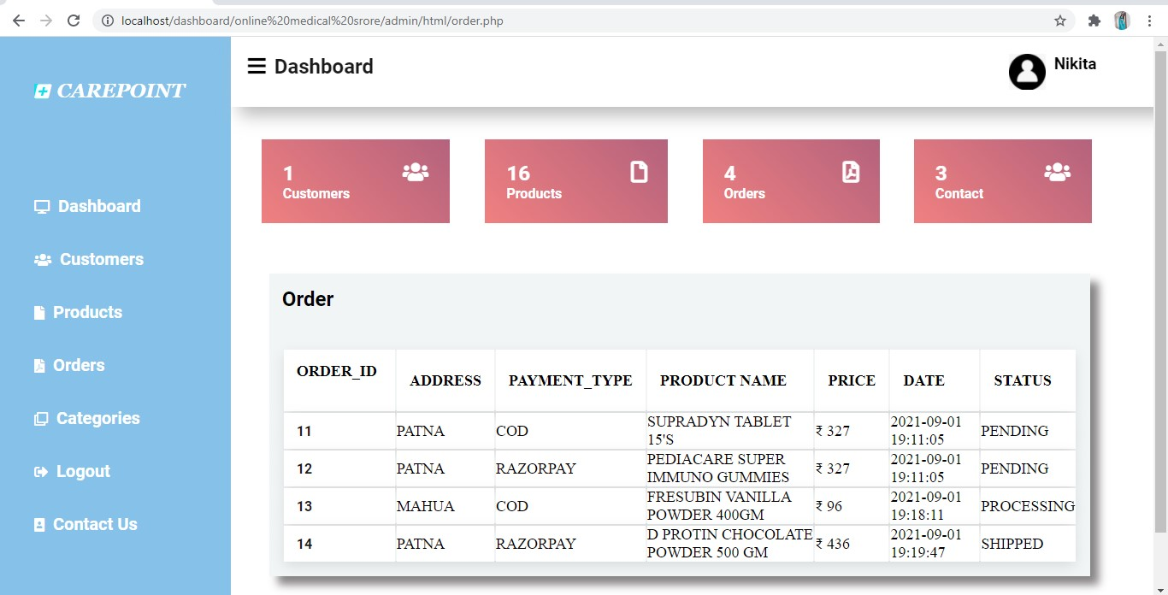

Figure 12 Admin Product Page

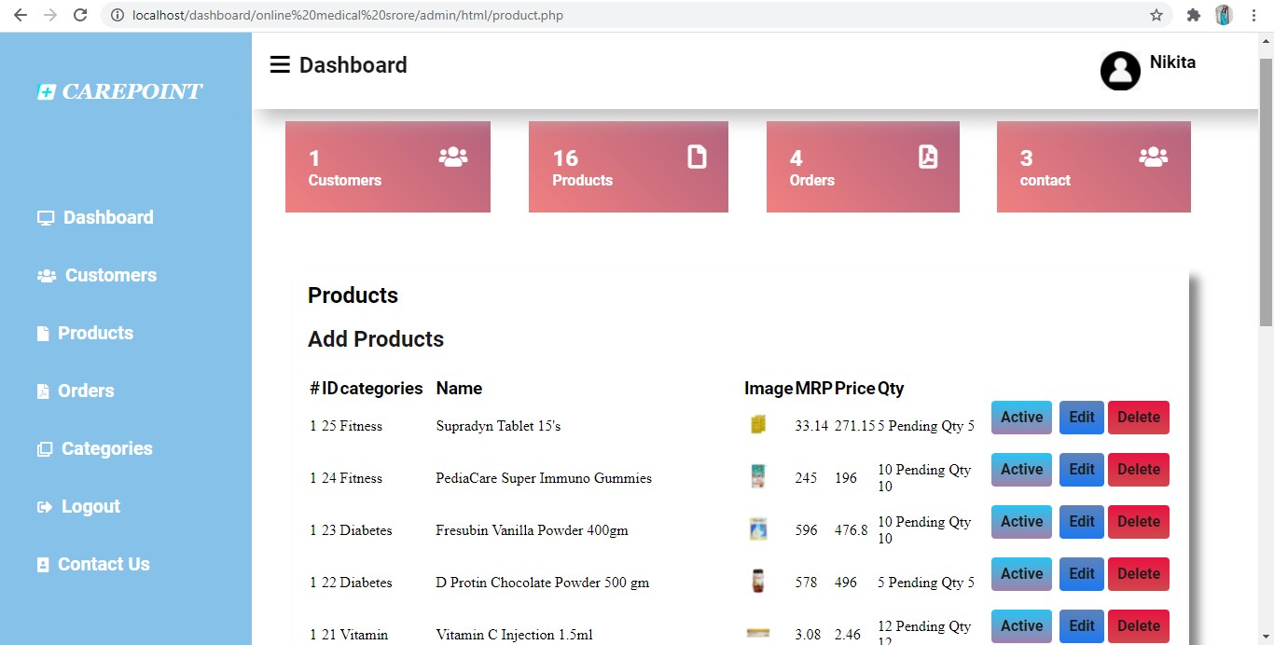

Figure 13Admin Add Product Page

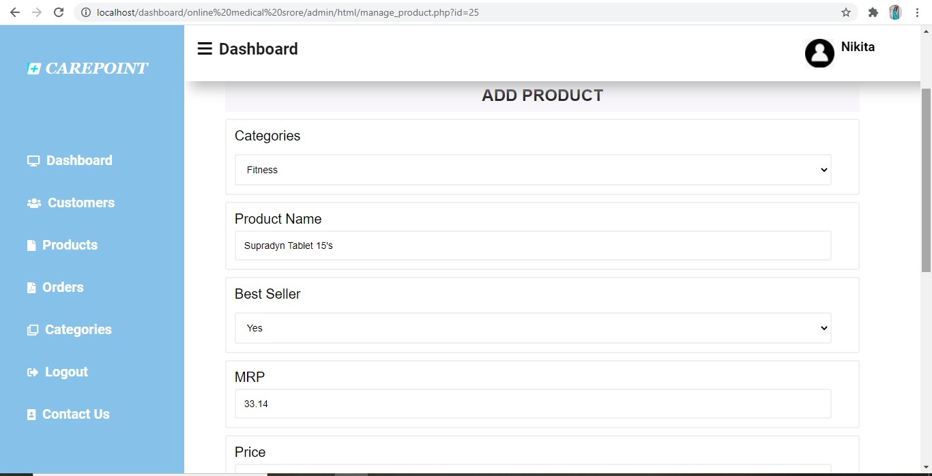

Figure 14 Customer details In Admin Panel

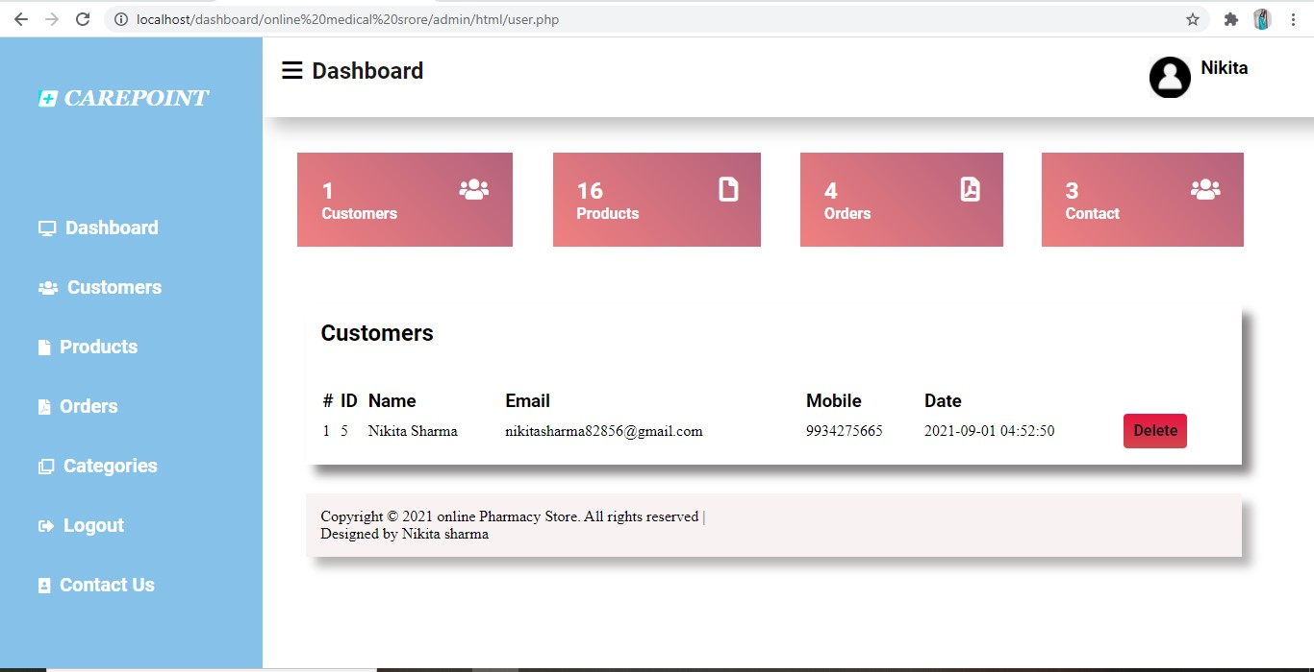

Figure 15 Manage Contact in admin panel

