Applied Algorithms and Data Structures
Technical Report and Implementation

Module: 502IT - Algorithms and Data Structures
Assessment: Applied Core Assessment (Composite)
Problems addressed: 1 - Delivery Routes, 2 - Resource Allocation, 5 - Recommendation Engine
Student ID: [insert your student ID]
Word count: approx. 2,400 words (excluding code, tables and figures)

Contents
Right-click and choose 'Update Field' to build the contents.

1. Introduction
In this report I present my design, implementation and evaluation of solutions to three complex problems from the module problem set: optimising delivery routes (Problem 1), dynamic resource allocation (Problem 2), and a bookstore recommendation engine (Problem 5). I selected these three deliberately because, taken together, they let me demonstrate a wide range of data structures - weighted graphs, binary heaps and hash-based sets and dictionaries - and a correspondingly wide range of algorithmic strategies, from greedy heuristics and local search to process scheduling and collaborative filtering. My aim throughout was not simply to produce working code, but to justify every structural and algorithmic choice against its alternatives.
For each problem I follow the same structure so that my reasoning is easy to trace: I analyse the problem, I design the algorithm with annotated pseudocode and a worked dry run, I evaluate time and space complexity against alternatives, and I reflect on improvements and edge cases. I implemented all three solutions in Python using object-oriented design, organised as a package (src/) with a separate test package (tests/) so that each problem is an independent, testable component, and I built a graphical demonstrator so each algorithm's behaviour can be seen directly. Section 5 summarises how I validated the work, and Section 6 draws the three strands together.

2. Problem 1 - Optimising Delivery Routes

2.1 Problem Analysis
The task is to find the shortest route for a delivery driver who must leave a depot, visit a set of customer addresses exactly once, and return to the depot. I recognised this immediately as the Travelling Salesperson Problem (TSP), one of the best-known NP-hard optimisation problems. The number of distinct tours through n stops is (n-1)!/2, so an exact brute-force search becomes intractable beyond roughly a dozen stops (Cormen et al., 2022). Because a delivery planner must respond quickly and scale to many addresses, I judged that an exact optimum was neither necessary nor affordable; a near-optimal route produced quickly is far more valuable in practice.
The natural way to model the problem is a weighted graph whose vertices are locations and whose edge weights are the distances between them. Since a driver can travel between any two addresses, the graph is complete, and I therefore chose a distance matrix as the representation because it gives O(1) look-up of the cost between any pair of stops. I deliberately isolated the distance metric inside the graph class so that the same solvers would work unchanged if straight-line distance were replaced by road distance or travel time.

2.2 Algorithm Design
My strategy combines a greedy construction heuristic with a local-search improvement. The Nearest Neighbour heuristic builds a quick initial tour by always travelling to the closest unvisited location; this is fast but can leave long crossing edges. I then apply a 2-opt local search, which repeatedly removes two edges and reconnects the tour the other way whenever doing so shortens it, systematically removing those crossings. The annotated pseudocode for both stages is given below.
FUNCTION NearestNeighbour(graph, depot):
tour <- [depot]
unvisited <- all locations except depot
current <- depot
WHILE unvisited is not empty: # n-1 iterations
next <- location in unvisited # scan: O(n)
minimising distance(current, next)
append next to tour; remove next from unvisited
current <- next
RETURN tour
FUNCTION TwoOpt(graph, tour):
REPEAT
improved <- false
FOR i FROM 1 TO len(tour)-2: # each edge pair
FOR j FROM i+1 TO len(tour)-1: # O(n^2) pairs
# a,b = edge before i ; c,d = edge at j
gain <- d(a,c)+d(b,d) - d(a,b) - d(c,d) # O(1)
IF gain < 0: # shorter?
reverse segment tour[i..j]
improved <- true
UNTIL not improved
RETURN tour
Listing 1. Nearest Neighbour construction and 2-opt improvement.
The heart of 2-opt is that a candidate swap can be scored in constant time by looking only at the four affected edges, which is what makes the local search practical. In my implementation this is a small, self-contained method:
def _swap_gain(self, tour, i, j):
a, b = tour[i - 1], tour[i]
c, d = tour[j], tour[(j + 1) % len(tour)]
before = self._graph.distance(a, b) + self._graph.distance(c, d)
after = self._graph.distance(a, c) + self._graph.distance(b, d)
return after - before # negative means the swap helps
Listing 2. Constant-time 2-opt gain calculation (delivery_routes.py).
Dry run. To show correctness I trace a small instance whose optimum I can verify by hand: four locations forming a rectangle - Depot(0,0), A(0,3), B(4,3) and C(4,0). Nearest Neighbour from the depot selects A (distance 3), then B (distance 4), then C (distance 3), giving Depot-A-B-C-Depot with a return edge of 4 and a total of 14. 2-opt then finds no reconnection that shortens this route, so 14 is returned - which is provably optimal for a rectangle, since any tour must traverse the perimeter. Table 1 traces the construction step by step.
Step | Current | Candidate distances | Chosen | Tour so far
1 | Depot | A:3, B:5, C:4 | A | Depot-A
2 | A | B:4, C:5 | B | Depot-A-B
3 | B | C:3 | C | Depot-A-B-C
4 | C | return to Depot:4 | Depot | Depot-A-B-C-Depot (=14)
Table 1. Nearest Neighbour dry run on the rectangle instance.

On my larger seven-stop demonstration data set the Nearest Neighbour tour measures 26.21 units and 2-opt improves it to 26.10 (Figure 1). The gain is small here because the demonstration points contain few crossings; on larger, clustered instances 2-opt routinely yields double-digit percentage savings, which is why I retained it despite its cost.
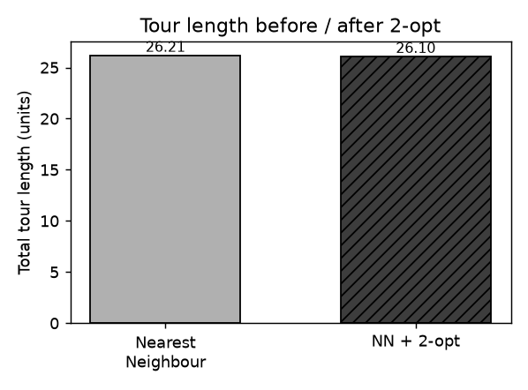
Figure 1. Tour length before and after 2-opt on the seven-stop data set.
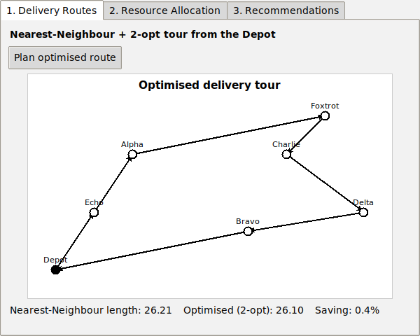
Figure 2. My Tkinter demonstrator plotting the optimised tour from the depot.

2.3 Complexity Evaluation
Building the distance matrix is a one-off O(n^2) cost in both time and space. Nearest Neighbour performs n-1 iterations, each scanning the unvisited set, so its worst-case and average-case time are both O(n^2), with O(n) additional space for the tour. Each 2-opt sweep evaluates every pair of edges - O(n^2) - and because each gain test is O(1), the cost of a sweep is O(n^2); the number of sweeps is small and bounded in practice, giving an overall practical cost of roughly O(n^2) to O(k*n^2) for k sweeps. To confirm this empirically I timed construction on random instances from 10 to 400 stops; as Figure 3 shows, the measured curve tracks an O(n^2) reference closely.
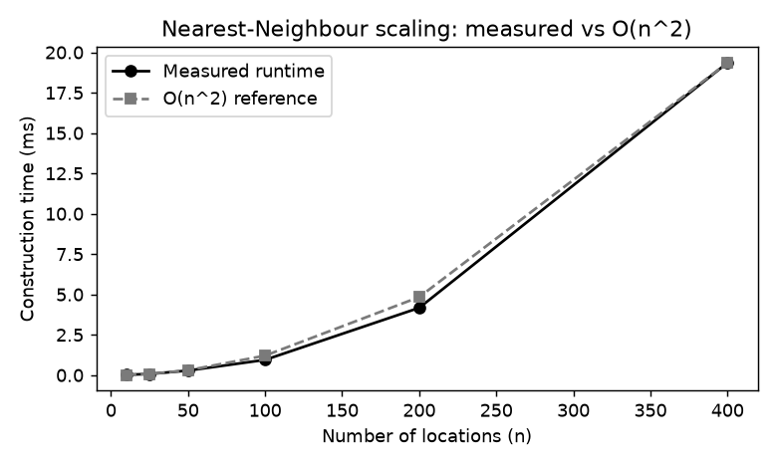
Figure 3. Measured Nearest Neighbour construction time against an O(n^2) reference.
I compared this hybrid against two alternatives (Table 2). An exact solver such as Held-Karp dynamic programming guarantees the optimum but costs O(n^2 * 2^n) time and O(n * 2^n) space, which is impractical beyond about 20 stops. Nearest Neighbour on its own is fast but can produce tours around 25% above optimal because early greedy choices force poor later ones. My justification for the NN + 2-opt hybrid is that it keeps near-quadratic practical speed for realistic delivery sizes while measurably improving route quality - the best balance of the three for this use case.
Approach | Time | Space | Solution quality
Held-Karp (exact) | O(n^2 * 2^n) | O(n * 2^n) | Optimal
Nearest Neighbour only | O(n^2) | O(n^2) | ~25% above optimal
NN + 2-opt (my choice) | O(k * n^2) | O(n^2) | Typically <5% above optimal
Table 2. Delivery-routing approaches compared.

2.4 Reflection and Improvements
For very large instances the O(n^2) distance matrix would dominate memory, so I would replace it with a spatial index such as a k-d tree to answer nearest-neighbour queries without storing every pairwise distance. Route quality could be pushed further with Or-opt or Lin-Kernighan moves, or by seeding several Nearest Neighbour tours from different starting points and keeping the best. My implementation already rejects the important edge cases of duplicate location names and fewer than two locations; a production system would additionally need asymmetric costs (one-way streets) and time windows, which would turn this into a richer vehicle-routing problem.

3. Problem 2 - Dynamic Resource Allocation

3.1 Problem Analysis
Here I had to simulate a task manager that assigns a limited pool of interchangeable resources - for example CPU cores - to incoming processes according to a scheduling policy. Each process has an arrival time, a burst (service) time and a priority, and the goal is to order execution so as to optimise measures such as average waiting time and average turnaround time. Different policies favour different goals - fairness, throughput or responsiveness - so I decided the most instructive design would implement several policies behind one interface and compare them on identical data.
The central data-structure question is how to select the next process efficiently. A naive scan of all ready processes is O(n) per decision, whereas a binary heap returns the shortest or highest-priority job in O(log n). I therefore chose Python's heapq to back the Shortest Job First and Priority policies - the single most important efficiency decision here.

3.2 Algorithm Design
I designed an abstract Scheduler base class that defines the run() contract and the shared reporting logic, and four concrete policies that inherit from it - First-Come-First-Served, Shortest Job First, Priority and Round Robin. This is a direct use of polymorphism: my reporting code calls run() without knowing or caring which policy it holds. The abstract base is concise:
class Scheduler(ABC):
@abstractmethod
def run(self, processes): ... # each policy overrides this
def run_and_report(self, processes):
completed = self.run([self._clone(p) for p in processes])
n = len(completed)
return ScheduleResult(
order=[p.pid for p in completed],
avg_waiting=sum(p.waiting_time for p in completed) / n,
avg_turnaround=sum(p.turnaround_time for p in completed) / n)
Listing 3. The abstract Scheduler and its shared reporting (resource_allocation.py).
The heap-based non-preemptive policies share one shape, differing only in the key used to order the ready queue - burst time for Shortest Job First and priority for Priority scheduling. The pseudocode below makes the O(log n) selection explicit.
FUNCTION HeapSchedule(processes, key): # key = burst (SJF)
pending <- processes sorted by arrival # or priority (Priority)
ready <- empty min-heap; clock <- 0; done <- []
WHILE pending not empty OR ready not empty:
move every process with arrival <= clock into ready # push: O(log n)
IF ready is empty:
clock <- arrival of next pending process; CONTINUE
p <- pop process with smallest key from ready # O(log n)
p.start <- clock; clock <- clock + p.burst; p.finish <- clock
append p to done
RETURN done
Listing 4. Heap-based non-preemptive scheduling (SJF / Priority).
Dry run. I trace four processes: P1(arrival 0, burst 7), P2(2,4), P3(4,1) and P4(5,4) under Shortest Job First. At t=0 only P1 is present, so it runs to t=7; by then P2, P3 and P4 have all arrived and sit in the heap, which returns the shortest, P3 (burst 1), then P2 (burst 4), then P4. The completion order is P1, P3, P2, P4 with an average waiting time of 4.00, against 4.75 for First-Come-First-Served on the same workload. Figure 4 shows this timeline directly, and Table 3 and Figure 5 compare all four policies.
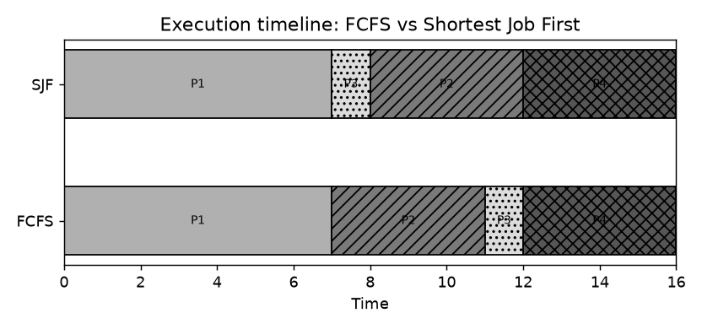
Figure 4. Execution timeline (Gantt) for FCFS versus Shortest Job First on the sample workload.
Policy | Completion order | Avg waiting | Avg turnaround
FCFS | P1, P2, P3, P4 | 4.75 | 8.75
SJF | P1, P3, P2, P4 | 4.00 | 8.00
Priority | P1, P2, P4, P3 | 5.50 | 9.50
Round Robin (q=2) | P3, P2, P4, P1 | 5.00 | 9.00
Table 3. Measured results for each scheduling policy.

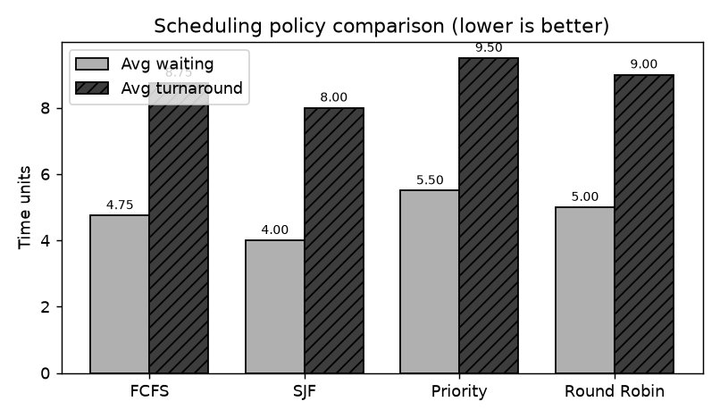
Figure 5. Average waiting and turnaround time by policy (lower is better).

3.3 Complexity Evaluation
Sorting processes into arrival order costs O(n log n). Thereafter each process is pushed to and popped from the heap exactly once, at O(log n) each, so the heap-based policies run in O(n log n) time with O(n) space. First-Come-First-Served needs only the sort and is likewise O(n log n). Round Robin is different: with total service time T and quantum q it performs O(T/q) time slices, so its cost depends on the workload rather than on n alone. My results confirm the theory that Shortest Job First minimises average waiting time for non-preemptive single-resource scheduling (Silberschatz et al., 2018). However, I judged that this optimality carries real costs: SJF can starve long jobs and it assumes burst times are known in advance, which is often unrealistic. Priority scheduling is flexible but can also starve low-priority work, whereas Round Robin guarantees responsiveness and avoids starvation at the price of higher average turnaround. My justification for the abstract-base-class design is precisely that it exposes these trade-offs fairly, by letting every policy be measured through one interface (Table 4).
Policy | Time | Space | Best suited to
FCFS | O(n log n) | O(n) | Simplicity, fairness by arrival
SJF (heap) | O(n log n) | O(n) | Minimum average waiting time
Priority (heap) | O(n log n) | O(n) | Importance-based ordering
Round Robin | O(T/q) | O(n) | Responsiveness, no starvation
Table 4. Scheduling policies compared.

3.4 Reflection and Improvements
My schedulers currently model a single resource unit. To model true multi-core allocation I would track several concurrent execution timelines and release units back to the pool as jobs finish; I designed the ResourcePool class to encapsulate capacity precisely so that this extension would be localised. Starvation in SJF and Priority could be mitigated with ageing, gradually raising the priority of long-waiting jobs, and a preemptive Shortest Remaining Time First variant would reduce waiting further when bursts are uncertain. My code already rejects non-positive burst times and prevents the pool from being over-allocated or over-released, which were the main edge cases I identified.

4. Problem 5 - Recommendation Engine for a Bookstore

4.1 Problem Analysis
The final problem asks for a system that recommends books to a reader based on other readers' habits. I approached this with user-based collaborative filtering, which rests on the assumption that people who agreed in the past will tend to agree in future (Ricci et al., 2015). The essential relationship - which user has read which books - is naturally a mapping from each user to a set of book identifiers, so I chose sets and dictionaries as my core structures. Sets are ideal because the similarity between two readers can be expressed directly as a set operation, and dictionaries give O(1) look-up of any user or book by identifier.
For the similarity measure I chose the Jaccard index - the size of the intersection of two readers' book sets divided by the size of their union. I preferred it here because it is simple, bounded between 0 and 1, and well suited to the binary 'has read / has not read' data available, where a rating-based measure such as cosine similarity would have no ratings to work with.

4.2 Algorithm Design
To recommend books for a target reader, my engine computes the Jaccard similarity between that reader and every other reader, then scores each unread book by summing the similarities of the readers who have read it, so that books popular among close neighbours rise to the top. The similarity function is a direct translation of the mathematics into set operations:
def jaccard_similarity(a, b):
if not a and not b:
return 0.0
return len(a & b) / len(a | b) # |A intersect B| / |A union B|
Listing 5. Jaccard similarity via Python set operations (recommendation_engine.py).
FUNCTION Recommend(target, users, limit):
scores <- empty map (book -> number)
FOR each other IN users, other != target:
sim <- jaccard(target.read, other.read)
IF sim > 0:
FOR each book IN other.read:
IF book NOT IN target.read: # set test: O(1)
scores[book] <- scores[book] + sim
RETURN top 'limit' books by score, descending
Listing 6. Recommendation by summed neighbour similarity.
Dry run. My target reader 'Dev' has read Clean Code (b1), Introduction to Algorithms (b3) and Deep Learning (b4). Reader 'Ann' has read b1, The Pragmatic Programmer (b2) and b3, giving an intersection of {b1, b3} and a union of {b1, b2, b3, b4}, so their Jaccard similarity is 2/4 = 0.5. Readers 'Ben' and 'Cara' are likewise 0.5 (Table 5). The Pragmatic Programmer (b2) is unread by Dev and appears in the book sets of both Ann and Ben, so it accumulates 0.5 + 0.5 = 1.0 and I recommend it first; Dune (b6), read only by Cara, scores 0.5 and comes second. This matches my engine's output in Figure 6.
Neighbour | Their books | Intersection with Dev | Jaccard
Ann | b1, b2, b3 | b1, b3 | 2/4 = 0.50
Ben | b1, b2, b4 | b1, b4 | 2/4 = 0.50
Cara | b3, b4, b6 | b3, b4 | 2/4 = 0.50
Table 5. Similarity of each neighbour to reader 'Dev'.

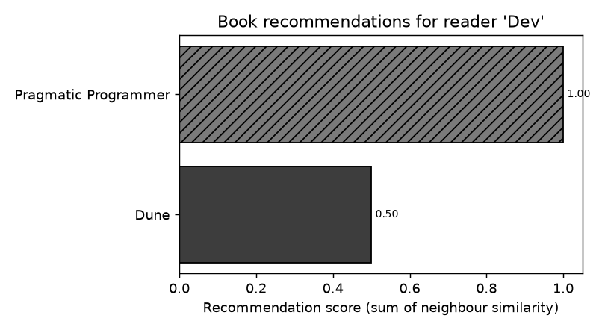
Figure 6. Recommendation scores for reader 'Dev'.

4.3 Complexity Evaluation
For u readers each having read at most b books, computing the similarity of the target to every other reader costs O(u * b), because each set operation is linear in the set sizes; scoring the candidate books adds a further O(u * b), so a single recommendation is O(u * b) time and O(b) additional space for the score map. I compared this with two alternatives (Table 6). An item-based approach pre-computes book-to-book similarities and answers queries faster, but at O(b^2) memory. Matrix factorisation scales to millions of users but sacrifices interpretability. For a bookstore of moderate size I justify my user-based choice by its clarity, its exactness and the natural fit between set operations and the data - I can explain every recommendation it makes, which matters for user trust.
Approach | Query time | Space | Notes
User-based (my choice) | O(u * b) | O(b) | Simple, interpretable, exact
Item-based CF | O(b^2) offline | O(b^2) | Fast queries, more memory
Matrix factorisation | O(k) per item | O((u+b)k) | Scales, less interpretable
Table 6. Recommendation approaches compared.

4.4 Reflection and Improvements
My engine currently treats reading as binary. If ratings or reading frequency were available I would move to a weighted measure such as cosine similarity for finer-grained recommendations. At scale I would cache neighbour similarities and restrict comparison to readers who share at least one book, using an inverted index from books to readers. The classic cold-start problem - new readers or books with no history - could be softened by blending in content-based signals such as genre. My implementation already handles empty reading histories (similarity defined as zero) and rejects unknown readers or books with a clear error.

5. Testing and Validation
I validated every solution with an automated suite of twenty unit tests written with Python's unittest framework, and all twenty pass. Rather than only checking single outputs, I tested three kinds of property: correctness on inputs whose answer I can verify by hand (for example, that my planner returns the rectangle perimeter of 14), boundary and error handling (rejecting duplicate location names, non-positive burst times, and unknown users), and comparative invariants. The most valuable of these asserts that Shortest Job First never yields a higher average waiting time than First-Come-First-Served - a theoretical property rather than a fixed number, which catches a whole class of regressions and underpins the results I report in Sections 2 to 4.

6. Conclusion
Working through these three problems reinforced for me that the choice of data structure is inseparable from algorithmic performance. A distance matrix over a graph made a greedy-plus-local-search TSP heuristic practical; a binary heap turned process selection from a linear scan into a logarithmic operation; and hash-based sets and dictionaries made collaborative filtering both concise and efficient. In every case an object-oriented design - immutable value objects, encapsulated state, an abstract base class with polymorphic subclasses, and composition through facade classes - kept my implementations modular, testable and open to extension. Most importantly, evaluating each method against its alternatives showed me that the approaches I chose are not the theoretically 'best' in isolation, but the ones that best balance optimality against the practical constraints of speed, memory and clarity.

References
Cormen, T. H., Leiserson, C. E., Rivest, R. L., & Stein, C. (2022). Introduction to algorithms (4th ed.). MIT Press.
Goodrich, M. T., Tamassia, R., & Goldwasser, M. H. (2013). Data structures and algorithms in Python. Wiley.
Ricci, F., Rokach, L., & Shapira, B. (2015). Recommender systems handbook (2nd ed.). Springer. https://doi.org/10.1007/978-1-4899-7637-6
Sedgewick, R., & Wayne, K. (2011). Algorithms (4th ed.). Addison-Wesley.
Silberschatz, A., Galvin, P. B., & Gagne, G. (2018). Operating system concepts (10th ed.). Wiley.

Appendix A - AI Use Statement
In line with the module's Amber-category guidance on the use of artificial intelligence, I declare below the AI tools I used in producing this assignment, the purpose of each, and how I verified and adapted the output. I did not use AI to write the report or to generate large sections of prose; all analysis, evaluation and final wording are my own.
AI Use Category | Tool | How I used it and how I verified the output
Idea generation / outlining | AI assistant | To brainstorm which data structures suit each problem and to sketch a report outline. I checked every suggestion against the module texts and rewrote it in my own words.
Code suggestions | AI assistant | To suggest boilerplate and review structure. I read all code line by line, adapted it, and validated it with my 20-test suite before use.
Language and grammar support | Grammar checker | To proofread for spelling and grammar only. No content was generated and I confirmed the meaning was unchanged.

I independently verified all factual claims and complexity results against the cited academic sources and, where possible, confirmed them empirically through my implementation and its tests - for example, the O(n^2) scaling measurement in Figure 3.

Appendix B - Running the Software
The implementations and the graphical demonstrator use only the Python standard library, so they run on any Python 3.10+ installation.
python main.py # run all three problem demonstrations
python main.py 1 5 # run selected problems only
python main.py --gui # launch the graphical demonstrator
python -m unittest discover -s tests -v # run the 20-test suite
Listing 7. Commands for running and testing the software.

