Assignment
Assignment Title: Flutter App with Back4App Integration
Assignment Title: Flutter App with Back4App Integration
Assignment Description:
In this assignment, you will create a Flutter app that connects to Back4App, a Backend-as-a-Service (BaaS) platform, to manage tasks. You will be responsible for setting up the Back4App backend, creating the Flutter app, and implementing the necessary functionality to interact with the backend.
Assignment Steps:
Step 1: Set Up Back4App
Sign up for a Back4App account (if not already done).
Create a new Back4App app.
Create a class in Back4App named Task with columns title (String) and description (String).
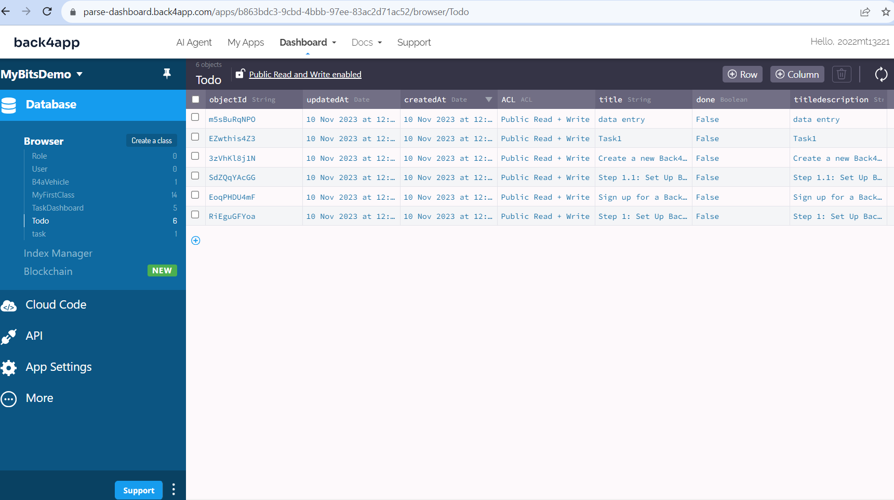
Step 2: Flutter Setup
Create a new Flutter project.
Add the required dependencies to your pubspec.yaml file.
Initialize the Parse SDK in your Flutter app.
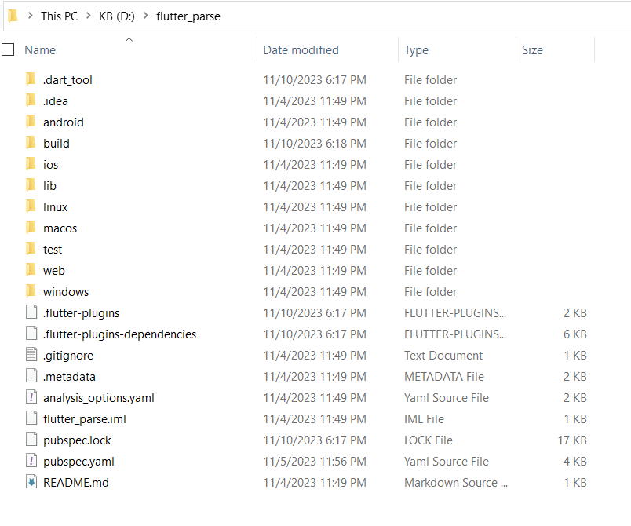
Step 3: Task List
Create a screen in your Flutter app to display a list of tasks.
Implement a function to fetch tasks from Back4App using the Back4App API.
Display the tasks in a list view with titles and descriptions.
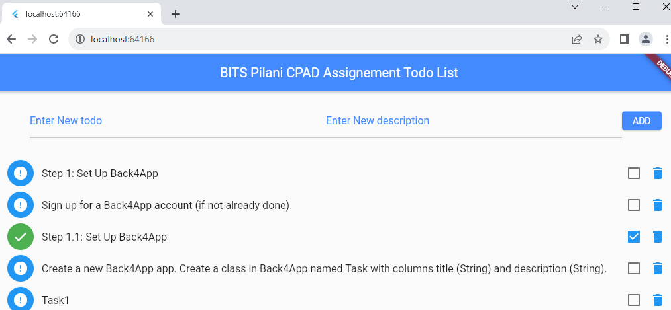

Step 4: Task Creation (10 points)
Create a screen for adding new tasks.
Implement functionality to create and save tasks to Back4App.
Verify that newly created tasks appear in the task list.
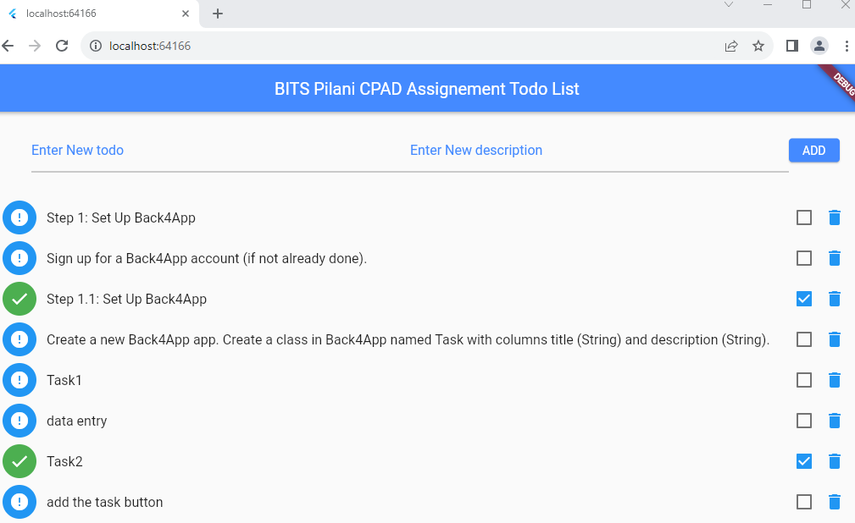
Step 5: Task Details
Add a feature to view task details when a task is tapped in the task list.
Display the title and description of the selected task.
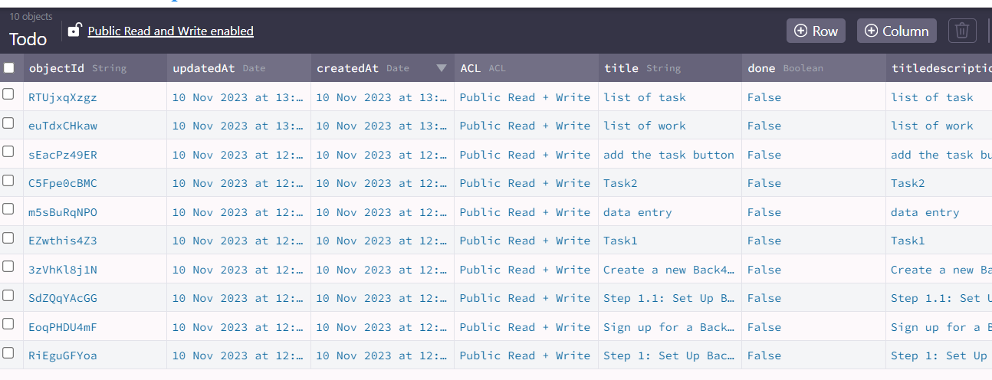
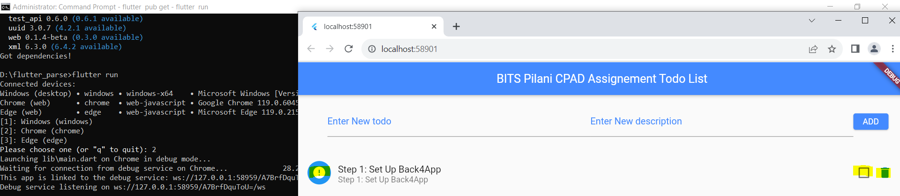
Step 6: Bonus Features
Add a feature to edit and update existing tasks.
Implement a feature for task deletion.
Add any additional features.
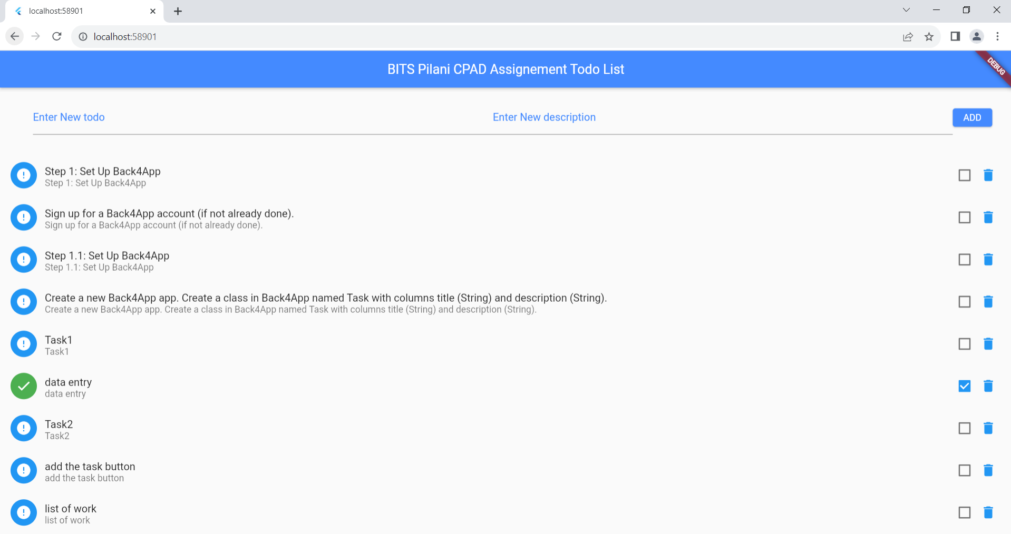
Click check for the done task
Delete symbol to delete the task
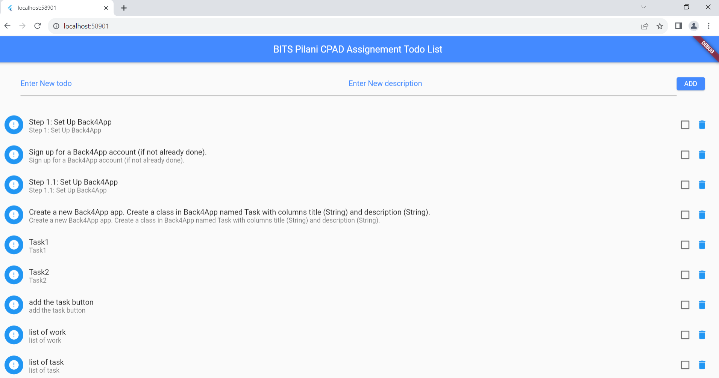

Submission:
Submit the link to your GitHub repository where you've hosted your Flutter app code.
Include a short README explaining how to set up and run your app.
Provide a brief overview of any bonus features you've implemented (if any).

Appendix A:

Need to set some local setting

Below file need to add manually under the local user folder
C:\Users\xxxx\AppData\Local\Pub\Cache\hosted\pub.dev\parse_server_sdk_flutter-7.0.0

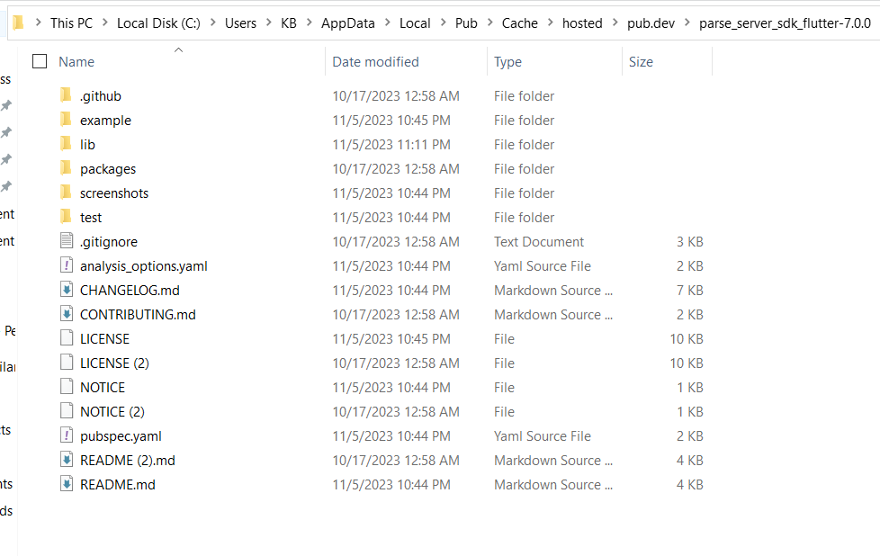

use the command prompt for accessing flutter_parse repository in local
Please don’t use the C drive, create the new drive like D:

Use the flutter pub get to build libs
Use flutter run to run the application

