|  |
| --- |
| The SAS System |

The REG Procedure

Model: MODEL1

Dependent Variable: Coin_Avg Coin_Avg

|  |  |
| --- | --- |
| **Number of Observations Read** | 219 |
| **Number of Observations Used** | 208 |
| **Number of Observations with Missing Values** | 11 |

| **Analysis of Variance** | | | | | |
| --- | --- | --- | --- | --- | --- |
| **Source** | **DF** | **Sum of Squares** | **Mean Square** | **F Value** | **Pr > F** |
| **Model** | 4 | 2775913657 | 693978414 | 213.53 | <.0001 |
| **Error** | 203 | 659770858 | 3250103 |  |  |
| **Corrected Total** | 207 | 3435684515 |  |  |  |

|  |  |  |  |
| --- | --- | --- | --- |
| **Root MSE** | 1802.80413 | **R-Square** | 0.8080 |
| **Dependent Mean** | 7405.71556 | **Adj R-Sq** | 0.8042 |
| **Coeff Var** | 24.34342 |  |  |

| **Parameter Estimates** | | | | | | |
| --- | --- | --- | --- | --- | --- | --- |
| **Variable** | **Label** | **DF** | **Parameter Estimate** | **Standard Error** | **t Value** | **Pr > |t|** |
| **Intercept** | Intercept | **1** | 27176 | 6181.30634 | 4.40 | <.0001 |
| **avg_dxy_value** |  | **1** | -398.64967 | 50.74575 | -7.86 | <.0001 |
| **snp_open** |  | **1** | 4.95821 | 0.95913 | 5.17 | <.0001 |
| **wallets_total** |  | **1** | 0.00010402 | 0.00002238 | 4.65 | <.0001 |
| **Buy_Bitcoin** | Buy_Bitcoin | **1** | 107.41745 | 10.62415 | 10.11 | <.0001 |

|  |
| --- |
| The SAS System |

The REG Procedure

Model: MODEL1

Dependent Variable: Coin_Avg Coin_Avg

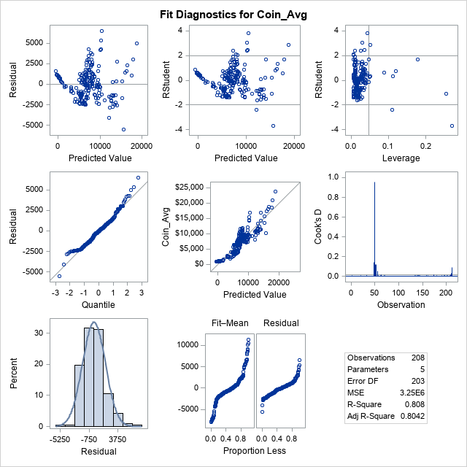

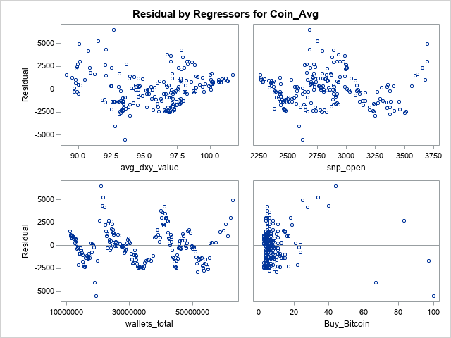

From my observation. It looks like there are 11 missing values in the table. The R.sq is 80% which means 80% variation of a dependent variable is explained by the independent variable(s) in this regression model. All variables avg_dxy_value, snp_open, and Buy_Bitcoin have contributed in this regression model except wallets_total which seems like somewhat same data.