Cluster Sampling Step-by-step Explanation
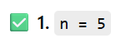
You are dividing the dataset into 5 clusters of equal size.
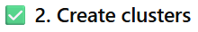
- range(1, n+1) generates: [1, 2, 3, 4, 5]
- len(dataset)/n divides the total rows by 5
- np.repeat() repeats the cluster numbers so each cluster has equal rows
- This creates a new column cluster_id in your dataset
✅ Example (if dataset has 20 rows):
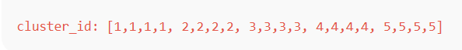
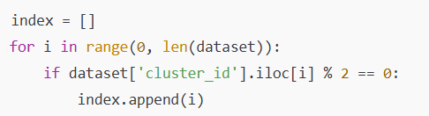
- Loops through every row
- Checks if the cluster number is even (2 or 4)
- If yes, store the row index
✅ Even clusters here are: Cluster 2 and 4
So, only rows from cluster 2 and cluster 4 are selected.

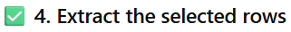
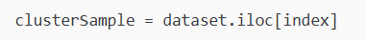
This creates a new dataset containing only rows from cluster IDs 2 and 4.
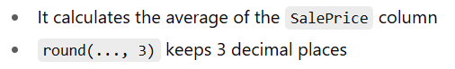
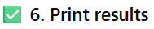
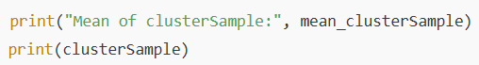
It shows:
✔️ The mean of SalePrice from selected clusters
✔️ The actual sampled rows

✅ Why do this?
This is an example of cluster sampling in statistics — used when:
- Data is too large to sample randomly
- You want faster and cheaper sampling
- You divide data based on natural groups
If you want me to write a cleaner or simpler version of this code, just ask!

Explanation - Stratified Random Sampling
✅ What is Stratified Random Sampling?
It’s a sampling method where you:
- Divide the population into groups (called strata) based on some characteristic
- Randomly select samples from each group
Each group gets represented fairly in the final sample.

✅ Easy Example:
Imagine a college has:
- 60% girls
- 40% boys
You want to survey 100 students.
With stratified sampling, you select:
- 60 girls
- 40 boys
✅ This way, your sample matches the real proportion of the population.
✅ Why is it useful?
Stratified random sampling helps you:
✔️ 1. Get accurate representation
You avoid the mistake of selecting too many from one group.
✔️ 2. Reduce bias
Every group (stratum) gets included fairly.
✔️ 3. Improve accuracy of results
Because you sample proportionally, conclusions are more reliable.

✅ When to use Stratified Sampling?
Use it when the population has distinct subgroups, like:
- Gender (Male/Female)
- Age (Teens, Adults, Seniors)
- Income Levels
- Regions (Urban, Rural)
- Education Level
✅ Quick Real-Life Examples
✅ Example 1: Education Survey
You want feedback from students of:
- Primary
- Middle
- High school
You divide students into these strata and sample equally/fairly.
✅ Example 2: Medical Study
A diabetes study might select people from:
- Age 20–40
- Age 41–60
- Age 61+
Each age group gets equal importance.
✅ Example 3: Customer Research
A company collects opinions from:
- Low-income customers
- Middle-income
- High-income

Step-by-step Explanation Stratified Random Sampling
Step 1: Reading the dataset
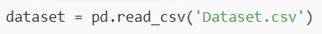
This loads a CSV file called Dataset.csv into a pandas DataFrame named dataset.
Step 2: Creating a 'strata' column
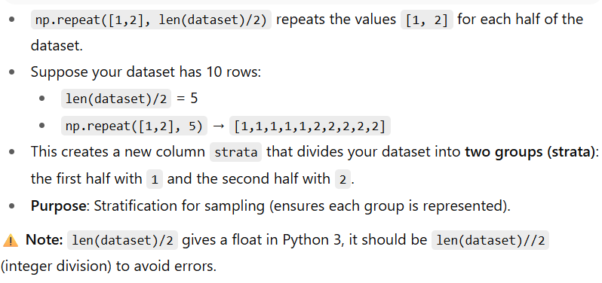
Step 3: Creating an index list
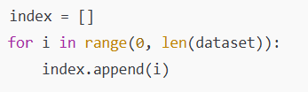
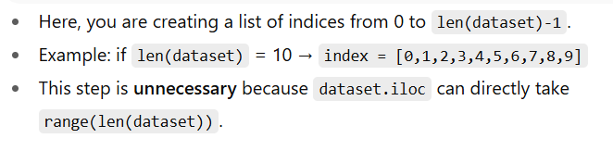

Step 4: Selecting rows using iloc
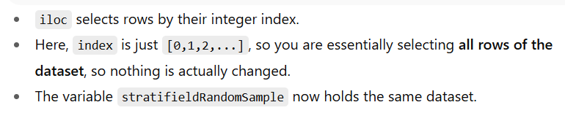
Step 5: Displaying the DataFrame
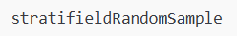
Prints or displays the full dataset with the new strata column.
✅ 1. Importing StratifiedShuffleSplit
You're importing StratifiedShuffleSplit and giving it a short name sss.
✅ 2. Set up the split
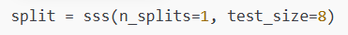
This means:
- n_splits=1: We want only one sample split
- test_size=8: We want 8 records in the sample
So you're creating a splitter that will select 8 records while maintaining proportion across the strata.
✅ 3. Split the data
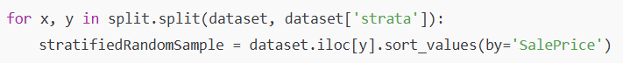
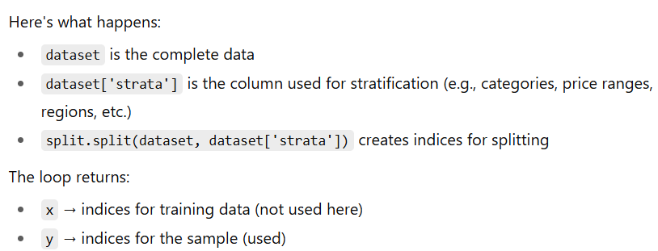
This:
✅ Selects only those 8 rows
✅ Sorts them by SalePrice

✅ Final Output
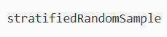
This displays the selected stratified random sample.

