METRO TRANSIT SYSTEM
Data Insights Report

1. Network Overview
25  Stations | 20  Trains | 465  Registered Passengers | 1,490  Total Bookings

₹146,091.57  Total Fare Revenue | ₹98.05  Average Fare / Booking | 52.6 min  Average Travel Time | 448  Passengers Who Booked ≥1 Trip

2. Bookings by Seat Class
Seat Class | Bookings | Revenue (₹) | % of Revenue
General | 1,200 | 117,361.90 | 80.3%
Premium | 290 | 28,729.67 | 19.7%

3. Revenue & Bookings by Route Line
Route Line | Bookings | Revenue (₹)
Line 3 | 526 | 52,723.24
Line 5 | 439 | 42,023.57
Line 2 | 294 | 28,627.04
Line 4 | 231 | 22,717.72

4. Top Performing Trains (by bookings)
Train Name | Bookings | Revenue (₹)
Teal Line Express | 84 | 8,389.57
Purple Line Local | 84 | 8,529.18
Silver Line Express | 81 | 8,738.62
Violet Line Local | 81 | 7,883.15
Pink Line Local | 79 | 7,869.02
18 of the 20 trains recorded more than 60 bookings each over the period; only 2 trains (Yellow Line Local and Blue Line Express) fell below that mark.

5. Top Boarding Stations (by revenue)
Station | Bookings | Revenue (₹)
Old Fort | 70 | 7,235.30
Tech Park | 72 | 6,680.53
Harbor Point | 65 | 7,023.67
Metro Mall | 65 | 6,715.65
Lakeview | 64 | 6,558.61
All 25 stations recorded at least one boarding — none are unused.

6. Fare Categories
Category | Definition | Bookings | Share
High Fare | > ₹100 | 717 | 48.1%
Medium Fare | ₹50 – ₹100 | 459 | 30.8%
Low Fare | < ₹50 | 314 | 21.1%
The single highest fare on record is ₹179.93 (Booking #194, Violet Line Local).

7. Monthly Booking Trend
Month | Bookings
April 2026 | 409
May 2026 | 378
June 2026 | 405
July 2026 (partial) | 298

8. Passenger Demographics
8 – 75  Age Range | 41.2 yrs  Average Age | 15  Passengers Without Email | 391  Repeat Bookers (>1 trip)

Top Passenger Cities
City | Registered Passengers
Mumbai | 69
Chennai | 66
Hyderabad | 62
Coimbatore | 58
Delhi | 56

9. Top 5 Passengers by Total Spend
Passenger | Trips | Total Fare Paid (₹)
Ritu Patel | 9 | 1,081.06
Suresh Gupta | 9 | 948.35
Anjali Verma | 8 | 986.60
Deepak Iyer | 8 | 815.84
Naveen Sharma | 8 | 791.36

10. Infrastructure Notes
• 3 of the 25 stations opened before the year 2000.
• Train seating capacity ranges from 180 to 320, averaging 245 seats per train.
11. Database Entity Relationship Diagram
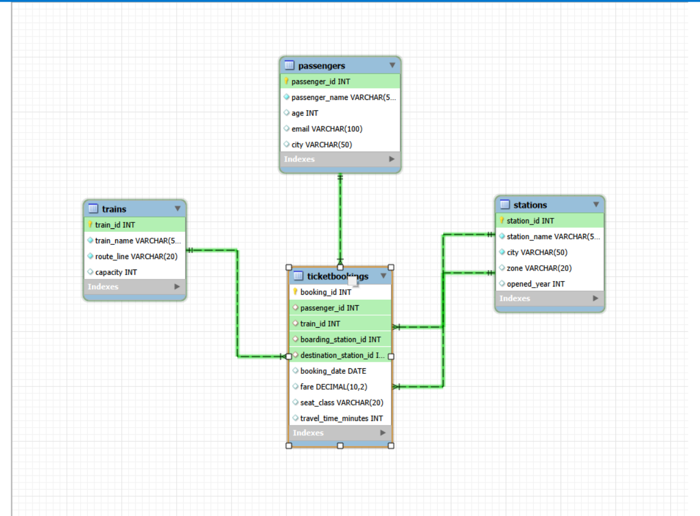
Figure 1. Entity relationship diagram showing the relationships among passengers, trains, stations, and ticket bookings.
12. Executive Summary
• The network contains 25 stations, 20 trains, 465 registered passengers, and 1,490 total bookings, generating ₹146,091.57 in fare revenue.
• General-class travel dominates demand, accounting for 1,200 bookings and 80.3% of total fare revenue, while Premium accounts for 290 bookings and 19.7%.
• Line 3 is the strongest route by volume, with 526 bookings and ₹52,723.24 in revenue.
• Teal Line Express and Purple Line Local jointly recorded the highest booking volume among trains, with 84 bookings each.
• Old Fort generated the highest boarding-station revenue at ₹7,235.30, and all 25 stations recorded at least one boarding.
• High-fare journeys above ₹100 represented the largest fare category, with 717 bookings or 48.1% of all bookings.
• April 2026 was the strongest full month with 409 bookings; July's 298 bookings represent a partial-month figure.
• Passenger demand is geographically broad, led by Mumbai with 69 registered passengers, followed by Chennai with 66 and Hyderabad with 62.
• The highest-spending passenger made 9 trips and paid ₹1,081.06 in total fares.
• Train capacity ranges from 180 to 320 seats, averaging 245 seats, while only 3 of the 25 stations opened before 2000.
Overall conclusion: The SQL dataset indicates a well-utilized metro network with broad station coverage, strong demand on Line 3, a clear preference for General seating, and a substantial share of higher-fare journeys. The database structure supports analysis across passengers, bookings, trains, and stations, making it suitable for monitoring demand, revenue performance, and network utilization.

