Architecture

System overview (Docker Compose)
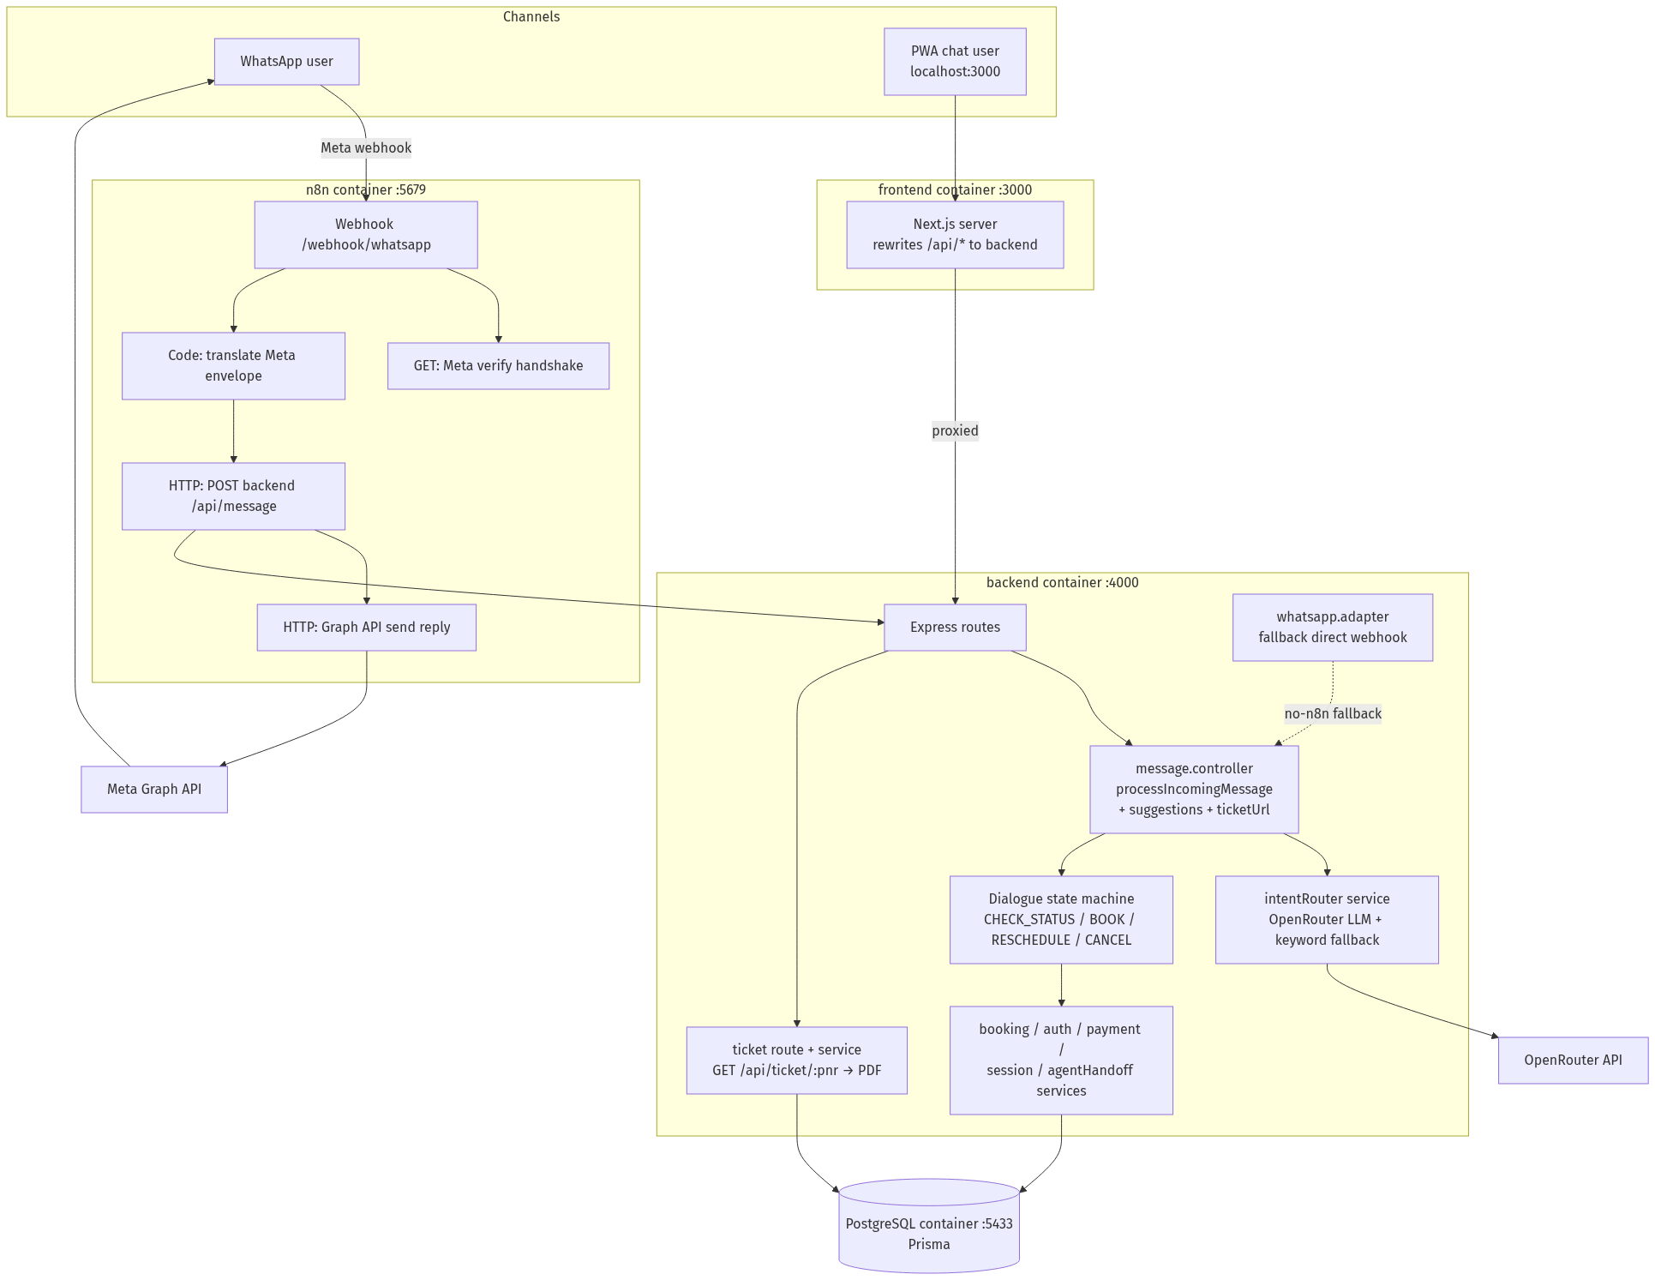

Key decisions
- Channel-agnostic core. All conversation logic lives behind processIncomingMessage(payload). The PWA hits it via POST /api/message; WhatsApp reaches the same function through n8n (primary) or the Express adapter (fallback). Adapters only translate message formats — no business logic.
- n8n as the WhatsApp orchestration layer. The webhook handshake, envelope translation, backend call, and Graph API reply are a visual, editable workflow (n8n/workflows/bluewings-whatsapp.json), auto-imported and activated when the container starts.
- LLM with a deterministic safety net. OpenRouter (comma-separated model fallback list, max 3) parses intent; output is zod-validated. On timeout (9s), non-200, invalid JSON, or confidence < 0.55, a keyword router takes over — an LLM outage never breaks a flow. Mid-flow inputs (slot values like "BOM" or "yes") skip the LLM entirely.
- Dialogue state in the database. ConversationSession stores flow, step, slots, and the handoff flag per (channel, userId), so conversations survive restarts and work identically across channels.
- All booking mutations in `prisma.$transaction()` — no partial writes.
- Verify once per session. A successful PNR + last-name check is stored in
ConversationSession.auth; servicing the same PNR again skips re-auth, and a
fresh booking marks its PNR verified.
- CX extras ride on the same response. suggestions (quick-reply chips) and
ticketUrl (on-demand PDF e-ticket, re-authenticated by the endpoint) are
channel-optional fields — the PWA renders them, WhatsApp falls back to
numbered text options.

Conversation lifecycle
