Customer Journey — BlueWings Conversational Booking & Servicing
The passenger persona used throughout: Priya, a domestic traveler who booked
BOM → DEL and manages everything from her phone. She never calls the contact
centre — every journey below happens in a single chat thread (WhatsApp or the
installable PWA), with the same conversation logic on both channels.

Journey map (all four flows)
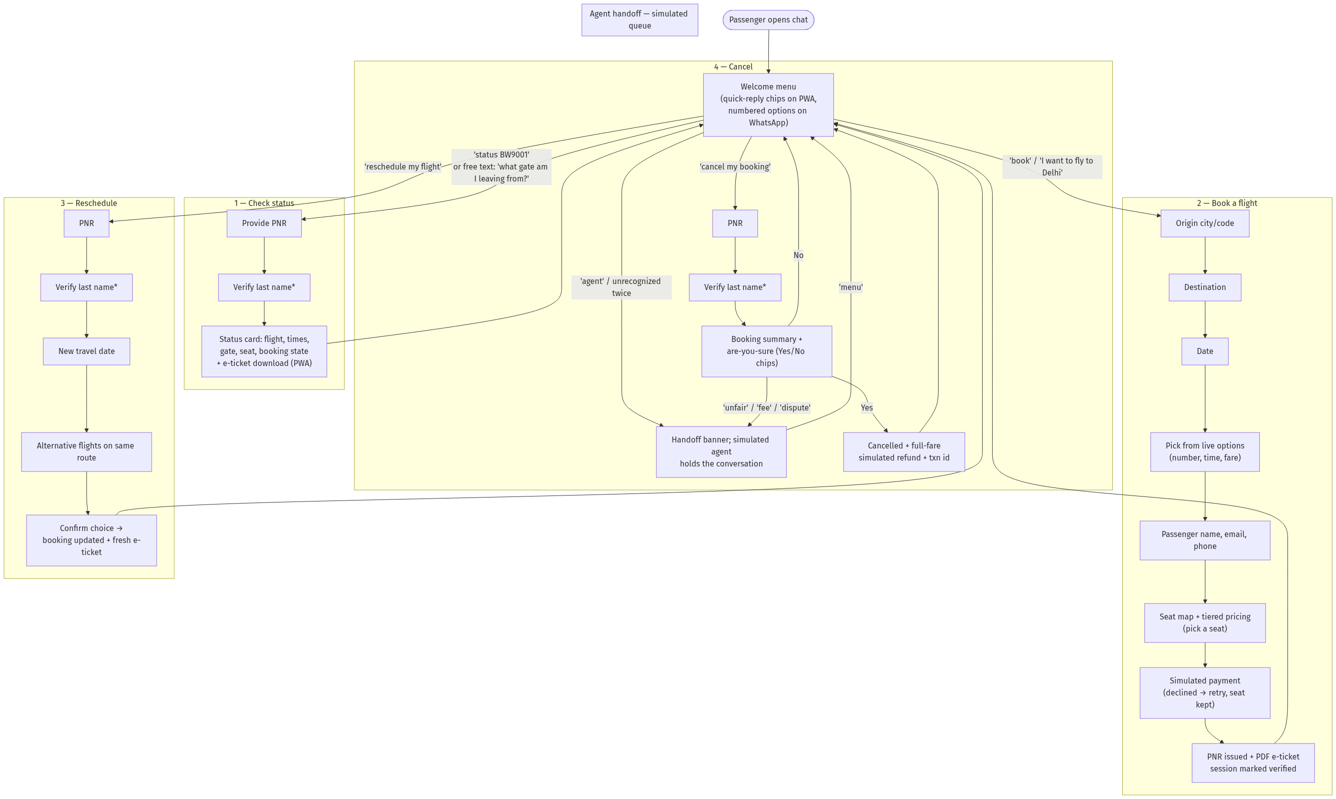
\ Verify once per session*: after one successful PNR + last-name check, servicing
the same PNR again (status → cancel → reschedule) skips re-verification. A different
PNR asks again. A new booking marks its PNR verified automatically.

Narrative walkthroughs

Journey 1 — "Which gate am I at?" (status, ~20 seconds)
- Priya types "what gate does my flight leave from? ref BW9001" — the LLM
extracts intent CHECK_STATUS and the PNR in one turn, so the bot only asks
for her last name.
- She replies "Doe". The bot returns flight, departure time (IST), gate, seat,
and status; on the PWA a Download e-ticket button appears.
- Wrong last name? Polite rejection, flow resets, nothing leaks.

Journey 2 — Booking (~90 seconds)
- "book a flight" → the bot asks origin. City names work ("mumbai" → BOM).
(Power users can do it in one line: "book mumbai to delhi on 2026-07-06".)
- Destination, then date (YYYY-MM-DD). Unserved routes/dates get a helpful
answer (which airports we fly from, which dates have flights) instead of a dead end.
- She picks a flight from the numbered options, gives name → email → phone.
- Seat selection: the bot shows a seat map (with an image on the PWA) and the
available seats; each seat is priced by class (premium vs standard, window/aisle/
middle). She taps one.
- Payment is simulated on the fare + seat total; a decline (test path) keeps her
seat and just asks for another payment number.
- The bot confirms with PNR, seat, total paid, transaction ref and the PDF
e-ticket. Her session is now verified for that PNR — follow-up servicing needs
no re-auth.

Journey 3 — Plans changed (reschedule, ~45 seconds)
- "reschedule my flight BW9002" → last-name check (skipped if already verified).
- New date → alternatives on the same route with times and fares.
- One tap/reply to confirm: status becomes RESCHEDULED, new e-ticket issued.

Journey 4 — Cancelling (~30 seconds)
- "cancel my booking BW9003" → verification → booking summary with an explicit
Yes / No confirmation (chips on PWA).
- Yes → cancelled, full simulated refund with transaction id.
- If she disputes fees or is upset, dispute keywords divert her to the agent queue.

Journey 5 — Escalation and coming back
- Explicit ("talk to a human"), out-of-scope requests, or **two consecutive
unrecognized messages** put Priya in a simulated agent queue with a clear banner.
- She's never trapped: typing menu (or the Back to menu chip) returns her to
the assistant instantly, with the session reset.

Experience principles applied
Principle | Where it shows up
Never go silent | Every path — including server errors — returns a friendly reply
Meet users' language | LLM intent parsing (free text), city-name → airport-code mapping
Don't re-ask what you know | PNR slot extraction from the first message; verify-once-per-session auth
Confirm before destructive acts | Cancellation requires explicit YES; NO aborts cleanly
Always offer an exit | 'menu' works everywhere, including inside the agent queue
Same brain, every channel | PWA and WhatsApp hit the same /api/message core; chips degrade to numbered text

