Database Schema
PostgreSQL via Prisma. Source of truth: `backend/prisma/schema.prisma`; migrations in backend/prisma/migrations/.
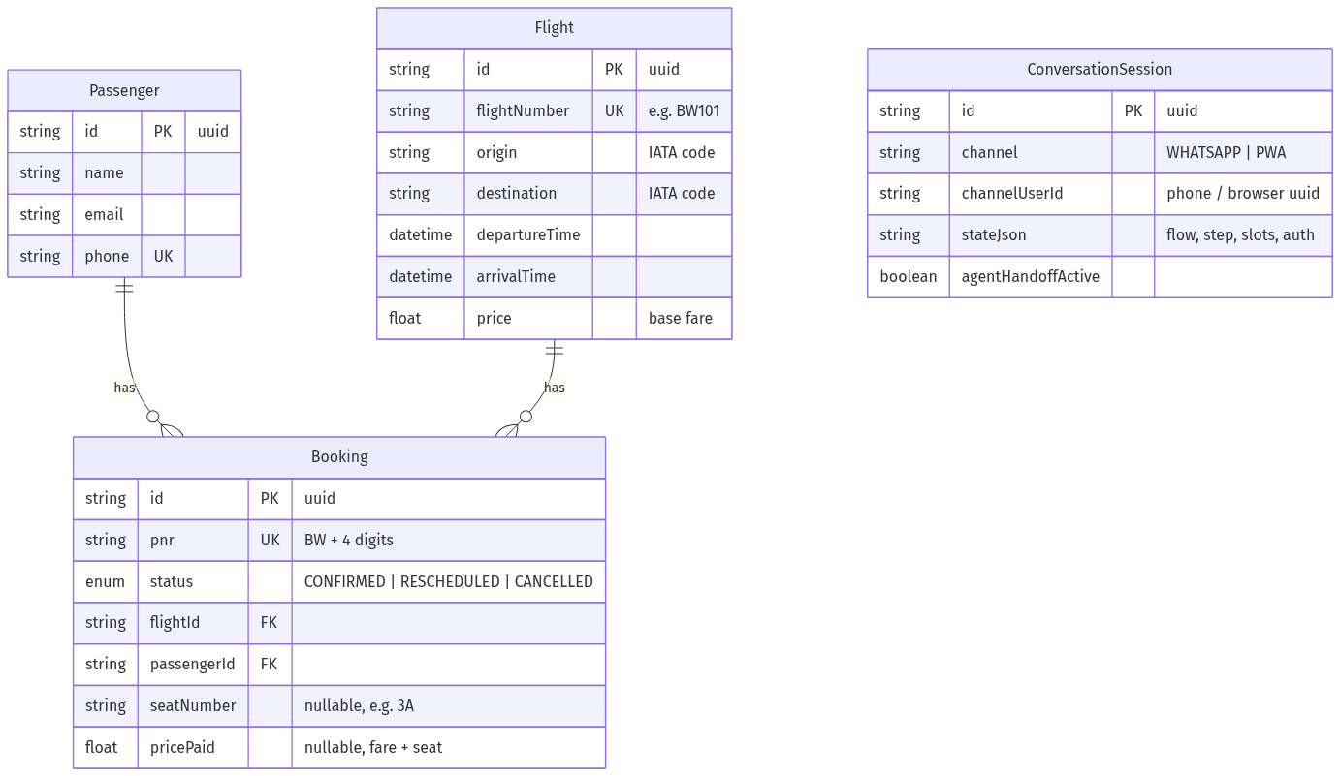

Notes
- `Booking.pnr` is the user-facing reference (BW + 4 digits), generated
uniquely inside the booking transaction.
- `Booking.seatNumber` / `Booking.pricePaid` (nullable — added in migration
20260703034638_add_seat_and_price_to_booking) capture the chosen seat and the
total charged (base fare + seat-class adjustment). Null on legacy/seed bookings
that never went through seat selection; the status/e-ticket views fall back to a
deterministic seat derived from the PNR.
- `ConversationSession` has a unique compound key (channel, channelUserId) —
one live conversation per user per channel. stateJson holds the dialogue state
machine's position: `{ currentFlow, step, slots, auth, consecutiveFailedParses,
pendingNotice }`. Verified identity and proactive delay notices live here too, so
they survive restarts and are identical across WhatsApp and the PWA.
- Rescheduling repoints Booking.flightId and sets status RESCHEDULED;
cancelling sets CANCELLED. History/audit tables are out of MVP scope.
- All booking mutations run inside prisma.$transaction() — no partial writes.

Seat pricing (derived, not stored per-seat)
Seat class and price adjustment are computed from the seat label at booking time:
Rows | Class | Window (A/F) | Aisle (C/D) | Middle (B/E)
1–2 | Premium | +₹1000 | +₹900 | +₹800
3–5 | Standard | +₹300 | +₹200 | +₹0
Occupied seats for a flight are read live from other bookings' seatNumber, so
the seat map never double-books.

Seed data (backend/prisma/seed.ts)
- 12 airports (BOM, DEL, BLR, AMD, HYD, MAA, CCU, PNQ, COK, JAI, GOI, LKO) →
every ordered pair = 132 routes, × 8 days × (morning + evening) ≈ 2112 flights
- 5 passengers, 5 bookings — BW9001–BW9004 confirmed, BW9005 cancelled
- Demo login: PNR BW9001, last name Doe

