Create a tomcat container and mount the webapps folder and access tomcat through browser

Pull tomcat image:

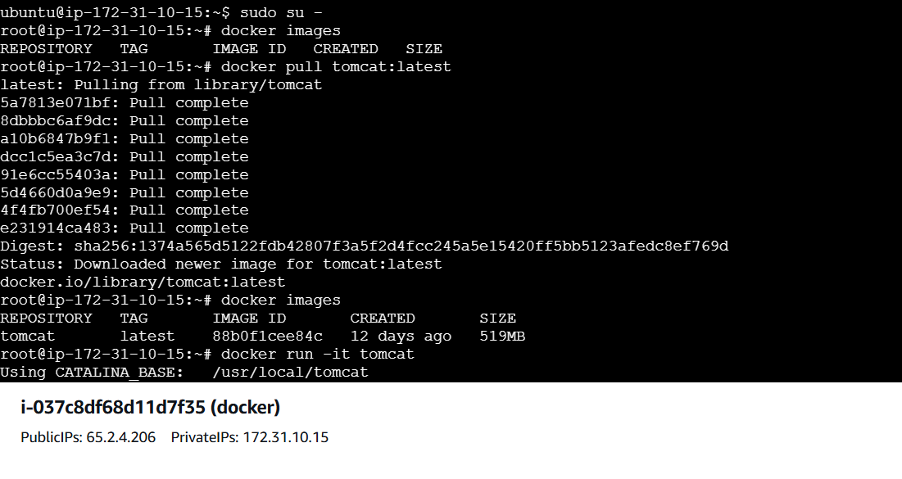

Run the docker Container:

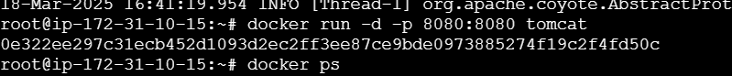

Tomcat is up and running 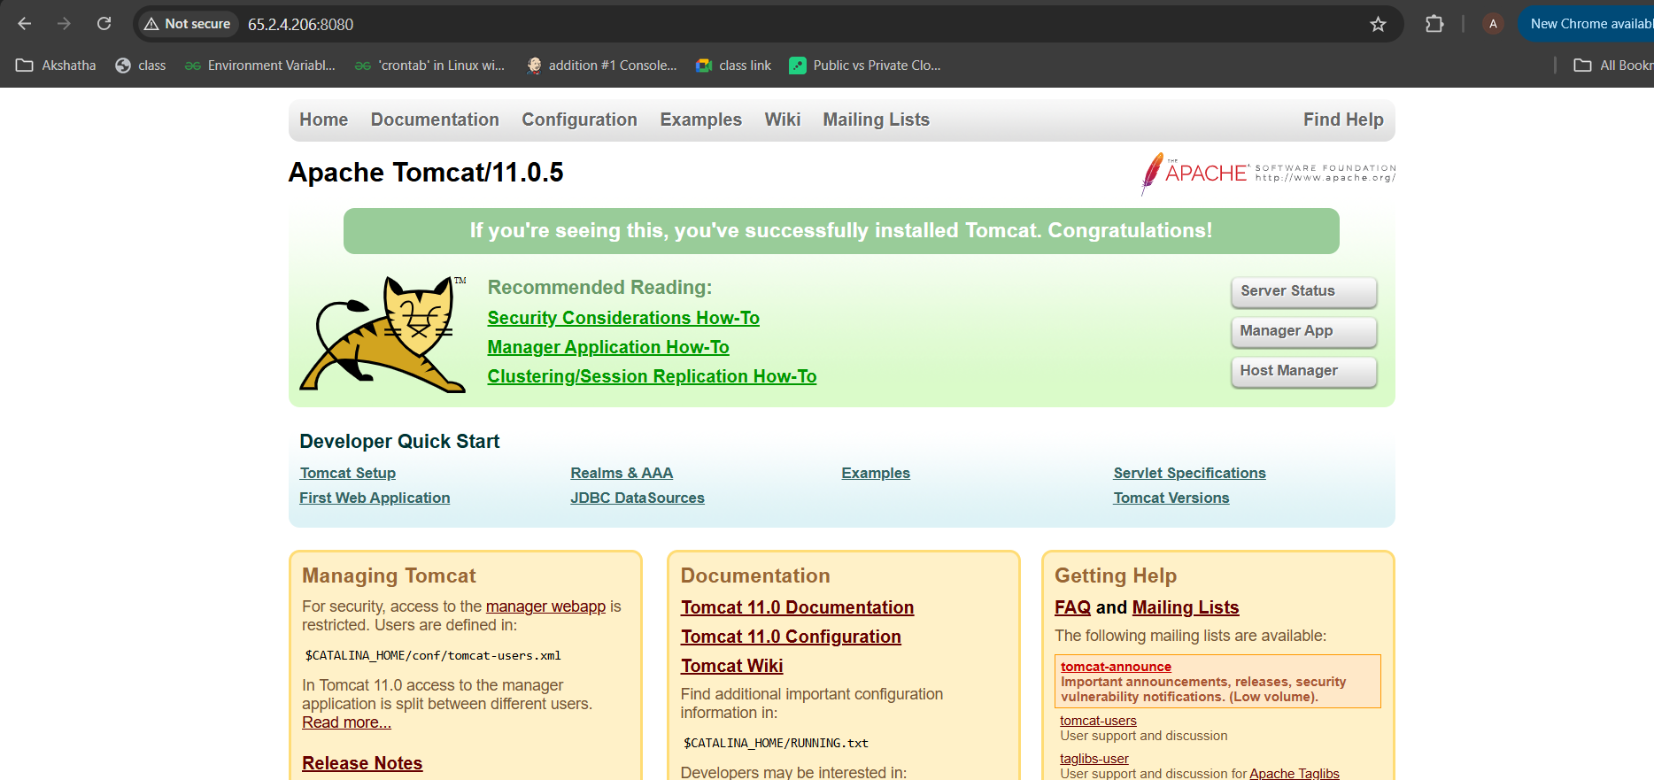

List the Docker Container and get inside the container

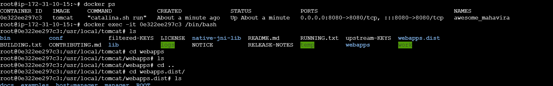

Copy the content to webapps as webapps is empty:



Stop the docker container



Create the folder in local and Mount with the tomcat container and get inside the container



Now Again webapps folder is empty , so tomcat is not up and running

So we need to add content to webapps folder and exit the container

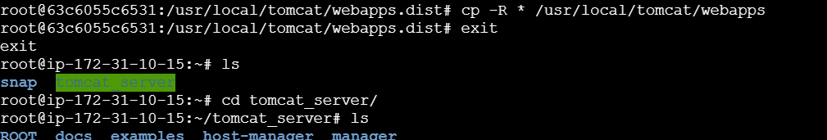

Mount the tomcat using below command

docker inspect 63c6055c6531e47deaef3328bc015f4a890b73e1cf99dd8e16a677748fb537fe

