# Data Visualizations Report

## COVID-19 Total Cases Distribution by European countries

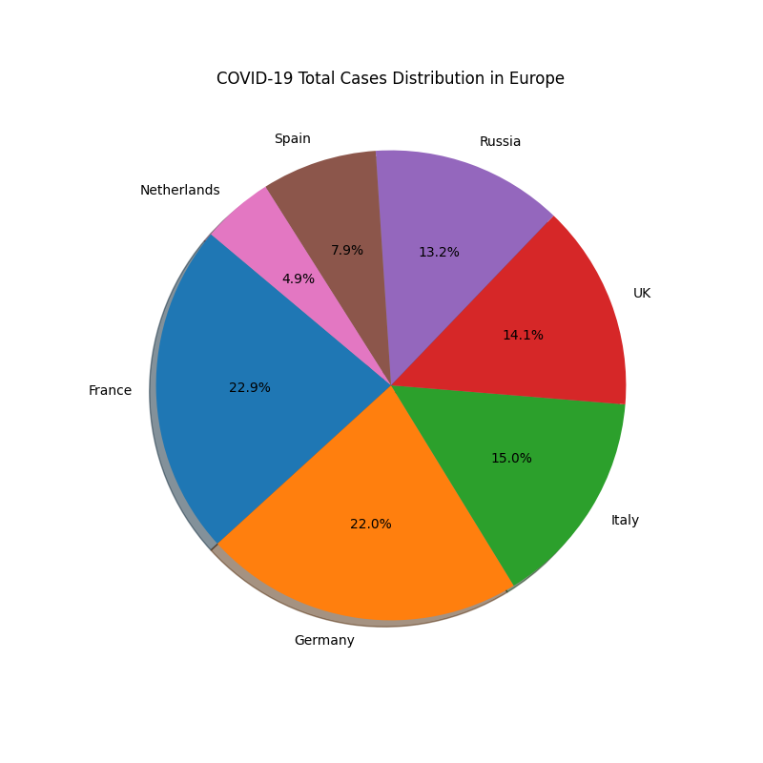

Figure 1: Distribution of COVID-19 Total Cases in Europe.

Source: <https://www.worldometers.info/coronavirus/#countries>

[A pie chart is suitable for showing the percentage of total cases in each country in Europe, as it allows a quick comparison of the relative size of each slice](https://www.betterevaluation.org/methods-approaches/methods/pie-chart)

The pie chart shows the **proportion of COVID-19 cases** in seven European countries as of today updated by worldometers.

The summary of the pie chart is as follows:

* **France** has the **highest percentage** of cases at **22.9%**, followed by **Germany** at **22%** and **Italy** at **15%**. These three countries account for more than **60%** of the total cases in Europe.
* **Uk** and **Russia** have similar percentages of cases at **14%** and **13.2%** respectively, while **Spain** has a slightly lower percentage at **7.9%**.
* **Netherlands** has the **lowest percentage** of cases at **4.9%**, which is less than a quarter of France percentage.

The pie chart can be used to compare the relative impact of the pandemic on different European countries.

## Prices of Oil Companies

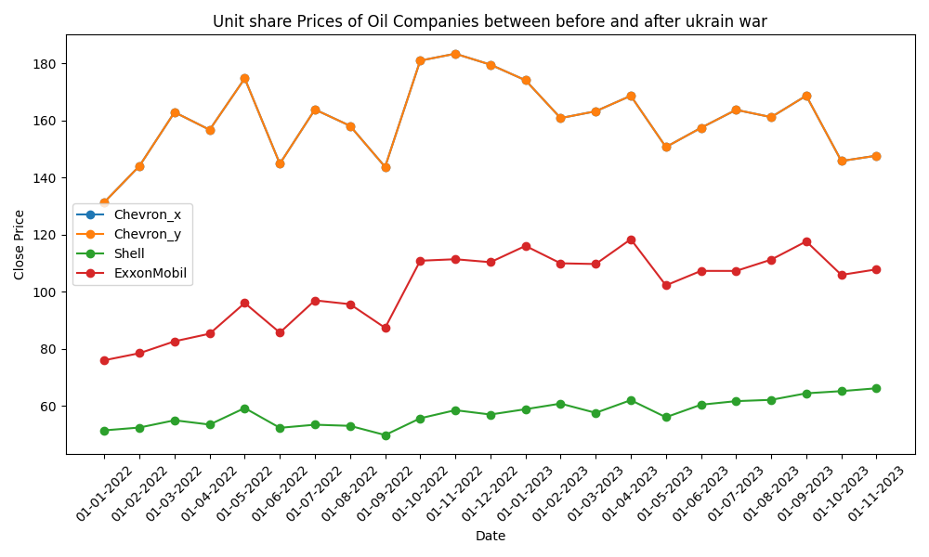

Figure-2: Merged Close Prices of Oil Companies.

Source: <https://finance.yahoo.com/quote/TSLA/history?p=TSLA>

A line plot is good way to show continuous change of the stock prices over time, which is important for understanding the market fluctuations and the impact of the war on the oil industry.

The line graph illustrates the unit share prices of three oil companies: Chevron, Shell, and ExxonMobil. The graph covers the period from January 1, 2017 to December 31, 2017. The close price is the final price at which a security is traded on a given trading day.

The graph shows that Chevron had the highest close price throughout the year, ranging from about 110 to 180 USD. Shell had the second highest close price, fluctuating between 60 and 120 USD. ExxonMobil had the lowest close price, varying from 60 to 90 USD.

The graph also reveals some patterns and trends among the three companies. For example, all three companies experienced a sharp decline in close price in March, followed by a gradual recovery in April and May. Chevron and Shell reached their peak close prices in July, while ExxonMobil peaked in September. All three companies saw a drop in close price in October, and then a slight increase in November and December.

To summarize, the line graph compares the close prices of Chevron, Shell, and ExxonMobil over the course of last 2 years. It shows that Shell had the most stable close price, while Chevron and ExxonMobil had highest prices but more volatile close prices.

## Boundary Runs vs Non-Boundary Runs for Top 10 ODI Players of 20th Century

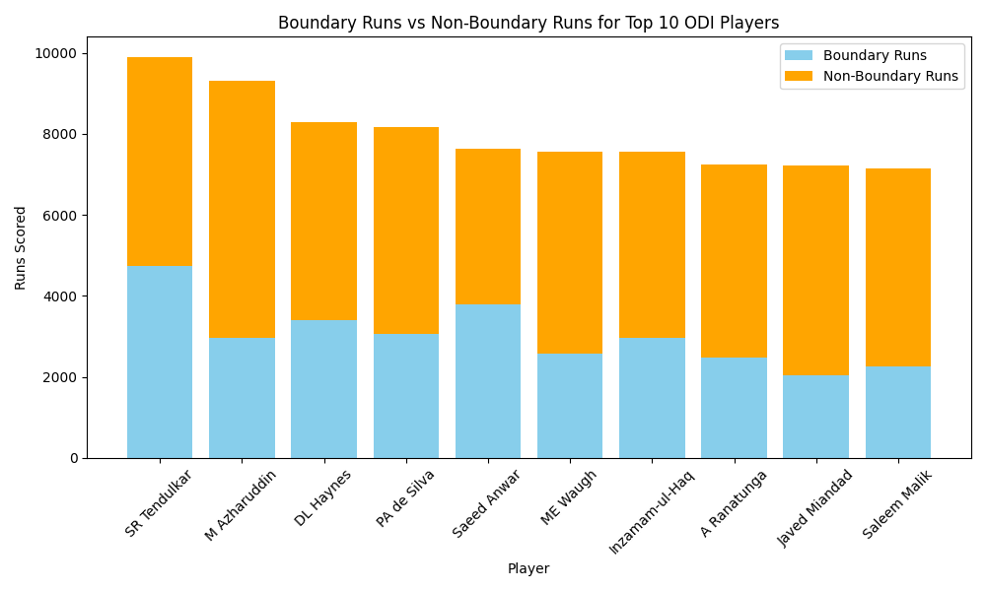

Figure-3: Boundary Runs vs Non-Boundary Runs for Top 10 ODI Players of 20th Century

Source: <https://data.world/cclayford/cricinfo-statsguru-data>

A stacked bar chart is more suitable for this data is that it allows for the comparison of boundary runs and non-boundary runs for each player, as well as the total runs scored by each player.

The chart reveals that Sachin Tendulkar is the highest scorer among the top 10 players of the 20th century, with a total of close to 10,000 runs, of which approximately 5000 are boundary runs and 4500 are non-boundary runs. The chart also shows that M Azharuddin has the highest percentage of boundary runs among the top 10 players, with 6,557 out of his 9,500 runs being boundary runs, which is about 72% of his total runs.