Remoting is the process through which we can access any remote object from one application domain to another application domain.

For creating remote object the class object must be inherited by MarshalByRefObject class.
Application domain is the runtime environment of application, For Microsoft Word, domain is MS office, For .NET program, .NET runtime environment.

Terms Used in Remoting
- Proxy: To avoid conjunction in networking. Main work is Task Distributing. There are two types of proxies.
  - Transparent proxy (There is no physical existence , Created by IIS server)
  - Real Proxy (Physical Existence)

- Channel: Channel provides the medium for transfer data from one location to another location. There are two types of channel.
  - TCP(work with Predefined root Connection oriented)
  - HTTP (No need predefined root)
- Formatters: Change the data in an appropriate format that it can traverse through channels.
There are two types of formatters
- Binary
- SOAP(Simple Object Access Protocol)
- Sink: Sink is used for security point of view. Before sending the data, the Data will be encrypted. Some additional bit will be added with the data to secure the data.
There are two types of sink
- Envoy sink
- Server Context Sink
Object Mode On Server: Two Types of Object Mode.
- SingleCall
- Singleton

For creating Remoting we have to create 3 applications:
- class Library (Of which Remote Object will be created)
- Server Application (Console Application)
- Client Application (Window Application)
RemoteClass

using System;
using System.Collections.Generic;
using System.Text;

namespace remoteclass
{
public class xx:MarshalByRefObject
{
public int sum(int a, int b)
{
return a + b;
}
}
}
Remote Server

using System;
using System.Collections.Generic;
using System.Text;
using System.Runtime.Remoting;
using System.Runtime.Remoting.Channels;
using System.Runtime.Remoting.Channels.Tcp;

namespace remoteserver
{
class Program
{
static void Main(string[] args)
{
TcpChannel ch=new TcpChannel(8085);
ChannelServices.RegisterChannel(ch);
RemotingConfiguration.RegisterWellKnownServiceType(typeof
(remoteclass.xx),"rahul",WellKnownObjectMode.Singleton);
Console.Write("Sever is Ready........");
Console.Read();
}
}
}

When user run this Remote Server application.

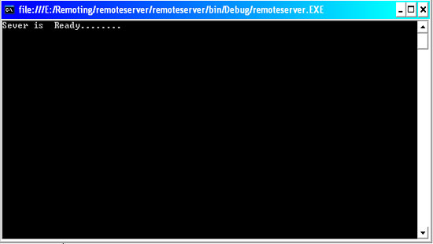
Figure 1: Server Application.
Remote Client

using System;
using System.Collections.Generic;
using System.ComponentModel;
using System.Data;
using System.Drawing;
using System.Text;
using System.Windows.Forms;
using System.Runtime.Remoting;
using System.Runtime.Remoting.Channels;
using System.Runtime.Remoting.Channels.Tcp;

namespace remoteclient
{
public partial class Form1 : Form
{
//TcpChannel ch = new TcpChannel();
remoteclass.xx obj = new remoteclass.xx();
public Form1()
{
InitializeComponent();
}

private void button1_Click(object sender, System.EventArgs e)
{
//ChannelServices.RegisterChannel(ch);
obj = (remoteclass.xx)Activator.GetObject(typeof(remoteclass.xx),
"tcp://localhost:8085/rahul");
int x = Int32.Parse(textBox1.Text);
int y = Int32.Parse(textBox2.Text);
textBox3.Text = (obj.sum(x, y)).ToString();
}
}
}
When user run the application.
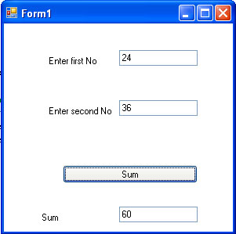
Figure 2: Client Application.

http://www.c-sharpcorner.com/UploadFile/rahul4_saxena/Remoting04252007233559PM/Remoting.aspx

