

Introducing Windows Communication
Foundation

 David Chappell, Chappell & Associates
January 2010

© Copyright Microsoft Corporation 2010. All rights reserved.

Contents
Describing Windows Communication Foundation 3
Illustrating the Problem: A Scenario 3
Addressing the Problem: What WCF Provides 5
Unification of Microsoft’s Distributed Computing Technologies 6
Interoperability with Applications Built on Other Technologies 8
Interoperability with Other Web Services Platforms 8
Interoperability with Microsoft’s Pre-WCF Technologies 11
Explicit Support for Service-Oriented Development 11
Using Windows Communication Foundation 12
Creating a WCF Service 12
Implementing a Service Class 12
Defining Service Contracts 13
Defining Data Contracts 16
Selecting a Host 17
Hosting a Service Using IIS or WAS 17
Hosting a Service in an Arbitrary Process 17
Defining Endpoints 18
Specifying Endpoints 20
Using Endpoints: An Example 22
Creating a WCF Client 23
Other Aspects of WCF 24
Messaging Options 24
Controlling Local Behavior 25
Security 26
Transactions 27
Transactions in the .NET Framework: System.Transactions 27
Transactions in WCF 28
RESTful Communication 29
Communication using POX, RSS, and ATOM 31
Queuing 32
Creating a Workflow Service 32
Extensibility 33
Tool Support: WCF and Visual Studio 33
Coexistence and Upgrade 34
Conclusion 37
About the Author 37

Describing Windows Communication Foundation
The move to service-oriented communication has changed software development. Whether done with SOAP or in some other way, applications that interact through services have become the norm. For Windows developers, this change was made possible by Windows Communication Foundation (WCF). First released as part of the .NET Framework 3.0 in 2006, then updated in the .NET Framework 3.5, the most recent version of this technology is included in the .NET Framework 4. For a substantial share of new software built on .NET, WCF is the right foundation.

Illustrating the Problem: A Scenario
To get a sense of the problems that WCF addresses, suppose that a car rental firm decides to create a new application for reserving cars. Since this application will run on Windows, the firm chooses to build it on the .NET Framework 4. The architects of this rental car reservation application know that the business logic it implements will need to be accessible by other software running both inside and outside their company. Accordingly, they decide to build it in a service-oriented style, with the application’s logic exposed to other software through a well-defined set of services. To implement these services, the new application will use WCF. Figure 1 illustrates this situation.
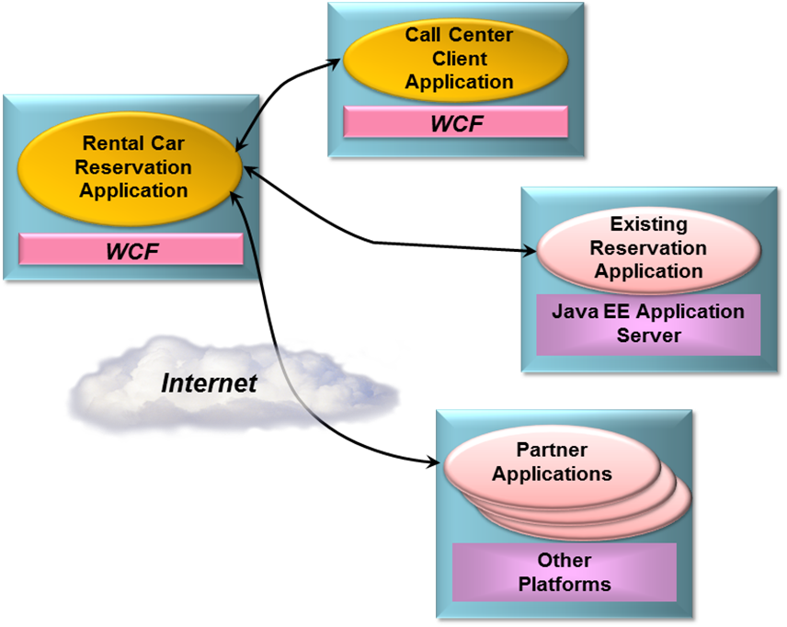
Figure 1: The rental car reservation application provides WCF-based services that can be accessed by various clients.
Over its lifetime, the rental car reservation application will likely be accessed by a range of other applications. When it’s designed, however, the architects of the rental car reservation application know that its business logic will be accessed by three other kinds of software:
- A client application running on Windows desktops that will be used by employees in the organization’s call center. Created specifically for the new reservations system, this application will also be built using the .NET Framework 4 and WCF. (In some sense, this application isn’t truly distinct from the new rental car reservation application, since its only purpose is to act as a client for the new system. Still, from a service-oriented perspective, it’s just another client for the reservation system’s business logic.)
- An existing reservation application built on a Java Platform, Enterprise Edition (Java EE) server running on a non-Windows system. Due to a recent merger with another car rental firm, this existing system must be able to access the new application’s logic to provide customers of the merged firms with a unified experience.
- Partner applications running on a variety of platforms, each located within a company that has a business arrangement with the car rental firm. Partners might include travel agencies, airlines and others that are required to make car rental reservations.
The diverse communication requirements for the new rental car reservation application aren’t simple. For interactions with the call center client application, for instance, performance is paramount, while interoperability is straightforward, since both are built on the .NET Framework. For communication with the existing Java EE-based reservation application and with the diverse partner applications, however, interoperability becomes the highest goal. The security requirements are also quite different, varying across connections with local Windows-based applications, a Java EE-based application running on another operating system, and a variety of partner applications coming in across the Internet. Even transactional requirements might vary, with only the internal applications being allowed to use distributed atomic transactions. How can these diverse business and technical requirements be met without exposing the creators of the new application to unmanageable complexity?
The answer to this question is WCF. Designed for exactly this kind of diverse but realistic scenario, WCF is becoming the default technology for Windows applications that expose and access services. This paper introduces WCF, examining what it provides and showing how it’s used. Throughout this introduction, the scenario just described will serve as an example. The goal is to make clear what WCF is, illustrate the problems it addresses, and show how it solves those problems.

Addressing the Problem: What WCF Provides
WCF is implemented primarily as a set of classes on top of the .NET Framework’s Common Language Runtime (CLR). This lets .NET developers build service-oriented applications in a familiar way. As Figure 2 shows, WCF allows creating clients that access services. Both the client and the service can run in pretty much any Windows process—WCF doesn’t define a required host. Wherever they run, clients and services can interact via SOAP, via a WCF-specific binary protocol, and in other ways.
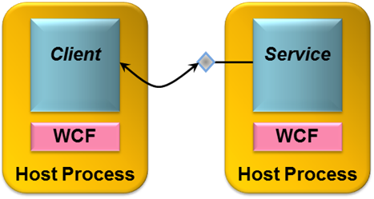
Figure 2: WCF-based clients and services can run in any Windows process.
As the scenario described earlier suggests, WCF addresses a range of problems for communicating applications. Three things stand out, however, as WCF’s most important aspects:
- Unification of the original .NET Framework communication technologies
- Interoperability with applications built on other technologies
- Explicit support for service-oriented development.
The following sections describe what WCF offers in each of these areas.

Unification of Microsoft’s Distributed Computing Technologies
Think about the team of developers implementing the rental car reservation application described earlier. In the world before WCF, this team would need to choose the right distributed technology from the multiple choices originally offered by the .NET Framework. Yet given the diverse requirements of this application, no single technology would fit the bill. Instead, the application would probably use several of these older .NET technologies. For example:
- ASMX, also called ASP.NET Web Services, would be an option for communicating with the Java EE-based reservation application and with the partner applications across the Internet. Given that Web services are widely supported today, this would likely be the most direct way to achieve cross-vendor interoperability.
- .NET Remoting is a natural choice for communication with the call center application, since both are built on the .NET Framework. Remoting is designed expressly for .NET-to-.NET communication, so it would offer the best performance for this situation.
- Enterprise Services might be used by the rental car reservation application for things such as managing object lifetimes and defining distributed transactions. These functions could be useful in communicating with any of the other applications in this scenario, but Enterprise Services supports only a limited set of communication protocols.
- Web Services Enhancements (WSE) might be used along with ASMX to communicate with the Java EE-based reservation application and with the partner applications. Because it implements more advanced SOAP-based standards, known collectively as the WS-* specifications, WSE can allow better security and more, as long as all applications involved support compatible versions of these specifications.
- System.Messaging, which provides a programming interface to Microsoft Message Queuing (MSMQ), could be used to communicate with Windows-based partner applications that weren’t always available. The persistent queuing that MSMQ provides is typically the best solution for intermittently connected applications.
- System.Net might be used to communicate with partner applications or perhaps in other ways. Using this approach, developers can create applications that use the HTTP-based communication style known as Representational State Transfer (REST).
If it were built on an earlier version of the .NET Framework, the rental car reservation application would need to use more than one of these communication technologies, and maybe even all of them, to meet its requirements. Although this is technically possible, the resulting application would be complex to implement and challenging to maintain. A better solution is needed.
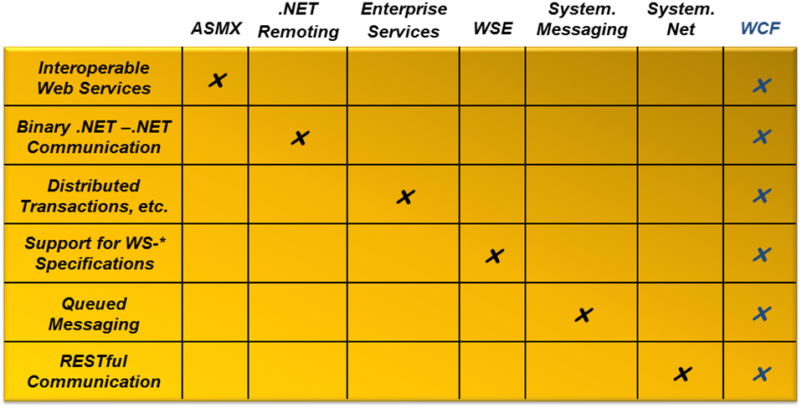
Figure 3: Rather than requiring different technologies for different communication styles, WCF provides a single unified solution.
With WCF, this solution is at hand. As Figure 3 shows, WCF can be used for all of the situations just described. Accordingly, the rental car reservation application can use this single technology for all its application-to-application communication. Here’s how WCF addresses each of these requirements:
- Because WCF can communicate using SOAP-based Web services, interoperability with other platforms that also support SOAP, such as Java EE application servers, is straightforward.
- To allow optimal performance when both parties in a communication are built on WCF, the wire encoding used in this case is an optimized binary version of SOAP. Messages still conform to the data structure of a SOAP message, referred to as its Infoset, but their encoding uses a binary representation of that Infoset rather than the standard angle-brackets-and-text format of XML. Using this option would make sense for communicating with the call center client application, since it’s also built on WCF, and performance is a paramount concern.
- Managing object lifetimes, defining distributed transactions, and other aspects of Enterprise Services are also provided by WCF. They are available to any WCF-based application, which means that the rental car reservation application can potentially use them with the other applications with which it communicates.
- Because it supports a large set of the WS-* specifications, WCF helps provide reliability, security, and transactions when communicating with any platform that also supports these specifications.
- WCF’s option for queued messaging, built on MSMQ, allows applications to use persistent queuing without needing to use another application programming interface.
- WCF has built-in support for creating RESTful clients and services.
The result of this unification is greater functionality and, overall, less complexity. Because WCF allows an application to address all of these communication requirements, it can more easily support scenarios that were difficult (or even impossible) with the collection of technologies that preceded it. While Microsoft still supports these earlier technologies, new applications that would previously have used any of them can instead be built on WCF.

Interoperability with Applications Built on Other Technologies
Reflecting the heterogeneity of most enterprises, WCF is designed to interoperate well with the non-WCF world. There are two important aspects of this: interoperability with platforms created by other vendors, and interoperability with the Microsoft technologies that preceded WCF. The following sections describe both.

Interoperability with Other Web Services Platforms
Enterprises today typically have systems and applications that were purchased from a range of vendors. In the rental car application, for instance, communication is required with various other software applications written in various languages and running on various operating systems. This kind of diversity is a reality in many organizations, and it will remain so for the foreseeable future. Similarly, applications that provide services on the Internet can be built on any platform. Clients that interact with them must be capable of communicating in whatever style is required.
WCF-based applications can work with other software running in a variety of contexts. As shown in Figure 4, an application built on WCF can interact with all of the following:
- WCF-based applications running in a different process on the same Windows machine
- WCF-based applications running on another Windows machine
- Applications built on other technologies, such as Java EE application servers, that support standard Web services. These applications can be running on Windows machines or on machines running other operating systems, such as Sun Solaris, IBM z/OS, or Linux.
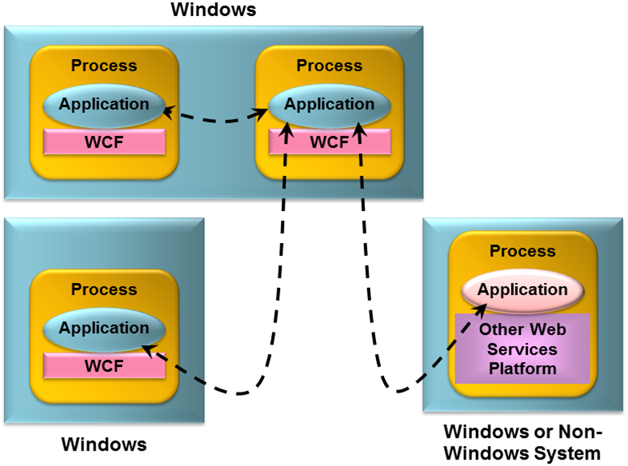
Figure 4: Applications built on WCF can communicate with other WCF-based applications or with applications built on other Web services platforms.
To allow more than just basic communication, WCF implements Web services technologies defined by the WS-* specifications. All of these specifications were originally defined by Microsoft, IBM, and other vendors working together. As the specifications have become stable, ownership has typically passed to standards bodies such as the Organization for the Advancement of Structured Information Standards (OASIS). As Figure 5 shows, these specifications address several different areas, including basic messaging, security, reliability, transactions, and working with a service’s metadata.
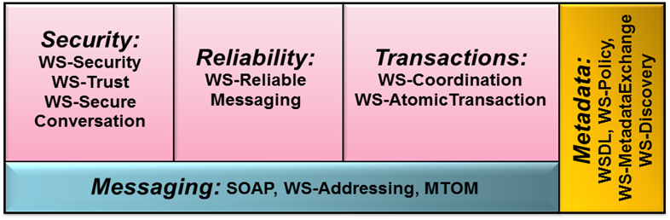
Figure 5: WCF implements a range of Web services standards.

WCF supports all the specifications shown in this figure. Grouped by function, those specs are:
- Messaging: SOAP is the foundation protocol for Web services, defining a basic envelope containing a header and a body. WS-Addressing defines additions to the SOAP header for addressing SOAP messages, which frees SOAP from relying on the underlying transport protocol, such as HTTP, to carry addressing information. The Message Transmission Optimization Mechanism (MTOM) defines an optimized transmission format for SOAP messages based on the XML-binary Optimized Packaging (XOP) specification.
- Metadata: The Web Services Description Language (WSDL) defines a standard language for specifying services and various aspects of how those services can be used. WS-Policy allows specification of more dynamic aspects of a service’s behavior that cannot be expressed in WSDL, such as a preferred security option. WS-MetadataExchange allows a client to request descriptive information about a service, such as its WSDL and its policies, via SOAP. Beginning with the .NET Framework 4 release, WCF also supports WS-Discovery. This broadcast-based protocol lets an application find services available elsewhere on its local network.
- Security: WS-Security, WS-Trust and WS-SecureConversation all define additions to SOAP messages for providing authentication, data integrity, data privacy and other security features.
- Reliability: WS-ReliableMessaging defines additions to the SOAP header that allow reliable end-to-end communication, even when one or more SOAP intermediaries must be traversed.
- Transactions: Built on WS-Coordination, WS-AtomicTransaction allows using two-phase commit transactions with SOAP-based exchanges.
The rental car reservation application would likely use several of these more advanced technologies. For example, WS-Addressing is essential whenever SOAP is running over a protocol other than HTTP, which might be the case for communication with the .NET Framework-based call center client application. WCF relies on WS-Policy and WS-MetadataExchange to discover whether the system it’s communicating with is also using WCF and for other things. Reliable communication is essential for most situations, so it’s likely that WS-ReliableMessaging would be used to interact with many of the other applications in this scenario. Similarly, WS-Security and the related specifications might also be used for communication with one or more of the applications, since all would require some kind of security. For the applications that are allowed to use transactions with the rental car reservation system, WS-AtomicTransaction would be essential. Finally, MTOM could be used whenever an optimized wire format made sense, and both sides of the communication supported this option.
The key point is that WCF implements interoperable SOAP-based Web services, complete with cross-platform security, reliability, transactions, and more. To avoid paying an unnecessary performance penalty, WCF-to-WCF communication can also be optimized—standard XML-based SOAP isn’t always required. In fact, as described later, it’s possible — easy, even — for a single application to expose its services to both kinds of clients.
Also, as mentioned earlier, WCF supports REST. Rather than sending SOAP messages over HTTP, RESTful communication relies directly on HTTP’s built-in verbs: GET, POST, and others. While SOAP is the right approach for some kinds of interoperability, such as situations that require more advanced security or transactional services, RESTful communication is a better choice in others. Accordingly, WCF supports both approaches.

Interoperability with Microsoft’s Pre-WCF Technologies
Many of Microsoft’s customers have made significant investments in the .NET Framework technologies that WCF subsumes. Protecting those investments was a fundamental goal of WCF’s designers. Installing WCF doesn’t break existing technology, so there’s no requirement that organizations change existing applications to use it. An upgrade path is provided, however, and wherever possible, WCF interoperates with those earlier technologies.
For example, both WCF and ASMX use SOAP, so WCF-based applications can directly interoperate with those built on ASMX. Existing Enterprise Services applications can also be wrapped with WCF interfaces, allowing them to interoperate with applications built on WCF. And because WCF’s persistent queuing relies on MSMQ, WCF-based applications can interoperate directly with non-WCF-based applications built using native MSMQ interfaces such as System.Messaging. In the rental car reservations application, for example, software built using any of these earlier technologies could directly connect to and use the new system’s WCF-based services.
Interoperability isn’t always possible, however. For example, even though WSE 1.0 and WSE 2.0 implement some of the same WS-* specifications as WCF, these earlier technologies rely on earlier versions of the specs. Because of this, only WSE 3.0 can interoperate with WCF—earlier versions cannot. For more on interoperability with older .NET Framework technologies, see the section Coexistence and Upgrade later in this paper.

Explicit Support for Service-Oriented Development
Creating applications in a service-oriented style is becoming the norm. For this to happen, the platforms on which those applications are built must provide the right support for creating service-oriented software. Achieving this is one of WCF’s most important goals.
Thinking of an application as providing and consuming services is hardly a new idea. What is new with WCF is a clear focus on services as distinct from objects. Toward this end, WCF’s creators kept four tenets in mind during the design of this technology:
- Share schema, not class. Unlike older distributed object technologies, services interact with their clients only through a well-defined XML interface. Behaviors such as passing complete classes, methods and all, across service boundaries aren’t allowed.
- Services are autonomous. A service and its clients agree on the interface between them, but are otherwise independent. They may be written in different languages, use different runtime environments, such as the CLR and the Java Virtual Machine, execute on different operating systems, and differ in other ways.
- Boundaries are explicit. A goal of distributed object technologies such as Distributed COM (DCOM) was to make remote objects look as much as possible like local objects. While this approach simplified development in some ways by providing a common programming model, it also hid the inescapable differences between local objects and remote objects. Services avoid this problem by making interactions between services and their clients more explicit. Hiding distribution is not a goal.
- Use policy-based compatibility. When possible, determining which options to use between systems should rely on mechanisms defined in languages such as WSDL and WS-Policy. The ability for a client to consume a service is based on the intersection of what the client supports and what the service supports.
As the service-oriented style continues to spread, this approach is becoming the default for a large share of new software. WCF is the foundation for service-oriented applications built on the .NET Framework, which makes it a mainstream technology for Windows-based software.

Using Windows Communication Foundation
The best way to understand what it’s like to use WCF is to dive in and look at the code. This section shows what’s required to create and consume a simple WCF service. Once again, the service used as an example is drawn from the rental car reservation application described earlier.

Creating a WCF Service
As Figure 6 shows, every WCF service has three primary components:
- A service class, implemented in C# or Visual Basic or another CLR-based language, that implements one or more methods.
- A host process in which the service runs.
- One or more endpoints that allow clients to access the service. All communication with a WCF service happens via the service’s endpoints.
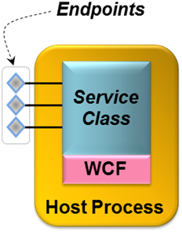
Figure 6: A WCF service class runs in a host process and exposes one or more endpoints.
Understanding WCF requires grasping all these concepts. This section describes each one, beginning with service classes.

Implementing a Service Class
A service class is a class like any other, but it has a few additions. These additions allow the class’s creator to define one or more contracts that this class implements. Each service class implements at least one service contract, which defines the operations this service exposes. The class might also provide an explicit data contract, which defines the data those operations convey. This section looks at both, beginning with service contracts.

Defining Service Contracts
Every service class implements methods for its clients to use. The creator of the class determines which of its methods are exposed as client-callable operations by specifying that they are part of some service contract. To do this, a developer uses the WCF-defined attribute ServiceContract. In fact, a service class is just a class that either is itself marked with the ServiceContract attribute or implements an interface marked with this attribute. Both options make sense in different situations, and both will be described shortly.
First, however, here’s a short description of the class, called RentalReservations, that will be used as an example throughout this section. It’s an implementation of the basic functions in the car rental reservation application described earlier, and it has four methods:
- Check, which allows a client to determine the availability of a particular vehicle class at a certain location on specific dates. This method returns a Boolean value indicating whether there is availability.
- Reserve, which allows a client to reserve a particular type of vehicle at a certain location on specific dates. This method returns a confirmation number.
- Cancel, which allows a client to cancel an existing reservation by providing its confirmation number. This method returns a Boolean value indicating whether the cancellation succeeded.
- GetStats, which returns a count of how many reservations currently exist. Unlike the other methods in this class, GetStats can be invoked only by a local administrator, not by clients of the service.
With this in mind, here’s an abbreviated C# example that uses the class-based approach to define RentalReservations as a service class:
using System.ServiceModel;

[ServiceContract]
class RentalReservations
{
[OperationContract]
public bool Check(int vehicleClass, int location,
string dates)
{
bool availability;
// code to check availability goes here
return availability;
}

[OperationContract]
public int Reserve(int vehicleClass, int location,
string dates)
{
int confirmationNumber;
// code to reserve rental car goes here
return confirmationNumber;
}

[OperationContract]
public bool Cancel(int confirmationNumber)
{
bool success;
// code to cancel reservation goes here
return success;
}

public int GetStats()
{
int numberOfReservations;
// code to get the current reservation count goes here
return numberOfReservations;
}
}

The ServiceContract attribute and all the other attributes that this example uses are defined in the System.ServiceModel namespace, so the code begins with a using statement that references this namespace. Each method in a service class that can be invoked by a client must be marked with another attribute named OperationContract. All the methods in a service class that are preceded by the OperationContract attribute are automatically exposed by WCF as services. In this example, Check, Reserve, and Cancel are all marked with this attribute, so all three are exposed to clients of this service. Any methods in a service class that aren’t marked with OperationContract, such as GetStats in the example above, aren’t included in the service contract, and so can’t be called by clients of this WCF service.
The example shown above illustrates the simplest way to create a WCF service class: marking a class directly with ServiceContract. When this is done, the class’s service contract is implicitly defined to consist of all methods in that class that are marked with OperationContract. It’s also possible (and usually better) to specify service contracts explicitly using a language’s interface type. Using this approach, the RentalReservations class might look like this:
using System.ServiceModel;

[ServiceContract]
interface IReservations
{
[OperationContract]
bool Check(int vehicleClass, int location, string dates);

[OperationContract]
int Reserve(int vehicleClass, int location, string dates);

[OperationContract]
bool Cancel(int confirmationNumber);
}

class RentalReservations : IReservations
{
public bool Check(int vehicleClass, int location,
string dates)
{
bool availability;
// logic to check availability goes here
return availability;
}

public int Reserve(int vehicleClass, int location,
string dates)
{
int confirmationNumber;
// logic to reserve rental car goes here
return confirmationNumber;
}

public bool Cancel(int confirmationNumber)
{
bool success;
// logic to cancel reservation goes here
return success;
}

public int GetStats()
{
int numberOfReservations;
// logic to determine reservation count goes here
return numberOfReservations;
}
}

In this example, the ServiceContract and OperationContract attributes are assigned to the IReservations interface and the methods it contains rather than to the RentalReservations class itself. The result is the same, however, so this version of the service exposes the same service contract as the previous one.
Using explicit interfaces like this is slightly more complicated, but it allows more flexibility. For example, a class can implement more than one interface, which means that it can also implement more than one service contract. By exposing multiple endpoints, each with a different service contract, a service class can present different groups of services to different clients.
Marking a class or interface with ServiceContract and one or more of its methods with OperationContract also allows automatically generating service contract definitions in WSDL. Accordingly, the externally visible definition of every WCF service contract can be accessed as a standard WSDL document specifying the operations in that contract. This style of development, commonly called code-first, allows creating a standard interface definition directly from types defined in programming languages such as C# or Visual Basic.
An alternative approach is contract-first development, an option that WCF also supports. In this case, a developer typically starts with a WSDL document describing the interface (i.e., the contract) that a service class must implement. Using a tool called svcutil, the developer can generate a skeleton service class directly from a WSDL definition.

Defining Data Contracts
A WCF service class specifies a service contract defining which of its methods are exposed to clients of that service. Each of those operations will typically convey some data, which means that a service contract also implies some kind of data contract describing the information that will be exchanged. In some cases, this data contract is defined implicitly as part of the service contract. For example, in the RentalReservations classes shown above, all the methods have parameters and return values of simple types, such as integer, string, and Boolean. For services similar to this one, where every operation uses only simple types, it makes sense to define the data aspects of their contract implicitly within the service contract. There’s no need for anything else.
But services can also have parameters of more complex types, such as structures. In cases like this, an explicit data contract is required. Data contracts define how in-memory types are converted to a form suitable for transmission across the wire, a process known as serialization. In effect, data contracts are a mechanism for controlling how data is serialized.
In a WCF service class, a data contract is defined using the DataContract attribute. A class, structure, or other type marked with DataContract can have one or more of its members preceded by the DataMember attribute, indicating that this member should be included in a serialized value of this type. For example, suppose the parameter lists of Check and Reserve in the RentalReservations class were changed to be a structure containing the same information. To pass this structure as a parameter using WCF requires defining it as a data contract, like this:
using System.Runtime.Serialization;

[DataContract]
struct ReservationInfo {
[DataMember] public int vehicleClass;
[DataMember] public int location;
[DataMember] public string dates;
}

Unlike the attributes shown so far, those used for data contracts are defined in the System.Runtime.Serialization namespace. Accordingly, this simple type definition begins with a using statement for this namespace. When an instance of the ReservationInfo type shown here is passed as a parameter in a method marked with OperationContract, all the fields marked with the DataMember attribute — which in this case is all three of them — will be passed. If any of the fields were not marked with this attribute, they would not be transmitted when this type was passed as a parameter.
One final point worth emphasizing about WCF contracts is that nothing becomes part of either a service contract or a data contract by default. Instead, a developer must explicitly use the ServiceContract and DataContract attributes to indicate which types have WCF-defined contracts, and then explicitly specify which parts of those types are exposed to clients of this service using the OperationContract and DataMember attributes. One of WCF’s design tenets was that services should have explicit boundaries, so WCF is an opt-in technology. Everything a service makes available to its clients is expressly specified in the code.

Selecting a Host
A WCF service class is typically compiled into a library. By definition, all libraries need a host Windows process to run in. WCF provides two main options for hosting libraries that implement services. One is to use a host process created by either Internet Information Services (IIS) or a related technology called the Windows Activation Service (WAS). The other allows a service to be hosted in an arbitrary process. The following section describes both options, beginning with the IIS/WAS approach

Hosting a Service Using IIS or WAS
The simplest way to host a WCF service is to rely on IIS or WAS. Both rely on the notion of a virtual directory, which is just a shorter alias for an actual directory path in the Windows file system.
To see how hosting with IIS and WAS works, suppose either of the RentalReservations classes shown earlier was compiled into the library reserve.dll, then placed in the virtual directory reservation on a system running Windows Server 2008. To indicate that the WCF service implemented in reserve.dll should be hosted by IIS or WAS, a developer creates a file in the reservation virtual directory with the extension .svc (which stands, of course, for “service”). For our simple example, this file might be called reserve.svc, and its entire contents could be:
<%@Service language=c# class="RentalReservations" %>
Once this has been done and an endpoint has been defined as shown in the next section, a request from a client to one of the RentalReservations service’s methods will automatically create an instance of this class to execute the specified operation. That instance will run in a process that IIS or WAS provides.
Because it provides a standalone activation service, WAS allows hosting WCF services without running a full-blown web server. And while hosting WCF services in IIS looks just like hosting them in WAS, as shown above, there are a couple of significant differences:
- IIS-hosted WCF services can only be accessed using SOAP over HTTP. No other transport protocols are supported.
- Although WAS doesn’t require a Web server to be installed on the system, WCF services hosted in IIS obviously do.
Whatever choice is made, both WAS and IIS provide WCF services with a range of support, such as the ability to configure automatic process recycling.

Hosting a Service in an Arbitrary Process
Relying on IIS or WAS to provide a process for hosting a WCF service is certainly the simplest choice. Yet applications often need to expose services from their own process rather than relying on one provided by Windows. Fortunately, this isn’t hard to do. The following example shows how to create a simple console application that hosts either of the RentalReservations classes defined earlier:
using System.ServiceModel;

public class ReservationHost
{
public static void Main()
{
ServiceHost s =
new ServiceHost(typeof(RentalReservations));
s.Open();
Console.Writeline("Press ENTER to end service");
Console.Readline();
s.Close();
}
}
Since the class ReservationHost includes a Main method, it runs as a distinct process. To host the example RentalReservations service, this method must create a new instance of the class ServiceHost, passing in the type of RentalReservations. Once an instance of this class is created, the only thing required to make the service available is to call the Open method on that instance. WCF will now automatically direct requests from clients to the appropriate methods in the RentalReservations class.
To allow a WCF service to take requests from its clients, the process that hosts it must remain running. With WAS-hosted services, the standard process ensures the host remains running, but a hosting application must solve this problem on its own. In this simple example, the process is kept running through the straightforward mechanism of waiting for input from a console user. In a more realistic case, a WCF service hosted in this way would be running in a Windows service, allowing it to be started when a system boots, or be hosted in a GUI application, such as one built with Windows Presentation Foundation.
In the example above, the service is explicitly closed by calling ServiceHost’s Close method. That isn’t required in this simple case, since the service will be automatically closed when the process ends. In a more complex situation, however, such as a process that hosts multiple WCF services, it might make sense to close individual services explicitly when they’re no longer needed.

Defining Endpoints
Along with defining operations in a service class and specifying a host process to run those operations, a WCF service must also expose one or more endpoints. Every endpoint specifies three things:
- An address indicating where this endpoint can be found. Addresses are URLs that identify a machine and a particular endpoint on that machine.
- A binding determining how this endpoint can be accessed. The binding determines what protocol combination can be used to access this endpoint along with other things, such as whether the communication is reliable and what security mechanisms can be used.
- A contract name indicating which service contract this WCF service class exposes via this endpoint. A class marked with ServiceContract that implements no explicit interfaces, such as RentalReservations in the first example shown earlier, can expose only one service contract. In this case, all its endpoints will expose the same contract. If a class explicitly implements two or more interfaces marked with ServiceContract, however, different endpoints can expose different contracts, each defined by a different interface.
An easy way to remember what’s required for WCF communication is to think of the ABCs of endpoints: address, binding, contract.
Addresses are simple to understand—they’re just URLs—and contracts have already been described. Bindings are also a critical part of how communication is accomplished, and they’re worth further explanation. Suppose, for instance, that a service’s creator wishes to allow clients to access that service using either SOAP over HTTP or SOAP over TCP. Each of these is a distinct binding, so the service would need to expose two endpoints, one with a SOAP-over-HTTP binding and the other with a SOAP-over-TCP binding.
To make bindings easier to use, WCF includes a set of predefined bindings, each of which specifies a particular group of options. Developers can configure these standard bindings if necessary, and they can also create wholly new custom bindings that provide exactly what a particular situation requires. Still, most applications will use one or more of the standard bindings that WCF provides. Among the most important of these are the following:
- BasicHttpBinding: Conforms to the Web Services Interoperability Organization (WS-I) Basic Profiles 1.2 and 2.0, which specify SOAP over HTTP. This binding also supports other options, such as using HTTPS as specified by the WS-I Basic Security Profile 1.1 and optimizing data transmission using MTOM.
- WsHttpBinding: Uses SOAP over HTTP, like BasicProfileBinding, but also supports reliable message transfer with WS-ReliableMessaging, security with WS-Security, and transactions with WS-AtomicTransaction. This binding allows interoperability with other Web services implementations that also support these specifications.
- NetTcpBinding: Sends binary-encoded SOAP, including support for reliable message transfer, security, and transactions, directly over TCP. This binding can be used only for WCF-to-WCF communication.
- WebHttpBinding: Sends information directly over HTTP or HTTPS—no SOAP envelope is created. This binding first appeared in the .NET Framework 3.5 version of WCF, and it’s the right choice for RESTful communication and other situations where SOAP isn’t required. The binding offers three options for representing content: text-based XML, JavaScript Object Notation (JSON), and opaque binary encoding.
- NetNamedPipesBinding: Sends binary-encoded SOAP over named pipes. This binding is only usable for WCF-to-WCF communication between processes on the same machine.
- NetMsmqBinding: Sends binary-encoded SOAP over MSMQ, as described later in this paper. This binding can only be used for WCF-to-WCF communication.
Unlike attributes, which are part of a service’s source code, bindings can be different for different deployments of the same service. There are a few situations where this could be problematic, however. As described later, for instance, whether a service can join an existing transaction passed to it by a client is controlled using bindings. This distinction makes sense, since different deployments of the same service might need to set this value differently. But what if a particular service class always requires this behavior? To make sure that it’s available, a developer can mark the class with the BindingRequirements attribute, specifying that the ability to flow transactions must be provided by all bindings this class uses. If the BindingRequirements attribute is present, WCF will check at runtime to make sure that the service’s bindings provide the required behavior.
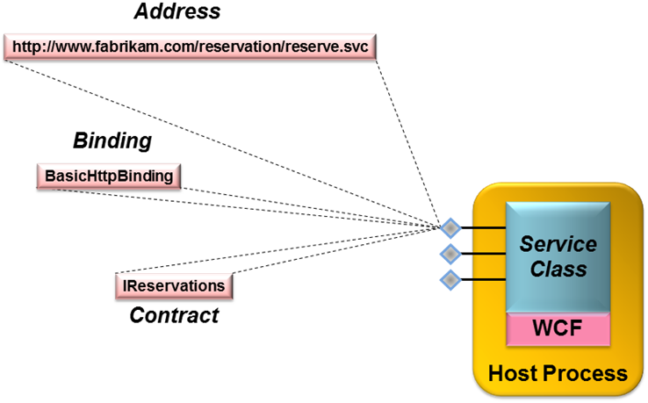
Figure 7: Each endpoint has an address, a binding, and a contract.
Figure 7 shows example values for each of the three elements in an endpoint for the second RentalReservations service class shown earlier. Assuming this service is hosted using either IIS or WAS, installed in the virtual directory reservation, and running on a machine named fabrikam.com, its address might be http://www.fabrikam.com/reservation/reserve.svc. The binding is BasicHttpBinding, and the name of the service’s contract is IReservations, which is the name of the interface that describes this service.

Specifying Endpoints
Unlike contracts, endpoints aren’t defined using attributes. It can sometimes be useful to specify endpoints in code, however, so WCF provides a way to do this. A service that’s explicitly hosted in a ServiceHost object, for instance, can use this object’s AddEndpoint method to create an endpoint. If this were done in the example shown earlier, the Main method might now look like this:
public static void Main()
{
ServiceHost s =
new ServiceHost(typeof(RentalReservations));
s.AddEndpoint(typeof(RentalReservations),
new BasicHttpBinding(),
"http://www.fabrikam.com/reservation/reserve.svc");
s.Open();
Console.Writeline("Press ENTER to end service");
Console.Readline();
s.Close();
}
The three parameters to AddEndpoint are the contract, binding and address of the new endpoint.
Even though defining endpoints programmatically is possible, the most common approach today is to use a configuration file associated with the service. Endpoint definitions embedded in code are difficult to change when a service is deployed, yet some endpoint characteristics, such as the address, are very likely to differ in different deployments. Defining endpoints in config files makes them easier to change, since changes don’t require modifying and recompiling the source code for the service class. For services hosted in IIS or WAS, endpoints can be defined in the web.config file, while those hosted independently use the configuration file associated with the application they’re running in (commonly referred to as app.config, although the actual filename varies). If used solely for the first RentalReservations service class shown earlier, this configuration file might look like this:
<configuration>
<system.serviceModel>
<services>
<service type="RentalReservations,RentalApp">
<endpoint
contract="IReservations"
binding=”basicHttpBinding”
address=
"http://www.fabrikam.com/reservation/reserve.svc"/>
</service>
</services>
</system.serviceModel>
</configuration>
The configuration information for all services implemented by a WCF-based application is contained within the system.serviceModel element. This element contains a services element that can itself contain one or more service elements. This simple example has only a single service, so there is just one occurrence of service. The type attribute of the service element identifies the service class that implements the service this configuration applies to, which in this case is RentalReservations. It also specifies the name of the .NET assembly that implements this service, which here is RentalApp. Each service element can contain one or more endpoint elements, each of which specifies a particular endpoint through which the WCF service can be accessed. In this example, the service exposes only a single endpoint, so only one endpoint element appears. The name of the endpoint’s contract is IReservations, which is the name of the interface that defines it, and the assembly name is once again included here. (If this configuration file were for the first RentalReservations service class shown earlier, which defined its service contract implicitly in the class, the value of the type attribute would remain the same, but the value of contract would instead be RentalReservations, the name of this class, rather than IReservations.) The binding specified here is basicHttpBinding, as shown earlier. And assuming RentalReservations is hosted using IIS or WAS, an address is created automatically, so there’s no need to specify one in this config file. Explicitly including it is legal, however, as this example shows.
As might be evident, WCF configuration can get complicated. The version of WCF included with the .NET Framework 4 provides some improvements over previous versions intended to make this simpler. There are more defaults, for example, so less work is required to configure common scenarios.

Using Endpoints: An Example
To get a more concrete sense of how endpoints can be used, think once more about the rental car reservation application. To meet the diverse communication requirements of its clients, this application, implemented in the RentalReservations service class, will probably choose to expose several endpoints, each with a different binding:
- For communication with the call center client application, high performance and full functionality including strong security and transactions are required. Since both the RentalReservations class and the call center client are built on WCF, a good binding option for the endpoint this client accesses would be NetTcpBinding. It’s the most efficient choice, and it also provides a full set of communication behaviors, including reliable transfer, strong security, and transactions.
- For communication with the Java EE-based reservation application, a binding that uses standard SOAP on the wire is required. If the application and the platform it runs on support some or all of the WS-* specifications, the endpoint used by this client might choose WsHttpBinding. This would allow reliable, secure, and transactional communication between the two applications. If this application and the platform it runs on support only standard SOAP matching the WS-I Basic Profile, however, the endpoint it uses to access the rental car reservation application would use BasicHttpBinding. If transport security is required, this binding could be configured to use HTTPS instead of plain HTTP.
- For communication with the various partner applications, different endpoints might be used depending on the binding requirements. For example, the a simple Web services client could access an endpoint that used BasicHttpBinding, while one that also supported transport security might use this same binding configured to use HTTPS. A partner application that was capable of using the WS-* technologies could instead use an endpoint with WsHttpBinding. It’s worth pointing out, however, that even a partner application built on WCF would find the NetTcpBinding problematic to use across the Internet. Communication with this binding uses a port other than port 80, so traffic using it cannot easily get through most firewalls.
For this simple application, all of these endpoints would specify the same service contract, because all provide the same set of exposed services. Each endpoint would typically have its own unique address, however, since each one must be explicitly identified by the clients that use it.

Creating a WCF Client
Creating a basic WCF service isn’t especially complicated. Creating a WCF client is even more straightforward. In the simplest approach, all that’s required is to create a local stand-in for the service, called a proxy, that’s connected to a particular endpoint on the target service, and then invoke the service’s operations via the proxy. Figure 8 shows how this looks.
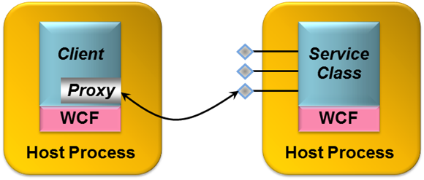
Figure 8: A WCF client can use a proxy to access a service.
Creating a proxy requires knowing what contract is exposed by the target endpoint, and then using the contract’s definition to generate the proxy. In WCF, this process can be performed using either Visual Studio or the command-line svcutil tool. If the service is implemented using WCF, these tools can access the service’s DLL to learn about the contract and generate a proxy. If only the service’s WSDL definition is available, the tools can read this to produce a proxy. If only the service itself is available, Visual Studio and svcutil can access it directly using either WS-MetadataExchange or a simple HTTP GET to acquire the service’s WSDL interface definition, and then generate the proxy.
However it’s generated, the client can create a new instance of the proxy, and then invoke the service’s methods using it. Here’s a simple example of how a client of the RentalReservations class might make a reservation for a compact car at Heathrow Airport in the autumn of 2009:
using System.ServiceModel;

public class RentalReservationsClient
{
public static void Main()
{
int confirmationNum;

RentalReservationsProxy p = new RentalReservationsProxy();
if (p.Check(1, 349, “9/30/09-10/10/09”)) {
confirmationNum = p.Reserve(1, 349, “9/30/09-10/10/09”);
}
p.Close();
}
}
In this simple example, the code for compact cars is 1, the location Heathrow Airport is designated as 349, and dates are given in the American style. All that is required is to verify availability by calling the Check method on the proxy, and then make the reservation by calling Reserve. The final call to the proxy’s Close method is not strictly required in this simple case, but it is good programming practice to clean up the communications infrastructure that has been created.
One more thing remains to be specified by the client: the exact endpoint on which it wishes to invoke operations. Like a service, the client must specify the endpoint’s contract, its binding and its address, and this is typically done in a config file. In fact, if enough information is available, svcutil will automatically generate an appropriate client configuration file for the target service.
Using proxies is simple, and it’s the right approach in many situations. It’s not the only choice, however. Beneath the veneer a proxy provides, the client’s communication with a service is handled by one or more channels. If desired, a client can work directly with these channels (as can a service). Using WCF’s ChannelFactory class, the developer can create whatever channels are required, then invoke their services directly. Doing this gives the developer more control, but also introduces somewhat more complexity.

Other Aspects of WCF
The basics of services and clients are fundamental to every WCF application. Most applications will also use other aspects of this technology, however. This section describes some of these additional capabilities.

Messaging Options
The simple examples shown so far all assume a synchronous remote procedure call (RPC) approach to client/service interaction. WCF supports this option, but it’s not the only choice. WCF supports several possibilities along with traditional RPC, including the following:
- Asynchronous RPC, with non-blocking paired calls carrying lists of typed parameters.
- Traditional messaging, with non-blocking calls carrying a single message parameter. Working directly with channels exposes methods to send and receive messages, and WCF defines a standard Message class that can be used to work directly with XML messages.
- Direct manipulation of SOAP messages using the WCF-defined attribute MessageContract. Using two related attributes, MessageHeader and MessageBodyMember, an application can explicitly access the contents of a SOAP message’s header and body.
To allow creating a method that sends information but doesn’t block waiting for a response, the OperationContract attribute has a property called IsOneWay. Methods marked with this attribute and property can have only input parameters and must return void. Here’s an example:
[OperationContract(IsOneWay=true)]
void NewCarAvailable(int vehicleClass, int location);

With this method, the caller gets nothing in return—it’s one-way communication. A typical use of one-way methods like this is to send unsolicited events. Suppose, for instance, that the call center client application wished to be informed whenever a car had become available in a previously sold-out location. That client might implement a WCF service contract containing the NewCarAvailable method, and then let the rental car reservation application invoke it as new cars became available.
It’s also possible to link together calls to methods, whether one-way or normal two-way methods, allowing both sides of the communication to act as client and service. To do this, each side implements a contract that’s linked with its partner, resulting in what are called duplex contracts. WCF provides special bindings for handling this case, such as WsDualHttpBinding for duplex contracts that use standard interoperable SOAP.

Controlling Local Behavior
Many aspects of WCF, such as contracts, bindings and more, are related to communication between a service and its clients. Yet there are also parts of a service’s behavior that are essentially local. How is concurrent access to a service instance managed, for example, and how is that instance’s lifetime controlled? To allow developers to set local behaviors like these, WCF defines two primary attributes, both of which have a number of properties. One of these attributes, ServiceBehavior, can be applied to any service class. The other, OperationBehavior, can be applied to any method in a service class that is also marked with the OperationContract attribute.
The ServiceBehavior attribute has various properties that affect the behavior of the service as a whole. For example, a property called ConcurrencyMode can be used to control concurrent access to the service. If set to Single, WCF will deliver only one client request at a time to this service, i.e., the service will be single-threaded. If this property is set to Multiple, WCF will deliver more than one client request at a time to the service, each running on a different thread. Similarly, ServiceBehavior’s InstanceContextMode property can be used to control how instances of a service are created and destroyed. If InstanceMode is set to PerCall, a new instance of the service will be created to handle each client request, and then destroyed when the request is completed. If it’s set to PerSession, however, the same instance of the service will be used to handle all requests from a particular client. (Doing this also requires setting ServiceContract‘s Session attribute to true and choosing a binding that supports sessions.) InstanceContextMode can also be set to Single, which causes a single instance of the service to handle all requests from all clients.
Suppose, for example, that the developer decided to make the RentalReservations class multi-threaded and have it use the same instance for all calls from all clients. The class’s definition would then look like this:
using System.ServiceModel;

[ServiceContract]
[ServiceBehavior(
ConcurrencyMode=Multiple,
InstanceContextMode=Single)]
class RentalReservations { ... }

Similarly, properties on the OperationBehavior attribute allow controlling the impersonation behavior of the method that implements a particular operation, its transactional requirements (described later), and other things.
Another aspect of local behavior is how a request from a client is routed within a WCF service. WCF in the .NET Framework 4 adds a standard content-based routing service that a developer can use with SOAP-based services. The routing service sits in front of other WCF services, routing each incoming message to one of those services based on the message’s content. For example, a developer might use the routing service to hide different versions of a service. This lets a client always sends to the same endpoint, regardless of the service version it’s targeting, while the routing service routes each message to the correct version of the service based on the message’s content.

Security
Exposing services on a network, even an internal network, usually requires some kind of security. How can the service be certain of its client’s identity? How can messages sent to and from a service be kept safe from malicious changes and prying eyes? And how can access to a service be limited to only those authorized to use it? Without some solution to these problems, it’s too dangerous to expose many kinds of services. Yet building secure distributed applications is difficult. Ideally, there should be straightforward ways to address common security scenarios, along with more fine-grained control for applications that need it.
To help achieve this, WCF provides the core security functions of authentication, message integrity, message confidentiality, and authorization. All of these depend fundamentally on the notion of identity: who is this user? Establishing an identity for a client or service requires supplying information such as a username and password, an X.509 certificate, or something else. A client or service can do this by directly invoking a WCF function, by using a config file, or in other ways, such as by referencing a certificate store. However it’s done, establishing an identity is an essential part of using WCF security.
Distributed security can get very complicated very fast. A primary goal of WCF’s designers was to make building secure applications easier. To allow this, WCF’s approach to authentication, data integrity and data privacy relies on bindings. Rather than require developers to insert the right attributes to secure each class and method, they can instead just use a binding that provides the right set of security services. A developer’s choices include the following:
- Use a standard binding that directly supports security. For example, applications that require end-to-end security for messages that go through multiple SOAP intermediaries can use a binding that supports WS-Security, such as WsHttpBinding.
- Use a standard binding that optionally supports security, then configure it as needed. For example, applications that need only transport-based security can choose BasicHttpBinding, configuring it to use HTTPS rather than HTTP. It’s also possible to customize other more-advanced security behaviors. For example, the authentication mechanism used by a binding such as WsHttpBinding can be changed if desired.
- Create a custom binding that provides exactly the security behavior a developer needs. Doing this is not for the faint of heart, but it can be the right solution for some problems.
- Use a standard binding that provides no support for security, such as BasicHttpBinding. While using no security is often a risky thing to do, it can sometimes be the only option.
For example, suppose the RentalReservations service wished to expose an endpoint that used the BasicHttpBinding with HTTPS rather than HTTP. The configuration file that defined this endpoint would look like this:
<configuration>
<system.serviceModel>
<services>
<service
type="RentalReservations,RentalApp"
<endpoint
contract="IReservations"
binding="basicHttpBinding"
bindingConfiguration="UsingHttps"
address=
”http://www.fabrikam.com/reservation/reserve.svc"/>
</service>
</services>
<bindings>
<basicHttpBinding>
<binding
configurationName="UsingHttps"
securityMode="Https"/>
</basicHttpBinding>
</bindings>
</system.serviceModel>
</configuration>

Unlike the configuration file shown earlier, which used just the standard basicHttpBinding, this version includes the bindingConfiguration attribute in the endpoint element. The configuration this attribute references, here given the name UsingHttps, is defined later in the config file within its bindings element. This configuration sets basicHttpBinding’s securityMode property to Https, causing all communication with this endpoint to use HTTPS rather than standard HTTP.
A WCF service can also control which clients are authorized to use its services. To do this, WCF relies on existing authorization mechanisms in the .NET Framework. A service can use the standard PrincipalPermission attribute, for example, to define who is allowed to access it. Alternatively, a WCF application that needed role-based authorization could use Windows Authorization Manager to implement this.
Helping developers build more secure applications without exposing them to overwhelming complexity is a challenging problem. By providing both a straightforward approach for the most common cases and fine-grained control for more complex situations, WCF aims at hitting this target in a usable and effective way.

Transactions
Handling transactions is an important aspect of building many kinds of business logic. Yet using transactions in a service-oriented world can be problematic. Distributed transactions assume a high level of trust among the participants, so it often isn’t appropriate for a transaction to span a service boundary. Still, since there are situations where combining transactions and services makes sense, WCF includes support for this important aspect of application design.

Transactions in the .NET Framework: System.Transactions
The transaction support in WCF builds on System.Transactions, a .NET Framework namespace focused solely on controlling transactional behaviors. Although it’s not required, developers commonly use the services of System.Transactions in concert with an execution context. An execution context allows the specification of common information, such as a transaction, that applies to all code contained within a defined scope. Here’s an example of how an application can use this approach to group a set of operations into a single transaction:
using System.Transactions;

using (TransactionScope ts =
new TransactionScope(TransactionScopeOption.Required)) {
// Do work, e.g., update different DBMSs
ts.Complete();
}

All of the operations within the using block will become part of a single transaction, since they share the transactional execution context it defines. The last line in this example, calling the TransactionScope‘s Complete method, will result in a request to commit the transaction when the block is exited. This approach also provides built-in error handling, aborting the transaction if an exception is raised.
Specifying TransactionScopeOption.Required for the new TransactionScope, as this example does, means that this code will always run as part of a transaction: joining its caller’s transaction if one exists, creating a new one if it does not. Much like Enterprise Services, other options, such as RequiresNew, can also be specified.
Unlike Enterprise Services and its predecessors Microsoft Transaction Server (MTS) and COM+, however, System.Transactions is focused entirely on controlling transactional behavior. There is no required connection between a transaction and the internal state of an object, for example. While Enterprise Services requires an object to be deactivated when it ends a transaction, System.Transactions makes no such demand. Since WCF builds on System.Transaction, WCF-based applications are also free to manage transactions and object state independently.

Transactions in WCF
WCF-based applications can use the types in System.Transactions directly, or they can control transactions using WCF-defined attributes that rely on System.Transactions under the covers. In the first option, a method marked with the OperationContract attribute might wrap its work in a transaction using TransactionScope, as just described. For example, this method might include a using statement that establishes a transaction scope, and then update two independent databases within that transaction.
Alternatively, a service’s methods can control transactional behavior via an attribute. Rather than explicitly relying on System.Transactions, a service can use the OperationBehavior attribute described earlier. Suppose, for instance, that the work done by the Reserve method in the RentalReservations class was always transactional. This is certainly plausible, since creating a new reservation might require updating more than one database system. In this case, Reserve could be defined like this:
[OperationContract]
[OperationBehavior(TransactionScopeRequired=true,
TransactionAutoComplete=true)]
private int Reserve(int vehicleClass, int location, string dates)
{
int confirmationNumber;
// logic to reserve rental car goes here
return confirmationNumber;
}

In this example, Reserve is now preceded by the OperationBehavior attribute with the TransactionScopeRequired property set to true. Because of this, all work done within this method will happen inside a transaction, just as if it were inside the transaction scope of the using block shown earlier. And because the TransactionAutoComplete property is also set to true, the method will automatically vote to commit the transaction if no exception is raised.
If the client invoking this method is not running inside a transaction, the Reserve method will run in its own transaction — there’s no other choice. But suppose the client is already part of an existing transaction when it calls Reserve. Will the work done by the Reserve method join the client’s transaction, or will it still run inside its own independent transaction? The answer depends on whether this service can accept a transaction context passed by the client, an option controlled using bindings. Some bindings, such as WsHttpBinding and NetTcpBinding, can be configured to include a transactionFlow element that determines whether a service can accept a transaction context passed by the client. If the binding used by the example service does this and the client passes in a transaction context, the work done by Reserve will become part of the client’s transaction. If not, this method’s work will remain in its own transaction.
To see how this might be used, think once again about the rental car reservation application. The endpoint that the call center client application accesses would likely be configured to accept a transaction context flowed from the client, since this application is trusted enough to engage the reservation system’s methods in a transaction. In fact, since this client is probably created by the same team producing the reservation application itself, it’s safe to assume that it won’t keep a transaction open — and thus lock the data that transaction uses — for too long. Similarly, the Java EE-based existing reservation application would access the rental car reservation system using an endpoint whose binding is configured to accept a transaction context flowed from the client. This application is also trusted to include the reservation system’s methods in transactions, since it’s controlled by the same company. But all the endpoints accessed by partner applications are likely to have bindings that will not accept a transaction context flowed from the client. Since these partner applications are owned by other organizations, they are unlikely to be trusted enough to engage the reservation application’s methods in transactions.
Finally, it’s worth emphasizing that applications built on WCF can participate in transactions that include applications running on non-WCF platforms. For example, a WCF-based application might start a transaction, update a record in a local SQL Server database, then invoke a Web service implemented on a Java EE-based application server that updates a record in another database. If this service is transactional and the platform it’s running on supports the WS-AtomicTransaction specification, both database updates can be part of the same transaction. Like security and reliable messaging, WCF transactions can work in the heterogeneous world that Web services make possible.

RESTful Communication
Communication using SOAP and the WS-* specifications addresses a broad set of the problems faced by distributed applications, especially enterprise applications running inside organizations. Yet there are plenty of situations where this breadth of functionality isn’t required. Clients that access services on the Internet via HTTP, for example, often don’t need support for reliability, distributed transactions, and other WS-* services. For cases like these, a simpler, more explicitly Web-based, approach to distributed computing makes sense.
The RESTful style meets this need. While SOAP and WS-* have been more visible in the last few years, it’s become clear that REST also has an important role to play. Accordingly, WCF provides explicit support for RESTful communication.
Although the REST approach is different from SOAP and WS-*, it’s simple to understand. Rather than exposing a different set of operations to clients for each service, as SOAP does, RESTful applications access everything using the same set of operations. Those operations are defined by the basic verbs in HTTP: GET, POST, PUT, DELETE, and perhaps others. And rather than specifying the data those operations work on via parameters, as is typically done with SOAP, everything—everything—is assigned a URL.
Suppose, for example, that the reservations system interface shown earlier was defined in a more RESTful style. It might look like this:
[ServiceContract]
interface IReservations
{
[OperationContract]
[WebGet]
bool Check(string vehicleClass, int location, string dates);

[OperationContract]
[WebInvoke]
string Reserve(string vehicleClass, int location,
string dates);

[OperationContract]
[WebInvoke(Method="DELETE")]
bool Cancel(string reservation);
}

The methods are the same: Check, Reserve, and Cancel. With the approach described earlier, however, each of these methods would be invoked via a SOAP message containing the name of the operation and its parameters, all expressed in XML. With REST, by contrast, no SOAP messages are created. Instead, the information in each operation is carried on a standard HTTP verb. The WCF attributes WebGet and WebInvoke are used to indicate which verb should be used.
In this example, the Check method is marked with WebGet, and so it will be invoked using an HTTP GET. The Reserve operation is marked with WebInvoke, and so it will be invoked using an HTTP POST, the default verb for this attribute. WebInvoke is used for all verbs except GET, however, as the next method in this interface shows. This method, Cancel, is invoked using an HTTP DELETE, as indicated by the Method parameter on WebInvoke.
One more important difference between SOAP Web services and RESTful Web services is the REST world’s complete reliance on URLs. Notice that the first parameter in each of the methods in IReservations is now a string. This parameter contains the URL against which the HTTP verb—GET, POST, or whatever—will be issued. To make it easier for developers to deal with the plethora of URLs a RESTful approach creates, WCF provides URI templates. The goal of these templates is to make it easier for developers to express URI patterns and work with URIs that match those patterns.
RESTful services expose endpoints, of course, and so adding support for REST required adding a new binding: WebHttpBinding. This quite simple option just encodes the information in an operation directly onto the specified HTTP verb—no SOAP envelope is added. And as mentioned earlier, this binding allows encoding the information carried by each operation using XML, JSON, or a binary encoding.
WCF 4 adds several new capabilities for RESTful development. These include Visual Studio project templates for common REST scenarios, guidance on security and error handling, and more. Despite Microsoft’s long-standing enthusiasm for SOAP and WS-*, it’s clear that WCF’s creators are also fans of RESTful communication.
Yet while REST’s simplicity is appealing, it’s more limited than SOAP and the WS-* standards. REST assumes HTTP, for example, while SOAP and WS-* are explicitly independent of the mechanism used for communication. (SOAP/WS-* can be used directly over TCP, for example, as in WCF’s NetTcpBinding.) SOAP/WS-* also provides a broader range of services. While RESTful applications commonly rely on point-to-point security using SSL, for example, WS-Security takes a more general approach. Similarly, RESTful communication defines no standard approach to addressing the problems solved by WS-AtomicTransaction and WS-ReliableMessaging.
Still, a RESTful approach is clearly the right choice for many applications. While it does present some challenges to developers—there’s no standard way to describe a RESTful interface, for example, so developers typically rely on some kind of human-readable documentation rather than a WSDL definition—it can be simpler than SOAP-based communication. Both approaches have value, and going forward, both are likely to be widely used.

Communication using POX, RSS, and ATOM
REST defines a stylized way to send information over HTTP. A less formalized approach to doing this is sometimes referred to as Plain Old XML (POX). While REST mandates specific behaviors, such as using HTTP verbs for operations and naming everything with URIs, POX usually refers to transmitting XML data over HTTP in any way (or at least any way except using SOAP). Another common use of XML-over-HTTP communication is syndication. Most often used with blogs, this approach typically relies on RSS or ATOM, two XML-based ways to describe information.
POX, RSS, and ATOM are all formats—they’re not protocols. Because of this, no special WCF binding is required to use them. All are usually sent directly over HTTP, with no SOAP header, and so the best binding choice is typically WebHttpBinding. (WCF’s first release also allowed sending XML directly over HTTP by setting a parameter on either BasicHttpBinding or WSHttpBinding that caused them not to use SOAP messages, an option that’s now deprecated).
To expose a syndication feed, for example, a WCF application might implement a method marked with the WebGet attribute that returns either RSS or ATOM data. While the RSS and ATOM formats look a bit different on the wire, both specify that a feed contains some number of items. To help create information in either format, WCF includes the types SyndicationFeed and SyndicationItem. Using these, an application can construct a feed containing one or more items, then render it in the required representation. WCF provides separate formatters for RSS and ATOM, allowing this data structure to be output using either option.

Queuing
Using a binding such as WsHttpBinding, a WCF-based application can communicate reliably with another application built on WCF or any other Web services platform that implements WS-ReliableMessaging. But while the technology this specification defines guarantees reliable end-to-end delivery of a SOAP message, it does not address message queuing. With queuing, an application sends a message to a queue rather than directly to another application. When the receiving application is ready, it can read the message from the queue and process it. Allowing this kind of interaction is useful, for example, when the sender of a message and its receiver might not be running at the same time.
Accordingly, WCF provides support for message queuing. This support is built on top of MSMQ, which means that unlike most other aspects of WCF, such as reliable messaging, security and transactions, WCF queuing does not interoperate directly across vendor boundaries. A bridge between MSMQ and IBM’s WebSphere MQ is available, however, and Microsoft also provides a channel that directly supports WebSphere MQ.
To use WCF queuing, a developer can create a standard WCF service class, marked as usual with ServiceContract. The operations in this class’s service contract have some limitations, however. In particular, they must all be marked as one-way, which means that no response is returned. This isn’t surprising, since invoking a queued operation sends a message into a queue rather than to its ultimate receiver, so waiting for an immediate response wouldn’t make much sense. And like any other service class, queued WCF-based applications expose endpoints. These endpoints use bindings such as NetMsmqBinding, which allows communication with other queued WCF-based applications, or MsmqIntegrationBinding, which allows a queued WCF-based application to interoperate with a standard MSMQ application that doesn’t use WCF. WCF queuing also supports other traditional aspects of queued environments, such as dead letter queues and handling of poison messages.
Queuing is the right approach for a significant set of distributed applications. WCF’s support for this communication style allows developers to build queued applications without needing to learn an entirely separate queuing technology.

Creating a Workflow Service
As its name suggests, Windows Workflow Foundation (WF) lets developers create workflow-based applications. WF workflows can be useful in a variety of different situations. For example, WF can make it easier to create scalable applications that pause, perhaps for a long time, while waiting for input. Whatever its purpose, every WF workflow is built from activities, each of which performs some function. An activity might do something simple, such as implement a While statement, or carry out a more complex task, such as executing custom business logic.
While it’s certainly not required, a developer can use WF to create the logic for a WCF service. Known as a workflow service, this technology combination often makes sense. The developer builds scalable business logic as a WF workflow, then lets that workflow’s activities interact with the outside world via WCF services.
To help do this, WF includes several activities specifically intended to allow WCF communication. For example, the Send activity sends a message via WCF, while the Receive activity receives a message. WCF 4 also allows correlation of multiple requests sent to a particular workflow instance. For example, suppose an instance of a workflow sends a request via WCF, then pauses waiting for a message in response. While it’s waiting, this workflow instance will be deactivated, with its state stored on disk. When a response message arrives, WCF can determine from the message’s contents which workflow instance it’s intended for—it can correlate this response message with the request message sent earlier. The target workflow instance can then be reactivated and the message delivered to the appropriate activity in that workflow.
Not every WCF service should be built using WF. In a surprisingly large number of cases, however, using WF and WCF together is the right choice. Workflow services can be useful things.

Extensibility
Most users will be perfectly happy with WCF’s standard functionality. Advanced developers, however, will in some cases need to extend what WCF provides. To allow this, WCF offers several extensibility options.
For example, it’s possible to create a custom channel. As described earlier, WCF clients and servers rely on channels to communicate (although clients will often hide the channel beneath a proxy). If necessary, a developer can create a channel that meets the specific requirements of her application. For example, suppose that a particular scenario requires an application to send SOAP messages over a protocol that isn’t supported by WCF, such as SMTP or a proprietary message queuing product. By creating a custom channel, the standard WCF programming model can be used on top of this existing communication technology.
Another extensibility option is to create a validator. Each validator defines an attribute and some associated code. That code is run every time an instance of a service that contains the attribute is started, giving the code the opportunity to check some aspect of the service. A validator might verify that a particular service has no endpoints that use bindings without security, for instance, or ensure that no duplex contracts are supported, or verify some other rule that’s meaningful in a particular organization or application. If a validator indicates that the conditions it’s checking are not met, the service will not execute. WCF itself actually uses this approach: the BindingRequirements attribute described earlier is implemented as a validator.
WCF also contains a number of behaviors that can be customized or adjusted in various ways using either custom attributes or config files. It’s possible to create an attribute that causes custom code to be executed whenever a message is sent or received, for instance, allowing WCF to be used in the style of aspect-oriented programming. It’s also possible to customize behaviors in other ways, including things such as substituting a custom serializer in place of the serializers that WCF provides. For applications that require specialized behaviors, these options can be essential.

Tool Support: WCF and Visual Studio
WCF has a tight relationship with Visual Studio, which provides a number of WCF-specific capabilities. They include the following:
- Several WCF-specific project types to make it easier for developers to get started creating typical WCF applications. These include projects for building:
- A Website or Web application that hosts a WCF service;
- A library implementation of a WCF service;
- A WCF application that exposes syndication feeds using RSS or ATOM;
- A WCF service designed for use by an AJAX client. This service is automatically configured to use the WebHttpBinding with JSON encoding.
- An AddServiceReference function that lets a developer specify an existing service’s endpoint, then let Visual Studio automatically generate a WCF proxy for that service.
- The ability to generate a client for testing new WCF-based Web services.
- A WCF Autohost that can automatically host a library-based WCF service.
- The Service Configuration Editor, a tool that makes creating and modifying WCF configuration files easier.
- IntelliSense for WCF configuration, allowing statement completion when creating XML elements in configuration files
As always, the goal is to make it as straightforward as possible to create, deploy, and maintain WCF applications using Visual Studio.

Coexistence and Upgrade
WCF represents a modern approach to creating distributed applications in the era of reliable, security-enhanced, and transactional services. A key point to understand, however, is that installing WCF will not break any existing applications. Current code running on ASMX, .NET Remoting, and the other technologies whose functionality is subsumed by WCF will continue to run.
Still, for each of the older technologies that were deeply affected by the advent of WCF, developers need to understand two things: whether applications built on this technology can interoperate with applications built on WCF, and how much work it is to port applications from this technology to the WCF environment. Here’s a short description of how each one addresses these issues:
- ASP.NET Web Services (ASMX): Web services built with ASMX will interoperate with WCF applications. Since ASP.NET Web services and WCF both support standard SOAP, this shouldn’t be surprising. Moving existing ASP.NET Web services code to WCF does require some mechanical work, however. The basic structure of the two technologies is quite similar, so for the most part only attributes and configuration files will need to be changed. Still, some advanced ASMX features, such as SOAP Extensions, will not be portable to WCF. They’ll instead need to be rewritten using the extensibility options that WCF provides.
- .NET Remoting: Applications built on .NET Remoting will not interoperate with applications built on WCF— their wire protocols aren’t compatible. Moving existing .NET Remoting code to WCF will require some effort, but it will be possible. Anyone who has built custom .NET Remoting extensions, however, such as channels and sinks, will find that this code won’t port to the new world. Similar extensions are possible in WCF, but the interfaces for doing it don’t match those in .NET Remoting.
- Enterprise Services: To allow an existing Enterprise Services application to interoperate with WCF clients (or other Web-services-based software), developers can identify exactly which interfaces in that application should be exposed. Using a WCF-supplied tool, service contracts can then be automatically created for those interfaces and exposed via WCF. For existing clients of Enterprise Services applications that are not built on the .NET Framework (and for other purely COM-based clients), a WCF moniker is provided to allow straightforward access to Web services. The effort required to port existing Enterprise Services applications to run directly on WCF is similar to what’s required to port ASMX applications. Much of the work, though not all of it, is straightforward mechanical changes to attributes and namespaces.
- Web Services Enhancements: WSE was Microsoft’s tactical solution for supporting Web services applications that required some or all of the functions provided by the early WS-* specs. Because the final specifications differed from those early drafts, applications built using WSE 1.0 and WSE 2.0 will not interoperate with applications built on WCF. However, applications built on WSE 3.0 do interoperate with WCF applications. For portability, the story is similar to the technologies already described: Some amount of effort is required to move existing code from WSE to WCF.
- Microsoft Message Queuing: Because WCF’s queuing functions are built on MSMQ, queued applications built on WCF can interoperate with queued applications built directly on MSMQ. Porting applications from the System.Messaging namespace provided with the original .NET Framework will require some work, since this earlier interface is different from what WCF provides.
To provide a concrete example of what moving to WCF entails, here’s an example of how the RentalReservations class, including a transactional Reserve method, might have been defined using ASMX:
using System.Web.Services;

class RentalReservations
{
[WebMethod]
public bool Check(int vehicleClass, int location, string dates)
{
bool availability;
// logic to check availability goes here
return availability;
}

[WebMethod(TransactionOption=TransactionOption.Required)]
private int Reserve(int vehicleClass, int location,
string dates)
{
int confirmationNumber;
// logic to reserve rental car goes here
return confirmationNumber;
}

[WebMethod]
private bool Cancel(int confirmationNumber)
{
bool success;
// logic to cancel reservation goes here
return success;
}

public int GetStats()
{
int numberOfReservations;
// logic to get the current number of reservations goes here
return numberOfReservations;
}
}

Compare this with a WCF-based implementation of the same class:
using System.ServiceModel;

[ServiceContract(FormatMode=ContractFormatMode.XmlSerializer)]
class RentalReservations
{
[OperationContract]
public bool Check(int vehicleClass, int location, string dates)
{
bool availability;
// logic to check availability goes here
return availability;
}

[OperationContract]
[OperationBehavior(AutoEnlistTransaction=true,
AutoCompleteTransaction=true)]
private int Reserve(int vehicleClass, int location,
string dates)
{
int confirmationNumber;
// logic to reserve rental car goes here
return confirmationNumber;
}

[OperationContract]
private bool Cancel(int confirmationNumber)
{
bool success;
// logic to cancel reservation goes here
return success;
}

public int GetStats()
{
int numberOfReservations;
// logic to get the current number of reservations goes here
return numberOfReservations;
}
}

The differences are relatively small:
- The using statement references a different namespace;
- The class is marked with ServiceContract (and due to a difference in serialization defaults, this attribute’s FormatMode property must be set as shown);
- The exposed operations use the OperationContract attribute rather than WebMethod;
- The Reserve method is made transactional using OperationBehavior rather than a property on WebMethod.
These changes are straightforward. In fact, writing a script that programmatically changed existing ASMX applications wouldn’t be too difficult.
Introducing new software always has an impact on what already exists. By providing a common foundation for building service-oriented applications, WCF offers a more consistent platform for developers. The goal of WCF’s creators is to make the transition as smooth as possible.

Conclusion
Because it unifies different approaches to communication, WCF can simplify the creation of distributed applications on Windows. Because it implements SOAP and the most important WS-* specifications, along with RESTful communication, WCF provides broad interoperability with other platforms. And because it offers explicit support for a service-oriented approach, WCF gives developers a natural environment for building modern software.
Service-oriented applications are becoming the norm, and WCF is now a mainstream technology for Windows. For anyone who creates software in this world, this shift qualifies as a significant step forward.

About the Author
David Chappell is Principal of Chappell & Associates (www.davidchappell.com) in San Francisco, California. Through his speaking, writing, and consulting, he helps people around the world understand, use, and make better decisions about new technology.

