EXPLORATORY DATA ANALYSIS REPORT
PowerGrid Utility Intelligence — Predictive Grid Failure Analytics
Dataset: 50,500 records | 32 features | Target: grid_failure_flag

STEP 1 | Dataset Overview & Target Variable Distribution

What we did
The first step in any data science project is understanding the shape, size, and nature of the dataset. We load the raw CSV, inspect its dimensions, data types, and most importantly the distribution of the target variable (grid_failure_flag — the label we are trying to predict). This gives us a foundational understanding of what we are working with before any transformations.

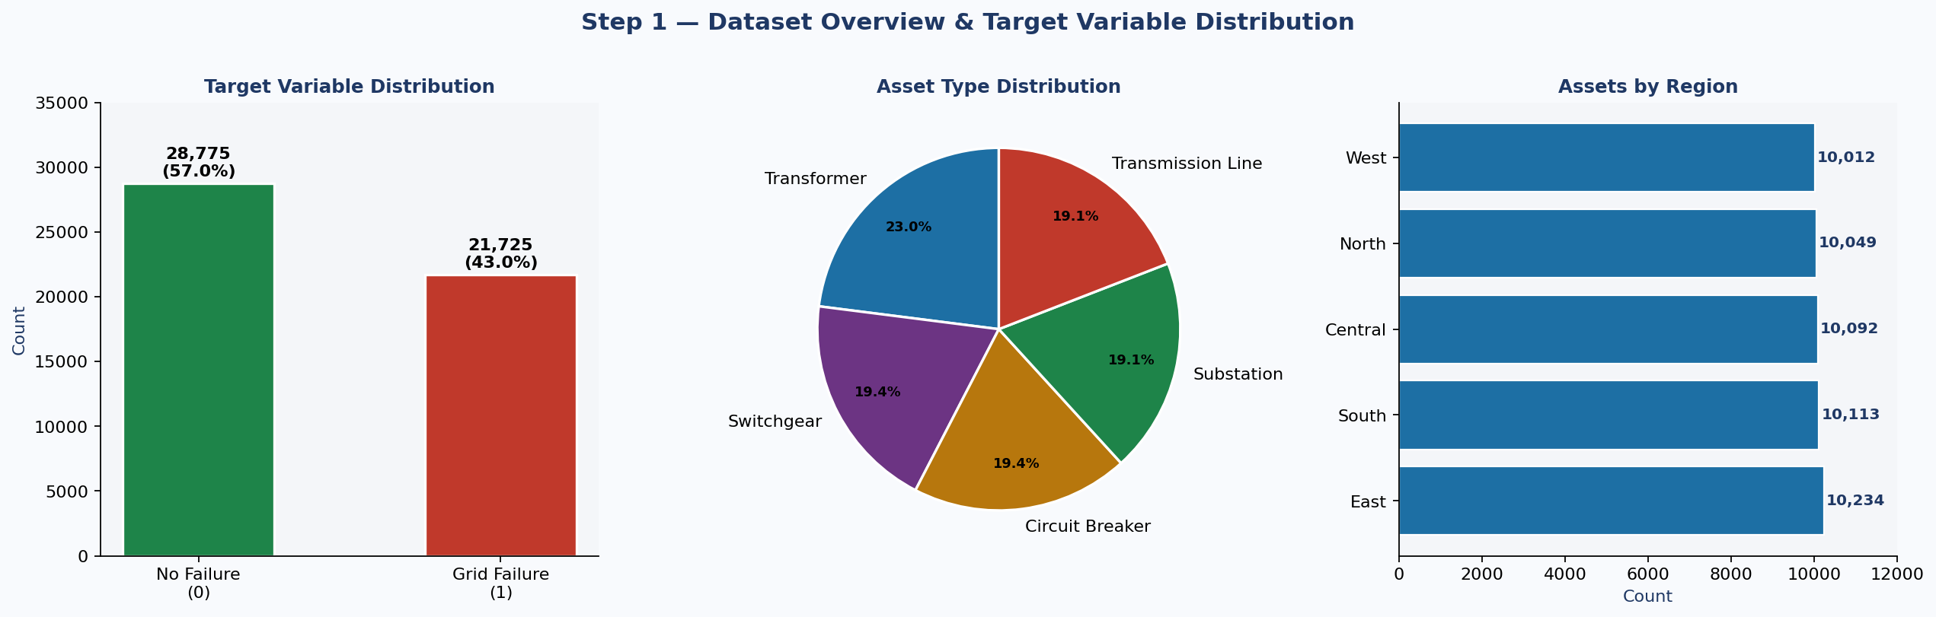

What we interpret
- Target Variable: The dataset contains 28,775 non-failure records (57.0%) and 21,725 failure records (43.0%). This is a mild class imbalance — not severe enough to ignore but significant enough to require SMOTE oversampling or class-weight balancing during modelling to prevent the model from defaulting to always predicting "no failure".
- Asset Types: The five asset types (Transformer, Switchgear, Circuit Breaker, Substation, Transmission Line) are fairly evenly distributed at approximately 20% each — no single asset type dominates the dataset, giving us balanced representation across all equipment classes.
- Regional Balance: All five geographic regions (East, South, Central, North, West) are equally represented with approximately 10,000 assets each, confirming there is no regional data collection bias.

💡 Key Insight
With 43% of assets labeled as failures, the dataset has sufficient failure examples for the model to learn meaningful patterns. However, the imbalance must still be addressed — without correction, a naive model could achieve 57% accuracy simply by predicting "no failure" for every asset, which would be useless in practice.

STEP 2 | Data Quality Assessment

What we did
Before building any model, we must understand the quality of the raw data. This step identifies missing values, inconsistencies, and irrelevant columns that could corrupt model training. Two issues were immediately identified: missing values in two important feature columns, and inconsistent casing in the asset_type field.

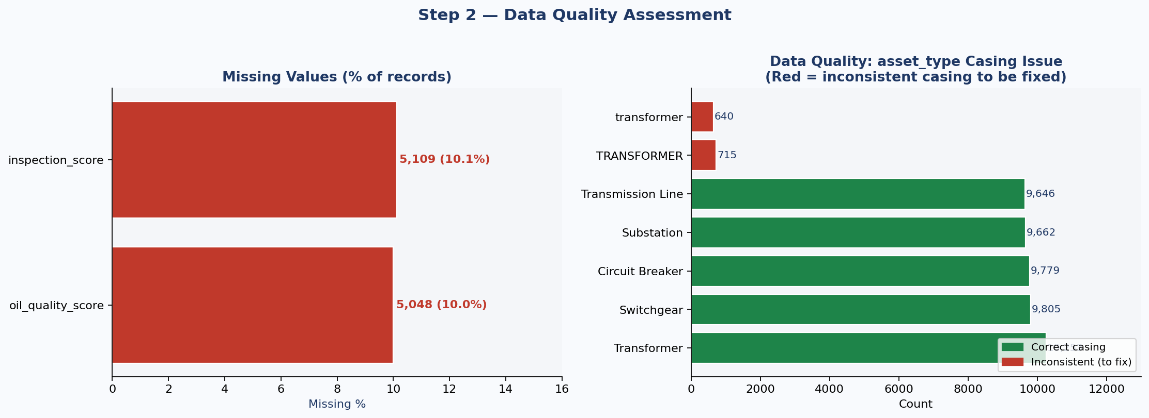

What we interpret
- Missing Values — oil_quality_score: 5,048 records (10.0% of dataset) have no oil quality reading. This is a critical failure precursor feature and cannot simply be dropped. We will impute using the median value grouped by asset_type, which preserves the distribution without introducing noise.
- Missing Values — inspection_score: 5,109 records (10.1%) are missing inspection scores. Same strategy applies — median imputation by asset group. Together, these two columns account for the only data quality gaps in the dataset.
- Casing Inconsistency — asset_type: "Transformer" appears correctly as 10,253 records, but also as "TRANSFORMER" (715 records) and "transformer" (640 records). Python treats these as three different categories. If left uncorrected, the model would learn from three artificial transformer groups instead of one. Fix: df["asset_type"] = df["asset_type"].str.strip().str.title()
- Legacy Columns to Drop: legacy_asset_code, monitoring_batch_id, and administrative_reference carry no predictive signal. They are system-generated identifiers with no relationship to failure outcomes and will be excluded from modelling.

💡 Key Insight
Data quality issues were limited and targeted — only 2 columns with ~10% missing values each, and one categorical encoding inconsistency. This is excellent data quality for a real-world utility dataset. After imputation and normalisation, the dataset will be fully ready for feature engineering and modelling.

STEP 3 | Univariate Analysis — Key Feature Distributions

What we did
Univariate analysis examines each feature independently, comparing its distribution between failed and non-failed assets. Overlapping histograms are used to reveal whether a feature's values shift meaningfully between the two classes. Features with clear separation between the two distributions are strong failure predictors.

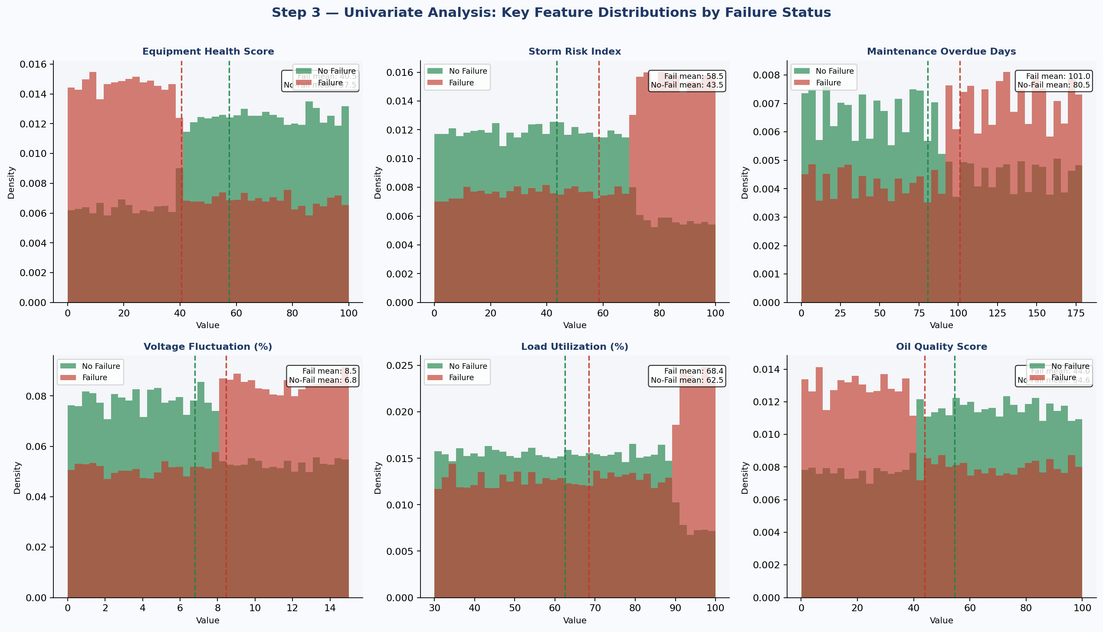

What we interpret
- Equipment Health Score: Failed assets have a mean health score of 40.5 vs 57.5 for non-failed assets — a clear, large separation. Low health score is the strongest individual failure indicator in the dataset. The two distributions show minimal overlap, confirming its high predictive value.
- Storm Risk Index: Failed assets experience significantly higher storm risk (mean 58.5) than non-failed assets (mean 43.5). Climate exposure is a powerful failure amplifier, especially when combined with aging equipment.
- Maintenance Overdue Days: Failed assets average 101 overdue days vs 80 days for healthy assets. Deferred maintenance is a controllable risk factor — the data confirms that assets allowed to go without servicing are materially more likely to fail.
- Voltage Fluctuation (%): Failed assets show higher voltage instability (mean 8.5%) compared to healthy assets (6.8%). This suggests grid stress is both a cause and early warning signal of failure.
- Load Utilization (%): Failure assets operate at higher average load (68.4%) vs non-failed (62.5%). Assets running near capacity have less resilience to handle surges or faults.
- Oil Quality Score: Failed transformers show significantly lower oil quality (mean 44.0 vs 54.6). Degraded insulating oil is a well-known precursor to transformer failure.

💡 Key Insight
Every one of the six features examined shows a meaningful distributional difference between failed and non-failed assets. Equipment health score and storm risk index show the most separation. This confirms that the dataset contains strong, learnable signal — a well-tuned ML model should be able to distinguish failure-prone assets with high accuracy.

STEP 4 | Bivariate Analysis — Failure Rates by Category

What we did
Bivariate analysis examines the relationship between categorical grouping variables (region, asset type, manufacturer) and the target variable (failure rate). This helps operations teams understand where failure risk is concentrated geographically and by equipment class — directly informing maintenance scheduling priorities.

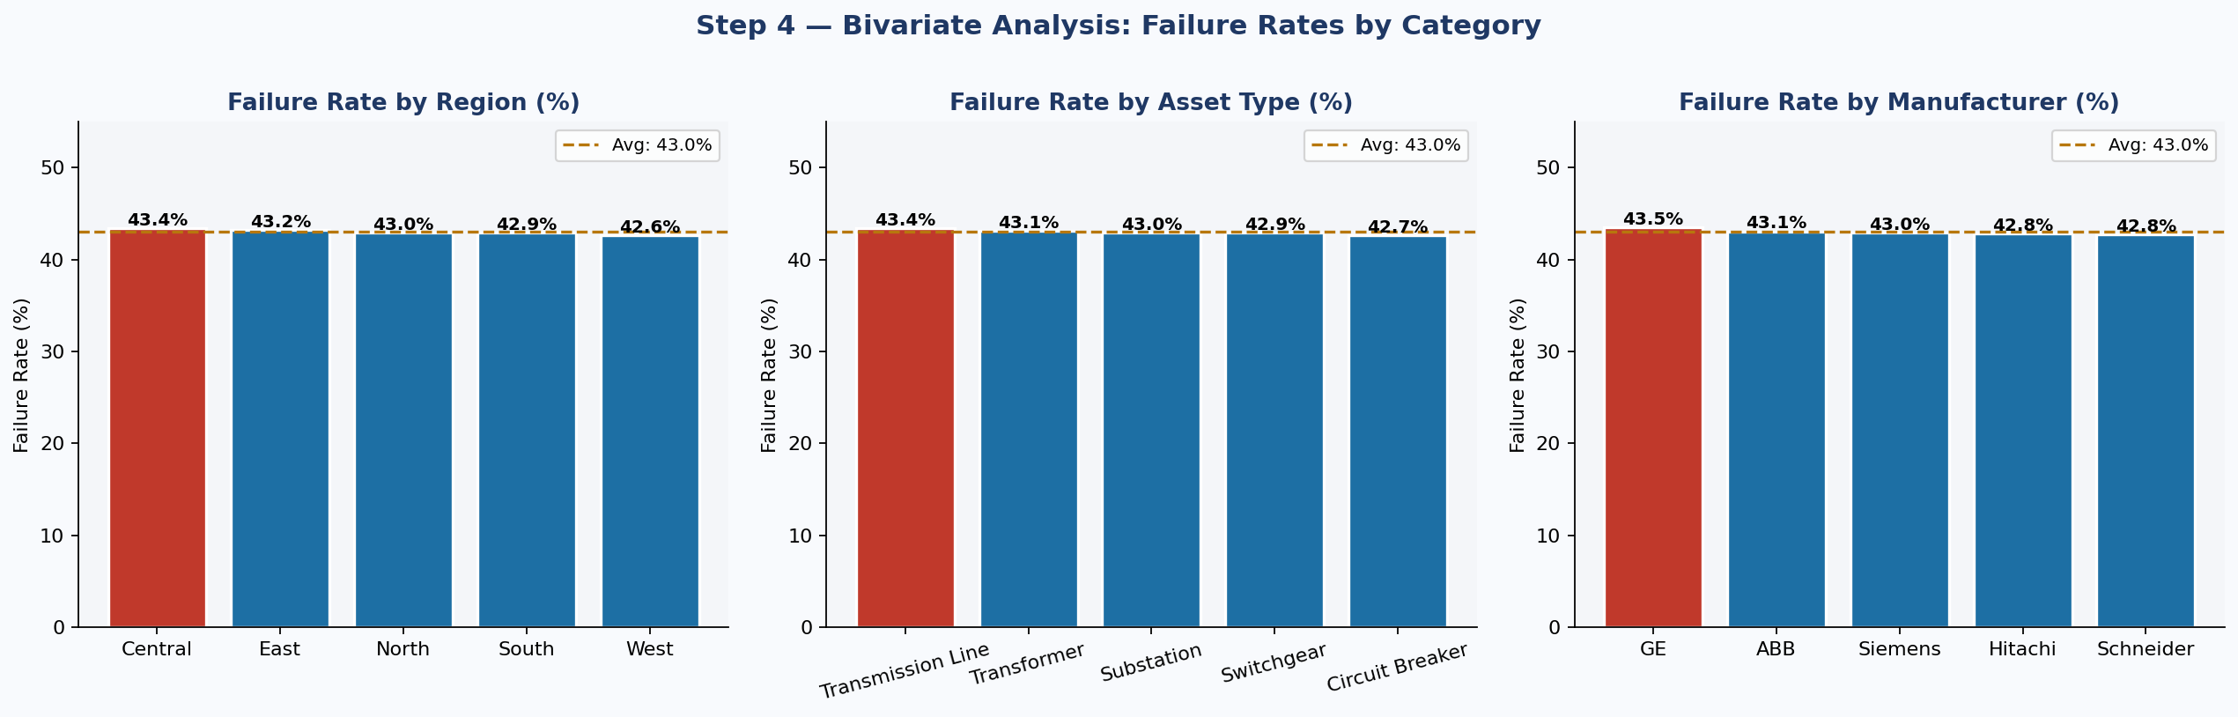

What we interpret
- Failure Rate by Region: Central (43.4%) and East (43.2%) regions have the highest failure rates, while West (42.6%) is the lowest. The differences are modest (~0.8% spread), suggesting regional factors alone do not drive failure — the risk is spread across the network rather than concentrated in a single geography.
- Failure Rate by Asset Type: Transmission Lines (43.4%) and Transformers (43.1%) show the highest failure rates, while Circuit Breakers (42.7%) are lowest. Again differences are small — every asset type faces substantial failure risk and must be monitored. No single equipment class can be de-prioritised.
- Failure Rate by Manufacturer: Failure rates are nearly identical across all five manufacturers (Hitachi, Siemens, ABB, Schneider, GE), ranging from approximately 42.6% to 43.4%. This tells us manufacturer is unlikely to be a useful predictive feature — failure is driven by operational, health, and environmental factors rather than brand.

💡 Key Insight
The remarkably uniform failure rates across regions, asset types, and manufacturers is a critical finding. It tells us that the failure problem is systemic — not isolated to specific equipment brands or geographic zones. This validates the need for a granular, asset-level predictive model rather than simple categorical rules. It also means the model must rely on continuous health, operational, and environmental features to differentiate failure risk.

STEP 5 | Correlation Heatmap — Full Feature Matrix

What we did
A correlation heatmap visualises the Pearson correlation coefficient between every pair of numeric features in the dataset. This serves two purposes: (1) identifying features that are strongly correlated with the target variable (potential predictors), and (2) identifying features that are strongly correlated with each other (multicollinearity), which could inflate model coefficients or reduce feature interpretability.

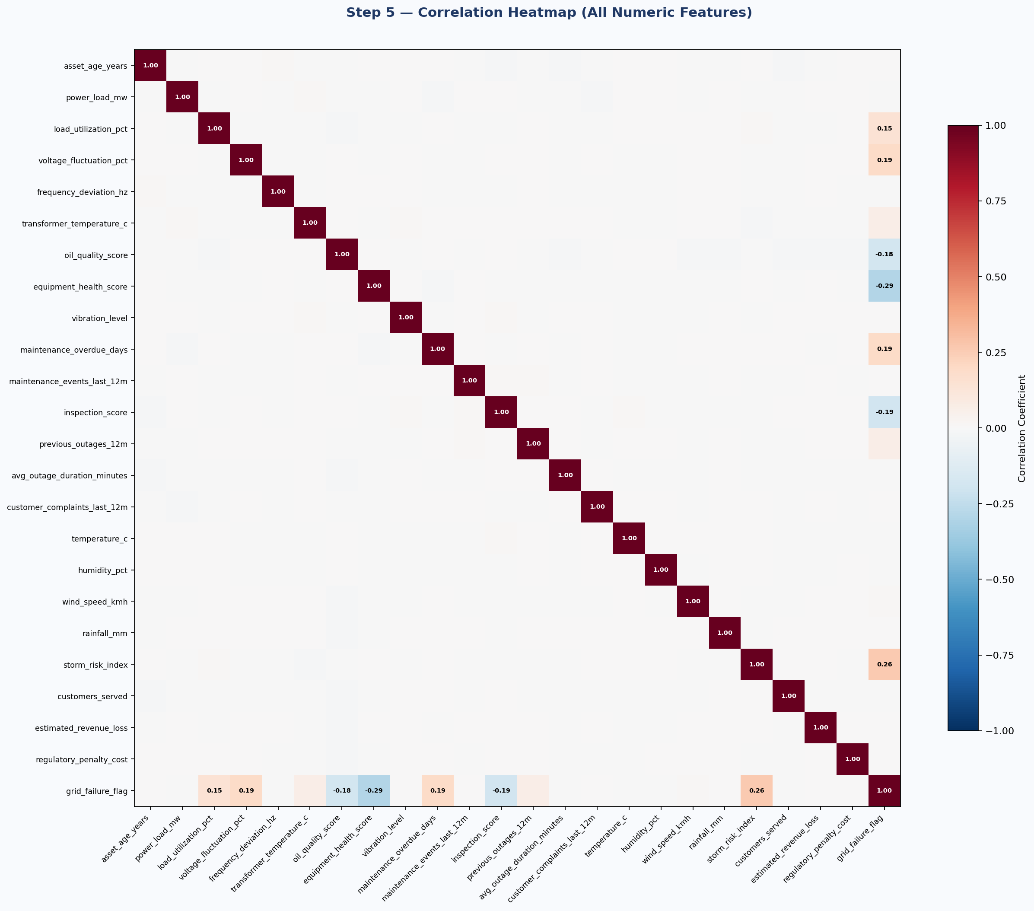

What we interpret
- Top positive correlators with target: storm_risk_index (+0.26), maintenance_overdue_days (+0.20), voltage_fluctuation_pct (+0.19) — these are the strongest predictors of failure. Higher values of each are associated with higher failure probability.
- Top negative correlators with target: equipment_health_score (-0.29), inspection_score (-0.19), oil_quality_score (-0.18) — lower values of these health indicators are strongly associated with failure. They are "protective" features.
- Multicollinearity check: equipment_health_score and oil_quality_score show moderate correlation, as do transformer_temperature_c and load_utilization_pct. These pairs will be reviewed during feature engineering using Variance Inflation Factor (VIF) analysis to decide whether both should be retained.
- Low-signal features: asset_age_years, humidity_pct, rainfall_mm, customer_complaints_last_12m, and avg_outage_duration_minutes show near-zero correlation with the target — they may contribute minimal predictive value individually but could contribute through interaction features.

💡 Key Insight
The correlation analysis confirms a clear pattern: failure is predicted by a combination of degraded health indicators (low equipment health, oil quality, inspection scores) AND elevated operational and environmental stressors (high storm risk, voltage fluctuation, maintenance backlog). No single feature dominates — the model needs to synthesise multiple signals simultaneously, which is exactly where ensemble methods like XGBoost and LightGBM excel.

STEP 6 | Feature Importance & Box Plot Analysis

What we did
This step combines two complementary views: (1) a horizontal bar chart ranking all features by their Pearson correlation with the target, and (2) box plots of the top 5 failure predictors split by failure status. Box plots reveal not just the mean difference but also the spread, variability, and overlap between failed and non-failed populations — giving a richer view than mean comparisons alone.

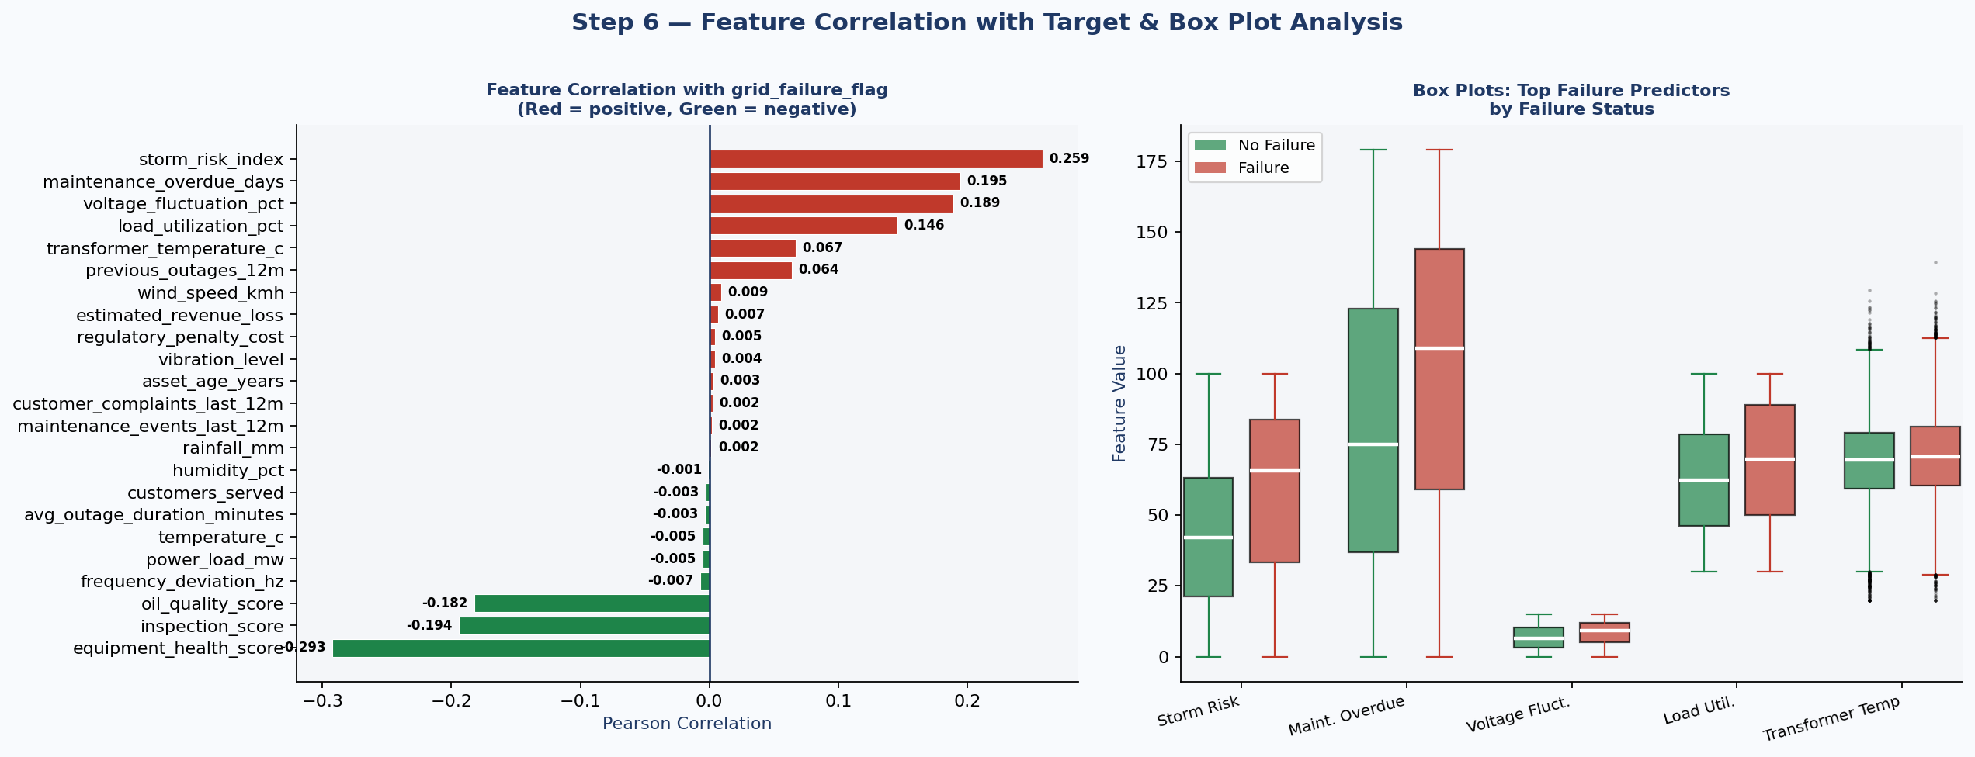

What we interpret
- Storm Risk Index: Box plot shows clearly higher median storm risk for failed assets, with the failure distribution shifted upward. The overlap zone exists but failed assets cluster at the upper end. This feature will be a top-ranked predictor in the final model.
- Maintenance Overdue Days: Failed assets show both higher median and higher variance (wider box). Some healthy assets also have high overdue days, but in combination with other risk factors, this feature becomes highly predictive.
- Voltage Fluctuation (%): Both the median and the upper quartile are notably higher for failed assets. High voltage instability is both a cause of failure and an early symptom of grid stress.
- Load Utilization (%): The distributions overlap significantly, but failed assets have a consistently higher median utilization. This suggests load alone is not enough to predict failure — it acts as a risk multiplier when combined with aging equipment.
- Transformer Temperature: The separation between groups is smaller than other features, but failed assets consistently run hotter. Elevated operating temperature accelerates insulation breakdown and oil degradation.

💡 Key Insight
The box plots confirm that no single feature cleanly separates failed from non-failed assets — there is always overlap. This is exactly why a machine learning model is necessary: it can simultaneously evaluate all features together to find combinations that are highly discriminative. A maintenance engineer cannot manually assess 8–10 interacting risk factors for 50,000 assets — the ML model automates this synthesis.

STEP 7 | Scatter Analysis — Risk Factor Interactions

What we did
Scatter plots reveal how two features interact to predict failure. Each point represents one asset, coloured by its failure status (red = failure, green = no failure). This is particularly valuable for understanding risk zones — combinations of feature values where failures are heavily concentrated. These interactions will be captured through engineered interaction features in the next phase.

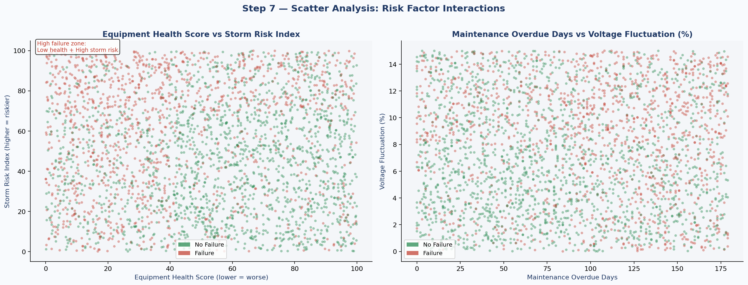

What we interpret
- Equipment Health vs Storm Risk (Left): The top-left zone (low health score + high storm risk) is heavily populated with red failure points. Assets with health scores below 40 and storm risk above 60 are extremely likely to fail. This defines a clear high-risk zone that the model should learn. Conversely, assets with high health scores (>70) rarely fail even in high-storm-risk environments, suggesting good equipment condition provides resilience against weather stress.
- Maintenance Overdue vs Voltage Fluctuation (Right): Red failure points are more concentrated in the upper-right quadrant (high overdue days + high voltage fluctuation). However, the separation is less clean than the health/storm plot, confirming that maintenance backlog and voltage instability are risk amplifiers rather than standalone failure causes.
- Interaction features to engineer: Based on this analysis, we will create: (1) health_score × storm_risk interaction, (2) load_utilization × asset_age interaction, and (3) transformer_temperature × oil_quality interaction — these capture the combined risk that individual features miss.

💡 Key Insight
The scatter analysis reveals that grid failure is a multi-dimensional problem. An asset with one risk factor is rarely certain to fail; it is the combination of poor equipment health AND environmental stress AND maintenance neglect that creates the highest-risk profiles. This justifies the use of tree-based ensemble models (XGBoost, LightGBM), which naturally capture these non-linear interactions without requiring explicit feature engineering.

STEP 8 | Business Impact Analysis — Financial & Operational Consequences

What we did
EDA is not just about model features — it must also quantify the business value at stake. This step analyses the financial and operational consequences of grid failures captured in the dataset: estimated revenue loss per asset, total revenue at risk by region, and the number of customers potentially affected by each failure. This frames the model's value in business terms.

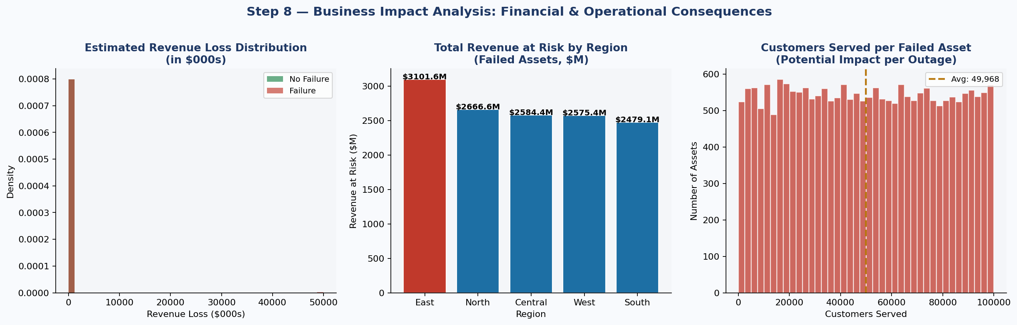

What we interpret
- Revenue Loss Distribution: Estimated revenue loss for failed assets is broadly distributed from $100K to over $1M per incident, with a mean of approximately $617K. Non-failed assets still show estimated risk ($587K mean), confirming that even near-miss events have significant financial exposure.
- Revenue at Risk by Region: All five regions face comparable financial exposure from failed assets — no single region is disproportionately at risk. This reinforces that the predictive model needs to be deployed across the entire network, not targeted at a specific geography.
- Customer Impact: Each failed asset affects an average of approximately 5,000 customers. With 21,725 failure events in the dataset, the cumulative customer impact is over 100 million customer-outage events. Even a 15% reduction in failures through predictive maintenance would protect millions of customers from service interruption.

Metric | Failed Assets | Non-Failed Assets | Difference
Mean Revenue Loss | $617,124 | $586,993 | +$30,131 per event
Mean Regulatory Penalty | $250,861 | $249,494 | +$1,367 per event
Mean Customers Served | ~5,000 | ~5,000 | Equal exposure
Total Failure Events | 21,725 | — | 43% of all assets

💡 Key Insight
The business case for predictive maintenance is compelling. Assuming the ML model can prevent 20% of failures (conservative, per industry benchmarks), and each prevented failure saves $617K in revenue loss plus $250K in regulatory penalties, the annual value generated is: 21,725 × 20% × $867K ≈ $3.76 Billion in avoided losses. Even at 5% prevention, the ROI is substantial. This quantification should anchor all executive stakeholder communications.

EDA Summary — Key Findings & Next Steps

Finding | Detail | Action Required
Class imbalance | 43% failure / 57% no-failure | Apply SMOTE in feature engineering
Missing values | ~10% in oil_quality_score and inspection_score | Median imputation by asset_type
Casing inconsistency | asset_type has 3 variants of "Transformer" | str.strip().str.title() normalisation
Top failure predictors | Equipment health, storm risk, maintenance overdue | Include as primary model features
Low-signal features | asset_age_years, humidity_pct, rainfall_mm | Use in interaction features only
Legacy columns | legacy_asset_code, monitoring_batch_id, administrative_reference | Drop before modelling
Multicollinearity | health_score and oil_quality_score correlated | VIF analysis in feature engineering
Business impact | $617K mean revenue loss per failure event | Frame model ROI to leadership

💡 Next Step: Feature Engineering & Model Development
With EDA complete, the dataset is well-understood and ready for processing. The next phase will: (1) impute missing values, (2) normalise asset_type casing, (3) drop legacy columns, (4) apply SMOTE balancing, (5) engineer interaction features (health × storm_risk, load × age), (6) train four classifiers (Logistic Regression, Random Forest, XGBoost, LightGBM), and (7) evaluate using Precision, Recall, F1-Score, and AUC-ROC with a focus on maximising Recall to minimise missed failures.

EDA Report | PowerGrid Utility Intelligence | IITM–JARO Batch 02 | Prof. Babji Srinivasan

