CAPSTONE PROJECT PRE-SUBMISSION DOCUMENT
PowerGrid Utility Intelligence
Predictive Grid Failure Analytics — Moving from Reactive to Proactive Operations

Submitted to | Prof. Babji Srinivasan | IITM – JARO
Batch | Batch 02
Domain | Power Grid / Utility Analytics | Dataset: 50,500 records | 32 features

1. Business Problem Understanding & Objective Formulation
1.1 Domain Context
PowerGrid Utilities Corporation operates one of the region's largest electricity transmission and distribution networks, serving millions of residential, commercial, industrial, and government customers across five geographic territories. Over the past decade, escalating urbanisation, industrial load growth, renewable energy integration, and increasingly severe climate events have dramatically increased the operational complexity of maintaining grid reliability and service continuity.

Executive leadership has identified a critical and costly gap in current operations: warning signals that precede major failures are already present within operational telemetry, equipment health monitoring platforms, maintenance records, and weather databases — yet they are not being acted upon in time. Several large-scale outages have resulted in significant financial losses, regulatory penalties, and reputational damage that post-incident analysis shows could have been prevented.
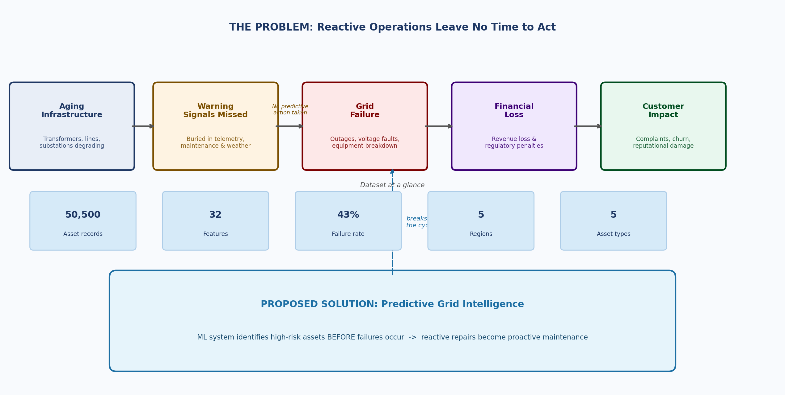
1.2 Problem Statement — Visualised
The diagram below maps the full business pain chain — from aging infrastructure through missed warning signals to grid failure and its downstream consequences:

1.3 Dataset Overview
The dataset provided contains 50,500 asset-level records across 32 attributes spanning six data domains:

Data Domain | Key Attributes | Business Significance
Equipment health | Health score, transformer temp, oil quality, vibration | Direct failure precursors
Operational telemetry | Load (MW), utilisation %, voltage fluctuation, frequency deviation | Real-time performance signals
Maintenance history | Overdue days, events (12m), inspection score, prior outages | Predictive maintenance indicators
Weather & environment | Temp, humidity, wind, rainfall, storm risk index | Climate-driven failure amplifiers
Business impact | Customers served, revenue loss estimate, regulatory penalty | Financial consequence quantification
Legacy / admin | legacy_asset_code, monitoring_batch_id, administrative_reference | To be excluded — no predictive value

1.4 Business & Analytical Objectives
Business Objective
Transition PowerGrid Utilities Corporation from reactive fault response to a proactive, predictive maintenance strategy that identifies high-risk assets and dangerous operating conditions before major service interruptions occur — reducing outages, cutting maintenance costs, and improving regulatory compliance.

Analytical Objectives
(1) Develop a binary classification model to predict grid failure (grid_failure_flag) for each asset with high recall to minimise missed failures. (2) Identify the most influential operational, health, and environmental drivers of failure using SHAP feature importance. (3) Generate asset-level risk-tier scores (High / Medium / Low) to prioritise maintenance interventions. (4) Quantify potential financial impact avoided through early, data-driven intervention.

2. Challenges & Constraints
Challenge | Description & Mitigation
Class imbalance | 43% failure vs 57% non-failure — will apply SMOTE oversampling and class-weight adjustments to prevent biased predictions toward the majority class.
Data quality & inconsistency | Inconsistent casing in asset_type field ("Transformer", "TRANSFORMER", "transformer") and presence of three uninformative legacy columns require normalisation and exclusion before modelling.
Feature collinearity | Equipment health score, oil quality, and transformer temperature are likely correlated — VIF analysis and feature selection techniques will manage multicollinearity.
Model interpretability | Utility operations staff require explainable outputs; black-box model results will be supplemented with SHAP summary plots and force plots for individual asset predictions.
Deployment feasibility | The model must score 50,000+ assets in near-real-time; lightweight gradient boosting models (LightGBM) will be prioritised for production-readiness.
Business adoption risk | Recommendations must be framed in financial and operational terms — revenue loss avoidance and maintenance cost savings — to facilitate executive decision-making.

3. Background Study / Literature Review
Predictive maintenance and grid reliability analytics have been extensively studied in both academic research and industry practice. The following review consolidates the most relevant methodologies and findings:

Technique | Source / Reference | Relevance to Project
XGBoost & LightGBM | Chen & Guestrin (2016); Ke et al. (2017) | Top performers on tabular utility data with non-linear interactions
SMOTE | Chawla et al. (2002) — JAIR | Handles 43% vs 57% class imbalance without data loss
SHAP Explainability | Lundberg & Lee (2017) — NeurIPS | Explains individual asset failure predictions for operators
Predictive maintenance in power grids | IEEE Transactions on Power Systems (multiple) | Benchmarks for asset failure prediction accuracy and ROI
Industry deployment | Duke Energy, Enel, National Grid case studies | 15–30% outage reduction; 10–20% maintenance cost savings
CIGRE / IEEE PES risk frameworks | CIGRE WG B3.06; IEEE Std 1584 | Composite risk indices combining age, health, and environment

Industry Benchmark
Utilities including Duke Energy, Enel (Italy), and National Grid (UK) have deployed ML-based predictive maintenance systems reporting 15–30% reduction in unplanned outages and 10–20% reduction in maintenance costs. These systems integrate SCADA telemetry, weather data, and maintenance records — directly mirroring the structure of the PowerGrid dataset provided for this project.

4. Proposed Methodology / Solution Approach
The project follows the CRISP-DM (Cross-Industry Standard Process for Data Mining) lifecycle, adapted for utility asset intelligence. The proposed solution workflow is illustrated in the two architecture diagrams below.
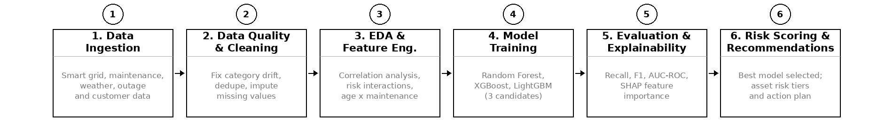

4.2 ML Pipeline
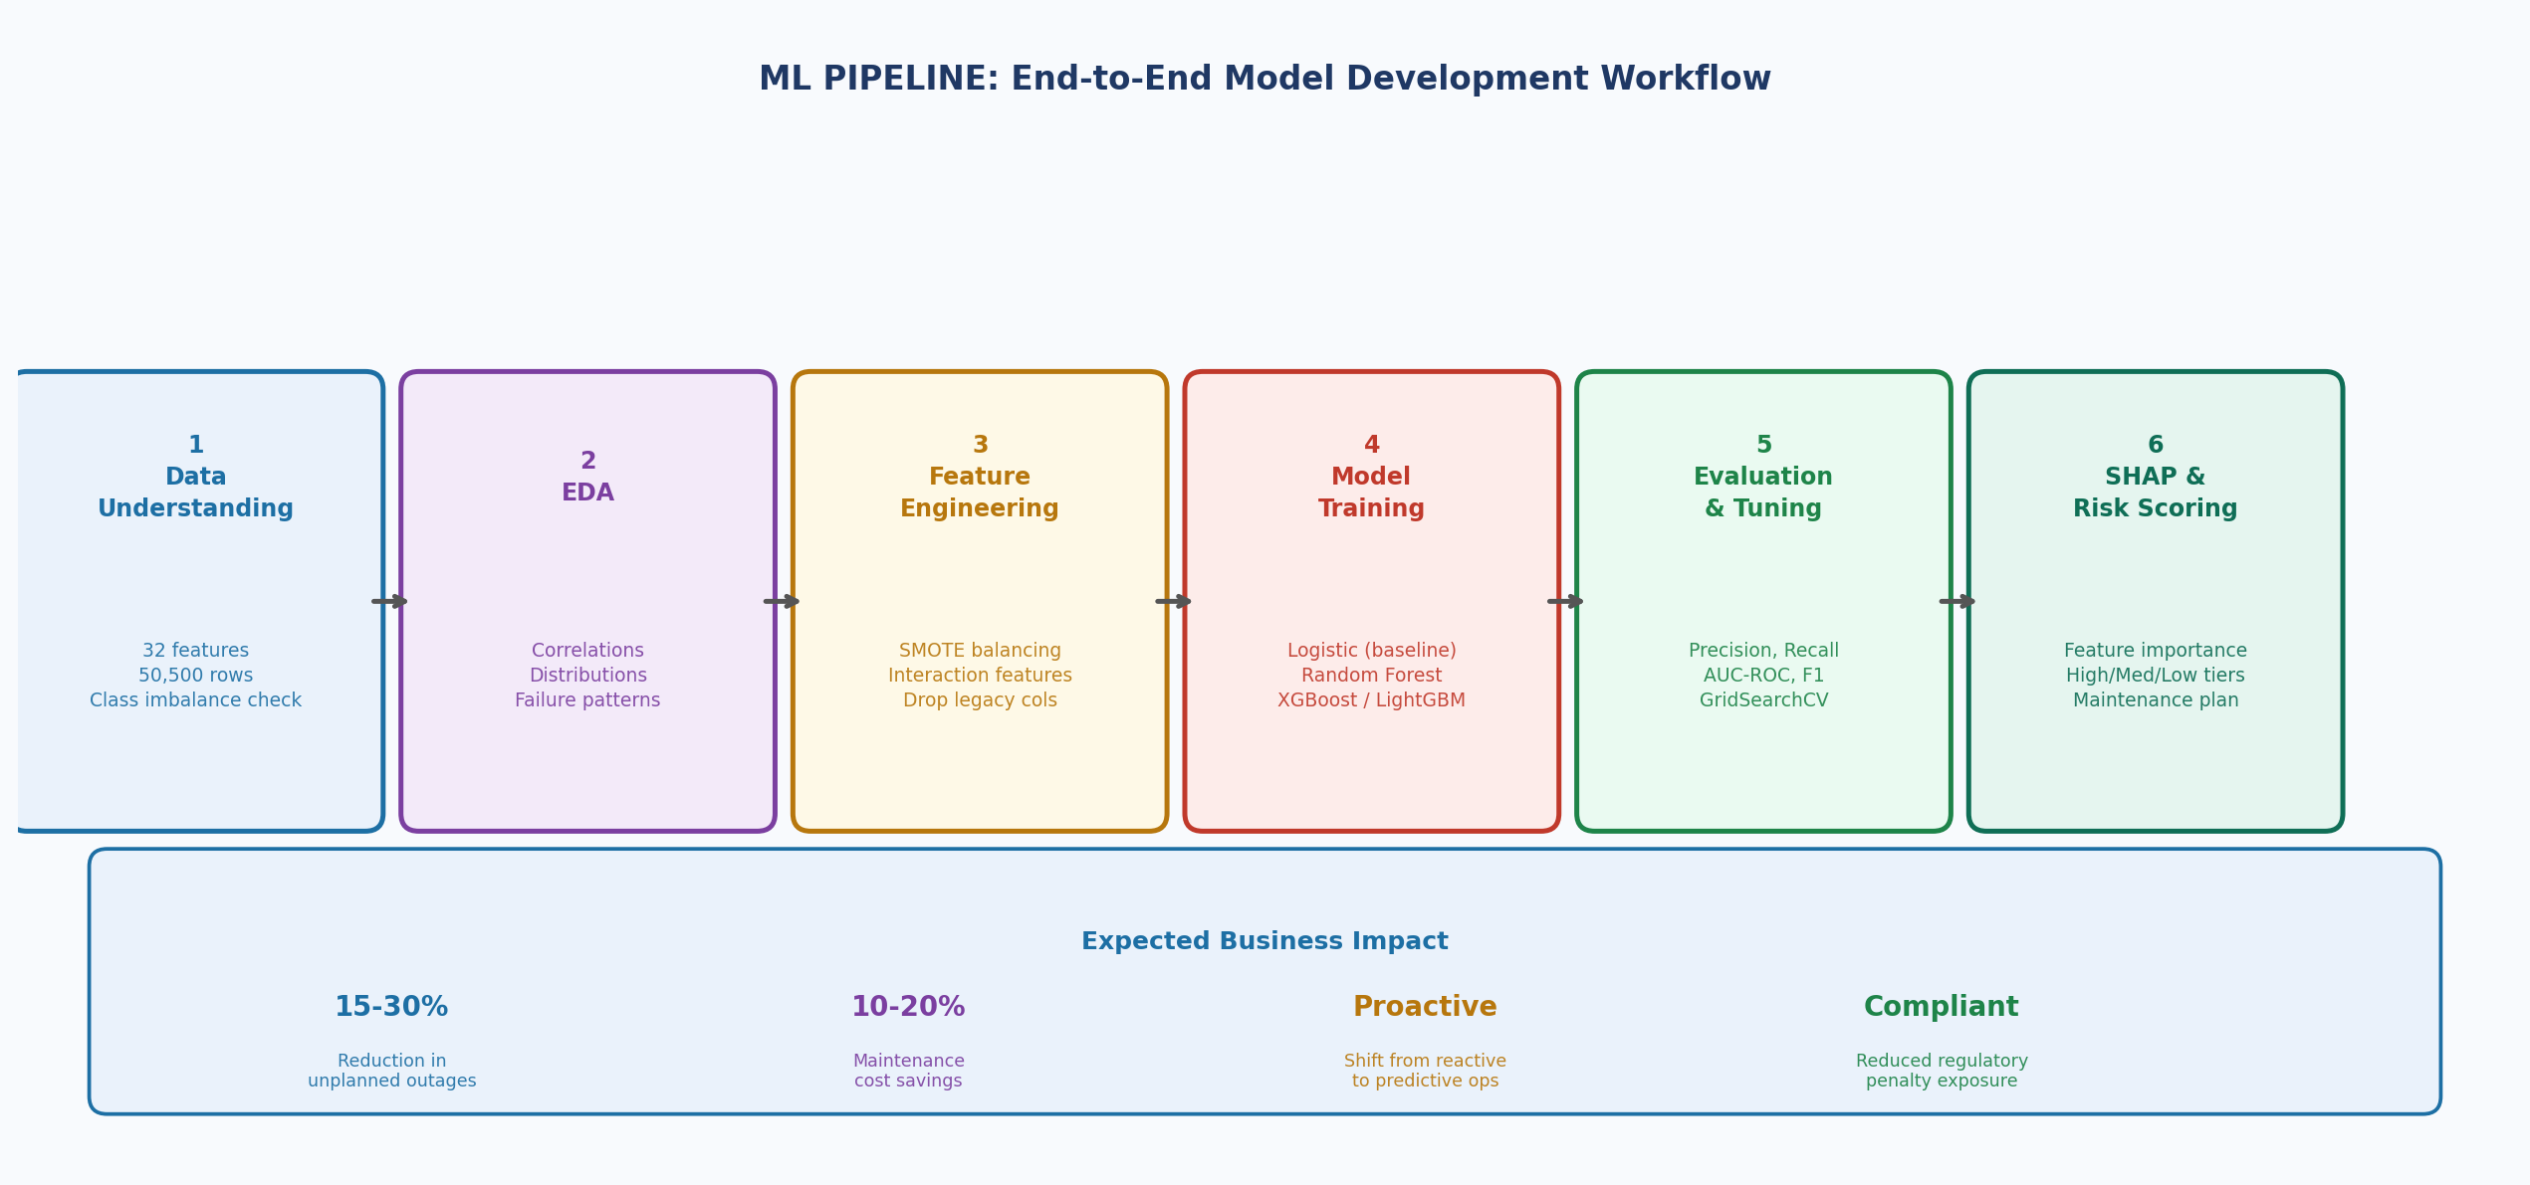

4.3 Methodology Details
Stage | Technique / Tool | Expected Output
Data Understanding | Pandas profiling, null analysis, distribution plots, class balance check | Quality assessment report
EDA | Correlation heatmaps, box plots, region-wise & asset-type failure rate charts | Insight summary & key patterns
Preprocessing | Missing value imputation, casing normalisation, drop irrelevant legacy columns | Clean dataset ready for modelling
Feature Engineering | SMOTE oversampling, label/one-hot encoding, StandardScaler, interaction features | Feature matrix (optimised)
Modelling | Logistic Regression, Random Forest, XGBoost, LightGBM; GridSearchCV/Optuna tuning | Best-performing classifier
Evaluation | Precision, Recall, F1, AUC-ROC, confusion matrix, SHAP summary & force plots | Model evaluation report
Risk Scoring | Probability threshold-based tier assignment (High/Medium/Low) per asset | Asset risk-tier ranking list
Deployment Plan | Model serialisation (pickle/ONNX), REST API sketch, dashboard wireframe | Deployment proposal

5. Proposed Project Timeline
Week | Phase / Activity | Key Milestone
1 | Business understanding, data profiling — explore all 32 columns, check data quality, missing values, class imbalance (43% failure vs 57% no-failure) | Dataset Profiling Report
2 | Exploratory Data Analysis (EDA) — univariate, bivariate, regional failure rates, correlation heatmaps, asset-type risk breakdown, weather impact analysis | EDA Notebook & Visualisations
3 | Feature engineering & preprocessing — fix inconsistent casing in asset_type, drop legacy cols (legacy_asset_code, monitoring_batch_id, administrative_reference), SMOTE balancing, encode categoricals, scale numerics, engineer interaction features (load × age, temperature × oil quality) | Cleaned & Engineered Dataset
4 | Model development — train Logistic Regression (baseline), Random Forest, XGBoost, LightGBM; cross-validation, hyperparameter tuning via GridSearchCV / Optuna | Trained ML Models
5 | Model evaluation & SHAP explainability — Precision, Recall, F1-Score, AUC-ROC, confusion matrices; SHAP feature importance; asset-level risk-tier scoring (High / Medium / Low) | Evaluation Report + Risk Dashboard
6 | Final report, business recommendations, presentation preparation, GitHub repository submission | All Final Deliverables

6. Expected Deliverables / Outputs
Deliverable | Description
Data Analysis Report | Dataset profiling, EDA findings, data quality issues, key statistical insights, and failure driver analysis
Feature Engineering Notebook | Preprocessing pipeline, SMOTE implementation, interaction features, and feature selection rationale
ML Models (4) | Trained and tuned classifiers — Logistic Regression, Random Forest, XGBoost, LightGBM — with comparative evaluation metrics
SHAP Interpretability Report | Global feature importance rankings + individual asset-level failure explanations for operational teams
Risk-Tier Scoring Output | Asset-level classification (High / Medium / Low) with ranked maintenance priority list and financial impact estimate
Business Recommendations Report | ROI-framed, actionable insights for maintenance scheduling, capital investment prioritisation, and outage risk mitigation
Risk Dashboard / Visualisation | Regional failure heatmap, asset health trends, risk-tier distribution, and top-10 high-risk assets
Final Technical Report | End-to-end documentation following standard data science reporting format with reproducible results
Final Presentation | Slides covering business problem, methodology, results, model performance, and recommendations
GitHub Repository | Structured repo with source code, Jupyter notebooks, README.md, and all supporting documentation

Definition of Success
This project succeeds not merely when a high-accuracy model is built, but when its outputs are interpretable, actionable, and presented in a way that enables PowerGrid operations and leadership teams to make faster, more confident, data-driven maintenance decisions — directly reducing outage frequency, financial loss, and regulatory risk.

Capstone Pre-Submission Document | PowerGrid Utility Intelligence | IITM–JARO Batch 02 | Prof. Babji Srinivasan

