PowerGrid Utility Intelligence: Predicting Grid Failures Before They Happen
Team Members (Domain 7): Vaibhav, Ravin, Ashok, Rajani
1. Business Problem Understanding and Objective Formulation
PowerGrid Utilities Corporation manages critical power infrastructure where equipment failures are becoming more frequent due to ageing assets, increasing demand, and changing weather conditions. Although maintenance, monitoring, and weather data contain early warning signals, failures are often addressed only after they occur. This project aims to predict potential failures in advance, enabling proactive maintenance and reducing outages, costs, and regulatory risks.
Power Transmission - From Generation to Home/Industry
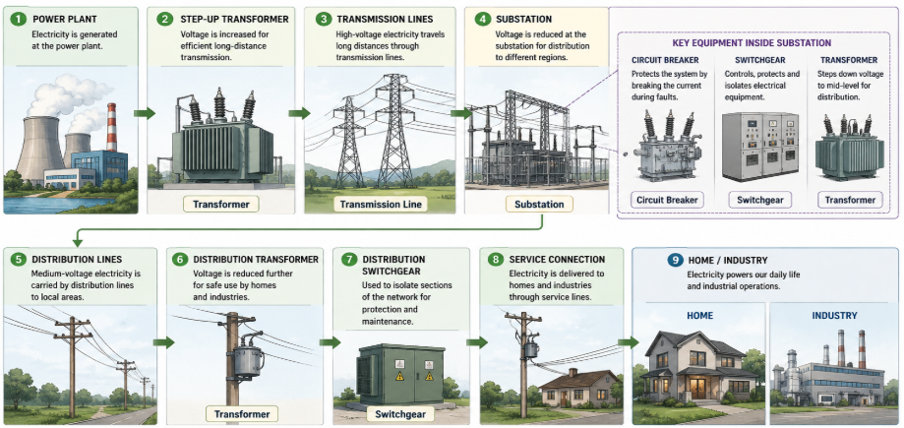
Dataset Overview (50,500 records | 32 features)
Data Domain | Key Features
Equipment Health | Health score, transformer temperature, oil quality, vibration
Operational | Load (MW), utilisation %, voltage fluctuation, frequency deviation
Maintenance | Overdue days, events last 12 months, inspection score, prior outages
Weather | Temperature, humidity, wind speed, rainfall, storm risk index
Business Impact | Customers served, estimated revenue loss, regulatory penalty cost
Business and Analytical Objectives
Business Objective: Reduce unplanned outages and financial exposure by proactively identifying high-risk grid assets for early intervention.
Analytical Objective: Build a classification model predicting grid_failure_flag using equipment health, maintenance, load, and weather features, and rank the key failure drivers to guide maintenance prioritisation.
To achieve this, the team will:
- Build a binary classifier focused on high Recall so that at-risk assets are not missed.
- Apply SHAP feature importance to identify which factors drive failures and give teams something actionable.
- Assign every asset a risk tier (High, Medium, Low) producing a clear, prioritised maintenance list.
- Estimate intervention value - industry benchmarks suggest 15-30% reduction in unplanned outages is achievable.
2. Challenges and Constraints
- Class imbalance: 43.0% failures versus 57.0% non-failures confirmed in the dataset. SMOTE oversampling and class-weight adjustments will be applied.
- Duplicate records: exactly 500 duplicate rows (~1%) confirmed and will be removed before any modelling.
- Missing values: oil_quality_score (10.0% missing) and inspection_score (10.1% missing) confirmed. Median imputation grouped by asset_type will be used.
- Data quality: asset_type has three casing variants of Transformer that Python treats as distinct categories - this will be normalised. Four administrative columns will be assessed and excluded if near-zero correlation is confirmed.
- Outliers: rainfall_mm (~1.4%), avg_outage_duration_minutes (~1.2%), and power_load_mw (~1.0%) confirmed from the dataset and will be treated before modelling.
- Feature collinearity: equipment health score, oil quality, and transformer temperature are likely correlated. VIF analysis will be run during feature engineering.
- False negative cost: a missed failure is far more costly than a false alarm, so Recall is the primary evaluation metric with threshold tuning applied at scoring time.
- Interpretability: SHAP summary and force plots will accompany all model outputs so predictions are transparent to operations staff.
3. Background Study / Literature Review
Predictive maintenance in power utility contexts is well-studied. Utilities such as Duke Energy, Enel, and National Grid have deployed ML-based systems integrating SCADA telemetry, weather data, and maintenance records - closely mirroring this dataset's structure. These deployments consistently report 15-30% reductions in unplanned outages and 10-20% reductions in maintenance costs. Condition-based monitoring literature confirms that sensor-derived health indices are stronger failure predictors than fixed maintenance schedules - consistent with findings from our preliminary data exploration.
Key Techniques and Literature
Technique | Source | Relevance
XGBoost | Chen and Guestrin (2016) | Top performer on tabular data; handles non-linear feature interactions
LightGBM | Ke et al. (2017) | Histogram-based gradient boosting; faster training and supports incremental retraining
Random Forest | Breiman (2001) | Robust ensemble baseline with built-in feature importance rankings
SMOTE | Chawla et al. (2002) | Addresses class imbalance without discarding failure examples
SHAP | Lundberg and Lee (2017) | Per-asset failure explanations that operations staff can act on
Industry Practice | Duke Energy, Enel,  National Grid | 15-30% outage reduction and 10-20% cost savings from comparable deployments
Other References | Indian Smart Grid  DSO-White-Paper.pdf | Domain Knowledge and current practices of AI/ML in Power utilities
From our preliminary data exploration, the table below shows the top feature correlates with grid_failure_flag, which directly informs our feature engineering decisions.
Top Feature Correlates with grid_failure_flag
Feature | Correlation | Direction
equipment_health_score | -0.293 | Lower score - higher failure risk
storm_risk_index | +0.259 | Higher storm risk - higher failure risk
maintenance_overdue_days | +0.195 | More overdue days - higher failure risk
inspection_score | -0.194 | Lower score - higher failure risk
voltage_fluctuation_pct | +0.189 | Higher fluctuation - higher failure risk
oil_quality_score | -0.182 | Poor oil quality - higher failure risk
4. Proposed Methodology / Solution Approach
The project follows the CRISP-DM lifecycle for utility asset intelligence. The approach centres on a compare-and-select evaluation across three candidate models rather than committing to one upfront. The pipeline is shown in Figure 1 below.
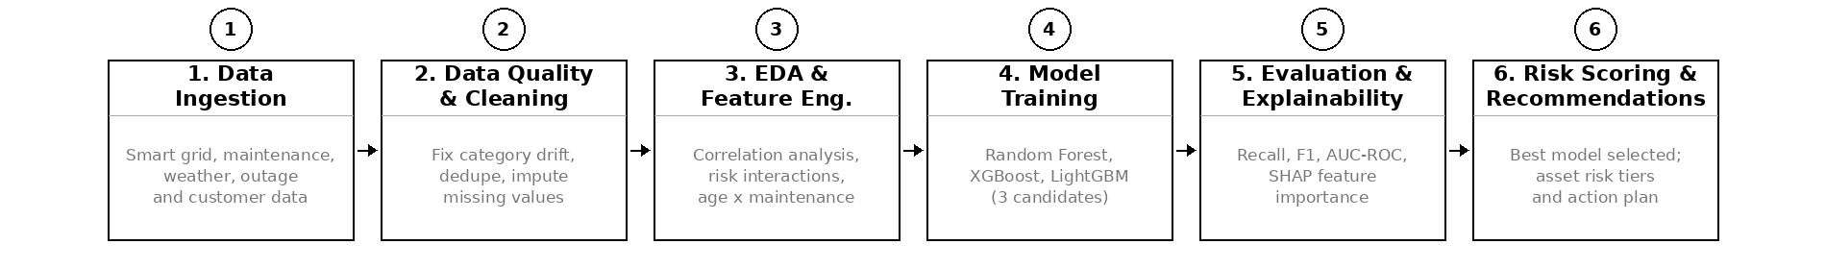
Figure 1: Model Evaluation Pipeline - best model selected based on evaluation metrics
Model Selection: We chose three candidate models for this problem. Logistic Regression was considered but dropped early - our preliminary EDA shows that no single feature has a correlation above 0.29 with the target, and the key signals interact with each other (health score combined with storm risk, load combined with age). A linear boundary cannot capture this, making Logistic Regression architecturally unsuitable.
Random Forest is included as a robust ensemble option that handles feature interactions well and gives us built-in feature importance. XGBoost is our primary candidate given its consistently strong performance on structured tabular data. We have also included LightGBM because at this stage we cannot fully determine how the model will be used in production - if PowerGrid wants to retrain on new data as assets age and outage records accumulate, LightGBM supports incremental learning that XGBoost does not. All three are tuned using cross-validation. The best performer on Recall and AUC-ROC is selected.
5. Proposed Project Timeline
Wk | Phase / Activity | Milestone
1 | Business understanding - confirm objectives, review data dictionary, validate dataset | Project Charter
2 | Data cleaning - fix casing, remove 500 duplicates, impute missing values, treat outliers | Clean Dataset
3 | Exploratory Data Analysis - univariate, bivariate, correlation heatmaps, regional breakdown | EDA Report
4 | Feature engineering - interaction features, composite risk scores, encoding, scaling | Engineered Feature Set
5-6 | Model development - train all three candidates, cross-validation, Optuna hyperparameter tuning | Trained Models
7 | Evaluation and SHAP explainability - compare models, select best, score all assets by risk tier | Evaluation Report
8 | Final report, business recommendations, risk dashboard, presentation and GitHub submission | All Deliverables
6. Expected Deliverables / Outputs
Deliverable | Description
Data Quality and EDA Report | Cleaning steps, statistical findings, visual insights, key failure driver analysis
Feature Engineering Notebook | Preprocessing pipeline, SMOTE, interaction features, feature selection rationale
Trained ML Models | All three candidates (RF, XGBoost, LightGBM) with evaluation metrics and artefacts
SHAP Interpretability Report | Global feature importance and asset-level failure explanations for the best model
Risk-Tier Scoring Output | Every asset ranked High, Medium, or Low with a prioritised maintenance list
Business Recommendations | Maintenance scheduling priorities, investment guidance, and outage risk reduction
Risk Dashboard | Regional heatmap, asset health trends, risk-tier distribution, top ten at-risk assets
Final Report and Presentation | Complete documentation with reproducible notebooks and structured GitHub repository

