Module 02

1. **What is software testing?**

* Software Testing is a process used to identify the correctness, completeness, and quality of developed computer software.

1. **What is Exploratory Testing?**

* Exploratory testing allows you to think outside the box and come up with use cases that might not be covered in test cases.

1. **What is a traceability matrix?**

* Traceability matrix is a table type document that is used in the development of software applications to trace requirements.

1. **What is Boundary value testing?**

* Boundary value is the process of testing between extreme ends or boundaries between partitions of the input values.

1. **What is Equivalence partitioning testing?**

* Equivalence partitioning is a method for testing software programs. In this technique the data fed into the software to be tested is divided into partitions of equal sizes. From each partition of data.

1. **What is Integration testing?**

* Integration testing is associated with the architectural design phase. Integration tests are performed to test the coexistence and communication of the internal modules within the system.

1. **What determines the level of risk?**

* As risk is determined by a combination of probability and severity the main area of the matrix reveals the risk levels.

1. **What is Alpha testing?**

* Type of testing a software product or system conducted at the developer's site. Usually it is performed by the end user.

1. **What is beta testing?**

* Final testing before releasing an application for commercial purpose. It is typically done by end-users or others.

1. **What is component testing?**

* Testing technique similar to unit testing but with a higher level of integration - testing is done in the context of the application instead of just directly testing a specific method. Can be performed by testing or development teams.

1. **What is functional system testing?**

* Functional system testing is a type of testing that seeks to establish whether each application feature works as per the software requirement.

1. **What is Non-Functional Testing?**

* Non-Functional testing assesses application priorities that aren’t critical to functionality but contribute to the end-user experience.

1. **What is GUI Testing?**

* Graphical user interface(GUI) testing refers to testing the functions of an application that are visible to the user.

1. **What is Adhoc testing?**

* Adhoc testing is a type of software testing which is performed informally and randomly after the formal testing is completed to find out any loophole in the system.

1. **What is white box testing and list the types of white box testing?**

* White box testing is an approach that allows testers to inspect and verify the inner workings of a software system-its code, infrastructure, and integrations with external systems.

**Types of White box testing :-**

1) Unit testing

* Execution Testing
* Operations Testing
* Mutation Testing

2) Integration testing

* Top-Down Approach
* Bottom Up Approach
* Hybrid Approach

1. **What is black box testing? What are the different black box testing techniques?**

* Black box testing assesses a system solely from the outside, without the operator or tester knowing what is happening within the system to generate responses to test actions.
* Black box testing can be applied to three main types of tests **Functional**, **Non-Functional**, **Regression Testing**.

1. **Mention what are the categories of defects?**

* The natural and severity of a defect determines which of the three categories.

1) Minor Defect

2) Major Defect

3) Critical Defect

1. **Mention what bigbang testing is?**

* Bigbang testing testing is an integration testing strategy wherein all units are linked at once, resulting in a complete system.

1. **What is the purpose of exit criteria?**

* Exit criteria used to determine whether a given test activity has been completed or not.

1. **When should "Regression Testing" be performed?**

* Whenever a new feature is developed, or when an existing feature is improved or if there are any UI updates made.

1. **What are 7 key principles? Explain in detail?**

* 7 key principles are as follows..

1) Testing shows presence of Defects :- Testing can show that defects are present, but cannot prove that there are no defects.

2) Exhaustive Testing is Impossible :- Testing everything including all combinations of inputs and preconditions is not possible.

3) Early Testing saves time and money :- Testing activities should start as early as possible in the development life cycle.

4) Defect Clustering Together :- Similarly, most operational failures of a system are usually confined to a small number of modules .

5) Beware of the pesticide paradox :- If the same tests are repeated over and over again, eventually the same set of test cases will no longer find any new defects.

6) Testing is context dependent :- Different kinds of sites are tested differently.

7) Absence of Errors Fallacy :- If the system built is unusable and does not fulfill the user’s needs and expectations then finding and fixing defects does not help.

1. **Difference between QA v/s QC v/s Tester.**

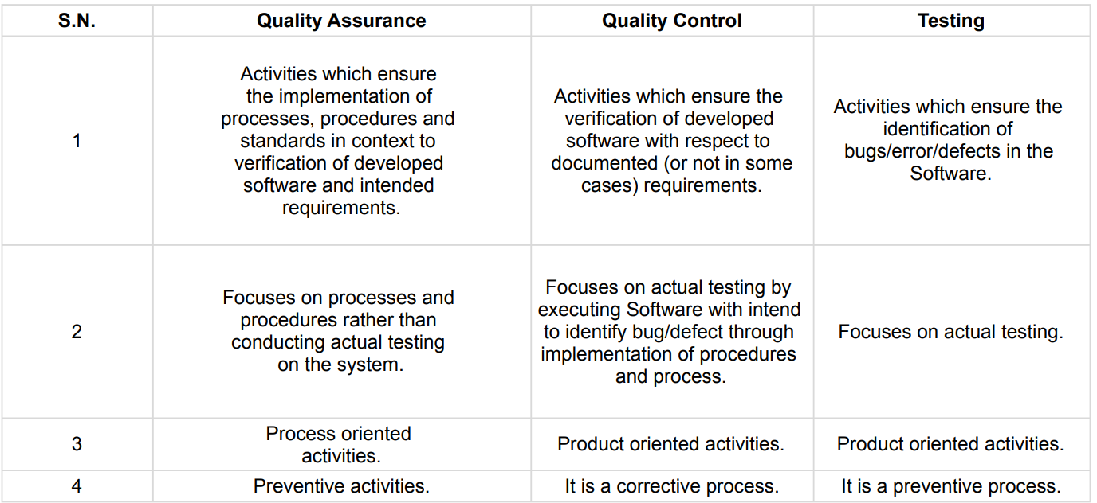

1. **Difference between Smoke and Sanity.**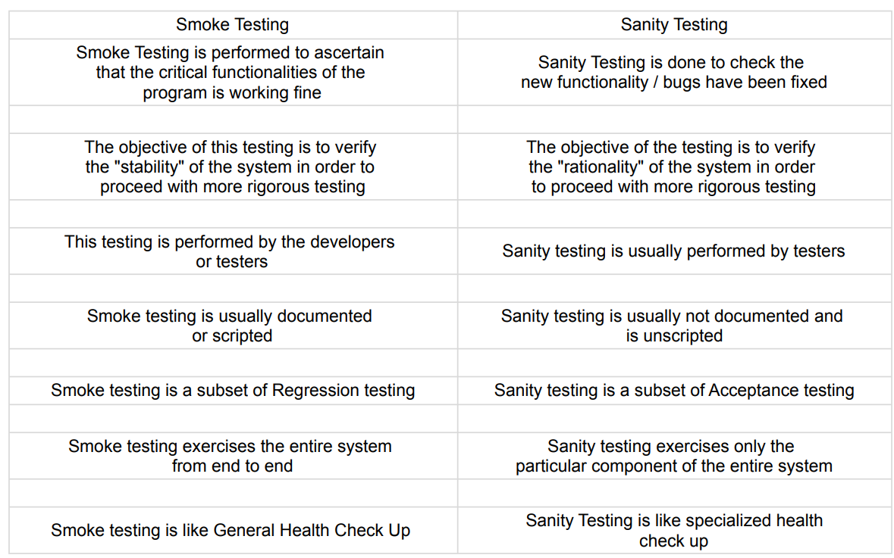
2. **Difference between verification and Validation**

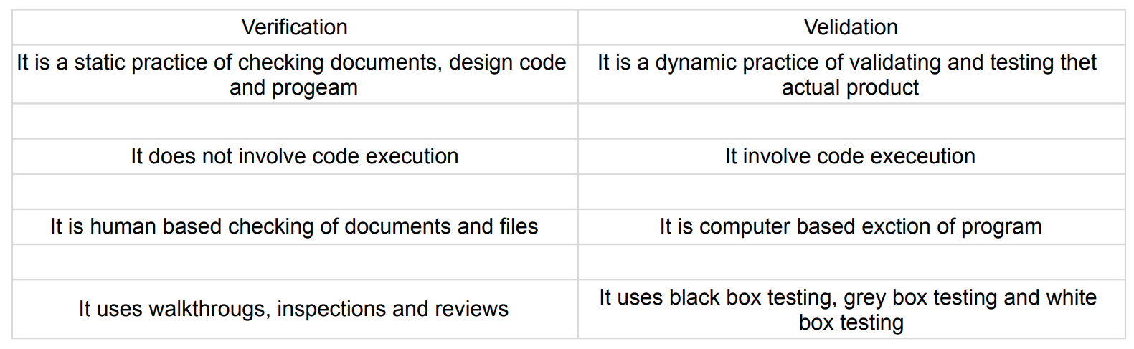

1. **Explain types of Performance testing.**

* Software performance testing is a means of quality assurance. It involves testing software applications to ensure they will perform well under their expected workload.

**Types of Performance Testing :-**

1> Load testing - It's performance testing to check system behavior under load.

2> Stress testing - Stress testing is to test the system behavior under extreme conditions and is carried out till the system failure.

3> Endurance testing - Type of testing which checks for memory leaks or other problems that may occur with prolonged execution.

4> Spike testing - Is a type of performance testing in which an application receives a sudden and extreme increase or decrease in load.

5> Volume testing - Testing which confirms that any values that may become large over time can be accommodated by the program and will not cause the program to stop working or degrade its operation in any manner.

6> Scalability testing - Part of the battery of non-functional tests which tests software.

1. **What is Error, Defect, Bug and failure?**

* A mistake in coding is called Error, error found by tester is called Defect, defect accepted by development team then it is called Bug, build does not meet the requirement then it called Failure.

1. **Difference between Priority and Severity.**

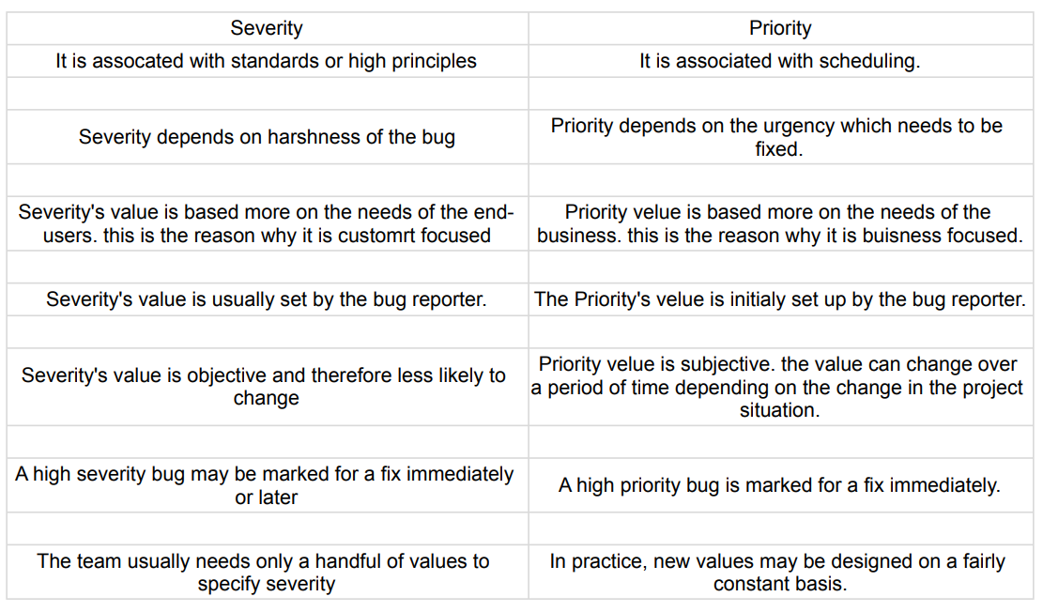

1. **What is the Bug Life Cycle?**

* Defect life cycle, also known as Bug life cycle is the journey of a defect cycle, which a defect goes through during its lifetime.
* It varies from organization to organization and also from project to project as it is governed by the software testing process and also depends upon the tools used.

1. **Explain the difference between Functional testing and Non-Functional testing.**

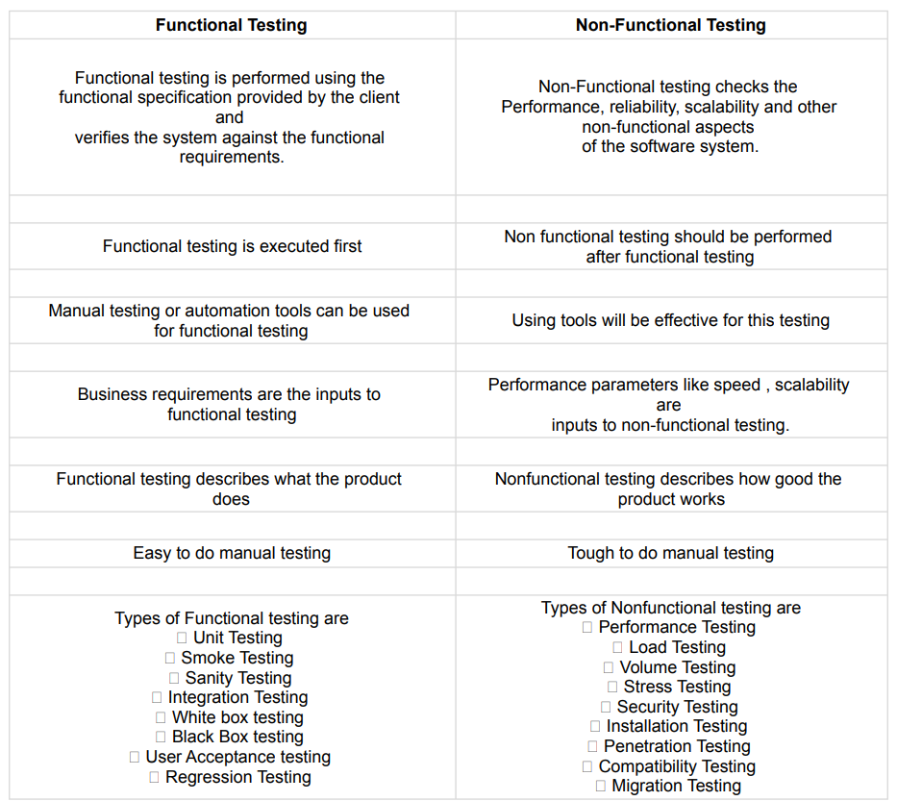

1. **What is the difference between the STLC (Software Testing Life Cycle) and SDLC (Software Development Life Cycle)?**

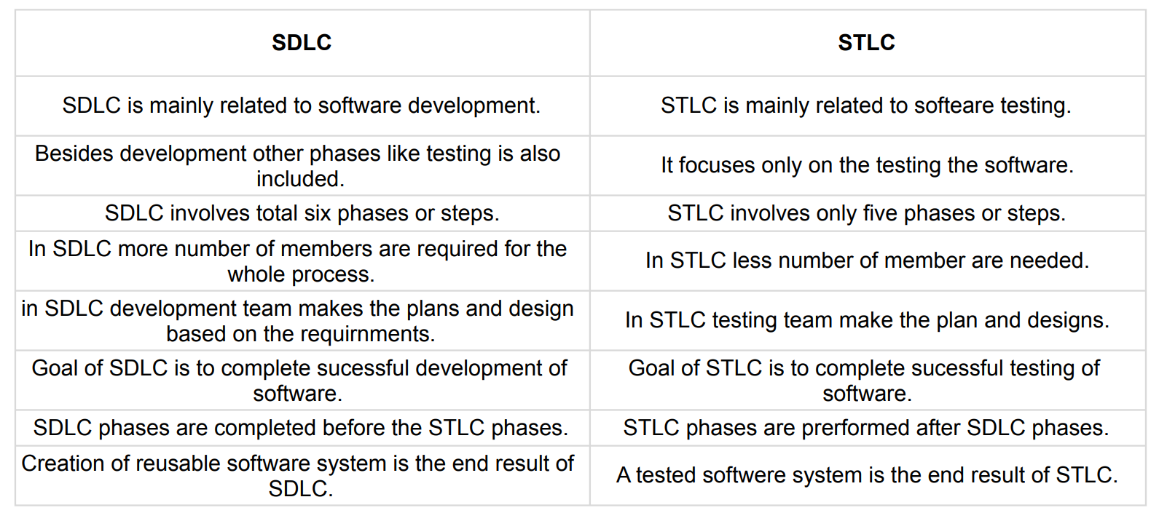

1. **What is the difference between test scenarios, test cases, and test scripts?**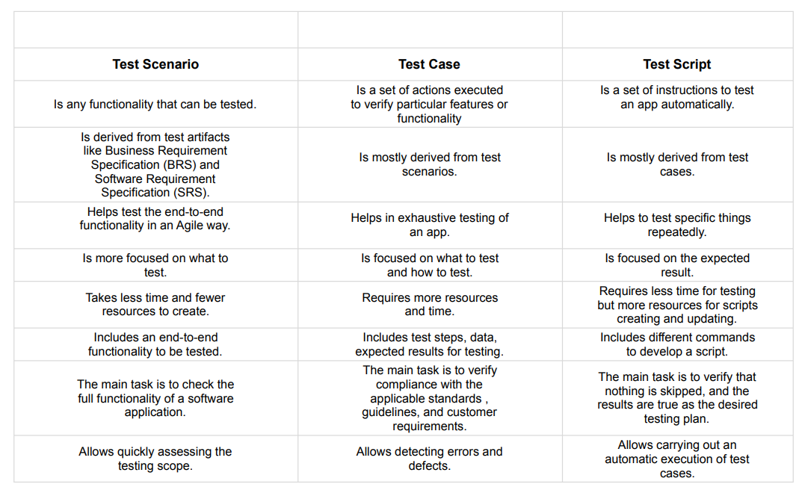
2. **Explain what Test Plan is? What is the information that should be covered?**

* A test plan refers to a detailed document that catalogs the test strategy, objectives, schedule, estimations, deadlines, and the resources required for completing that particular project.
* Think of it as a blueprint for running the tests needed to ensure the software is working properly-controlled by test managers.

1. **What are the different Methodologies in Agile Development Model?**

* Agile Methodology meaning a practice that promotes continuous iteration of development and testing throughout the software development life cycle of the project. In the Agile model in software testing, both development and testing activities are concurrent, unlike the Waterfall model.

Agile software development emphasizes four core values.

1) Individual and team interactions over processes and tools.

2) Working software over comprehensive documentation.

3) Customer collaboration over contract negotiation.

4) Responding to change over following a plan.

1. **Explain the difference between Authorization and Authentication in Web testing.**

* As mentioned, authentication and authorization may sound alike, but each plays a different role in securing systems and data. Unfortunately, people often use both terms interchangeably as they both refer to system access. However, they are distinct processes. Simply put, one verifies the identity of a user or service before granting them access, while the other determines what they can do once they have access.
* The best way to illustrate the differences between the two terms is with a simple example. Let's say you decide to go and visit a friend's home. On arrival, you knock on the door, and your friend opens it. She recognizes you (authentication) and greets you. As your friend has authenticated you, she is now comfortable letting you into her home. However, based on your relationship, there are certain things you can do and others you cannot (authorization). For example, you may enter the kitchen area, but you cannot go into her private office. In other words, you have the authorization to enter the kitchen, but access to her private office is prohibited

1. **What are the common problems faced in Web testing?**

* Generally in the Manual Testing scenario, developers go through the build to the test team assuming that the responsible test team or tester will pick the build and come to enquire what the build is about? This is the case in organizations that are not following so-called ‘Processes’.
* Tester is the middleman between developing a team and the customers, handling pressure from both sides. We assume most of our readers are smart enough to handle this pressure. Aren’t you?
* This is not always the case. Sometimes testers may add complications to a testing process due to their unskilled way of working.