**Module-1**

1. **What is SDLC ?**

**ANS:-** SDLC mesnd software development life cycle. Six phase of SDLC.

1. Requirement of customer
2. Analysis
3. Design
4. Implitation
5. Testing
6. Mantenance

**1)Requirement of customer :**

- all the customer requirement take documents are in written form.

-All requirments uselly in **naturale lenguage ,diagram and table**.

**2) Analysis :**

- analys of costomer requirement we eble to complet all the needs of customer.

**3)Design:**

- Designer design as per required for customer requirements.

**4) Implitation:**

- developer coding as per required.

**5)Testing**

- Tester testing the web/app. By manual or automation.

**6)Mantanance**

-Software maintenance is one of the activities in software engineering, and is the process of enhancing and optimizing deployed software (software release), as well as fixing defects.

1. **What is agile methodology?**

**ANS:-**

* Agile SDLC model is a combination of iterative and incremental process models with focus on process adaptability and customer satisfaction by rapid delivery of working software product.
* **Individuals and interactions -** in agile development, self-organization and motivation are important, as are interactions like co-location and pair programming.
* **Working software -** Demo working software is considered the best means of communication with the customer to understand their requirement, instead of just depending on documentation.
* **Customer collaboration -** As the requirements cannot be gathered completely in the beginning of the project due to various factors, continuous customer interaction is very important to get proper product requirements..
* **Responding to change -** agile development is focused on quick responses to change and continuous development.

**Prons:-**

* Is a very realistic approach to software development.
* Promotes teamwork and cross training.
* Functionality can be developed rapidly and demonstrated.
* Resource requirements are minimum.
* Suitable for fixed or changing requirements.
* Good model for environments that change steadily.
* Easy to manage.
* Littele or no plnning required.

**Cons:-**

* Not suitable for handling complex dependencies
* More risk of sustainability, maintainability and extensibility.
* An overall plan, an agile leader and agile PM practice is a must without which it will not work.
* There is very high individual dependency, since there is minimum documentation genera

1. **What is SRS ?**

**ANS:-**

* A software requirements specification (SRS) is a complete description of the behavior of the system to be developed
* There are three types of requirement

1. Customer requirement
2. Functional requirement
3. Non-functional reuirement
4. **What is oops ?**

**ANS:-**

* OOP means objects oriented programming
* Identifying objects and assigning **responsibilities** to these objects.
* Objects communicate to other objects by sending **messages**.
* Messages are received by the methods of an object
* An object is like black box
* The internal details are hidden
* Object is derived from abstract data type
* Object orient programming has web of interacting objects, each hoise keeping its own state
* Object of program interact by sending massages each other

1. **Write Basic Concepts of oops ?**

**ANS:-**

* **Concept of oops**

1) Object

2) Class

3) Encapsulation

4) Inheritance

5) Polymorphism

6) Overriding

7) Overloading

8) Abstraction

1. **What is object ?**

**ANS:-**

* This is the basic unit of object oriented programming (OOP).
* An object represents an individual, identifiable item, unit, or entity, either real or abstract, with a well-defined role in the problem domain.
* An "object" is anything to which a concept applies.
* That is both data and function that operate on data are bundled as a unit called as object.

1. **What is class ?**

**ANS:-**

* When you define a class, you define a blueprint for an object.
* This doesn't actually define any data, but it does define what the class name means, that is, what an object of the class will consist of and what operations can be performed on such an object.
* A class represents an abstraction of the object and abstracts the properties and behavior of that object
* Class can be considered as the blueprint or definition or a template for an object and describes the properties and behavior of that object, but without any actual existence.
* **An object is a particular instance of a class** which has actual existence and there can be many objects (or instances) for a class.
* In the case of a car or laptop, there will be a blueprint or design created first and then the actual car or laptop will be built based on that. We do not actually buy these blueprints but the actual objects.

1. **What is encapsulation ?**

**ANS:-**

* **Encapsulation is the practice of including in an object everything it needs hidden from other objects. The internal state is usually not accessible by other objects.**
* **Encapsulation** in Java is the process of wrapping up of data (properties) and behavior (methods) of an object into a single unit; and the unit here is a Class (or interface).
* Encapsulation enables data hiding, hiding irrelevant information from the users of a class and exposing only the relevant details required by the user.
* We can expose our operations hiding the details of what is needed to perform that operation.

1. **What is inheritance?**

**ANS:-**

* **Inheritance means that one class inherits the characteristics of another class. This is also called a “is a” relationship**
* One of the most useful aspects of object-oriented programming is code reusability. As the name suggests Inheritance is the process of forming a new class from an existing class that is from
* the existing class called as base class, new class is formed called as derived class.

1. **What is polymorphism?**

**ANS:-**

* **Polymorphism means “having many forms”.**
* **It allows different objects to respond to the same message in different ways, the response specific to the type of the object.**
* The most important aspect of an object is its **behaviour**. A behavior is initiated by **sending a message** to the object
* The ability to use an operator or function in different ways in other words giving different meaning or functions to the operators or functions is called polymorphism.

1. **What is RDBMS ?**

**ANS:-**

* RDBMS stands for Relational Database Management System.
* RDBMS is the basis for SQL, and for all modern database systems like MS SQL Server, IBM DB2, Oracle, MySQL, and Microsoft Access.

1. **What is SQL ?**

**ANS:-**

* SQL stands for Structured Query Language.
* SQL is used to communicate with a database.
* According to ANSI (American National Standards Institute), it is the standard language for relational database management systems.
* SQL statements are used to perform tasks such as update data on a database, or retrieve data from a database.
* Some common relational database management systems that use SQL are: Oracle, Sybase, Microsoft SQL Server, Access, Ingres, etc.

1. **Write SQL Commands ?**

**ANS :-**

* DDL – Data Definition Language
* DML – Data Manipulation Language
* DCL – Data Control Language
* DQL – Data Query Language SQL

1. **Draw Usecase on Online book shopping.**

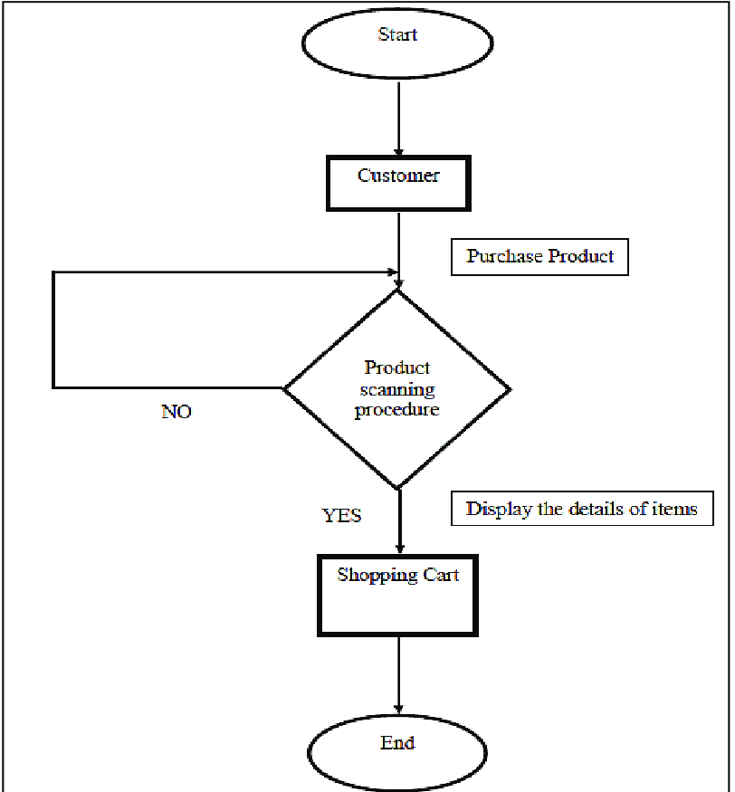

1. **Draw Usecase on online bill payment system (paytm)**

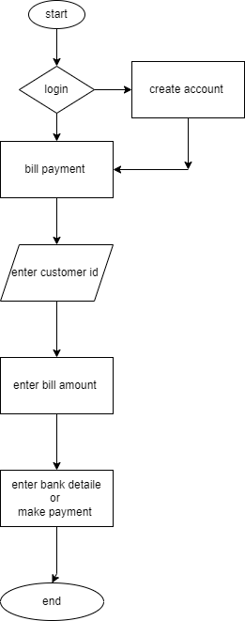

1. **Write SDLC phases with basic introduction**

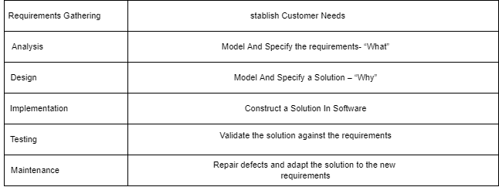

1. **Explain Phases of the waterfall model**

* Waterfall model has six phase

1. requirment : getting customer requirment

2.analysis: analysis of what is customer requirment?

3. design : specify solution why ?

4. implemetation : specify solution in software

5. testing : testing software against actule result and expected result are same or not

6.repair defect and adpat new requirment

1. **Write phases of spiral model**
2. Planning : Determination of objectives, alternatives and constraints.
3. Risk Analysis : Analysis of alternatives and identification/resolution of risks.
4. Engineering : Development of the ‘Next Level’ products.
5. Customer Evalutional : Assessment of the result of engineering.
6. **Write agile manifesto principles**

* **Individuals and interactions** :-  in agile development, self-organization and motivation are important, as are interactions like co-location and pair programming.
* **Working software** :-  Demo working software is considered the best means of communication with the customer to understand their requirement, instead of just depending on documentation.
* **Customer collaboration** :- As the requirements cannot be gathered completely in the beginning of the project.
* **Responding to change** - agile development is focused on quick responses to change and continuous development.

1. **What is join?**

join is use for fatch two table base on condition

**four type of join**

**1 lest join**

**2 right join**

**3 inner join**

**4 outer join**

1. **Explain working methodology of agile model and also write pros and cons.**

**pros**

* Is a very realistic approach to software development
* Promotes teamwork and cross training.
* Functionality can be developed rapidly and demonstrated.
* Resource requirements are minimum.
* Suitable for fixed or changing requirements
* Delivers early partial working solutions.

**cons**

* Not suitable for handling complex dependencies.
* More risk of sustainability, maintainability and extensibility.
* An overall plan, an agile leader and agile PM practice is a must without which it will not
* work. Strict delivery management dictates the scope, functionality to be delivered, and adjustments
* to meet the deadlines. Depends heavily on customer interaction, so if customer is not clear, team can be driven in
* the wrong direction. There is very high individual dependency, since there is minimum documentation generated