**I2C- Inter Integrated Circuit**

I2C is a Two Wire Interface

Preferred only for communication in a Short Distances

SCL-Serial Clock

SDA-Serial Data

I2C also known as TWI or twi or Two Wire Interface

Any devices can be a master or slave

Any devices can transmit or receieve data

4 Modes of operation:

1.Master Transmitter

2.Master Receiever

3.Slave Transmitter

4.Slave Receiever

**Data format:**

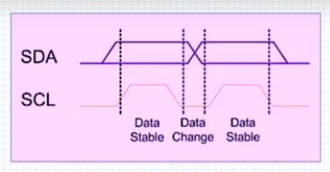

**Start and Stop condition:**

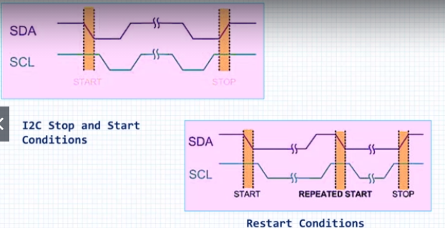

1. When Master made the BUS to Start, no other master tries to control the BUS until there is a STOP condition

2. The master can restart the process using REPEATED START condition

**9-Bit data format**

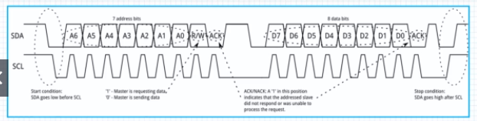

All data in I2C has 9bit

1. 7 bit data + R/W + ACK by the receiever

2. 8bit data + ACK by the reveiever

**ACK**

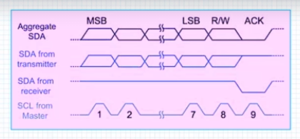

1. During the 9th clock or 9th BIT clock, the transmitter gives the SDA line control to receiever
2. If its a positive ACK then the receiever pulls the SDA line to GND
3. If its a negative ACK then the receiever doesn't pulls the SDA line to GND