What is unix?

Unix is a multi-user operating system which allows more than one person to use the computer resources at a time

|  |  |
| --- | --- |
| **pwd** | This command is used to show the current working directory. For example, ***/home/foobar*** |

To create new directory use "mkdir" command. For example, to create directory TMP in the current directory issue either "mkdir TMP" or "mkdir ./TMP". It's a good practice to organize files by creating directories and putting files inside of them instead of having all files in one directory.

**ls** is a Linux shell command that lists directory contents of files and directories.  It provides valuable information about files, directories, and their attributes.

The cd command, also known as chdir (change directory), is a command-line shell command used to change the current working directory in various operating systems. It can be used in shell scripts and batch files.

Cd ..:- command will bring us to the parent directory of the current working directory.

Cd ~:- to go to home directory

Rename dir:- by using mv name/ changedname

To remove directory:-

Rmdir dirname/

cp -r Option 'r' with the copy command can be used to copy a directory including all its content from a source directory to the destination directory.

cat command is a utility command in Linux. One of its most common usages is to print the content of a file onto the standard output stream

Word count in a file:-

Wc filename,txt

Rename a file:-

Mv xyz.txt we.txt

Copy a file to folder:-

To delete a file :-

Rm filename.txt

To list all the hiddn files :-

Ls -a

To del folder along with files:-

Rm -rf foldername/

To copy one folder into another folder:-

Cp -r foldername/ pathtocopythisfile

To save a file:-

Press esc and then :wq!

If we want to imsert text into file :-

Press i

And then enter esc and then add :wq! To save that data into a file

If we write something and don’t want to save:-

Press esc and then write this :q! it will close without saving anything

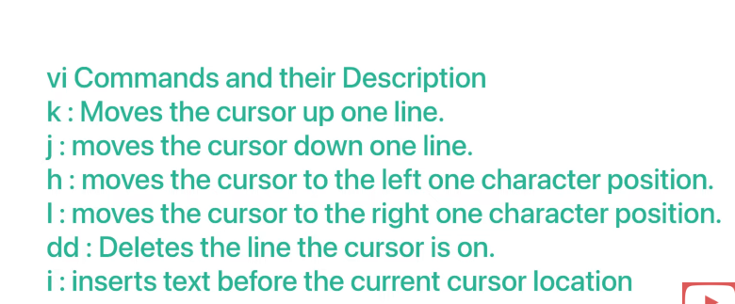

**Modes of VI Editor in Unix**

* Command Mode:- where we start a file using vi command
* Insert Mode: we can put I and insert data into a file
* Escape Mode:-using esc and :wq! To save a file

Using esc and :q! not save a file and close

3 Different types of permissions:-

1.Owner permissions

2.Group permisssions

3.Other(world)pe 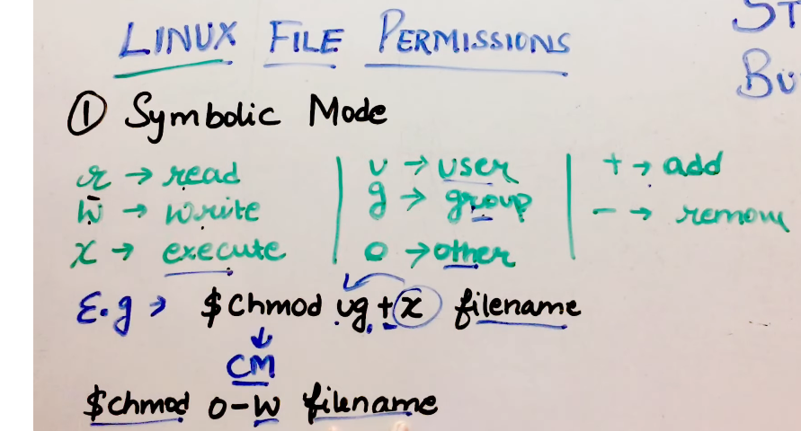

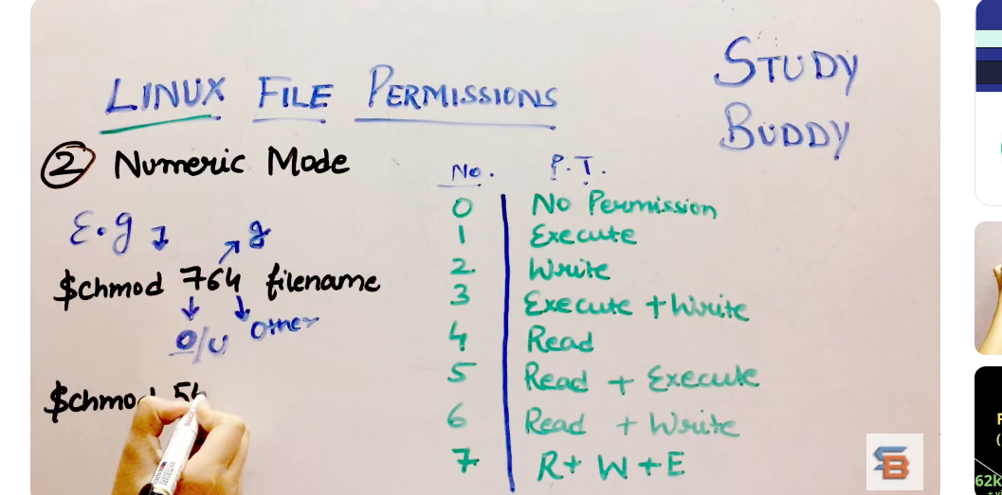

Permisssions.

grep command Grep command in Unix/Linux is the short form of 'global search for the regular expression'. The grep command is a filter that is used to search for lines matching a specified pattern and print the matching lines to standard output. The pattern is specified as a regular expression.

Pipe command (|):-

Output of one program is input to net program.

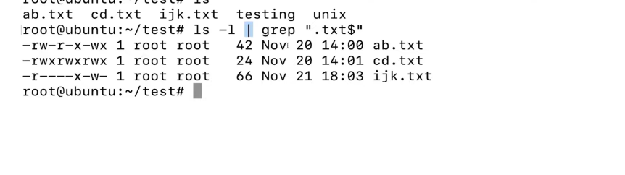

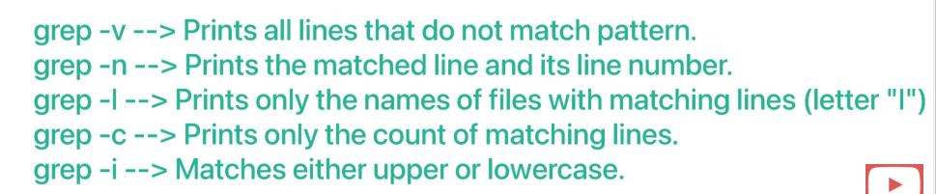

1. **The types of processes we see in the process table are:**

* **Foreground Processes:**These processes are user dependent. If the foreground processes are run from the terminal, the shell prompt remains unavailable and will be available only when the foreground process is terminated or stopped.
* **Background Processes**: These processes are usually run independently from the user. If a background process is started from a terminal by the user, the shell prompt remains available. One must append **&** a symbol after the process name in the terminal to start it in the background.

1. **Foreground Processes**

* When we start a foreground process from the terminal, the shell prompt is unavailable to the user.
* To get back the shell prompt, press Ctrl+Z which sends a STOP [signal](https://www.geeksforgeeks.org/shell-scripting-how-to-send-signal-to-a-processes/) to the process.
* The process stops and the shell prompt is now available to execute the commands to view the PID of that foreground process.

1. **Background Processes**

* Some background processes are started in the shell by the user while some of them are by the kernel without any user intervention.
* To start a background process from the terminal, write the process name(if its [address](https://www.geeksforgeeks.org/absolute-relative-pathnames-unix/) is not stored in the PATH [variable](https://www.geeksforgeeks.org/environment-variables-in-linux-unix/), then you have to give its full absolute or relative address) and append the **&** symbol at the end

Ps -ef command:-

ps -ef is a command that displays information about running processes on the system

if we want to stop something in ackgroup use kill command :-

kill -9 pid;

Network communication utilities:-

ftp utility:-

to send file from one computer to another computer 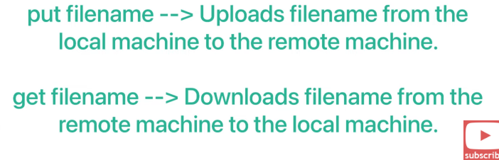

Telnet utility:-

The telnet command in Linux is used to communicate with another host using the Telnet protocol

the **telnet** command is used to create a remote connection with a system over a TCP/IP network

