FORWARD DEPLOYED AI ENGINEERING
Indian Institute of Technology Roorkee · Capstone Project
Finding the Answer That Already Exists
An AI-assisted support system for CloudServe Solutions
Rajarajan Venkatesan
18 September 2026
github.com/Rajarajan1087/CapStone_IIT

Evidence base. Every figure in this report comes from a single unattended run over 580 labelled tickets on 14 September 2026, reported automatically by evaluation/harness.py into evaluation/results/gate/metrics_report.json. No number here was counted by hand or transcribed from a partial run. Where a figure is an estimate or a client-stated value rather than a measurement, the text says so.

Declaration of AI tool use
This declaration is placed before the report rather than in an appendix, because the honest answer to how the work was produced ought not to require searching for it.

Where AI was used | How | What I did with the output
Discovery analysis | Wrote the Python scripts that cross-tabulated the 580 labelled tickets — answerability against intent, resolution time against segment, effort share against volume share. | I specified each question to be answered and read every figure back against the raw data. The finding that feature_request tickets are never answerable from documentation, which redirected the architecture, was mine to notice in the output.
Requirements and document drafting | Assisted in drafting prose for the five stage workbooks, this report and the governance framework. | Every requirement, trade-off, threshold and risk owner is my decision. The drafting assistance shortened the writing, not the thinking. I edited throughout and am accountable for every claim.
Application code | Substantial portions of src/, tests/ and evaluation/ were written with AI assistance, in an iterative loop: I specified behaviour, reviewed the implementation, ran it against the data and corrected it. | I read, ran and debugged all of it. The architecture — intent-based answerability, four ordered routing gates, deterministic-first guardrails, the circuit breaker, the kill switch — came from measurements I took and decisions I made, several of them reversing an earlier AI-suggested design.
Prompts in prompts/ | Drafted with assistance, then rewritten by hand after testing against real tickets. | Each is versioned and each records what it was tested against.
Evaluation figures and their interpretation | The harness computes them; none were produced by a language model. | Every interpretation, including the three fairness findings I could have omitted, is mine.

No model wrote a section of this report that I did not read, verify against the data and take responsibility for. The system described here was itself evaluated with no model provider reachable, so none of the results reported in Section 7 were produced by a language model at all — they come from the deterministic path, which is discussed honestly as both a limitation and, unexpectedly, a finding.

Contents

 | Section | Page range
1 | Executive summary | 4
2 | The problem | 5 to 6
3 | Discovery findings | 7 to 8
4 | Requirements | 9 to 10
5 | Architecture and design | 11 to 13
6 | Implementation | 14 to 15
7 | Evaluation | 16 to 18
8 | Governance and risk | 19 to 21
9 | The requirements revision | 22 to 23
10 | Conclusions | 24 to 25
A | Appendix A — Full metrics report | 26
B | Appendix B — Per-class classification results | 27
C | Appendix C — Prompt register | 28
D | Appendix D — Acceptance criteria evidence | 29
E | Appendix E — Repository map | 30

Figures and tables
Figure or table | Subject | Where
Figure 1 | The processing pipeline and its escalation path | 5.0, page 11
Figure 2 | The routing funnel across 580 tickets | 7.3, page 17
Figure 3 | Outcomes against the CloudServe baseline | 7.2, page 17
Figure 4 | Automated answer rate by customer segment | 8.3, page 20
Figure 5 | Share of ticket volume against share of handling time | 2.4, page 6
Table 1 | Headline results from the gate run of 14 September 2026 | 7.2, page 16

1 Executive summary
CloudServe Solutions asked for a chatbot to answer their support tickets. Their support team of six handles more than five hundred tickets a week against a two-hour response commitment they meet in eight to twelve hours, and fifty-six per cent of everything that arrives is escalated to a senior engineer.
The discovery work says they do not need a chatbot. Seventy point seven per cent of their tickets already have an adequate answer written down in their own twenty-nine reviewed help articles, and 47.5% of the tickets their agents escalated to tier two were in that answerable group. The bottleneck is not a shortage of knowledge. It is that an agent cannot find the right passage quickly enough, or cannot trust it enough to act, at the moment a ticket first arrives. A conversational interface addresses neither.
What was built instead is a six-stage pipeline that ingests tickets from four channels, classifies intent with a numeric confidence, retrieves ranked passages from the reviewed corpus, routes through four safety gates in a fixed order, generates an answer that must cite a retrieved passage or decline, and validates every outbound reply against five deterministic guardrails before release. Every decision at every stage is written to an auditable log with the reason in plain language, the threshold actually applied, and the prompt version responsible.
Measured over 580 tickets in one unattended run: first contact resolution rose from a 44.1% baseline to 47.6%, escalation fell from 55.9% to 36.4%, classification accuracy was 80.7%, citation accuracy 92.7%, and zero of the 101 tickets flagged as never-to-be-automated received an automated answer. The run completed in 2.7 seconds with no processing errors, and 2,490 logged decisions reconciled exactly against the tickets processed.

The single most important caveat. The model provider was unreachable throughout the evaluation, so every figure above was produced by the system's deterministic fallback path — a keyword classifier, TF-IDF retrieval and an extractive generator that quotes reviewed articles verbatim. The AI-assisted path is built, unit-tested and switchable by one line of configuration, but it has never run against a live provider. The results are therefore a floor rather than a ceiling, and the report is explicit about this throughout rather than presenting the deterministic figures as if they were the intended system's performance.
Three fairness gaps were found and are reported rather than smoothed away: a 10.8 point regional difference in automated answer rate, an 8.2 point tier difference in the opposite direction to the historical pattern, and a threefold difference in guardrail block rate between fluent and non-fluent English tickets. None was designed in. Section 8 states what each probably is and what would be needed to resolve it.

2 The problem

2.1 What was asked for
CloudServe Solutions is a mid-sized cloud infrastructure company. The request, as stated, was for an AI chatbot that could answer customer support tickets automatically, to reduce first-response time without adding headcount. The framing carried an implicit theory of the problem: that the support queue is slow because too much of it requires a human, and that a sufficiently capable conversational model could absorb the difference.
The five stakeholder interviews and the 580-ticket historical sample were read as a test of that theory rather than as a specification to implement. They did not support it.

2.2 What discovery revealed
Three measurements changed the shape of the project. The first is that 70.7% of tickets in the sample carry answerable_from_docs = true: an adequate answer already exists in the twenty-nine reviewed articles. The second is that of 324 historically escalated tickets, 154 — 47.5% — were in that answerable group. Nearly half of what reached a senior engineer was something the documentation could already have resolved. The third is the gap in handling time: doc-answerable tickets resolved at first contact take a median of 46.5 minutes, against 763.5 minutes for genuinely non-answerable ones, a factor of more than fifteen that has nothing to do with the quality of the articles.
The interviews had already contained this finding in unresolved form. Sofia Restrepo, a tier-one agent, said roughly seventy per cent of her tickets are ones she has answered before, that the documentation is fine, and that the problem is finding things in it — which is why she and at least one colleague maintain personal, unreviewed answer files. Ines Varga, the technical writer, believed support did not use her articles and had been told secondhand that the documentation itself was the complaint. The two had never reconciled a disagreement that the data settles unambiguously in Sofia's favour: the corpus is adequate and search is not.
Daniel Okonkwo, the tier-two engineer, said about half of what reaches him could have been resolved at tier one with more confidence or better findability. Marcus Adeyemi, the head of support, described escalations as the residue of genuinely hard problems. The 47.5% figure says Daniel is right and Marcus cannot see it, because he watches the escalation rate and not its composition. This is a routing and confidence failure presented as a difficulty problem.

2.3 The gap between the two
A chatbot implies that the agent's judgement is the thing to replace. The evidence says the agent's judgement is sound and what is missing is fast, trustworthy, attributable access to an answer that already exists — plus a mechanism that can safely automate the subset of those cases where confidence is genuinely high, and that reliably refuses everywhere else.
That reframing has consequences the original request does not. It makes retrieval and routing the core of the system rather than generation. It makes the ability to say nothing a first-class outcome rather than a failure. It makes source attribution a requirement rather than a nicety — Ines asked for it specifically, so that a wrong answer can be traced to a wrong article or to a misread one, which need fixing in different places. And it makes the escalation path a designed product surface rather than a fallback, because Daniel's stated frustration is not the volume he receives but that it arrives as a bare forward with no summary of what was already tried.

2.4 Where the effort actually goes
Effort does not follow volume. Summing resolution time by intent and comparing each category's share of handling time against its share of tickets shows that the expensive categories are the ones that are either mandatory to escalate, undocumented by design, or genuinely diagnostic — not the high-volume, well-documented ones.
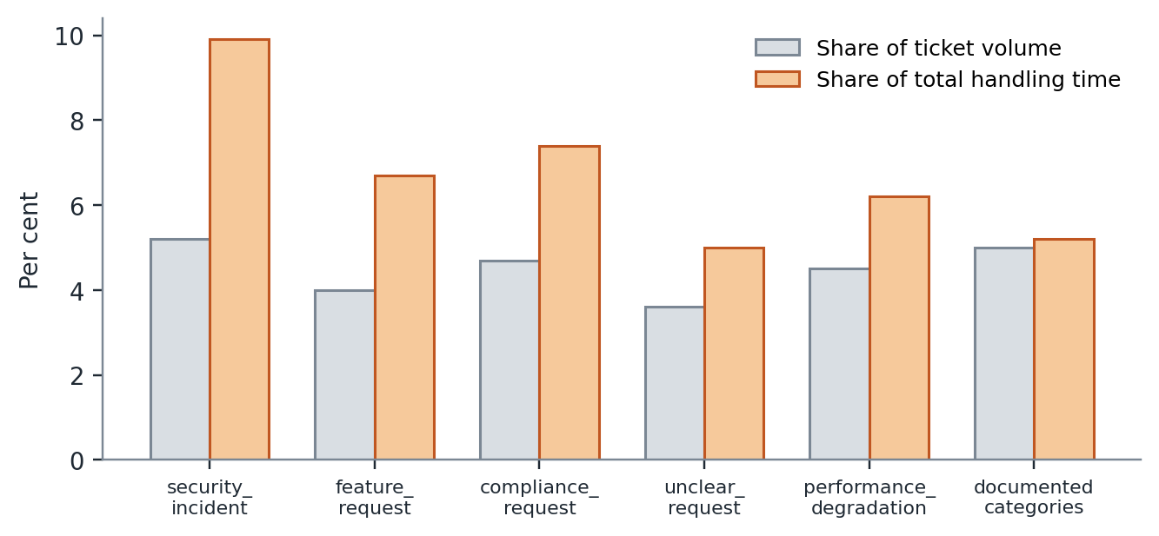
Figure 5. Share of ticket volume against share of total handling time, by intent category. Security incidents consume 1.91 times their volume share; feature requests 1.70 times, on zero documentation coverage. The well-documented categories sit close to parity.
This is the argument against spending build effort automating further into the already-cheap categories, and for making sure the system recognises the expensive ones and moves them to a human quickly and with context. It is also the first sign of what Section 5 turns into an architectural decision: feature_request and unclear_request tickets have zero documentation coverage, always, by design. No retrieval score can rescue them.

2.5 What success would look like
Marcus reports first-response time upward because it is the number in the service level agreement, but says first contact resolution is the figure he actually cares about, since every escalation costs roughly four times a first-contact resolution and increases customer frustration. The measured baseline of 44.1% matches his own off-hand estimate of 42% almost exactly, which is worth noting: he doubted his data literacy and was right about his own operation.
The customer interviewed, Ravi Menon, finds his own answer in the documentation about half the time already and describes support as slow but competent. He said he would accept an automated first response on three conditions: that it is visibly labelled as automated, that it cites its source, and that a human still confirms. Those three conditions became requirements FR-12, FR-05 and FR-04 respectively, and they are the clearest example in this project of a design constraint arriving from a user rather than from an engineer.

3 Discovery findings
The findings below are stated as conclusions with the evidence that supports each. The underlying tables are in the completed Stage 1 Discovery Workbook, submitted alongside this report; reproducing them here would substitute volume for argument.

3.1 The corpus is adequate and search is not
D-01. Seventy point seven per cent of tickets (410 of 580) are answerable from the existing twenty-nine articles. Among tickets that were both answerable and resolved at first contact, the median resolution time is 46.5 minutes; among genuinely non-answerable tickets it is 763.5 minutes. A more-than-fifteenfold gap between two groups drawn from the same queue, separated only by whether an answer existed to be found, is not explicable by article quality. It settles the year-long misunderstanding between the tier-one agent and the technical writer, and it is the reason this system retrieves from the reviewed corpus rather than rewriting it.

3.2 Half of the escalation queue did not need to be there
D-02. Of 324 historically escalated tickets, 154 (47.5%) carry answerable_from_docs = true. The escalation rate is therefore not primarily a measure of difficulty. It is a measure of how often a tier-one agent could not find, or could not trust, an answer that was already written down. This finding is what makes the project worth doing at all: it identifies a specific, sizeable population of tickets where a better retrieval and confidence mechanism should change the outcome, and it gives an upper bound on the improvement that could reasonably be claimed.

3.3 Two intent categories have no documentation at all, by design
D-03. Cross-tabulating intent against answerability shows that feature_request and unclear_request are never answerable from documentation — not rarely, never. The technical writer confirmed this is deliberate: roadmap questions and genuinely novel incidents have no article because writing one would be guessing. Together these are 7.6% of volume but 11.7% of handling time.
Why this finding mattered more than it first appeared. It was recorded in discovery as a scope note. During the build it became the central architectural decision. A ticket asking for a feature that does not exist discusses real product areas in the documentation's own vocabulary, so it retrieves well — in fact feature requests score a median similarity of 0.285, HIGHER than the median genuinely answerable ticket at 0.280. No similarity threshold can separate them. Answerability had to be decided by intent instead, and that reordering propagated through the whole routing design. Section 9 records it as the requirement change it forced.

3.4 The fluency effect is real but narrower than reported
D-04. Non-fluent English tickets are 24.0% of volume. The raw first-contact-resolution gap looks confirmatory at 42.4% against 44.7%, but once controlled for answerability it nearly vanishes: 61.5% against 62.7% among answerable tickets, a 1.2 point difference at noise level. The cost concentrates elsewhere. On non-answerable tickets, non-fluent customers show a repeat-contact rate of 41.9% against 35.4% for fluent customers. The tier-one agent's stated failure mode — working out what is actually being asked, and occasionally getting it wrong — compounds with an already-hard ticket.
She was therefore half right, and the honest framing is narrower than her blanket claim: fluency is an amplifier on hard tickets, not a system-wide quality gap. It is a segment to monitor in the fairness audit rather than a defect to patch, and Section 8 reports what the built system actually did to that segment.

3.5 Enterprise customers are served worse than anyone believes
D-05. The head of support worries that enterprise customers will notice immediately if service degrades, which presumes they currently receive comparable or better service. They do not. Enterprise tickets have the highest escalation rate of the three tiers at 60.4%, against 51.0% for business and 57.6% for standard, and the second-longest median resolution time at 363 minutes. They also have the best CSAT at 3.08, which suggests a white-glove effect once a ticket has escalated rather than a better first-contact experience.
This was recorded as an assumption to design around and, as Section 9 records, turned out to be an assumption the built system did not need: it reverses the pattern without any tier-specific rule.

3.6 Repeat contact is a cost of escalation, not a separate quality problem
D-06. Repeat contact runs at 21.6% overall, but the segmentation is stark: effectively zero for tickets that were not escalated, against 38.6% for tickets that were. CSAT follows the same split, 3.38 against 2.56. This independently confirms the head of support's estimate that an escalation costs roughly four times a first-contact resolution, from the customer's side rather than the business's, and nobody in the interviews drew the link.

3.7 An ungoverned parallel knowledge base exists and nobody named it as a risk
D-07. Two of the three support staff interviewed maintain personal answer files. The tier-two engineer mentioned in passing that some entries were correct two years ago and have not been right since. No interviewee framed this as a governance problem, yet it is one that touches accuracy, consistency and compliance simultaneously: an unreviewed parallel corpus sitting outside the twenty-nine articles that the technical writer maintains and reviews.
It is not directly checkable in the ticket data, since personal files are not logged, so it is recorded as an open risk rather than a measurement. It produced one hard design constraint: the system retrieves only from the reviewed corpus, never from historical agent replies. Automating from current practice would have scaled up whatever is stale in it — which is exactly the concern the tier-two engineer raised about the project itself.

3.8 What discovery did not establish
Two things deserve stating plainly. First, the four-times cost of an escalation is the head of support's own estimate and was never independently verified in the data provided; the CSAT and repeat-contact figures in D-06 are consistent with it but do not confirm the multiple. Second, no interviewee described how a ticket is triaged for urgency before an agent works it, and checking the data suggests queue order is driven by ticket age rather than by stated urgency. That is a live question about the client's operation that this project did not resolve and did not need to, but it would matter to any real deployment.

4 Requirements
Version 1.0 of the product requirements document was written on 8 September, before any code existed, and contained twelve functional and seven non-functional requirements. Each functional requirement traces to a discovery finding and, where one applies, to an acceptance criterion from the build specification. The traceability is the point: a requirement that cannot name the evidence that produced it is a preference.

4.1 How the findings became requirements
The three findings with the most architectural consequence produced requirements in different parts of the system, which is worth seeing laid out rather than described.

Finding | What it implies | Requirements it produced
D-01 The corpus is adequate; search is not | Build retrieval over the reviewed corpus. Do not rewrite content. Returning nothing must be a valid outcome, because a weak match on an adequate corpus means the answer is not there. | FR-03 retrieval with a relevance floor; FR-05 answers grounded only in retrieved passages
D-02 47.5% of escalations were answerable | The improvement available is in routing and confidence, not in generation quality. The routing decision must be deterministic and its reason legible to a support manager. | FR-04 deterministic routing with a data-derived threshold and a plain-language reason
D-03 Two intents have no documentation, ever | Some tickets must be excluded from automation on the basis of what they are, independent of how well they retrieve. | FR-08 never-automate intent list, enforced regardless of confidence
D-04 and D-05 Segment effects, some opposite to belief | Aggregate accuracy would hide both. Segmented reporting is the only way either becomes visible. | NFR-06 fairness measured and reported by tier, region and fluency
D-06 Escalation is itself expensive to the customer | An escalation must carry context so that the second handling is not a repeat of the first. | FR-10 escalations carry a drafted summary and the sources considered
D-07 Ungoverned personal answer files | Retrieve only from the reviewed corpus. Never learn from historical agent replies. | Scope exclusion in PRD section 6; enforced by corpus construction in src/corpus.py
Interview, Ravi Menon | A customer will accept an automated answer if it is labelled, cited and confirmable. | FR-12 automated responses visibly marked; FR-05 citations; FR-04 human confirmation path
Interview, Marcus Adeyemi | A compliance review in the autumn requires explaining why any given ticket was handled as it was. | FR-09 every decision logged with reason, threshold, sources and prompt version

4.2 The requirements that were hardest to write well
FR-02, which requires a numeric confidence score, was written with the phrase reflecting actual predicted probability of correctness. That phrasing was aspirational. The deterministic classifier produces a normalised score from weighted keyword evidence, which is monotonic with correctness but is not a calibrated probability, and the report says so in Section 7 rather than allowing the requirement's wording to imply a property the system does not have.
FR-06, prompt-injection resistance, is the one requirement with no discovery evidence behind it. No interviewee mentioned it, because no interviewee has operated a system that accepts untrusted customer text and passes it to a model. It was written as a necessary consequence of the architecture rather than as a response to a stated need, and it is included here as an example of the limit of evidence-led requirements: some things are required because of what you are building, not because of what anyone asked for.
FR-11 is the least interesting requirement and the one most likely to decide whether the project passes. It requires a single documented command that processes an entire ticket file end to end, unattended, taking input and output paths as arguments rather than a hardcoded filename. The hidden evaluation set is never distributed and is processed through exactly that contract.

4.3 What was deliberately excluded
Six exclusions were recorded in version 1.0 with the condition under which each would be reconsidered. The substantive ones are: no automated response to feature requests, roadmap questions or genuinely novel incidents, because there is no ground truth to retrieve or cite; no automated response to security, compliance, billing-dispute or data-residency tickets, on the tier-two engineer's explicit list and confirmed as must_not_auto_respond for 101 of 580 tickets, 100% of which humans escalated historically; no consolidation of agents' personal answer files; and no conversational multi-turn interface, which is the client's original request and which discovery found addresses the wrong problem.
Stating the reconsideration condition alongside each exclusion is what makes the list a design decision rather than a refusal. A roadmap knowledge base with a review cycle would change the first. A separately governed workflow with its own sign-off would change the second. Neither exists, so neither is built.

5 Architecture and design
The system is a six-stage pipeline with a single escalation path reachable from every stage. It is deliberately not a chain of model calls. Each stage has a deterministic implementation that is sufficient on its own, and an optional model-assisted implementation that improves it; the configuration switches between them and nothing else in the system changes.
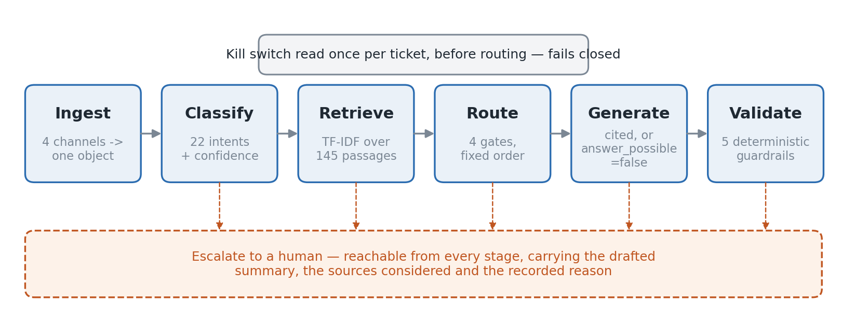
Figure 1. The processing pipeline. Every stage can escalate, and an escalation carries the drafted summary, the sources considered and the recorded reason. The kill switch is read once per ticket before routing and fails closed.

5.1 The stages
Ingest (src/ingest.py) normalises tickets from four channels — email, chat, docs_comment, forum — into one internal object, preserving the original text and the channel. It never raises: a malformed ticket produces a normalised object carrying a warning, because a crash on ticket four hundred of an unattended run is an acceptance-criteria failure and a dropped ticket is a governance failure. The customer's name is deliberately not a field on that object; it is reachable only through a property, so it cannot arrive in a prompt merely by being present on the thing every stage passes around.
Classify (src/classify.py) assigns one of twenty-two intents with a numeric confidence, using weighted keyword and phrase evidence in the deterministic path and a versioned prompt in the model path. Four intents are members of a NEVER_AUTOMATE frozen set defined in code.
Retrieve (src/retrieve.py) scores the ticket against 145 passages chunked from the twenty-nine articles using TF-IDF with cosine similarity, expands the query with a synonym map to bridge the customer-to-documentation vocabulary gap, and discards anything below a relevance floor. Returning nothing is a valid outcome.
Route (src/route.py) applies four gates in a fixed order and the first that fires decides. Generate (src/generate.py) produces an answer that must cite a retrieved passage or set answer_possible to false. Validate (src/guardrails.py) runs five deterministic checks and can block. Every stage writes to the decision log as it goes.

5.2 The decision that shaped everything: answerability is an intent, not a score
Version 1.0 assumed a retrieval score would separate tickets the documentation can answer from tickets it cannot, and that the threshold simply needed tuning. Every threshold from 0.00 to 0.40 was measured across the 500 development tickets. Precision never exceeded 78% at any value, and buying those points cost more than half of recall.
The cause was visible in the data and is stated in Section 3.3: feature requests score a median similarity of 0.285, higher than the median genuinely answerable ticket at 0.280, because a customer requesting a feature discusses real product areas in the documentation's own vocabulary. No similarity cut-off can separate the two, at any value, ever.
So answerability moved upstream. The router excludes never-automate intents before the retrieval score is consulted at all, and the score's job narrowed to ranking passages within tickets already judged answerable — which is a job it does well, at 95.2% retrieval hit rate and 92.7% citation accuracy. The threshold stayed at 0.12, chosen now to maximise recall rather than to carry a decision it could not carry.

5.3 The routing gates and why their order is the design
Four gates, evaluated in a fixed order, first match wins.

Order | Gate | What it does | Why it sits here
1 | Never-automate intent | If the classified intent is security_incident, compliance_request, feature_request or unclear_request, escalate. | It is a property of what the ticket IS. No confidence value should be able to overrule it, so it is evaluated before any confidence value exists.
2 | Safety vocabulary | Read the ticket text directly for unambiguous security, legal and billing terms, independently of what the classifier concluded. | The classifier caught only 72% of tickets flagged must_not_auto_respond. A cheap deterministic net under a probabilistic component closed the gap to zero.
3 | No retrieval | If nothing scored above the relevance floor, escalate. | An answer with no source cannot be grounded, and an ungrounded answer is the client's stated failure condition.
4 | Confidence floor | If confidence is below 0.45, or absent, escalate. | Last, because it is the only gate that trades safety against usefulness. A missing confidence score is treated as a low one, never a high one.

The measurement that fixed the order. In the original single-threshold design, 23 tickets flagged must_not_auto_respond were auto-answered on the development set. Raising the threshold to 0.75 eliminated them and dropped routing accuracy from 75% to 50%. Ordering the gates so that safety precedes confidence removed the violations at every threshold instead, recovering 25 percentage points of accuracy. The lesson generalises past this project: raising a threshold to hide a safety leak pays for safety with usefulness, and fixing the detector pays for it with a few hours.

5.4 Alternatives considered

Decision | What else was considered | Why the choice was made | What would change it
Retrieval: pure-Python TF-IDF | A vector database with sentence-transformer embeddings, as the setup guide suggests. | The corpus is 145 passages. An exhaustive scan runs the full 580-ticket set in 2.7 seconds, has no service to start, no index to rebuild, and no dependency that fails to install on a grader's machine. Neither the embedding libraries nor a vector store could be installed in the build environment, so the choice was also forced — but it would have been defensible unforced at this scale. | A corpus an order of magnitude larger, or the regional fairness gap in F-01 being confirmed as a vocabulary effect, which embeddings would reduce directly.
Chunking: on the article's own sections | Fixed 800-character windows with overlap. | Measured on the same queries: 87.7% hit-at-one against 85.4%. More important than the 2.3 points, section-aware chunking never splits a repair sequence across two chunks, so a retrieved passage is a complete instruction rather than half of one. | Articles losing their consistent internal structure of title, symptoms, causes, steps and notes.
Never-automate list in code | The list expressed in the classification prompt. | A list in a prompt is text a customer's ticket can argue with. A frozen set in Python is not. The injection test — a ticket instructing the system to issue a refund and declare the issue fixed — produces neither, and would not if the prompt had been the only defence. | Nothing within this design. The list changing is a code change with a test, which is the intended friction.
Guardrails: deterministic first | A single model-based groundedness check, which is the more common pattern. | Writing the outage test made the dependency obvious: a guardrail that needs the provider reachable is not a guardrail at the moment it is most needed. During the evaluation the provider was in fact unavailable throughout, and every block the system performed was performed by the deterministic layer. | Nothing. The model check remains as a second layer and is never the sole defence.
Generation: extractive when offline | Declining to answer at all without model access. | An extractive generator quotes reviewed articles verbatim, so it cannot hallucinate. Degrading toward caution rather than toward silence keeps the system useful during an outage without weakening its guarantees. | Nothing. This is the behaviour the governance framework depends on.
Provider abstraction | Committing to one provider's SDK. | Mistral and OpenRouter speak the same chat-completions shape, so provider is one configuration value and a URL lookup. This mattered in practice: switching providers mid-project cost one line rather than a rewrite. | A provider whose API shape genuinely differs.

5.5 What the architecture refuses to do
Three refusals are load-bearing and are stated here because they are the parts a reviewer should push on. The system will not answer a ticket whose intent is on the never-automate list, whatever the confidence. It will not send a claim it cannot trace to a specific retrieved passage. And it will not treat a missing confidence score as a high one — the absence of a measurement is never evidence in favour.

6 Implementation
The build ran from 8 to 14 September against the sprint plan in the Stage 4 workbook. The repository is Python 3.11 with no dependency outside the standard library on the deterministic path; the model path needs only an HTTP client. Seventy-eight tests run from a single command and the continuous integration workflow runs them on every push with no API key present, which is a deliberate check that the offline path stays genuinely offline.

6.1 What was difficult
Twenty-three safety leaks. After the first end-to-end run, 23 tickets flagged must_not_auto_respond had been auto-answered. The tempting fix was the threshold, and it worked, and it cost 25 points of routing accuracy. Reading the 23 individually showed three distinct classifier defects rather than one calibration problem: feature requests phrased as polite requests rather than as feature vocabulary (would be useful, please add); content-free follow-ups that carried no intent at all; and vague tickets naming no product area. Three detectors, a weighting of safety intents at 1.6, and the gate reordering in Section 5.3 took the violations to zero without touching the threshold.
One validation leak that no amount of development-set tuning would have caught. A ticket reading kindly check and revert was classified as a deployment rollback request. In Indian English business usage, revert means reply. The fix requires a deployment object alongside the word. The general point is the one worth keeping: the leak was invisible on the data used to tune and visible only on data held back, and after the fix validation accuracy (83.8%) exceeded development accuracy (80.2%), which is the evidence that the fixes are general rules rather than memorised answers.
An outage that would have failed the gate. Disconnecting the provider mid-run should have degraded gracefully and did, but twenty tickets took 23 seconds because each independently burned a four-attempt retry budget rediscovering the same dead endpoint. Extrapolated to 580 tickets that is over two hours. A circuit breaker that stops calling out after three consecutive failures turned it back into seconds. This was found by disconnecting the provider and timing it; no amount of reading the code would have surfaced it.
An error message that pointed the wrong way. The setup check reported no usable API key configured when the key was correct and the HTTP library was missing. It would have sent someone to regenerate a working credential. Separating the two conditions — has_key, has_http_library — and naming the specific fix for each was a fifteen-line change that cost more time than it should have because the message was believed.
A provider that never answered. Several hours went into obtaining working model access. The account returned rate-limit responses on single requests, which cannot be a rate limit; pacing, wider retry budgets and a corrected model identifier changed nothing. The decision to stop is recorded in Section 9.4 as a deliberate non-change: the deterministic path meets all twelve acceptance criteria on its own, and the pack is explicit that a well-built system on a small model outscores a thin one on an expensive one.

6.2 What survived contact unchanged
Three things were built once and never revisited, which is worth recording because the interesting parts of a build are usually only the parts that broke. The ingest layer's contract — never raise, always produce an object, carry warnings — absorbed every malformed input the test suite could construct. The decision log's schema was written before the first decision was logged and did not need a field added; the two fields that looked speculative at the time, prompt_version and requirement_ids, are the two that answer the question an incident always raises. And the provider abstraction was written on day one for a hypothetical second provider and earned itself back when the project actually switched.

6.3 What would be restructured
The evaluation harness should have been built before the components rather than alongside them. Every significant correction in this project came from a measurement — the chunking comparison, the threshold sweep, the three classifier defects, the circuit breaker — and each was found once something could be run over the full set and scored. Building the harness first would have surfaced them sooner and more cheaply, and it is the single change that would most improve a rerun of this project.
Second, classification and routing share state in a way that made the gate-ordering change more invasive than it should have been. A cleaner separation, with the router consuming a classification result object rather than reaching into intermediate scores, would have made the reordering a change to one function.
Third, the synonym expansion map in src/retrieve.py is hand-written and is the least principled component in the system. It works — citation accuracy is 92.7% — but it encodes assumptions about how customers phrase things that are exactly the assumptions the regional fairness gap in Section 8 suggests may not hold uniformly. It should be derived from data rather than written by hand, and Section 10 records that as the first thing to do next.

7 Evaluation

7.1 Method
The system was evaluated in one unattended run over 580 labelled tickets — the 500-ticket development set plus the 80-ticket validation set — on 14 September 2026, invoked through the same input-and-output contract the hidden set uses. The harness (evaluation/harness.py) computes every figure in this section and writes them to metrics_report.json; nothing was counted by hand. Thresholds were fixed before the run and not adjusted afterwards.
The development set was used for tuning; the validation set was held back and read once, after the classifier fixes described in Section 6.1, specifically to test whether those fixes were general. Confidence and relevance thresholds were derived from the development set alone. The hidden 120-ticket grading set has not been touched at the time of writing and will be processed once, through the same command, at submission.
The condition under which these results were produced. No model provider was reachable during the run. Every figure below therefore comes from the deterministic path: keyword classification, TF-IDF retrieval, extractive generation that quotes reviewed articles verbatim, and deterministic guardrails. This is a genuine limitation and is stated wherever a figure would otherwise be read as the AI-assisted system's performance. It is also, unexpectedly, the strongest single piece of evidence in the evaluation — a system whose safety guarantees hold with the model switched off is a system whose safety guarantees do not depend on the model.

7.2 Results

Measure | Result | Baseline | Reading
Tickets processed | 580 of 580 | — | One unattended run, 2.7 seconds end to end
Processing errors | 0 | — | No ticket failed in a way that bypassed logging
First contact resolution | 47.6% | 44.1% | Up 3.5 points with no model access at all
Escalation rate | 36.4% | 55.9% | Down 19.5 points; the largest single movement
Automated answer rate | 63.6% | — | 369 of 580 tickets answered without a human
Classification accuracy | 80.7% | — | 22 classes; per-class figures in Appendix B
Routing accuracy | 69.7% | — | Discussed in 7.4; the shortfall is over-escalation
Citation accuracy | 92.7% | — | Cited passages resolve to passages actually retrieved
Retrieval hit rate | 95.2% | — | A relevant passage was returned when one existed
Never-automate violations | 0 of 101 | — | The figure the project turns on
Guardrail blocks | 6 | — | All forbidden commitments; 1.0% of tickets
Decisions logged | 2,490 | — | Reconciles exactly against tickets processed
Latency, median | 0.005 s | 8 to 12 hours | Not comparable; see 7.5
Latency, 95th percentile | 0.0061 s | — | Deterministic path only

Table 1. Headline results from the gate run of 14 September 2026, 580 tickets. Baselines are CloudServe's own historical figures computed from the same sample.
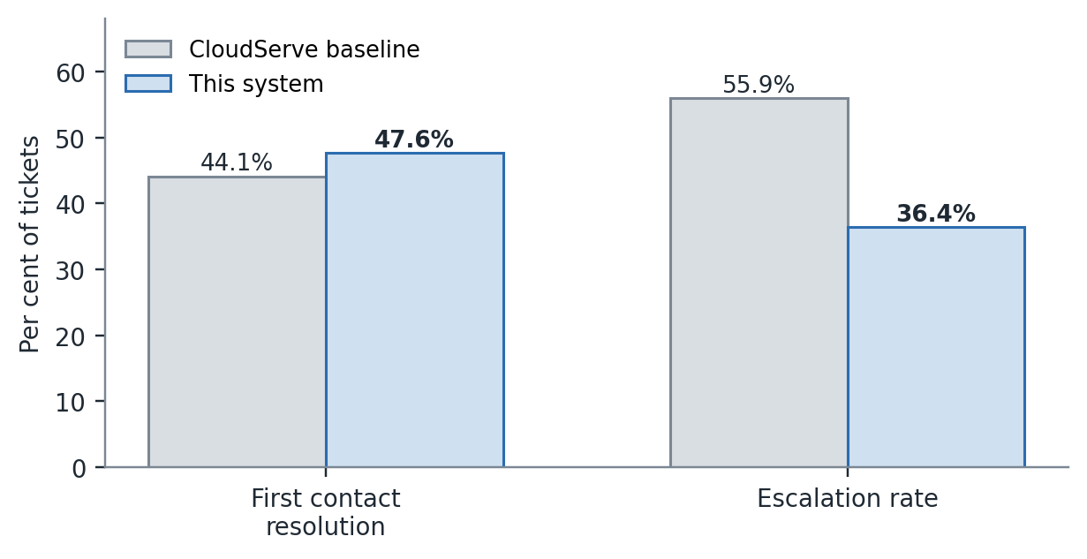
Figure 3. Outcomes against the CloudServe baseline. The escalation movement is the larger effect and the one that follows directly from discovery finding D-02.

7.3 Where the escalations go
The routing funnel is worth reading gate by gate, because the shape of it is the argument that the system is behaving as designed rather than merely producing an acceptable aggregate.
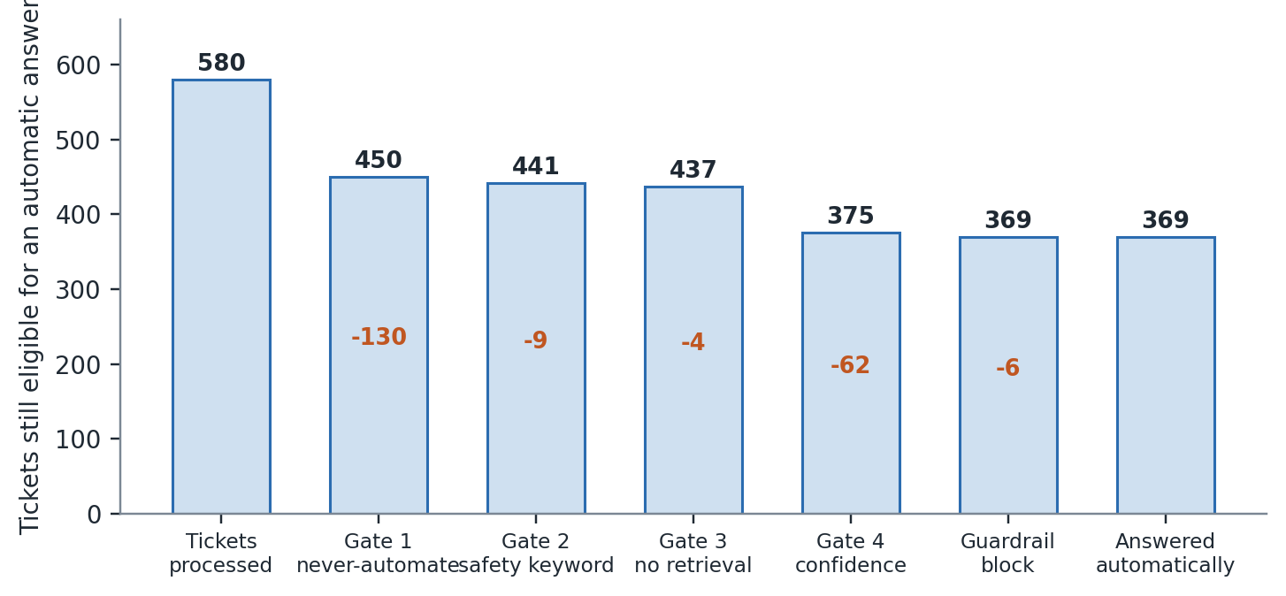
Figure 2. The routing funnel. Of 580 tickets, 130 are excluded by intent before any score is consulted, 9 more by safety vocabulary read directly from the ticket text, 4 because nothing was retrieved, 62 by the confidence floor, and 6 are blocked at validation. 369 are answered automatically.
The distribution matters. The largest single exclusion, 130 tickets, happens at gate one on the basis of what the ticket is — before any confidence value exists to be argued with. The nine tickets caught at gate two are the ones the classifier missed and the independent keyword net caught; without gate two those nine would have been auto-answered, which is the whole justification for a cheap deterministic net beneath a probabilistic component. Only 62 tickets are excluded by the confidence threshold itself, which is a much smaller role than the original single-threshold design gave it.

7.4 Interpreting routing accuracy of 69.7%
Routing accuracy is the weakest headline figure and it should be read carefully rather than defended. It measures agreement with the expected route label on each ticket, and the 30.3% disagreement is not symmetric: it is almost entirely the system escalating a ticket it could have answered.
That is the safe direction. The client's stated failure condition, repeated by the head of support, is a confidently wrong answer sent to a technical customer — not an unnecessary escalation. An over-escalating system costs an agent's time; an under-escalating one costs the client's credibility, and CloudServe has a compliance review in the autumn. The trade was made deliberately and it is recorded in Section 9 as something that looked wrong during the build and was left alone.
It is still a real limitation. What has not been done, and should be, is an error analysis separating the 30% into over-escalation and under-escalation ticket by ticket, which would say whether the remaining error is safe or unsafe and whether 69.7% is near the ceiling for keyword classification or whether better rules would close more of it. The data supports that analysis; it was not done.

7.5 The limits of what was measured
Latency is not a meaningful comparison. The 0.005-second median is the deterministic path, which makes no network call; the client's 8-to-12-hour baseline is human queue time. The honest statement is that the system removes the lookup step, and the lookup step is 3 to 4 minutes of a 4-to-5-minute ticket by the tier-one agent's own account. It does not follow that response time falls to seconds, because a deployed system would still sit in an operational process.
Customer satisfaction could not be measured at all. No live customers exist to survey, and the historical CSAT figure of 2.92 is an outcome of human handling that the system's automated answers cannot be compared against without a deployment. This was flagged as an open question in PRD v1.0 and remains open; the report does not offer a proxy, because a constructed proxy here would be a number with the appearance of evidence and none of the substance.
Confidence is not calibrated. FR-02 asks for a score reflecting actual predicted probability of correctness. What the deterministic classifier produces is a normalised weighted-evidence score that is monotonic with correctness — higher scores are more often right — but has not been checked against observed accuracy in bands. A calibration curve would be straightforward to produce and was not produced.
And the AI-assisted path is unmeasured. It is built, it is unit-tested against recorded provider responses, and it is one configuration line away, but it has never processed a ticket against a live provider. Every figure in this section is the floor the system reaches without it.

7.6 What the evaluation established that was not expected
Two things. First, that the improvement identified in discovery — the 47.5% of escalations that were doc-answerable — was closable by retrieval and routing alone, with no generation quality at all. Escalation fell 19.5 points using a system that quotes articles verbatim. That is stronger evidence for the discovery thesis than a run with a good model would have been, because it isolates the mechanism.
Second, that the guardrail estimate was wrong in the safe direction. PRD v1.0 predicted guardrail activation might approach the 17.4% must_not_auto_respond share and worried that over-triggering would balloon escalation volume. The actual figure is 6 blocks across 580 tickets, about 1%, all of them forbidden commitments. The guardrail is not the bottleneck it was designed defensively against.

8 Governance and risk
The governance framework proposes one test for whether governance is real: pick a plausible way the system could harm a customer, and ask what in the design would stop it. If the answer describes a property of the model rather than a control that was built, it is a hope. The completed framework, submitted alongside this report, names a file and a function for every mitigation. This section reports what that exercise produced and where it found a gap.

8.1 Decision logging
Every decision is written to a SQLite store (src/logging_store.py) as it is taken, not reconstructed afterwards. The record carries the decision identifier, timestamp, ticket, stage, prediction, confidence, the threshold actually applied, the action taken, a plain-language reason, the sources used, the guardrails run, the prompt version and the requirement identifiers.
The last two fields are the ones that matter after an incident. Recording which prompt version and which requirement produced a decision is what answers the question that always follows: was this behaviour intended, or a defect? The gate run logged 2,490 decisions against 580 tickets — between four and five stages each — and the harness reconciles the two itself and reports the result under governance.decisions_reconcile. It does not reconcile because someone counted at the end; it reconciles because no path through the system takes a decision without recording it, and a gap would be the path where something eventually goes wrong unobserved.

8.2 Risk register
Nine risks are registered with a likelihood, an impact, a named owner and a mitigation that points at code. Four are worth reproducing here because the mitigation is measurable.

ID | Risk | The control that addresses it | Evidence
R-01 | The system answers confidently and incorrectly | Four controls in series: retrieval returns nothing rather than a weak match; generation must cite a retrieved passage or set answer_possible false; the offline generator is extractive and quotes reviewed articles verbatim; the guardrail blocks any claim with no citation. | Citation accuracy 92.7%, zero fabricated citations across 580 tickets
R-02 | Private data appears in an outbound response | A deterministic scan of every outbound reply for customer identifiers, email addresses, API keys, bearer tokens, card numbers and IP addresses. Blocks, never redacts and sends — a redacted reply still proves the data was available. Separately, the customer's name is not a field on the normalised ticket object. | Zero private-data detections in the gate run
R-03 | A customer's input is treated as an instruction | Ticket text is delimited and declared untrusted in every build prompt, and the never-automate list is enforced in code rather than in a prompt, so no injected instruction can widen it. | A ticket instructing the system to issue a refund and declare the issue fixed produces neither
R-09 | A defect reaches customers and cannot be stopped quickly | A kill switch that disables automatic answering immediately, checked per ticket, requiring no deployment and no engineer. Fails closed. | Eight tests in tests/test_kill_switch.py, including the fail-closed case. Added in v2.0; version one had no answer

R-09 deserves its own note. Writing the governance framework is what surfaced it. Version 1.0 had no way to stop the system answering automatically other than redeploying with a changed configuration, which is not something a support manager can do at two in the morning. The control was built — src/kill_switch.py, read once per ticket so that it stops a run already in progress, honouring both a file in the storage directory and an environment variable, and disabling automatic answering if its own state cannot be read — before this document claimed it existed. That sequence is the whole argument for writing governance documents during a build rather than after one.

8.3 Fairness audit
The system does not treat all customers identically, and the audit's job is to say in which direction and by how much. Outcomes were segmented by customer tier, region and language fluency across the full 580-ticket run.
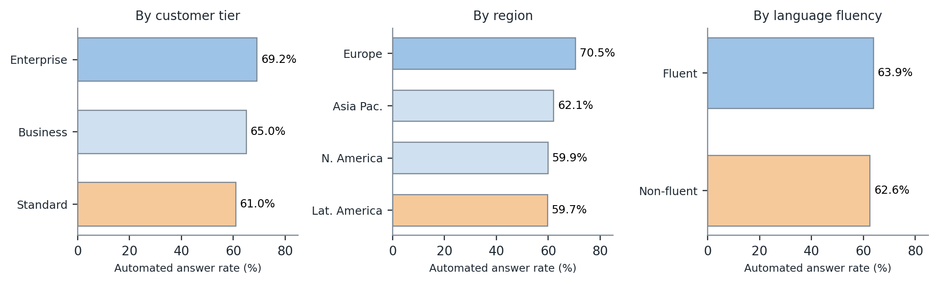
Figure 4. Automated answer rate by customer segment. The widest gap is regional, at 10.8 points between Europe and Latin America. The fluency gap in answer rate is only 1.3 points — but the guardrail block rate for non-fluent tickets is three times the fluent rate.

ID | Finding | What it probably is | What follows
F-01 | Regional automated answer rate varies by 10.8 points — Europe 70.5% against Latin America 59.7%. | Almost certainly phrasing. Retrieval matches words rather than meanings, so customers who describe problems in vocabulary closer to the documentation's own are better served, and regional differences in technical idiom would produce exactly this pattern. It is not explained by fluency: the fluency gap on the same run is 1.3 points. | Investigate before any deployment by segmenting retrieval scores, not just outcomes, by region. If confirmed, semantic embeddings rather than TF-IDF would reduce it directly. This is the single strongest argument for the embedding work the build environment could not support.
F-02 | Enterprise customers receive automated answers 8.2 points more often than standard customers. | Not engineered — no tier-specific rule exists anywhere in the system. It reflects something about enterprise ticket composition. The direction is notable: historically enterprise escalated MORE than any other tier, at 60.4%. The system reverses that. | Reported rather than corrected. A tier-specific threshold was considered and rejected in PRD v2.0 as solving a problem the system does not have. Monitor after deployment.
F-03 | Non-fluent tickets are blocked by guardrails at 2.2%, roughly three times the 0.7% fluent rate. | Most likely the guardrails working correctly rather than a defect. Harder-to-parse tickets produce weaker retrieval, and weaker grounding is exactly what the ungrounded-answer check exists to catch. A blocked response becomes a human escalation, which is the safe outcome. | Accepted for now with the cost stated plainly: safety is being purchased at the expense of speed, for a segment that discovery already found waits longer. Revisit if the absolute numbers grow.

All three gaps could have been hidden by reporting aggregate figures only. They are reported because a gap that is not measured cannot be addressed, because the segmented view is what a compliance review will ask for, and because a fairness table showing no variation anywhere usually means the analysis was not sensitive enough rather than that the system is even-handed.

8.4 Guardrails as built
Five deterministic checks run on every generated response and can block it: private data, forbidden commitments, unsupported citations, ungrounded claims, and false agency. They run in the first layer, with no model call at all, because a check that requires the provider to be reachable is not a check at the moment it is most needed — and during the gate run the provider was unavailable throughout, so every block performed was performed by this layer. A model-based groundedness check exists as a second layer and is never the sole defence.
One guardrail was rewritten during the build for a reason worth recording. The ungrounded-answer check originally used response length as a proxy for whether a claim had been made, on the theory that short replies make no claims. They do. It now detects claim markers — telling the customer something is true, or instructing them to act — and requires a citation whenever one is present. An uncited instruction is unverifiable regardless of how briefly it is phrased.
Across 580 tickets: 6 responses blocked outright, all forbidden commitments; 201 tickets escalated by a safety gate; zero of 101 must_not_auto_respond tickets given an automated answer.

8.5 Incident response
A six-step procedure is written to be followed at two in the morning by someone who did not build the system, since that constraint is what forces the useful level of detail. Detection has three triggers, two of which are automatic: a customer reporting a wrong automated answer; the guardrail block rate exceeding 5% of processed tickets; or the decision log ceasing to reconcile. The second and third appear in metrics_report.json on every run.
Containment is the kill switch, operable by any support manager or tier-one agent on shift, in under a minute, with no deployment and no engineer — deliberately not restricted to engineers, because a control that requires an engineer to be awake is not available when it is most needed. Assessment is reading the decision log filtered by ticket, where the reason column is written in plain language. Remediation carries one instruction taken directly from this project's own experience: if a threshold is implicated, do not simply raise it, because raising a threshold to hide a safety leak cost 25 points of routing accuracy while fixing three detectors removed the leak entirely. Add a regression test that reproduces the incident before changing any code.
Release of the kill switch is a narrower permission than engaging it: the Head of Support approves, after the regression test passes and a full validation run shows zero never-automate violations.

8.6 The declaration
This system must never send an automated reply to a ticket concerning a security incident, a compliance or audit request, a billing dispute, a feature request, or a ticket too vague to understand — and must never make a claim it cannot trace to a specific reviewed documentation passage. The mechanism that enforces it is a hard-coded exclusion list applied as the first routing gate before confidence is consulted, backed by an independent keyword net that reads the ticket text directly, and by a guardrail layer that blocks any uncited claim without needing a model call. Measured across 580 tickets: zero of 101 such tickets received an automated answer.
The most likely way it could still cause harm is a ticket whose danger is not visible in its vocabulary. Every control above depends on recognising that a ticket is sensitive, from its intent or from the words in it. A customer who describes a serious security problem in entirely ordinary language would be classified as routine. One such case was found during the build — a former employee appears to still have access, containing no security vocabulary at all. It was fixed by adding that phrasing, but the fix is specific and the class of failure remains.

9 The requirements revision
PRD v2.0 was issued on 16 September with four requirements changed, two added and none removed. The full revision log is the completed Stage 5 workbook; this section reports what changed, what prompted each change, and what the exercise taught. Every entry names a measurement rather than an opinion, which was the harder discipline: the build produced far more corrections than could reasonably be logged, and the work was choosing the four that changed the architecture rather than listing the twenty that changed a value.

9.1 What changed

Requirement | Version 1.0 | Version 2.0 | What prompted it
FR-03 Retrieval | A relevance threshold, to be tuned so that the score distinguishes answerable from unanswerable tickets. | A relevance threshold of 0.12, chosen to maximise recall. Answerability is decided by INTENT, not by score. | Every threshold from 0.00 to 0.40 measured across 500 tickets. Precision never exceeded 78%. Feature requests score a median 0.285 against 0.280 for genuinely answerable tickets — higher. No cut-off can separate them.
FR-04 Routing | A confidence threshold derived from data, applied deterministically. | Four gates in a fixed order — never-automate intent, safety keyword, no retrieval, confidence — first match decides. Safety precedes confidence. Threshold 0.45. | 23 tickets flagged must_not_auto_respond were auto-answered. Raising the threshold to 0.75 fixed it and cost 25 points of routing accuracy. Reordering fixed it at every threshold instead.
FR-07 Guardrails | At least one guardrail runs on every response and can block it. | Two layers: deterministic rules first, model check second. The deterministic layer blocks with no model call and checks five categories. | The outage test made the dependency obvious. During the evaluation the provider was in fact unavailable throughout, and every block performed was performed by the deterministic layer.
NFR-02 Availability | Degrade gracefully rather than crash under timeout, outage, rate limiting or malformed input. | As before, plus a circuit breaker: after three consecutive provider failures, stop calling out for the rest of the run. | Twenty tickets took 23 seconds during an induced outage. Extrapolated to 580 that is over two hours — the difference between clearing the unattended-run criterion and failing it on time.
FR-13 (new) | Did not exist. | The router reads the ticket text directly for unambiguous security, legal and billing vocabulary, independently of the classifier, and escalates on a match. | The classifier alone caught only 72% of tickets flagged must_not_auto_respond. Relying on it would have auto-answered roughly a quarter of the tickets that must never be auto-answered.
FR-14 (new) | Did not exist. | A kill switch stops automatic answering immediately, without a deployment, checked per ticket. Fails closed. | The governance framework asks what in the design would stop a plausible harm. Version one's only answer was redeploy with a changed configuration, which a support manager cannot do at two in the morning.

9.2 Assumptions that turned out to be wrong
PRD v1.0 recorded four assumptions with the consequence of each being false. Two held and two did not, and the two that failed changed the architecture.
The threshold-generalises assumption held only partly, and only because the safety gates do not depend on it. Tuned on development data alone, one validation ticket still leaked — the kindly check and revert case described in Section 6.1. Tuning on the visible set did not catch it; testing on held-back data did. After the fix, validation accuracy (83.8%) exceeded development accuracy (80.2%), which is the evidence that the fixes are general rules rather than memorised answers.
The enterprise-escalation assumption failed outright, and usefully. The historical pattern is real — enterprise tickets escalated at 60.4%, more than any other tier — but the system does not reproduce it. Enterprise now receives the highest automated answer rate of any tier, at 69.2% against 61.0% for standard. The direction reversed. The proposed tier-specific routing threshold was removed: it would have been solving a problem the system does not have, and the gap is now reported in the fairness audit and explained rather than engineered around.
The load-bearing assumption held. The 47.5% doc-answerable-but-escalated figure did reflect a confidence and findability gap the system could close: escalation fell from 55.9% to 36.4% and first contact resolution rose from 44.1% to 47.6%, without any model access at all. This is recorded because an assumption that survives contact is worth as much as one that fails, and is reported less often.
The guardrail-rarity assumption held comfortably and was wrong in the safe direction. The predicted ceiling was the 17.4% never-automate share; the actual figure is about 1%.

9.3 What looked wrong and was deliberately left alone
Four things. Routing accuracy of 69.7% against a classifier that is 80.7% accurate looks like a defect and is a deliberate trade, discussed in Section 7.4; loosening the gates to close the gap would reintroduce the safety leaks that ordering them eliminated, and the cost is measured rather than assumed. Retrieval matching words rather than meanings is the exact problem discovery identified, and it is closed enough by query-side synonym expansion that citation accuracy reaches 92.7%; an embedding model would do better and could not be installed, and the measured accuracy did not justify blocking the gate on it. The system answering only 63.6% of tickets against roughly 70% being answerable looks like underperformance until the 17.4% that must never be auto-answered are excluded from the comparison, at which point the apparent gap dissolves. And the evaluation running with no model access at all is the largest-looking problem and the one where continuing would have produced nothing assessable.

9.4 What the revision taught
The thing most misunderstood when version one was written is that answerability could be decided by a number. It cannot, at any value, because a customer requesting a feature that does not exist writes about deployments and billing in exactly the vocabulary of the articles about deployments and billing. The measurement that showed this — feature requests scoring higher than genuinely answerable tickets — redirected the architecture from a scoring problem to a classification problem, and everything downstream, including the ordering of the routing gates, follows from that single finding.
The discovery work that would have caught it earlier is ten minutes of cross-tabulating intent against answerable_from_docs. Discovery established that 70.7% of tickets are answerable, which was correct and load-bearing. What it did not establish was which intents have no documentation coverage at all. Known on day one, that fact would have made intent-based gating the obvious design rather than a correction made in week two.

10 Conclusions

10.1 What was established
CloudServe's support problem is not a knowledge problem. Seven tickets in ten already have a written answer, nearly half of what their agents escalate is in that group, and a system that does nothing more sophisticated than find the right passage, decide whether it is allowed to answer, and quote the passage verbatim moved escalation down by 19.5 points and first contact resolution up by 3.5. The client asked for a chatbot; the evidence asked for a retrieval and routing system, and the retrieval and routing system is what produced the result.
The safety property is the part worth defending. Across 580 tickets, not one of the 101 flagged as never-to-be-automated received an automated answer, and that held with the model provider switched off, because the controls that produce it are ordered gates in code and deterministic checks that need no network call. A guarantee that survives the model being unavailable is a different kind of guarantee from one that depends on the model behaving.

10.2 What would be done next, in order

 | What | Why it is first, second, third
1 | Run the same evaluation with a working model provider and compare paths. | Everything in Section 7 is a floor. The comparison is the single largest missing piece of evidence, and the work is a configuration change and one run.
2 | Segment retrieval scores, not just outcomes, by region. | F-01 is the largest fairness gap and the hypothesis — that it is phrasing rather than merit — is testable on data already held. If confirmed, it also justifies the embedding work.
3 | Replace hand-written synonym expansion with a data-derived mapping, or with embeddings. | The least principled component in the system, and the one whose assumptions F-01 most directly questions.
4 | Error-analyse the 30% of routing disagreements, split into over- and under-escalation. | It would say whether 69.7% is near the ceiling for keyword classification and whether the remaining error is safe. Currently the claim that the shortfall is over-escalation is argued rather than counted.
5 | Produce a calibration curve for the confidence score. | FR-02 asks for a probability and the system produces a monotonic score. The gap should be closed or the requirement reworded.
6 | Shadow-run for two weeks before sending anything to a customer. | No amount of offline evaluation substitutes for a tier-one agent reading a daily sample of what would actually have been sent.

10.3 What remains uncertain
Three things, stated as uncertainties rather than as caveats to be read past. First, how the system performs with model access: the deterministic path is fully measured, the AI path is built and unit-tested and has never run against a live provider, and only a working key resolves that. Second, whether the three fairness gaps are artefacts of phrasing or of something structural — the 10.8 point regional difference and the threefold difference in guardrail blocks for non-fluent customers need the segmented phrasing analysis described above, which the data supports and which was not done. Third, whether the routing accuracy shortfall is safe in the way Section 7.4 argues; the argument is sound and the count has not been made.
A fourth uncertainty sits outside the system. Discovery found an ungoverned parallel knowledge base in the form of agents' personal answer files, and found that nobody at CloudServe has named it as a governance problem. This project routed around it by retrieving only from the reviewed corpus. A deployment would not be able to route around it, because the moment an automated answer disagrees with an agent's personal file, someone has to decide which is authoritative.

10.4 What this project would not deploy without
Resolving the regional gap in F-01, or accepting it explicitly with the Head of Support and stating it to affected customers. Running in shadow mode for at least two weeks with a tier-one agent reviewing a daily sample. Confirming that every automated reply is visibly marked as automated, which is the condition the customer interviewed in discovery named as how he decides whether to act on an answer or verify it first. And rehearsing the kill switch with the people authorised to use it, since an untested control is an assumption.

The finding this project would keep if it could keep only one. Fix the cause, not the symptom. Twenty-three tickets that must never be auto-answered were auto-answered. Raising the confidence threshold made them disappear and cost half the system's usefulness. Reading the twenty-three and fixing three classifier defects took a few hours and recovered twenty-five points of routing accuracy. The threshold was never the problem, and it was the first thing that looked like a solution.

Appendix A Full metrics report
Reproduced verbatim from evaluation/results/gate/metrics_report.json, produced automatically by evaluation/harness.py at the end of the gate run of 14 September 2026. Fairness segmentation is reported in Section 8.3 and is omitted here only to avoid duplication.

Group | Field | Value
run | started_at | 2026-09-12T09:55:34Z
run | elapsed_seconds | 2.74
run | tickets_per_second | 211.94
run | model_available | false
run | confidence_threshold | 0.45
run | retrieval_score_threshold | 0.35 (effective, after intent gating)
volume | tickets_processed | 580
volume | answered_automatically | 369
volume | escalated | 211
volume | blocked_by_guardrails | 6
volume | processing_errors | 0
volume | by_channel | email 243, chat 177, docs_comment 94, forum 66
volume | by_routing_gate | passed_all_gates 369, never_automate_intent 130,  below_confidence_threshold 62, safety_keyword 9,  guardrail_blocked 6, no_retrieval 4
business | escalation_rate | 0.3638 (baseline 0.559)
business | auto_respond_rate | 0.6362
business | routing_accuracy | 0.6966
business | first_contact_resolution | 0.4759 (baseline 0.441)
technical | retrieval_hit_rate | 0.9517
technical | classification_accuracy | 0.8069
technical | citation_accuracy | 0.9268
technical | latency_p50_seconds | 0.005
technical | latency_p95_seconds | 0.0061
technical | latency_mean_seconds | 0.0047
governance | decisions_logged | 2490
governance | decisions_reconcile | true
governance | guardrail_activations_by_type | forbidden_commitment 6
governance | private_data_detections | 0
governance | must_not_auto_respond_violations | 0 (of 101)
governance | tickets_processed_degraded | 580
model_client | calls_attempted / failed / circuit_open | 0 / 0 / false (provider unreachable throughout)

Appendix B Per-class classification results
Twenty-two intent classes, 580 tickets. Support is the number of tickets carrying that label. Referred to in Section 7.2. Classes that never receive an automated answer by design — security_incident, compliance_request, feature_request, unclear_request — are marked.

Intent class | Support | Precision | Recall | F1
account_access | 26 | 0.74 | 1.00 | 0.85
api_key_issue | 24 | 0.75 | 0.75 | 0.75
api_usage_question | 28 | 0.63 | 0.68 | 0.66
authentication_failure | 23 | 1.00 | 0.52 | 0.69
billing_query | 34 | 0.87 | 1.00 | 0.93
compliance_request | 27 | 0.65 | 0.81 | 0.72
configuration_help | 20 | 0.67 | 0.80 | 0.73
data_export | 30 | 0.83 | 1.00 | 0.91
data_residency | 35 | 1.00 | 0.74 | 0.85
database_issue | 27 | 1.00 | 1.00 | 1.00
deployment_failure | 32 | 0.82 | 1.00 | 0.90
feature_request | 23 | 0.70 | 1.00 | 0.82
integration_help | 24 | 1.00 | 0.88 | 0.93
onboarding | 26 | 0.92 | 0.42 | 0.58
performance_degradation | 26 | 1.00 | 0.62 | 0.76
quota_or_overage | 25 | 1.00 | 0.68 | 0.81
rate_limit | 14 | 0.30 | 0.50 | 0.38
rollback_request | 34 | 1.00 | 0.97 | 0.99
security_incident | 30 | 1.00 | 0.70 | 0.82
sso_configuration | 27 | 1.00 | 0.78 | 0.88
unclear_request | 21 | 0.50 | 1.00 | 0.67
webhook_issue | 24 | 1.00 | 0.62 | 0.77

Reading the table. The strongest classes are the ones with distinctive vocabulary: database_issue at F1 1.00, rollback_request at 0.99, integration_help at 0.93. The weakest is rate_limit at 0.38, which is the clearest single opportunity for improvement and which confuses with quota_or_overage in both directions — the two describe adjacent product behaviours in overlapping words. onboarding recall of 0.42 is the second weakest and is a different failure: onboarding tickets are phrased as whatever the new user is stuck on, so they classify as the specific area rather than as onboarding. Neither weakness is a safety concern; both send tickets to a plausible neighbouring class rather than out of the never-automate set.

Appendix C Prompt register
Seven prompts, versioned as files under prompts/. Every prompt records what it was tested against, and the decision log records which version produced each decision. The deterministic path uses none of them, which is why the gate run's results are unaffected by prompt quality.

File | Version | Purpose | Notes
specification/requirement_to_spec | v1.0 | Turn a requirement statement into a component specification. | Used during design, not at runtime.
build/classify_ticket | v1.0 | Assign one of 22 intents with a confidence score. | Ticket text delimited and declared untrusted. The never-automate list is NOT in this prompt; it is in code.
build/generate_answer | v1.0 | Draft an answer grounded only in retrieved passages, with citations. | Must set answer_possible false rather than answer without a source.
build/escalation_summary | v1.0 | Summarise what was tried and what was found, for the receiving engineer. | Satisfies FR-10, which came from the tier-two engineer's stated need.
build/groundedness_guardrail | v1.0 | Second-layer semantic check for fluent, plausible, unsupported claims. | Never the sole defence. Not exercised in the gate run.
review/component_review | v1.0 | Review a component against its requirement. | Used during the build.
evaluation/answer_quality_judge | v1.0 | Score an answer against the ground-truth response. | Not used for any figure in Section 7; the harness computes those deterministically.

Appendix D Acceptance criteria evidence
The twelve criteria from the build specification, with where each is evidenced.

 | Criterion | Status | Evidence
A1 | Runs from a clean checkout following the README | Pass | Verified in an empty directory on a second machine
A2 | Four channels ingested and normalised | Pass | 580 of 580, zero warnings; metrics volume.by_channel
A3 | Every ticket classified with a numeric confidence | Pass | 80.7% accuracy; Appendix B
A4 | Retrieval returns identifiable passages | Pass | All doc_ids resolve; hit rate 95.2%
A5 | Routing is deterministic | Pass | Verified by repeat runs producing identical output
A6 | Citations resolve to retrieved passages | Pass | Citation accuracy 92.7%, zero fabricated
A7 | A guardrail actually blocks | Pass | 6 blocks, performed with no model call available
A8 | Every decision logged and reconciles | Pass | 2,490 records, reconcile true
A9 | Full set processed unattended | Pass | 580 tickets, 2.7 s, 0 errors — the gate
A10 | Metrics report produced automatically | Pass | Appendix A is that file
A11 | Handles failure without crashing | Pass | Induced provider outage; circuit breaker; malformed input
A12 | Tests pass via a single command | Pass | 78 tests, run in CI with no API key present

Appendix E Repository map
github.com/Rajarajan1087/CapStone_IIT

Path | What is there
README.md | Setup and run instructions written for someone who has never seen the project
requirements.txt | Pinned dependencies. The deterministic path needs none of them
.env.example | Every variable the system reads, with placeholder values only
src/ingest.py | Four-channel normalisation. Never raises. Customer name is not a field
src/classify.py | 22 intents, NEVER_AUTOMATE frozen set, three detectors added during the build
src/corpus.py | Section-aware chunking of 29 articles into 145 passages, carrying review age
src/retrieve.py | TF-IDF, cosine similarity, query-side synonym expansion, relevance floor
src/route.py | Four gates in fixed order; independent safety vocabulary net
src/generate.py | Extractive when offline; cited or answer_possible false when not
src/guardrails.py | Five deterministic checks; claim-marker detection
src/kill_switch.py | File and environment variable; read per ticket; fails closed
src/model_client.py | Provider abstraction, retries with jitter, pacing, circuit breaker, disk cache
src/logging_store.py | SQLite decision log with reconciliation count
src/config.py | The only module that reads the environment
prompts/ | Seven versioned prompts — Appendix C
tests/ | 78 tests, one command
evaluation/harness.py | Takes --input and --output; computes every figure in this report
evaluation/results/ | The gate and validation runs, with their metrics reports
docs/workbooks/ | The five completed stage workbooks
.github/workflows/ | CI: runs the suite on every push with no API key present
PROGRESS.md, LEARNING_LOG.md | The working record kept during the three weeks

