Assignment: SQL Joins
Instructions:
- Use appropriate JOIN types based on the scenario.
- Submit SQL queries along with brief explanations where required.
- Use any sample tables ( Customers , Orders , Employees , Products , etc.) or define your own schema if needed.

Q1. Theoretical
Explain the difference between INNER JOIN , LEFT JOIN , and FULL OUTER JOIN with the help of a Venn diagram.
Include real-life examples for each.

- In StudentRegistry table ..student roll no , class, house name
- IN Exams table exam no, Student roll no,subject , marks
  - When u need students who attended exam of internal with code starts with int312026(3rd std 1st exmyear) and status is pas(marks > 35) uses inner join.
  - Need student ho did not attend exa tajkes left join where stdeunt details are not matching here in exam table..
  - When u need all the stdeunt records where student attended , passed , not attend all in in one full outer in gets used

Q2. Hands-on
You have two tables:

Customers(CustomerID, Name, City) Orders(OrderID, CustomerID, Amount)
Write SQL queries for the following:
- a) List all customers and their order amounts (include customers with no orders).
- 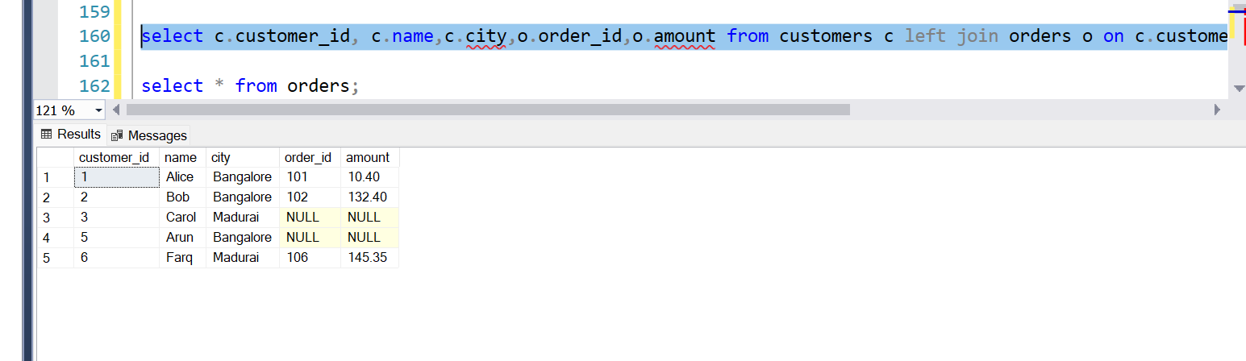
- b) List only those customers who have placed at least one order.
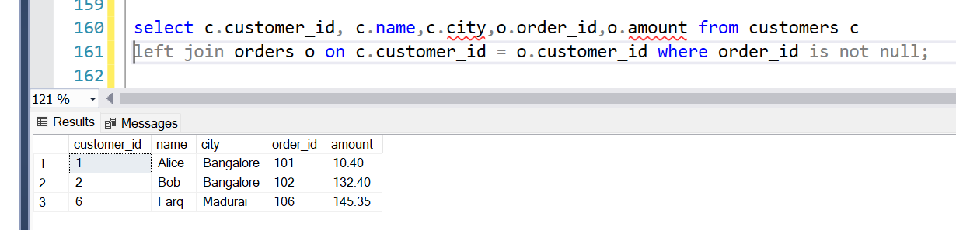
Q3. Hands-on
Using the tables:
Employees(EmpID, Name, DepartmentID)
Departments(DepartmentID, DeptName)
Write an SQL query to get a list of all employees along with their department names. If any employee is not assigned a department, show “Not Assigned”.

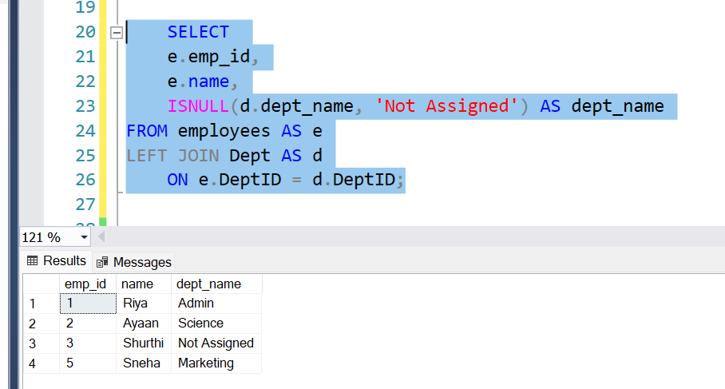
Q4. Theoretical + Hands-on
Scenario:
You are designing a dashboard that shows product sales. You have the following tables:
Products(ProductID, ProductName)

Sales(SaleID, ProductID, QuantitySold)
- Which type of join would you use to show all products and their sales count, including those with zero sales?
Left join
- Write the SQL query.
SELECT
e.prd_id,
e.name,
ISNULL(d.QtySold, ‘Zero Sales’) AS QuantitySold
FROM products AS e
LEFT JOIN sales AS d
ON e. prd_id= d. prd_id;
Q5. Hands-on
Write a query to find customers who placed orders but whose details are missing from the Customers table.
Use appropriate JOIN and explain why this type of join is suitable.
Right join because order details in right side megged with left customer details shows customer missing details as null hence we can capture which order hs issues without customer names and can seggragate as needed.

