Practice Assignment: LEFT JOIN Applications
Tables to Create
Table 1: students
roll_no | name
1 | Riya
2 | Ayaan
3 | Priya
4 | Meena

Table 2: submissions
roll_no | status
1 | Submitted
2 | Submitted

Practice Questions
Q1. Write a LEFT JOIN query to show each student’s name and their assignment submission status.
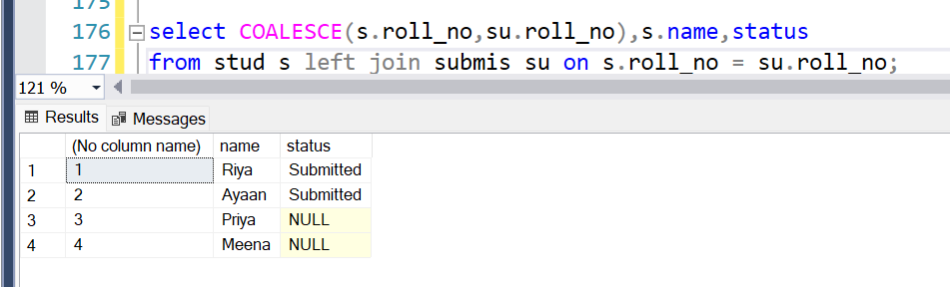
Q2. Modify the query to display only students who did not submit the assignment (i.e., status IS NULL ).

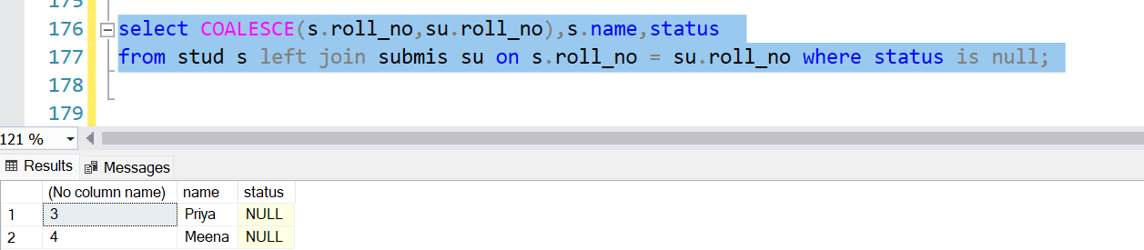
Q3. Sort the result by student name in ascending order and show NULLs at the bottom.
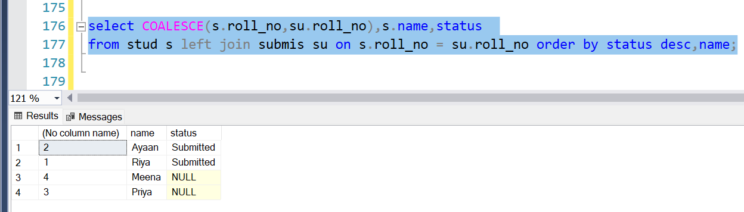
Q4. Assume a third column subject is added to the submissions table. Write a query to list all students with their submitted subject (if any).
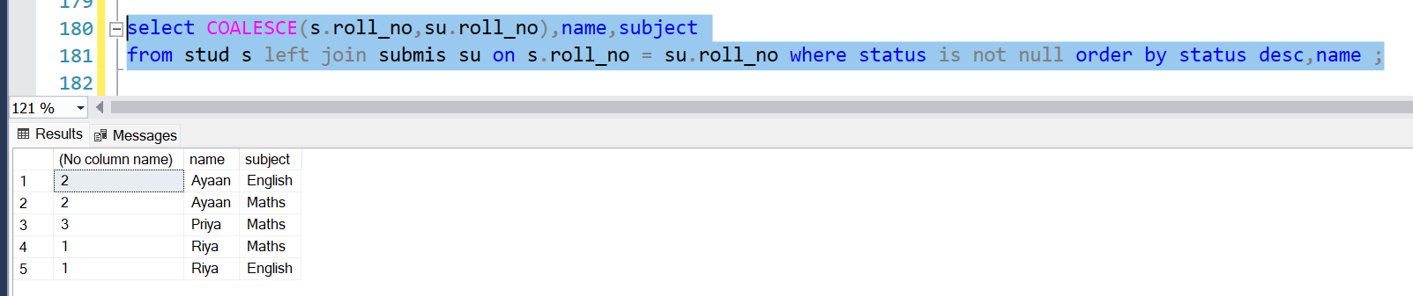
Q5. In a corporate setting:
Create employees(emp_id, name) and projects(emp_id, project_name) .
Write a query using LEFT JOIN to find employees not assigned to any project .

