Assignment / Activity: Sorting Results with ORDER BY
Title: Top Performers and Ranked Listings
Instructions : Use an online SQL editor like https://sqliteonline.com and complete the following:

Q1. Create a table exam_results with the following columns:
- student_id (INTEGER, Primary Key)
- student_name (TEXT)
- subject (TEXT)

- marks (INTEGER)
create table exam_results_2026
( result_id int primary key identity(2026,1),
student_id int references students(id),
subject varchar(20),
marks int check(marks>0 and marks<101));

Q2. Insert at least 5 records for subject = 'Math'. Example:
INSERT INTO exam_results (student_id, student_name, subject, marks)
VALUES (1, 'Riya', 'Math', 88);
INSERT INTO exam_results_2026(Student_id,subject,marks) VALUES (1000,'Maths',91);
INSERT INTO exam_results_2026(Student_id,subject,marks) VALUES (1000,'Science',78);
INSERT INTO exam_results_2026(Student_id,subject,marks) VALUES (1001,'Maths',98);
INSERT INTO exam_results_2026(Student_id,subject,marks) VALUES (1001,'Science',98);
INSERT INTO exam_results_2026(Student_id,subject,marks) VALUES (1002,'Maths',87);
INSERT INTO exam_results_2026(Student_id,subject,marks) VALUES (1002,'Science',79);
INSERT INTO exam_results_2026(Student_id,subject,marks) VALUES (1003,'Maths',89);
INSERT INTO exam_results_2026(Student_id,subject,marks) VALUES (1004,'Science',72);

Q3. Write a query to display all Math students sorted by marks (highest first).
select s.name,e.subject,e.marks from exam_results_2026 e inner join
Students s on e.student_id = s.id where e.subject = 'Maths' order by e.marks desc;

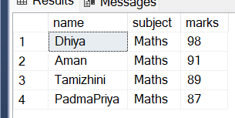

Q4. Write a query to display the top 3 students in ‘Science’based on marks.
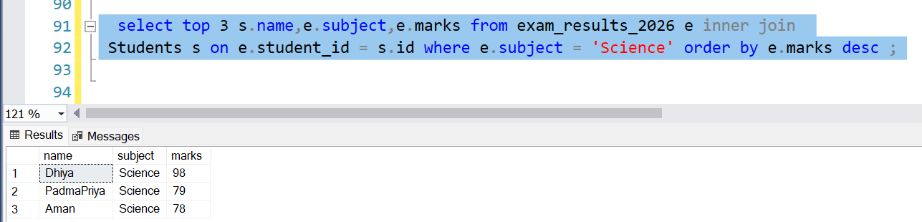

Q5. Write a query to sort all students by subject alphabetically, and then by marks in descending order.

