Assignment / Activity: Analyzing Data with GROUP BY
Title: Summarizing Student and Sales Data
Instructions : Use https://sqliteonline.com or any SQL IDE to practice the following.

Q1. Create a students table with the following columns:
- id (INTEGER, Primary Key)
- name (TEXT)
- class (INTEGER)
- subject (TEXT)

- marks (INTEGER)
Insert at least 6 records across two classes and subjects.

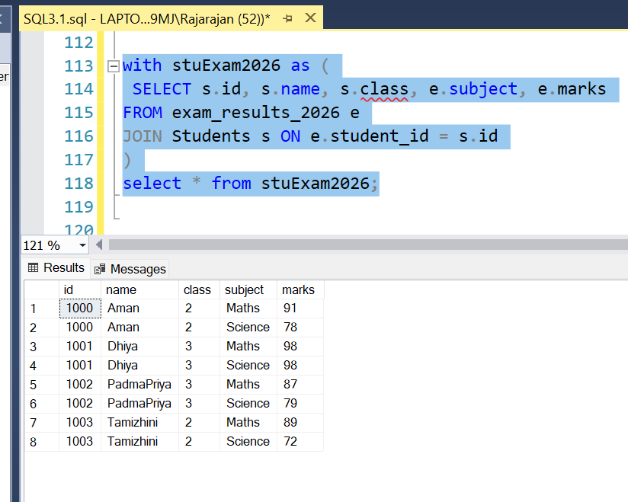

Q2. Write a query to count the number of students in each class.

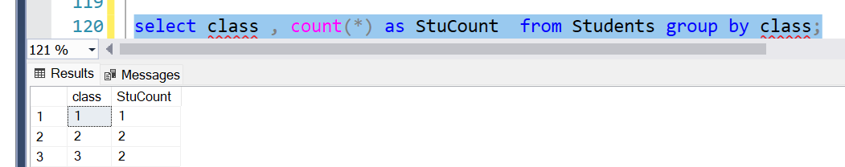

Q3. Write a query to get the average marks per subject.

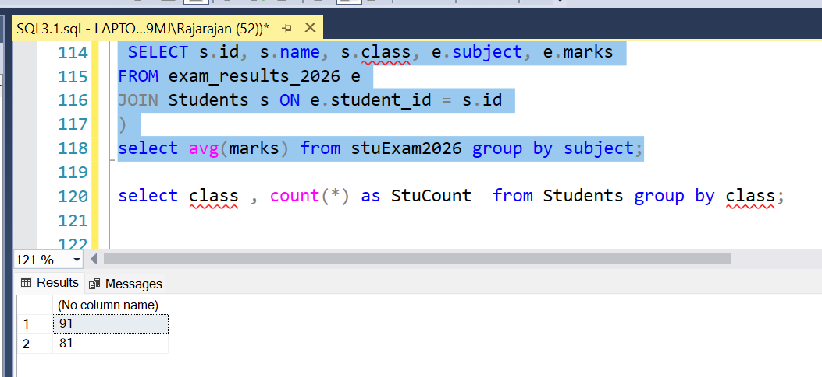

Q4. Write a query to get the total marks per subject per class.
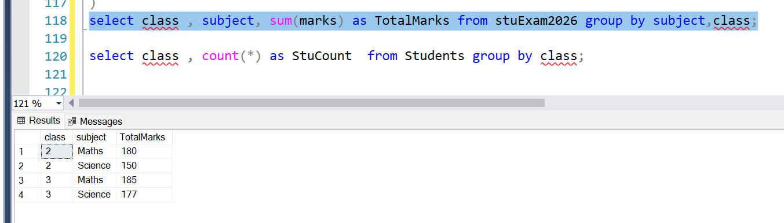

Q5. Create another table orders with columns: city , category , price . Insert 5–6 records. Write a query to get total revenue per city and category using GROUP BY city, category .

