Assignment / Activity: Practice Using HAVING Clause
Title: Filtering Grouped Data Based on Aggregates
Instructions : Use https://sqliteonline.com or any SQL IDE to complete the following:

Q1. Create a table students with the following columns:
- id (INTEGER, Primary Key)
- name (TEXT)
- class (INTEGER)

- marks (INTEGER)
Insert at least 6–8 records across different classes.
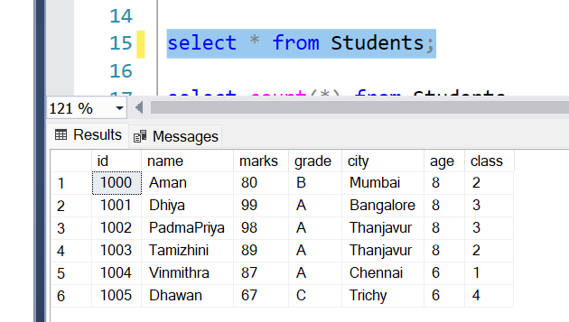

Q2. Write a query to calculate the average marks per class using GROUP BY .

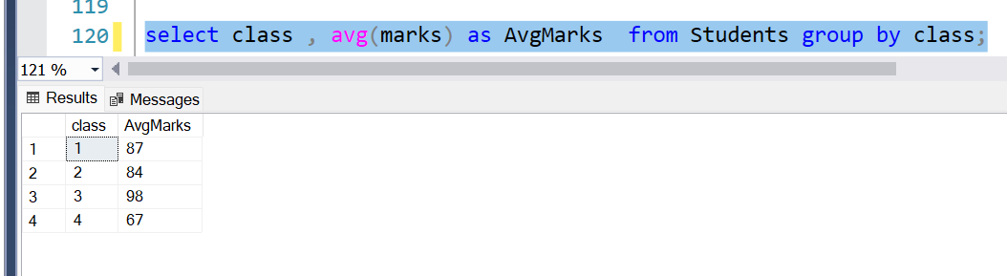

Q3. Modify the query to only show classes with an average mark above 85 using HAVING .
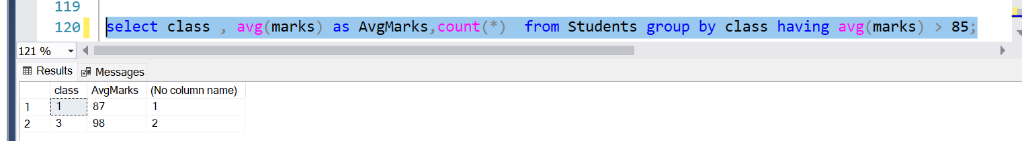

**Q4. Create another table called orders with columns: city , price . Insert data for at least 2 cities with 3+ orders each. Write a query to show total revenue per city using GROUP BY .

Q5. Now filter and display only those cities where the total revenue exceeds ₹400 using HAVING .

