Take-Home Practice Assignment: SQL Basics
Instructions:
Use https://sqliteonline.com or your local SQL environment. Create the following table and answer each question with the appropriate SQL query.


Table: students
id | name | class | subject | marks | city
1 | Riya | 10 | Math | 92 | Mumbai
2 | Aarav | 10 | English | 85 | Delhi
3 | Sneha | 12 | Math | 76 | Mumbai
4 | Karan | 12 | English | 89 | Chennai
5 | Meena | 10 | Math | 80 | Delhi
6 | Rahul | 12 | English | 95 | Mumbai

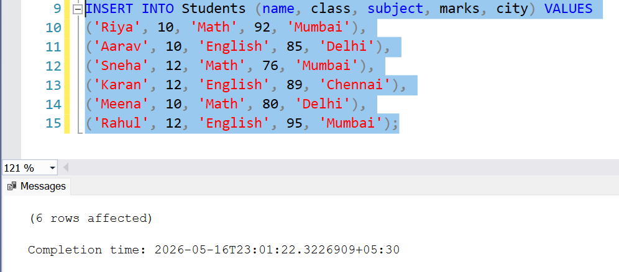
Practice Questions:
Q1. Write a query to fetch all records from the students table.
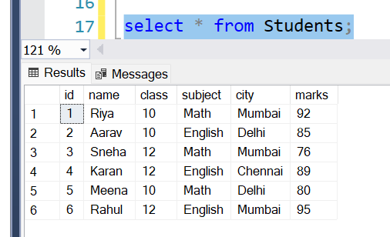
Q2. Write a query to display only the name , marks , and subject of all students.
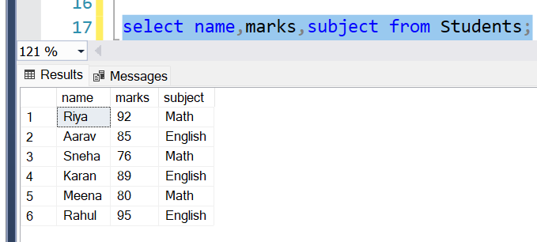
Q3. Write a query to display students who scored more than 85 marks.
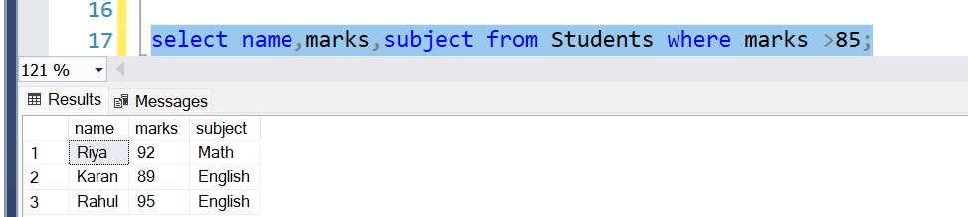
Q4. Write a query to display students from the city 'Delhi' and subject 'Math' .
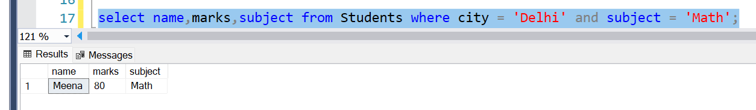
Q5. Write a query to display all students ordered by their marks in descending order.
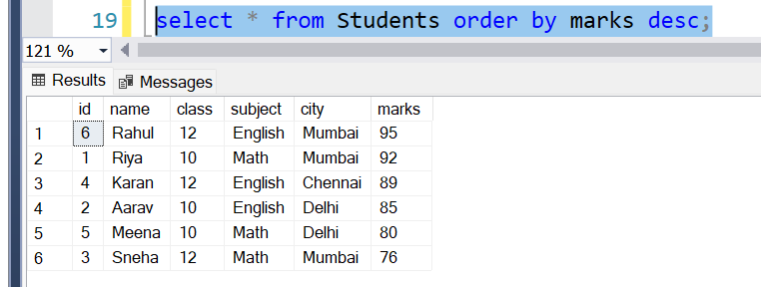
Q6. Write a query to count how many students are in the table.
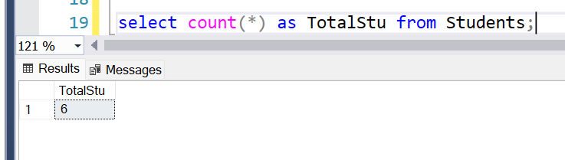
Q7. Write a query to find the average marks of all students.

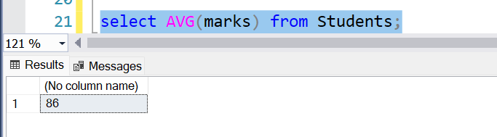
Q8. Write a query to display the total marks obtained by students in each subject .
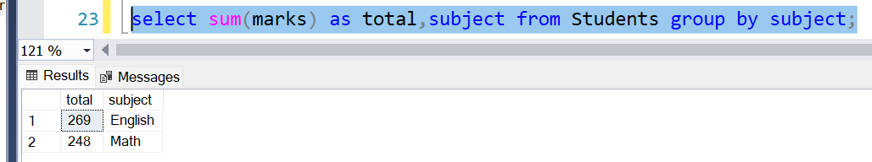

Q9. Write a query to display the average marks per class .
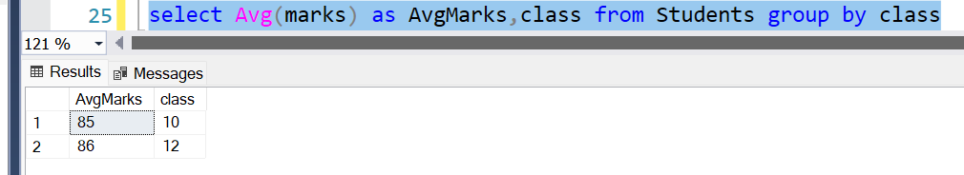
Q10. (Bonus) Write a query to show only those classes where the average marks are greater than 85 .
