Take-Home SQL Assignment: Practice INNER JOIN

Instructions
Use https://sqliteonline.com or a local SQL environment. Create the following tables and answer each query with the appropriate SQL.

Table 1: students
roll_no | name
1 | Riya
2 | Ayaan
3 | Sneha
4 | Arjun


Table 2: marks
roll_no | marks
1 | 88
2 | 72
4 | 95

Practice Questions
Q1. Write a query to display all student names along with their marks using INNER JOIN .
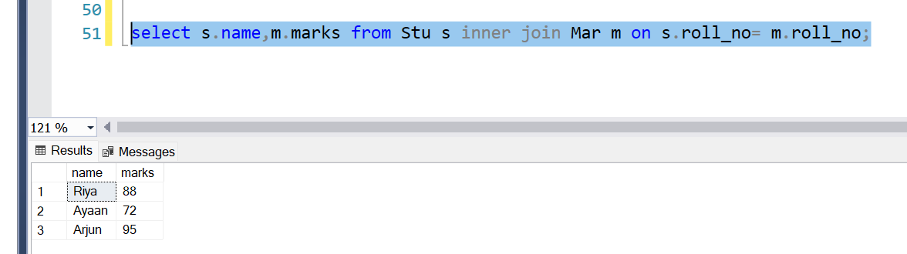
Q2. Modify the above query to only show students who scored more than 75.
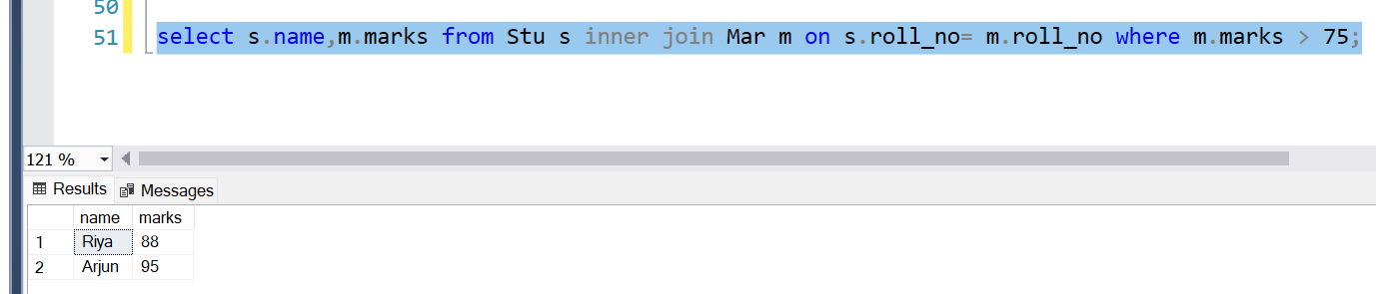
Q3. Sort the joined result by marks in descending order.
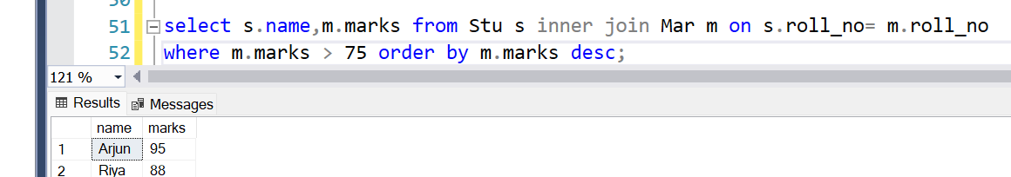
Q4. Add a new column subject to the marks table (assume values) and write a query to show each student’s name, subject, and marks.

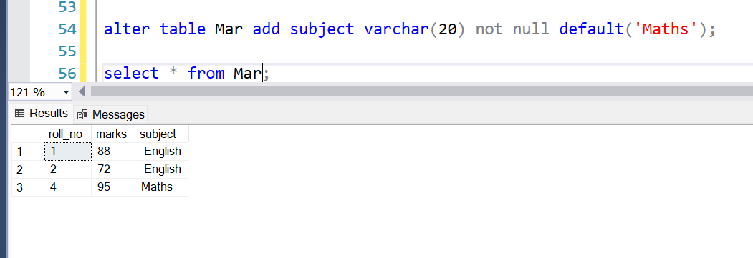
Q5. Write a query to count how many students have corresponding marks in the marks table (using INNER JOIN and COUNT()).

