Assignment Questions: RIGHT JOIN & FULL JOIN

- Explain with an example: When would you prefer RIGHT JOIN over LEFT JOIN?
Instructions:
  - Describe a real-world use case (e.g., students and marks, products and sales).
  - Write a short SQL query using RIGHT JOIN.
  - Explain why RIGHT JOIN is better suited in your example.

Where orders and customer gets joined and we need to customer data even with no order to make sure.. data displayed to understand how many customer available with no order dne so far.. we can use right join and
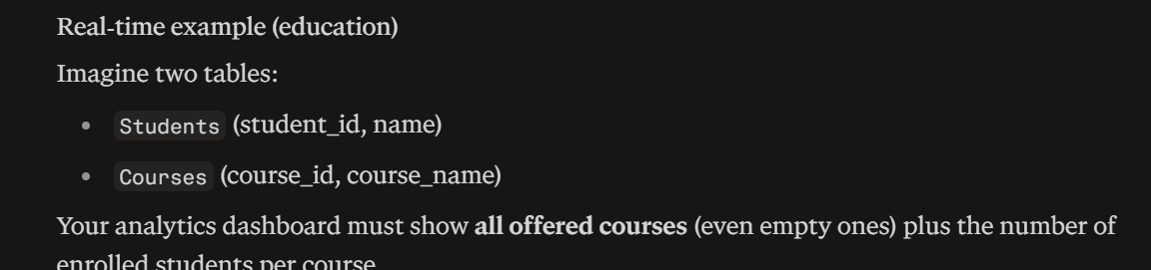

SELECT
c.course_name,
COUNT(s.student_id) AS enrolled_count
FROM Students s
RIGHT JOIN Courses c
ON s.course_id = c.course_id
GROUP BY c.course_name;

I need to show course created in this list overall even with no students joined to make sure.. course list is intact as er expectation with no copurs left.

- Write a query using RIGHT JOIN that lists all sales, even if some products are missing from the product list.
Tables:
  - sales(sale_id, product_id, amount)
  - products(product_id, product_name)
Expected Output:
  - product_name, amount
  - If the product is missing, show NULL in product_name.
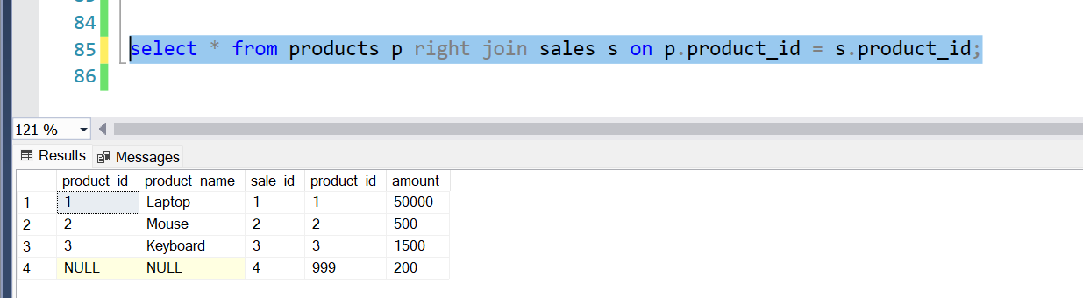

- Create a scenario where FULL JOIN is the best choice. Explain your answer and show the query.
Instructions:
  - Think of a real case (e.g., comparing employees with time logs, student attendance vs. assignment submissions).
  - Describe why FULL JOIN is important here. ● Write a query using FULL JOIN.

- Given two tables with mismatched records, use FULL JOIN to list all entries and highlight unmatched rows using a CASE statement.
Tables:
  - employees(emp_id, name)
  - timesheet(emp_id, hours_logged)
Task:
  - Write a query that shows:
○ emp_id, name, hours_logged, status
○ status = 'Only in employees' / 'Only in timesheet' / 'Matched'

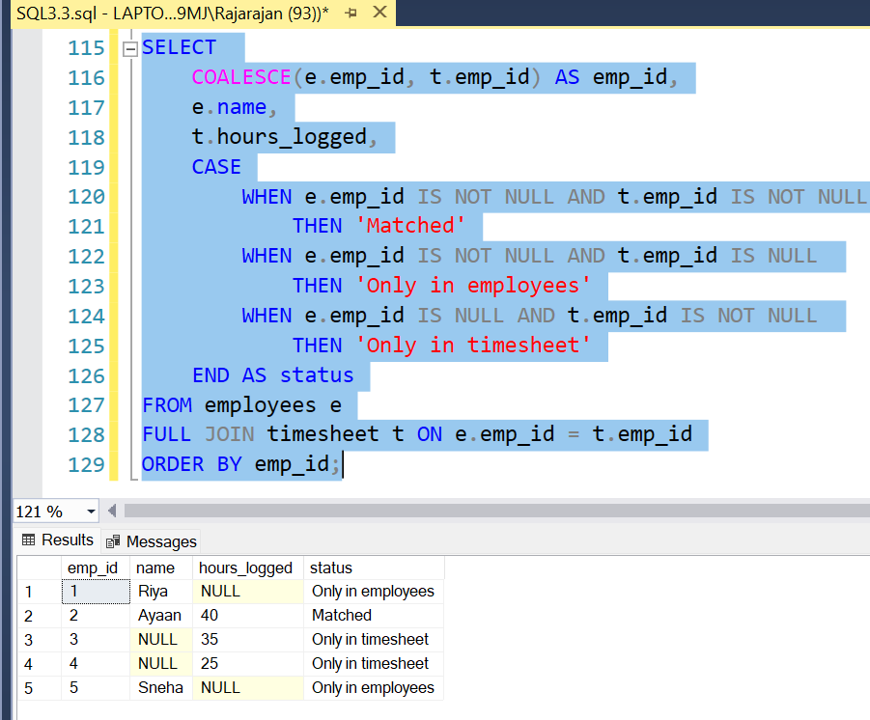

- Consider the following data and write the FULL JOIN output manually.
Table A: customers
customer_id | name
1 | Alice
2 | Bob
3 | Carol
Table B: orders
customer_id | order_id
1 | 101
2 | 102
4 | 103
Task:
  - Write the result of FULL JOIN between customers and orders on customer_id.
  - Include all columns and use NULL where needed.
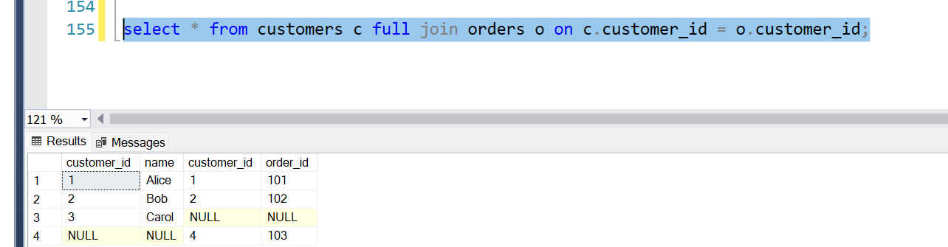

- What is the difference between RIGHT JOIN and FULL JOIN? Write two
queries and explain their outputs using the same tables.

Taken only data in right table and only matching data frmleft table where in full join matching data gets tagged once and all data from left and right even its matched gets accumulated in full join

- Modify a FULL JOIN query to only show unmatched rows (i.e., rows where one side is NULL).
Hint: Use WHERE clause to filter out matched rows.
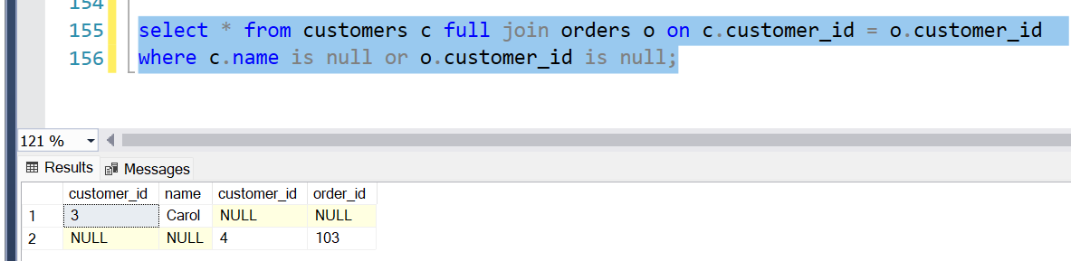

- Create two sample tables with at least 5 rows each, where some keys match and some don’t. Perform:
  - INNER JOIN ● RIGHT JOIN
  - FULL JOIN
Compare the output and explain what differences you see.

Full join :

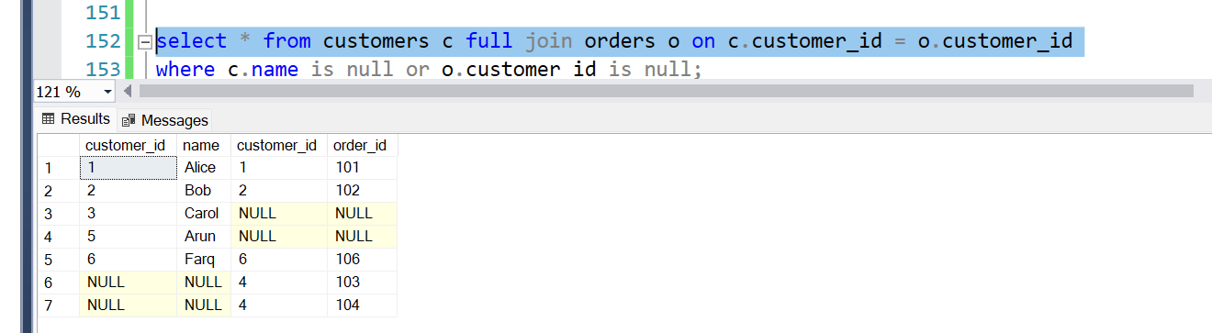

Right Join :

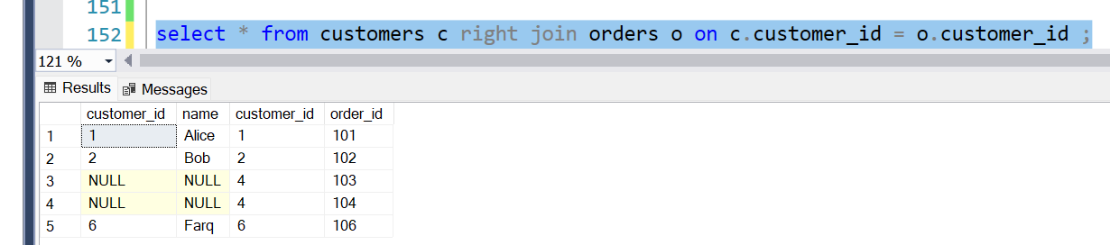

Inner join :
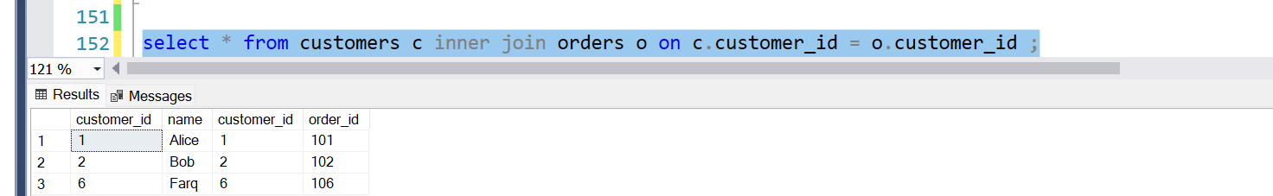

Left Join :
