
4.1 Assignment Questions
Short Answer / Conceptual Questions
- Explain the difference between AND , OR , and NOT in SQL with simple examples.
And – to merge multipe condition and make sure all are satisfied
Or – check any one condition in the multipole condition gets satisfioed
Not – opposite of condition defined is gets satified( mnajorly a Boolean value )
- Why are parentheses important when combining multiple logical conditions in a WHERE clause?
To prioperly merge and convert filter than using left right or any illogical filter ioptions gets trigered
- What is the significance of NULL in logical operations and how should it be handled?
To identigy missing data or to filter out non matching rows in in outer joins
Hands-On / Practical Tasks
- Write a SQL query to retrieve employees from a table Employees who:
○ Work in the "Sales" department
○ Have either a salary above 50000 or more than 5 years of experience ○ Use parentheses appropriately

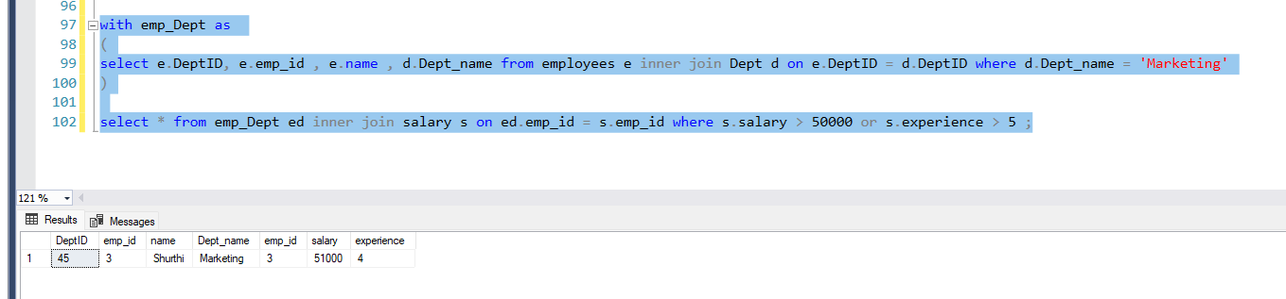
- Given a table Students(Name, Age, Grade) , write SQL queries to:
  - Select all students older than 18 AND with grade 'A'
  - Select all students who are either below 18 OR have grade 'C'
  - Exclude students whose age is less than 16
- Create a truth table manually or in a spreadsheet that shows the outcomes of different combinations of A and B using AND , OR , and NOT A .
