4.2 Assignment Questions
Short Answer / Conceptual Questions
- Why is it important to understand the business context before writing SQL queries?
It is important to understand the business context before writing SQL queries because it helps define the correct logic, filters, and rules, so the query returns accurate and meaningful results.
- Describe a situation where using HAVING instead of WHERE is necessary.
  - When data been declare4d for specific group user and summation , avg or any other grouped data.
- Explain the difference between filtering with WHERE and filtering with CASE .
  - Where works only on specific single conditions but case works and gives results when condition output varies multi if condition and needed to choose condition out of multiple condition.
Hands-On / Practical Tasks

- Based on a sample e-commerce database, write SQL queries to:
  - Find the top 2 best-selling products in the last month (use GROUP BY , SUM() , ORDER
BY , LIMIT )

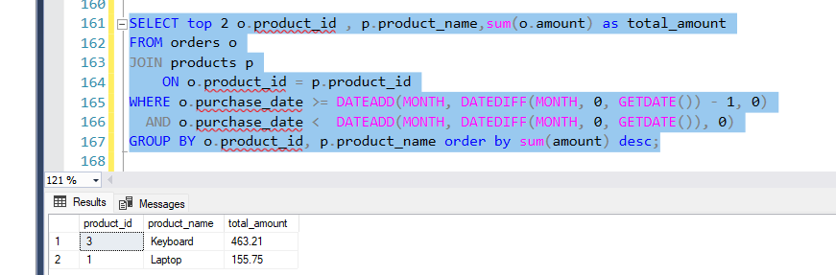
SELECT top 2 o.product_id , p.product_name,sum(o.amount) as total_amount
FROM orders o
JOIN products p
ON o.product_id = p.product_id
WHERE o.purchase_date >= DATEADD(MONTH, DATEDIFF(MONTH, 0, GETDATE()) - 1, 0)
AND o.purchase_date < DATEADD(MONTH, DATEDIFF(MONTH, 0, GETDATE()), 0)
GROUP BY o.product_id, p.product_name order by sum(amount) desc;

  - Identify customers who made purchases in at least 3 different months (use
COUNT(DISTINCT MONTH(date)) )

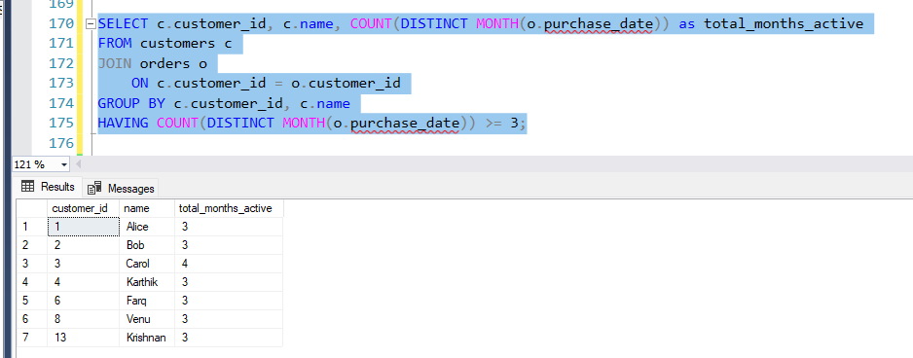 SELECT c.customer_id, c.name, COUNT(DISTINCT MONTH(o.purchase_date)) as total_months_active
FROM customers c
JOIN orders o
ON c.customer_id = o.customer_id
GROUP BY c.customer_id, c.name
HAVING COUNT(DISTINCT MONTH(o.purchase_date)) >= 3;

  - Compare total revenue between first-time and repeat customers using CASE and GROUP BY
- 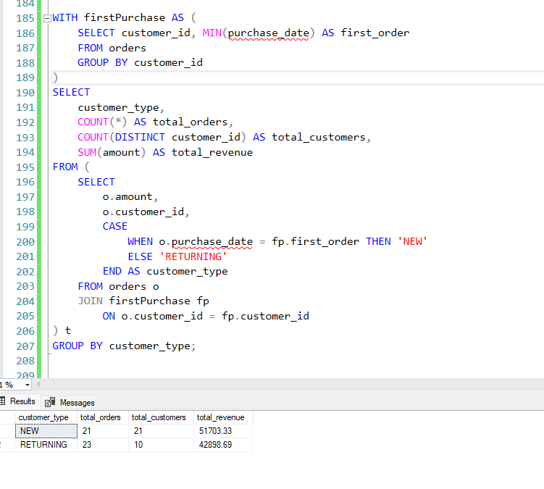
- Given a table StockLog(ProductID, Date, InStock) , write a query to list all products that were out of stock ( InStock = 0 ) for more than 5 days in the last 30 days.
- Design a real-life query challenge based on your domain (e.g., education, retail, finance), define the problem clearly, and write the SQL logic (or pseudo-code) that would solve it step-by-step.

