**INTRODUCTION**

In this project, user can keep their personal record like they do in a diary. They can keep records of the important things they do in their daily life, like meetings and various other tasks.

**KEY FEATURES OF PERSONAL DIARY MANAGEMENT SYSTEM**

* password protection
* Adding and viewing new diary record
* Modifing and updating added record
* Deleting record permanently from system file

**APPROACH**

The idea is to form an individual function for each operation. All the functions are unified together with switch cases to form software. Below is the illustration of the functions:

* int password() – contains/manages/handles password protection
* void addrecord() – to add new diary record
* void viewrecord() – to view added record in list
* void editrecord() – to modify and update an added record
* void editpassword() – to modify/change a password
* void deleterecord() – to delete or remove a record permanently from system file

**SWOT ANALYSIS**

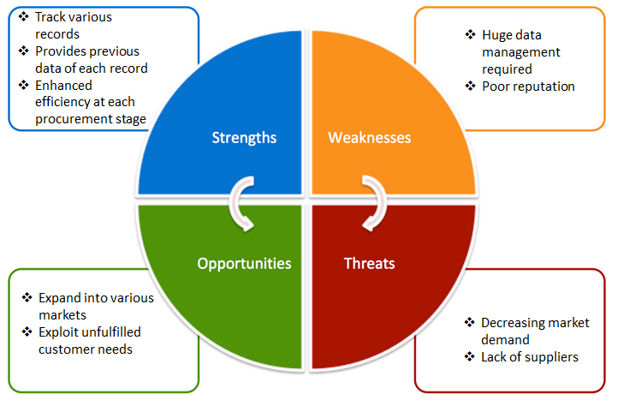

## 4W'S AND 1'H

## Who:

This software can be used in all schools, colleges and universities.

## What:

The system ensures overall student development, along with eliminating the tedious admin tasks. It is easy to maintain and manage an ERP system than a hand written file.

## Where:

This software can be used all across the globe.

## How:

Enhance the efficiency of schools in meeting their requirements and capabilities. Communicate the key information and advice for good ecosystem.

# DETAIL REQUIREMENTS

## High level requirements

|  |  |  |  |
| --- | --- | --- | --- |
| ID | Description | Category | Status |
| HR01 | User should be able to add a new diary record | Technical | Implemented |
| HR02 | User should be able to update diary record | Technical | Implemented |
| HR03 | User should be able to delete diary record | Technical | Implemented |
| HR04 | User should be able to read records | Technical | Implemented |

## Low level requirements

|  |  |  |  |
| --- | --- | --- | --- |
| **ID** | **Description** | **HLR ID** | **Status** |
| LR01 | While adding data enter password | HR01 | Implemented |
| LR02 | User should get the data from the records and update if required | HR02 | Implemented |
| LR03 | User should get the date of the record to delete the record | HR03 | Implemented |
| LR04 | User should be able to read the data by searching date or by printing all the available records | HR04 | Implemented |