Aim :

 To Design a system for car stereo systems such that whenever the increase volume button is pressed, a red background given by red LED blinks the number of times the button is pressed.

Apparatus :

Breadboard, Arduino UNO, Red LED, Push Button , Wires .

(Simulated the hardware and their functioning on TinkerCAD)

Circuit Diagram :

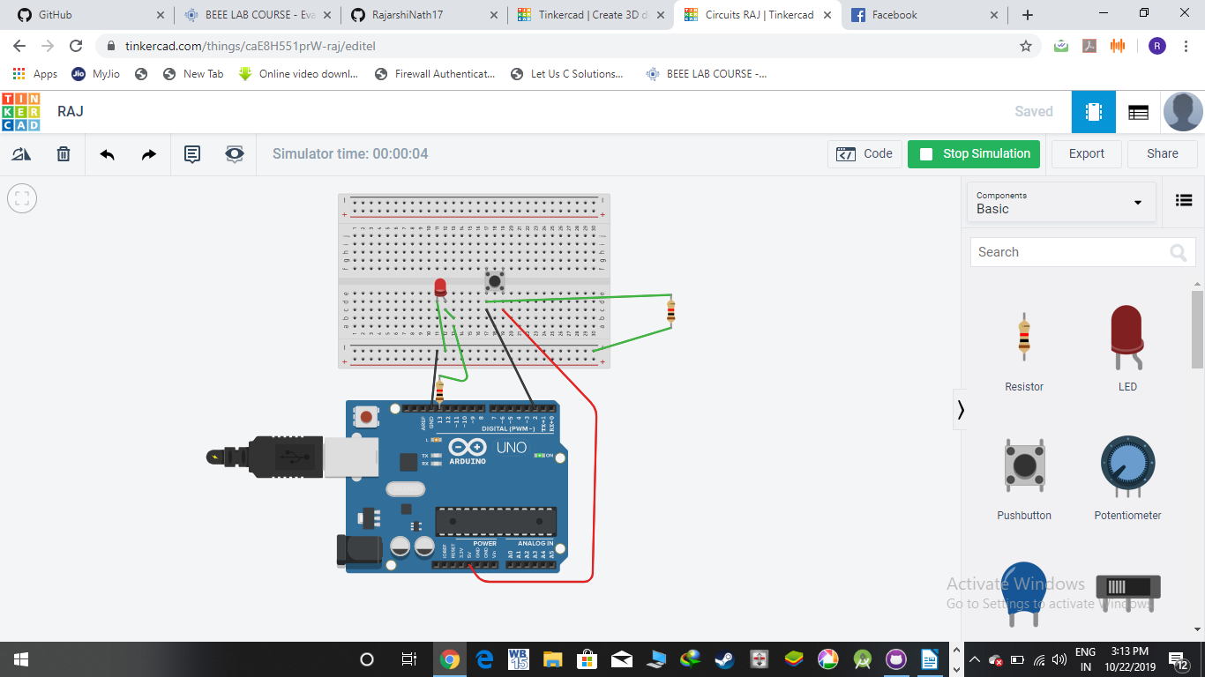

Working Code :

int BUTTON = 0;

void setup()

{

pinMode(13, OUTPUT);

pinMode(2, INPUT);

}

void loop()

{

digitalWrite(13, HIGH);

if (digitalRead(2) == HIGH) {

digitalWrite(13, LOW);

delay(200); // Wait for 200 millisecond(s)

}

else {

digitalWrite(13, HIGH);

delay(200); // Wait for 200 millisecond(s)

}

}

*/\* The Original File is attached in the repository with the file name raj.ino \**/

Theory

When we press the push putton or release it , the arduino receives the corresponding singnals and acts accordingly

Sources of Error :

Connectiond should be proper and tight.

Logic in the codes need to be properly established according to the problem.

Precautions :

Silly mistakes might be done due to lack of attention . This needs to be avoided.