**DESIGN PATTERNS AND PRINCIPLES**

1. **Implementing the singleton pattern:**

**CODE:**

class Logger

{

static Logger obj=new Logger();

private Logger()

{

}

public static Logger getInstance()

{

return obj;

}

}

class Main {

public static void main(String[] args) {

Logger obj1 = Logger.getInstance();

Logger obj2 = Logger.getInstance();

System.out.println("Are both objects same? " + (obj1 == obj2));

}

}

**OUTPUT:**

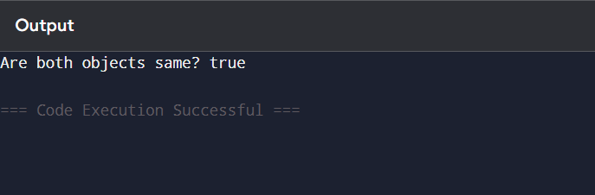

1. **Implementing the Factory Method Pattern.**

**CODE:**

interface Document {

void open();

void write();

void close();

}

class WordDocument implements Document {

public void open() {

System.out.println("Opening Word document.");

}

public void write() {

System.out.println("Writing in Word document.");

}

public void close() {

System.out.println("Closing Word document.");

}

}

class PdfDocument implements Document {

public void open() {

System.out.println("Opening PDF document.");

}

public void write() {

System.out.println("Writing in PDF document.");

}

public void close() {

System.out.println("Closing PDF document.");

}

}

class ExcelDocument implements Document {

public void open() {

System.out.println("Opening Excel document.");

}

public void write() {

System.out.println("Writing in Excel document.");

}

public void close() {

System.out.println("Closing Excel document.");

}

}

abstract class DocumentFactory {

public abstract Document createDocument();

}

class WordFactory extends DocumentFactory {

public Document createDocument() {

return new WordDocument();

}

}

class PdfFactory extends DocumentFactory {

public Document createDocument() {

return new PdfDocument();

}

}

class ExcelFactory extends DocumentFactory {

public Document createDocument() {

return new ExcelDocument();

}

}

class Main {

public static void main(String args[]) {

DocumentFactory wordFactory = new WordFactory();

Document wordDoc = wordFactory.createDocument();

wordDoc.open();

wordDoc.write();

wordDoc.close();

System.out.println();

DocumentFactory pdfFactory = new PdfFactory();

Document pdfDoc = pdfFactory.createDocument();

pdfDoc.open();

pdfDoc.write();

pdfDoc.close();

System.out.println();

DocumentFactory excelFactory = new ExcelFactory();

Document excelDoc = excelFactory.createDocument();

excelDoc.open();

excelDoc.write();

excelDoc.close();

}

}

**OUTPUT:**

