Project Proposal

AgentOps Control Tower for Autonomous Supply Chain Agents

A Governance, Risk, Audit, and Human-Oversight Layer for AI-driven Supply Chain Planning

1. Objective
The objective of this project is to build a proof-of-concept system that demonstrates how autonomous AI agents can be safely used in supply chain planning while being monitored, governed, risk-scored, and audited through an AgentOps Control Tower.
The project will simulate a supply chain scenario where AI agents respond to a demand spike by forecasting demand, checking inventory, recommending procurement, and suggesting logistics routes. Alongside this, a governance layer will track every agent action, evaluate policy violations, calculate risk scores, escalate high-risk decisions for human approval, and maintain an audit trail.
The goal is to show not only how AI agents can automate supply chain decisions, but also how enterprises can control and trust those agents before deploying them in real business workflows.

2. Problem Statement
Supply chain teams frequently face volatile demand, inventory shortages, supplier delays, logistics disruptions, and changing costs. Traditional supply chain planning is often manual, fragmented, slow to react, and difficult to audit across procurement, inventory, and logistics functions.
Autonomous AI agents can help by dynamically analyzing data and recommending actions such as procurement quantity, supplier selection, and delivery route. However, this introduces a new challenge: AI agents are not just generating answers; they may recommend or trigger business actions.
This creates important enterprise risks:
- Unauthorized data access
- Unapproved supplier selection
- High-value procurement without approval
- Missing explanation or source traceability
- Lack of audit trail
- Poor accountability for autonomous actions
- Tool misuse or policy violation by agents
Therefore, the core problem addressed by this project is:
How can enterprises safely monitor, govern, and audit autonomous AI agents before they make operational or financial decisions?

3. Proposed Solution
The proposed solution is an AgentOps Control Tower for Autonomous Supply Chain Agents.
The system will have two connected layers:

Layer 1: Autonomous Supply Chain Agent System
This layer performs the business planning workflow. It includes specialized AI agents for:
- Demand forecasting
- Inventory analysis
- Procurement recommendation
- Logistics route planning
- Overall workflow coordination

Layer 2: AgentOps Control Tower
This layer governs the agents. It monitors all agent actions and provides:
- Tool-call monitoring
- Data-access tracking
- Policy enforcement
- Risk scoring
- Human approval workflow
- Immutable-style audit logging
- Governance dashboard
Each agent action will be evaluated and classified as:
- Allow – action is safe and can proceed
- Escalate – action requires human approval
- Block – action violates policy and must not proceed

4. Project Scope
The project will focus on one clear end-to-end use case:

Use Case: Demand Spike Response with Governed Procurement and Logistics Planning
A supply chain planner provides a request such as:
“Demand for Product P-101 has increased in the South region. Check inventory, recommend procurement quantity, select the best supplier, and suggest a logistics route.”
The system will execute the following workflow:
1 Demand spike
2 → Forecast demand
3 → Check inventory
4 → Identify shortage
5 → Recommend supplier and procurement quantity
6 → Recommend logistics route
7 → Evaluate policies
8 → Calculate risk score
9 → Escalate if required
10 → Log all actions
11 → Display results on dashboard

In Scope
The MVP will include:
- Synthetic supply chain datasets
- Multi-agent workflow simulation
- Forecasting, inventory, procurement, and logistics agents
- Policy engine
- Risk scoring module
- Human approval queue
- Audit log database
- Streamlit dashboard
- Red-team test scenarios
- Exportable audit logs

Out of Scope for MVP
To keep the project feasible within the internship timeline, the following will not be included initially:
- Real ERP integration
- Real supplier/vendor API integration
- Real payment execution
- Real email sending
- Fine-tuned LLM
- Deep learning forecasting
- Production authentication
- Cloud deployment

5. High-Level Architecture
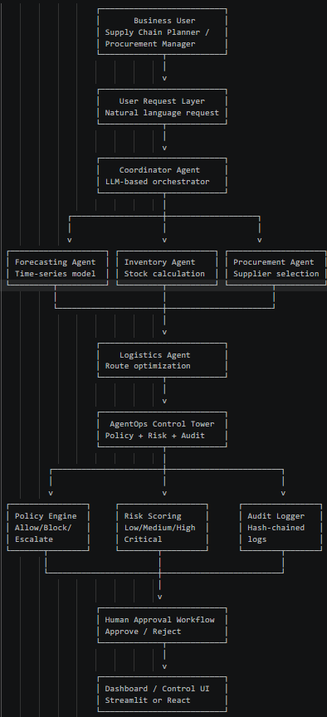
Coordinator Agent
Orchestrates the complete workflow and calls the relevant agents.
Forecasting Agent
Predicts demand using historical sales data.
Inventory Agent
Checks current stock, safety stock, and shortage quantity.
Procurement Agent
Recommends supplier, procurement quantity, cost, and lead time.
Logistics Agent
Suggests delivery route based on cost, distance, and disruption risk.
Policy Engine
Checks whether agent actions violate predefined rules.
Risk Scoring Engine
Assigns risk scores based on financial, operational, compliance, and data risks.
Audit Logger
Stores all agent actions, tool calls, policy decisions, and approval status.
Dashboard
Displays supply chain plan, agent activity, policy violations, approval queue, and audit trail.

6. Key Governance Policies
The MVP will include the following policy rules:
Policy Area | Rule | System Action
High-value procurement | Procurement above ₹50,000 requires approval | Escalate
Vendor compliance | Unapproved vendors cannot be selected | Block
Source traceability | Final recommendations must cite source data | Block
External communication | Supplier emails or external actions require approval | Escalate
Restricted data access | Agents cannot access HR/payroll data | Block
Route disruption | High-severity route disruption requires review | Escalate
These policies demonstrate how autonomous agents can be controlled before executing or recommending sensitive business actions.

7. Risk Scoring Approach
Each agent action will be assigned a risk score.
final_risk_score = min(calculated_score, 100)
Example risk factors:
1 Base score: 10
2
3 +30 if procurement value > ₹50,000 (Financial)
4 +40 if vendor is unapproved (Vendor Compliance)
5 +25 if external communication is attempted (External Action)
6 +30 if confidential data is accessed (Data access)
7 +20 if source citation is missing (Traceability)
8 +25 if route disruption exists (Operational)
9 +20 if forecast confidence is low (Model Confidence)
Risk levels:
1 0–30 Low
2 31–60 Medium
3 61–80 High
4 81–100 Critical
The final decision will be based on both policy rules and risk score.

8. Data and Resource Requirements
The MVP will primarily use synthetic data to avoid confidentiality issues and to make it easier to design controlled test scenarios.

Required Data Files
- products.csv
- sales_history.csv
- inventory.csv
- suppliers.csv
- routes.csv
- disruptions.csv
- agent_permissions.csv
- policy_rules.yaml

Technology Stack
Component | Proposed Tool
Programming language | Python
Dashboard | Streamlit
Database | SQLite
Data files | CSV
Policy rules | YAML
Forecasting | pandas / scikit-learn / statsmodels
Route logic | Custom route scoring or OR-Tools
Agent orchestration | Langgraph
LLM usage | Optional, for coordination and explanation
Audit logs | SQLite + CSV/JSON export

Compute Requirements
A GPU is not required for the MVP. The project can run on a normal laptop using CPU because the forecasting, policy checks, route scoring, dashboard, and database operations are lightweight.

9. Dashboard Scope
The dashboard will act as the AgentOps Control Tower and will include:
- Executive Overview
Total actions, allowed actions, blocked actions, escalations, pending approvals, and critical violations.
- Supply Chain Plan View
Forecasted demand, current stock, shortage, recommended supplier, procurement cost, route, and delivery time.
- Agent Activity Log
Timestamped record of agent actions, tools used, data accessed, risk score, and decision.
- Policy Violations
Details of triggered policies, severity, agent responsible, and decision.
- Human Approval Queue
Escalated actions that can be approved or rejected by a human reviewer.
- Audit Trail
Complete trace of agent actions with immutable-style logs.

10. Timeline
The project is planned for an 8-week internship window.
Week | Activity
Week 1 | Finalize scope, architecture, and risk taxonomy
Week 2 | Prepare synthetic data and policy rules
Week 3 | Build forecasting, inventory, procurement, and logistics agents
Week 4 | Build coordinator workflow and structured outputs
Week 5 | Build policy engine, risk scoring, audit logger, and approval workflow
Week 6 | Build Streamlit dashboard
Week 7 | Add red-team scenarios, audit enhancements, and export functionality
Week 8 | Polish demo, prepare documentation, final presentation, and POV deck

11. Expected Deliverables

Technical Deliverables
- Working multi-agent supply chain workflow
- Policy engine
- Risk scoring module
- Human approval workflow
- SQLite audit log database
- Streamlit dashboard
- Red-team scenario tests
- Exportable audit logs
- README and setup guide

Consulting Deliverables
- Problem statement
- Architecture diagram
- Agentic AI risk taxonomy
- Governance control framework
- Demo script
- Red-team testing report
- Final presentation deck
- Future roadmap

12. Expected Outcome
By the end of the internship, the project will demonstrate a working prototype where autonomous supply chain agents can generate a response plan for a demand spike while being continuously monitored and governed by an AgentOps Control Tower.
The expected outcome is a system that shows:
- How AI agents can support supply chain planning
- How agent actions can be tracked and audited
- How risky actions can be blocked or escalated
- How human approval can be integrated into agentic workflows
- How enterprises can operationalize AI agents responsibly
The final demo will show a scenario where a demand spike leads to a procurement recommendation above ₹50,000. The AgentOps Control Tower detects the risk, escalates the action for approval, logs the full decision trail, and displays everything through the dashboard.

13. Project Value
This project is relevant because it combines:
- AI engineering through multi-agent workflows
- Supply chain domain knowledge through demand, inventory, procurement, and logistics planning
- Governance and risk management through policies, approvals, and audit logs
- Enterprise AI readiness through observability, control, and accountability
Most AI agent demos focus only on automation. This project focuses on the missing enterprise layer:
How can organizations trust, monitor, and govern autonomous AI agents that act on business processes?

Final Proposal Summary
This project will build an AgentOps Control Tower for Autonomous Supply Chain Agents. The system will simulate a demand spike response workflow where AI agents forecast demand, check inventory, recommend procurement, and suggest logistics routes. A governance layer will monitor every action, apply policy rules, calculate risk scores, escalate high-risk decisions, and maintain audit logs. The prototype will demonstrate how enterprises can safely operationalize agentic AI in supply chain planning through observability, policy enforcement, human oversight, and auditability.

