Connection.js

const mysql = require("mysql")

const con = mysql.createConnection({

    host: "localhost",

    user: "root",

    password: "admin",

    database: "infosys",

    port: 3306

});

con.connect((err) => {

    if (err) throw err;

    console.log("Connection created..!!");

});

module.exports.con = con;

main.js

const express = require("express")

const app = express();

const port = 3006;

const mysql=require("./connection").con

//configuration

app.set("view engine","hbs");

app.set("views", "./view");

//Routing

app.get("/",(req,res)=>{

    res.render("index")

});

app.get("/add", (req, res) => {

    res.render("add")

});

app.get("/search1", (req, res) => {

    res.render("search1")

});

app.get("/search2", (req, res) => {

    res.render("search2")

});

app.get("/update", (req, res) => {

    res.render("update")

});

app.get("/delete", (req, res) => {

    res.render("delete")

});

app.get("/view", (req, res) => {

    let qry = "select * from spring";

    mysql.query(qry, (err, results) => {

        if (err) throw err

        else {

            res.render("view", { data: results });

        }

    });

});

app.get("/addstudent", (req, res) => {

    // fetching data from form

    const { eid, ename, empdesig, empdept, empsal, emploc } = req.query

    // Sanitization XSS...

    let qry = "select * from spring where eid=?";

    mysql.query(qry, [eid], (err, results) => {

        if (err)

            throw err

        else {

            if (results.length > 0) {

                res.render("add", { checkmesg: true })

            } else {

                // insert query

                let qry2 = "insert into spring values(?,?,?,?,?,?)";

                mysql.query(qry2, [eid, ename, empdesig, empdept, empsal, emploc], (err, results) => {

                    if (results.affectedRows > 0) {

                        res.render("add", { mesg: true })

                    }

                })

            }

        }

    })

});

app.get("/updatesearch", (req, res) => {

    // fetching data from form

    const { eid } = req.query;

    let qry = "select * from spring where eid=?";

    mysql.query(qry, [eid], (err, results) => {

        if (err) throw err

        else {

            if (results.length > 0) {

                res.render("update", { mesg1: true, mesg2: false, data: results })

            } else {

                res.render("update", { mesg1: false, mesg2: true })

            }

        }

    });

})

app.get("/updatestudent", (req, res) => {

    // fetching data from form

    const { eid, emploc } = req.query;

    let qry="update spring set emploc=? where eid=?";

    mysql.query(qry, [eid, emploc], (err, results) => {

        if (err) throw err

        else {

            if (results.affectedRows > 0) {

                res.render("update", { umesg: true })

            }

        }

    })

})

app.get("/removestudent", (req, res) => {

    // fetch data from the form

    const { eid } = req.query;

    let qry = "delete from spring where eid=?";

    mysql.query(qry, [eid], (err, results) => {

        if (err) throw err

        else {

            if (results.affectedRows > 0) {

                res.render("delete", { mesg1: true, mesg2: false })

            } else {

                res.render("delete", { mesg1: false, mesg2: true })

            }

        }

    });

});

app.listen(port,(err)=>{

    if(err)

        throw err

    else

        console.group("Server running at %d port",port);

});

app.get("/searchstudentbyphno", (req, res) => {

    // fetch data from the form

    const { empdept } = req.query;

    let qry = "select * from spring where empdept=?";

    mysql.query(qry, [empdept], (err, results) => {

        if (err) throw err

        else {

            if (results.length > 0) {

                res.render("search1", { mesg1: true, mesg2: false })

            } else {

                res.render("search1", { mesg1: false, mesg2: true })

            }

        }

    });

})

app.get("/searchstudentbysal", (req, res) => {

    // fetch data from the form

    const { empdept,empsal } = req.query;

    let qry = "select * from spring where empdept=? and empsal>120000";

    mysql.query(qry, [empdept, empsal], (err, results) => {

        if (err) throw err

        else {

            if (results.length > 0) {

                res.render("search2", { mesg1: true, mesg2: false })

            } else {

                res.render("search2", { mesg1: false, mesg2: true })

            }

        }

    });

})

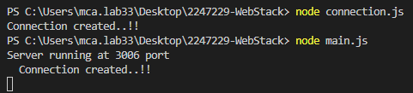

Index.html

<!doctype html>

<html>

<head>

  <script src="https://cdnjs.cloudflare.com/ajax/libs/angular.js/1.4.7/angular.min.js"></script>

  <script src="https://cdnjs.cloudflare.com/ajax/libs/angular.js/1.4.7/angular-route.min.js"></script>

  <style>

        @import url('https://fonts.googleapis.com/css2?family=Poppins&display=swap');

    *{

      padding: 0;

      margin: 0;

      box-sizing: border-box;

      font-family: 'Poppins';

      background-color: #A3D4D1;

    }

    h1{

      margin: 2rem;

      text-align: center;

      font-family: 'Times New Roman', Times, serif;

      font-weight: 600;

      font-size: 3.5rem;

      color: blueviolet;

    }

    h2{

      margin: 1rem;

      text-align: center;

      font-family: 'Times New Roman', Times, serif;

      font-weight: 600;

      font-size: 2rem;

      color: blueviolet;

    }

    .options{

      padding: 1.5rem;

      margin-top: 1rem;

      text-align: center;

    }

    a{

      text-decoration: none;

    }

    .links {

      align-items: center;

      padding: 10px;

      cursor: pointer;

      font-size: 25px;

      color: black;

    }

    .links:hover {

      align-items: center;

      border-radius: 10px;

      transition: all 0.3s ease;

      font-size: 35px;

      color: red;

    }

  </style>

</head>

<body>

  <h1>INFOSIS SPRINGBOARD</h1>

  <h2>Click on the following links to see the working of each operations of employee</h2>

  <div class="options">

    <a href="/add">

      <div class="links">

        <span class="material-icons">Add Employee</span>

      </div>

    </a>

    <a href="/search1">

      <div class="links">

        <span class="material-icons">Search Employee by Department</span>

      </div>

    </a>

    <a href="/search2">

      <div class="links">

        <span class="material-icons">Search Employee by Department and Salary</span>

      </div>

    </a>

    <a href="/delete">

      <div class="links">

        <span class="material-icons">Delete Employee</span>

      </div>

    </a>

    <a href="/update">

      <div class="links">

        <span class="material-icons">Update Employee</span>

      </div>

    </a>

    <a href="/view">

      <div class="links">

        <span class="material-icons">View Employee</span>

      </div>

    </a>

  </div>

</body>

</html>

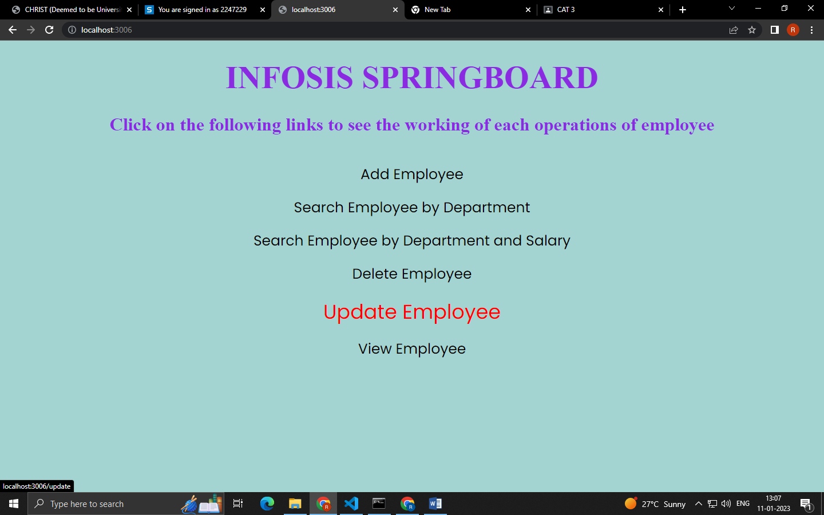

Add.hbs

<!DOCTYPE html>

<html lang="en">

<head>

    <meta charset="UTF-8">

    <meta http-equiv="X-UA-Compatible" content="IE=edge">

    <meta name="viewport" content="width=device-width, initial-scale=1.0">

    <title>Add Records</title>

    <style>

      *{

        padding: 0;

        margin: 0;

        box-sizing: border-box;

        font-family: 'Poppins';

        background-color: #A3D4D1;

      }

      h1{

        margin: 2rem;

        text-align: center;

        font-family: 'Times New Roman', Times, serif;

        font-weight: 600;

        font-size: 3.5rem;

        color: blueviolet;

      }

      h2{

      margin: 1rem;

      text-align: center;

      font-family: 'Times New Roman', Times, serif;

      font-weight: 600;

      font-size: 2rem;

      color: blueviolet;

        }

      .container{

        padding: 1.5rem;

        margin: 2rem;

        text-align: center;

        font-family: 'Times New Roman', Times, serif;

      }

      label,input{

        margin-bottom: 1.5rem;

        font-family: 'Times New Roman', Times, serif;

        font-weight: 600;

        font-size: 25px;

      }

      .registerbtn{

        padding: 1rem;

        font-size: 15px;

        font-weight: 600;

        cursor: pointer;

      }

      .registerbtn:hover{

        padding: 1.5rem;

        background-color: aliceblue;

        transition: 3ms ease-in-out;

      }

      a{

        text-decoration: none;

        font-weight: 600;

        font-size: 25px;

      }

      a:hover{

        font-size: 30px;

        transition: 3ms ease-in-out;

      }

    </style>

</head>

<body>

    <h1>INFOSYS SPRINGBOARD</h1>

  <h2>ADD EMPLOYEE</h2>

    <div class="container">

       <form action="/addstudent" onsubmit="validate()">

    <label for="eid"><b>Employee ID</b></label>

    <input type="text" placeholder="Enter EmpID" name="eid" id="eid" required>

    <br>

    <label for="ename"><b>Employee name</b></label>

    <input type="text" placeholder="Enter EmpName" name="ename" id="ename" required>

    <br>

    <label for="empdesig"><b>Employee Designation</b></label>

    <input type="text" placeholder="Enter EmpDesignation" name="empdesig" id="empdesig" required>

    <br>

    <label for="empdept"><b>Employee Department</b></label>

    <input type="text" placeholder="Enter EmpDepartment" name="empdept" id="empdept" required>

    <br>

    <label for="empsal"><b>Employee Salary</b></label>

    <input type="number" placeholder="Enter EmpSalary" name="empsal" id="empsal" required>

    <br>

    <label for="emploc"><b>Employee Location</b></label>

    <input type="text" placeholder="Enter EmpLocation" name="emploc" id="emploc" required>

    <br>

    <button type="submit" class="registerbtn">ADD EMPLOYEE</button>

  <br>

  <br>

    <a href="./" style="color:black">BACK TO HOME PAGE</a> <br>

     {{#if mesg}}

     <h1>Data Inserted</h1>

     {{/if}}

      {{#if checkmesg}}

     <h1>Emailid or Phoneno already present!</h1>

     {{/if}}

</form>

</div>

<script>

  function validate()

    {

      validate_username();

      checkphone();

    }

  function validate_username()

    {

      var usr=document.getElementById("ename").value;

      var testcase = /^[a-zA-z]+$/;

      if(!testcase.test(usr))

      {

        document.getElementById('ename').style.border="1px solid red";

      window.alert("Invalid username. Try to put all characters");

      event.preventDefault();

      }

    }

</script>

</body>

</html>

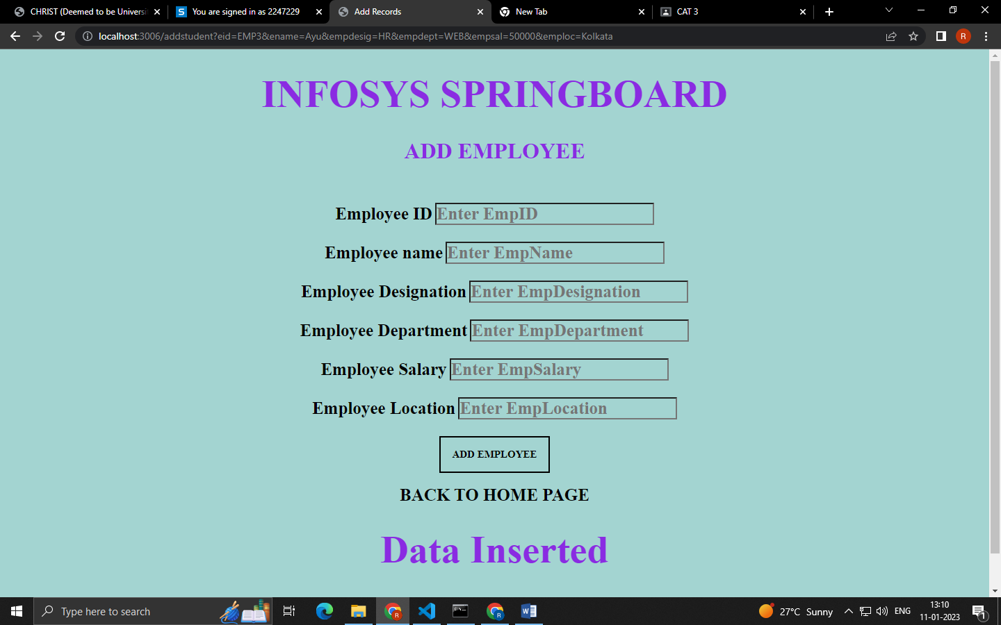



View.hbs

<!DOCTYPE html>

<html lang="en">

<head>

    <meta charset="UTF-8">

    <meta http-equiv="X-UA-Compatible" content="IE=edge">

    <meta name="viewport" content="width=device-width, initial-scale=1.0">

    <title>View</title>

    <style>

      *{

        padding: 0;

        margin: 0;

        box-sizing: border-box;

        font-family: 'Poppins';

        background-color: #A3D4D1;

        text-align: center;

      }

      h1{

        margin: 2rem;

        text-align: center;

        font-family: 'Times New Roman', Times, serif;

        font-weight: 600;

        font-size: 3.5rem;

        color: blueviolet;

      }

      .registerbtn{

        padding: 1rem;

        font-size: 15px;

        font-weight: 600;

        cursor: pointer;

      }

      .registerbtn:hover{

        padding: 1.5rem;

        background-color: aliceblue;

        transition: 3ms ease-in-out;

      }

      a{

        text-decoration: none;

        font-weight: 600;

        font-size: 25px;

      }

      a:hover{

        font-size: 30px;

        transition: 3ms ease-in-out;

      }

      table{

        width: 75%;

        margin: 2rem auto;

        border-collapse: collapse;

      }

    th{

            text-align: center;

            font-size: 25px;

            font-weight: 600;

            background-color: darkgoldenrod;

            color: white;

            padding: 25px;

        }

    td{

            text-align: center;

            font-size: 20px;

            font-weight: 400;

            background-color: white;

            color: black;

            padding: 25px;

        }

    </style>

</head>

<body>

<h1>VIEW INFOSYS SPRINGBOARD EMPLOYEE</h1>

    <table>

    <thead>

        <tr>

        <th scope="col">Emp_ID</th>

        <th scope="col">Emp_Name</th>

        <th scope="col">Emp_Designation</th>

        <th scope="col">Emp_Department</th>

        <th scope="col">Emp_Salary</th>

        <th scope="col">Emp_Location</th>

        </tr>

    </thead>

    <tbody>

        {{#data}}

        <tr>

        <td>{{eid}}</td>

        <td>{{ename}}</td>

        <td>{{empdesig}}</td>

        <td>{{empdept}}</td>

        <td>{{empsal}}</td>

        <td>{{emploc}}</td>

        </tr>

        {{/data}}

    </tbody>

    </table>

      <a href="./">BACK TO HOME PAGE</a> <br>

</body>

</html>

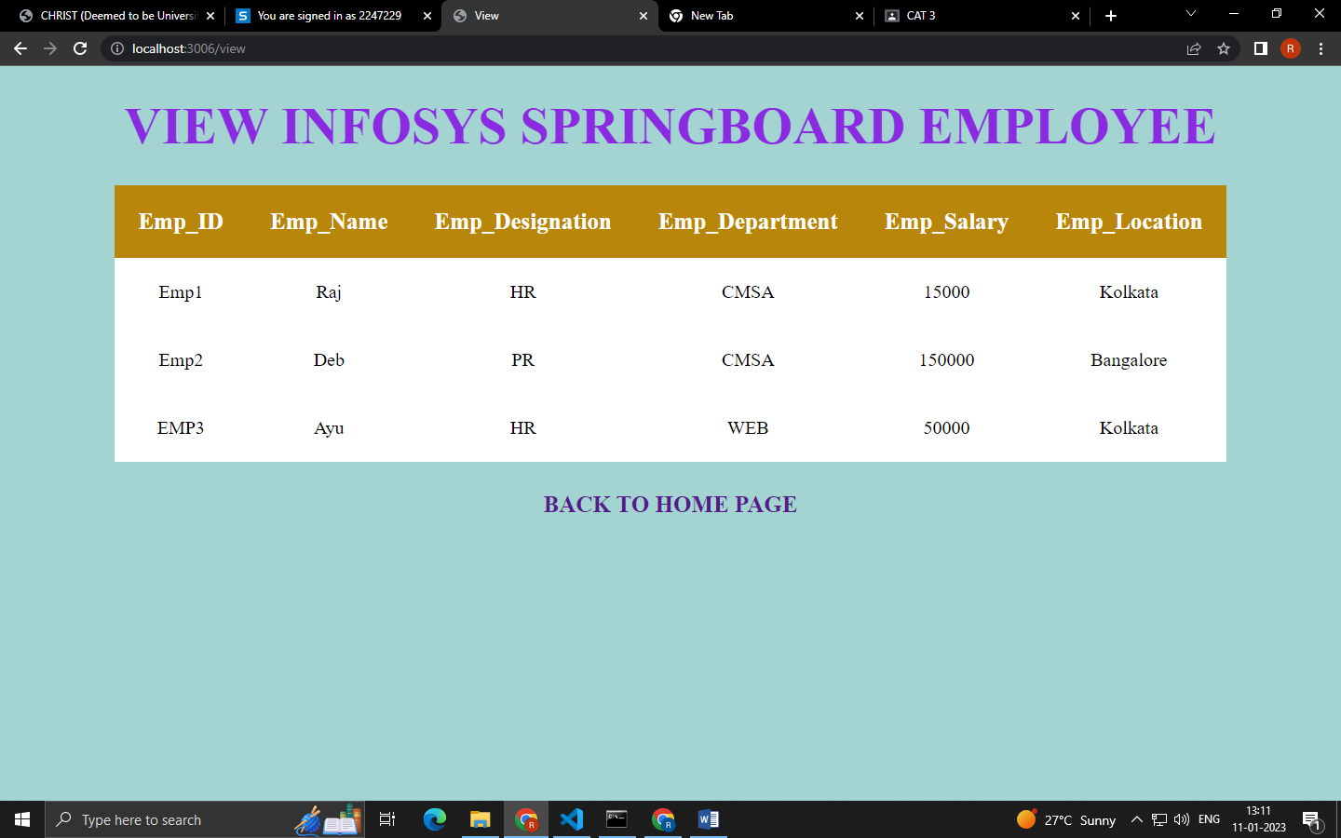

Delete.hbs

<!DOCTYPE html>

<html lang="en">

<head>

    <meta charset="UTF-8">

    <meta http-equiv="X-UA-Compatible" content="IE=edge">

    <meta name="viewport" content="width=device-width, initial-scale=1.0">

    <title>Delete</title>

    <style>

      *{

        padding: 0;

        margin: 0;

        box-sizing: border-box;

        font-family: 'Poppins';

        background-color: #A3D4D1;

      }

      h1{

        margin: 2rem;

        text-align: center;

        font-family: 'Times New Roman', Times, serif;

        font-weight: 600;

        font-size: 3.5rem;

        color: blueviolet;

      }

      h2{

      margin: 1rem;

      text-align: center;

      font-family: 'Times New Roman', Times, serif;

      font-weight: 600;

      font-size: 2rem;

      color: blueviolet;

        }

      .container{

        padding: 1.5rem;

        margin: 2rem;

        text-align: center;

        font-family: 'Times New Roman', Times, serif;

      }

      label,input{

        margin-bottom: 1.5rem;

        font-family: 'Times New Roman', Times, serif;

        font-weight: 600;

        font-size: 25px;

      }

      .registerbtn{

        padding: 1rem;

        font-size: 15px;

        font-weight: 600;

        cursor: pointer;

      }

      .registerbtn:hover{

        padding: 1.5rem;

        background-color: aliceblue;

        transition: 3ms ease-in-out;

      }

      a{

        text-decoration: none;

        font-weight: 600;

        font-size: 25px;

      }

      a:hover{

        font-size: 30px;

        transition: 3ms ease-in-out;

      }

    </style>

</head>

<body>

    <h1>INFOSYS SPRINGBOARD</h1>

  <h2>DELETE EMPLOYEE </h2>

    <div class="container">

      <form action="/removestudent">

    <label for="EID"><b>Employee ID</b></label>

    <input type="text" placeholder="type employee id" name="eid" id="eid" required>

    <br>

    <button type="submit" class="registerbtn">DELETE EMPLOYEE</button>

    <br><br>

    <a href="./" style="color:black">BACK TO HOME PAGE</a>

    <br>

    {{#if mesg1}}

    <h1>Data deleted!</h1>

    {{/if}}

     {{#if mesg2}}

    <h1>Employee Data Not found!</h1>

    {{/if}}

    </form>

  </div>

</body>

</html>

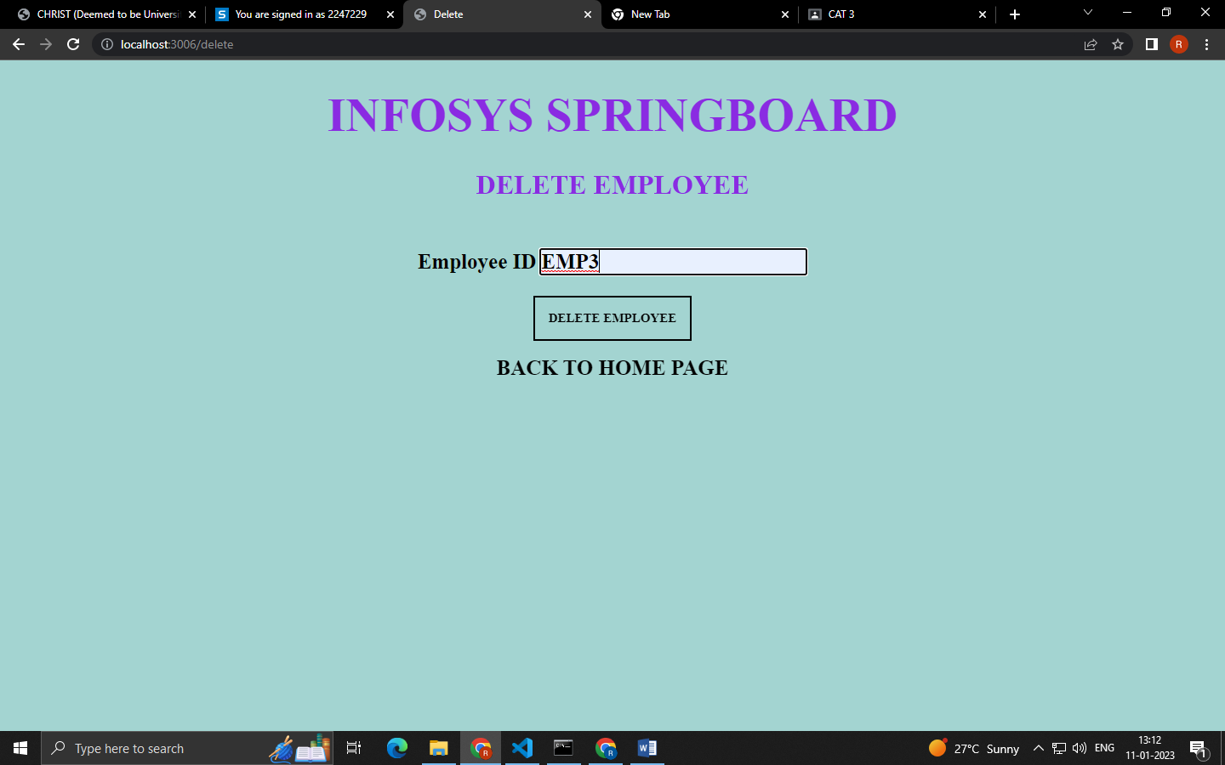

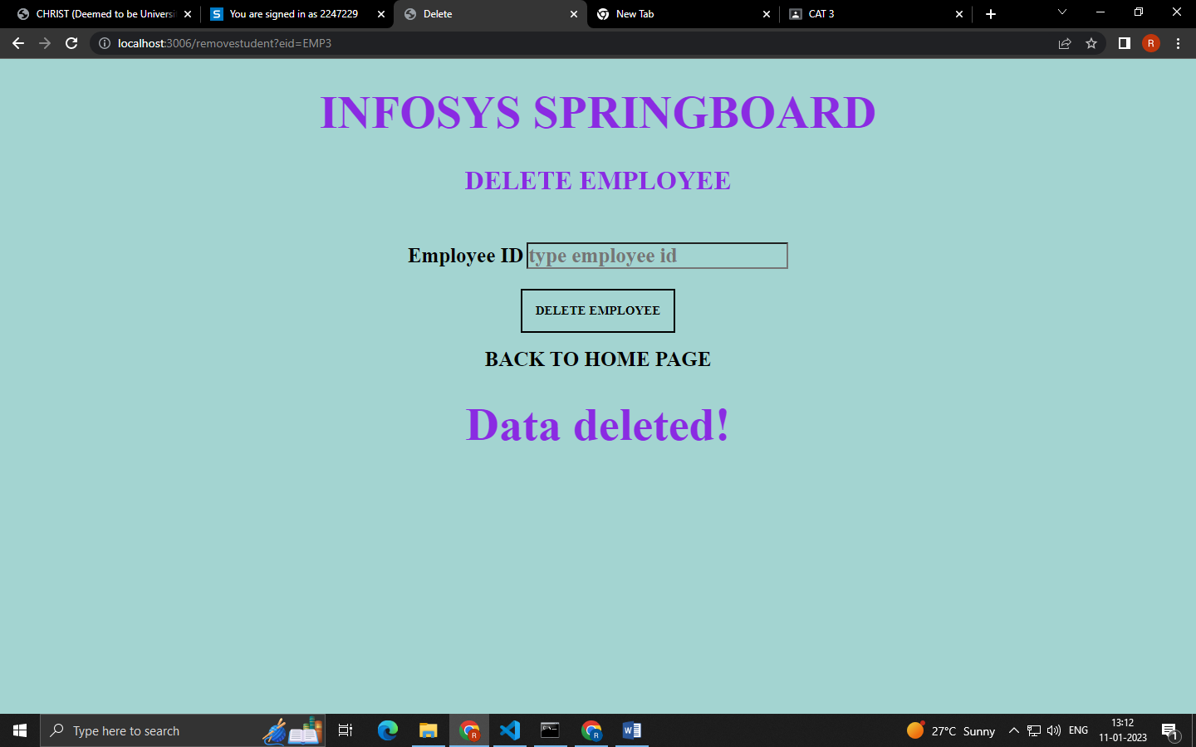

Search.hbs

<!DOCTYPE html>

<html lang="en">

<head>

    <meta charset="UTF-8">

    <meta http-equiv="X-UA-Compatible" content="IE=edge">

    <meta name="viewport" content="width=device-width, initial-scale=1.0">

    <title>Search</title>

    <style>

      *{

        padding: 0;

        margin: 0;

        box-sizing: border-box;

        font-family: 'Poppins';

        background-color: #A3D4D1;

      }

      h1{

        margin: 2rem;

        text-align: center;

        font-family: 'Times New Roman', Times, serif;

        font-weight: 600;

        font-size: 3.5rem;

        color: blueviolet;

      }

      h2{

      margin: 1rem;

      text-align: center;

      font-family: 'Times New Roman', Times, serif;

      font-weight: 600;

      font-size: 2rem;

      color: blueviolet;

        }

      .container{

        padding: 1.5rem;

        margin: 2rem;

        text-align: center;

        font-family: 'Times New Roman', Times, serif;

      }

      label,input{

        margin-bottom: 1.5rem;

        font-family: 'Times New Roman', Times, serif;

        font-weight: 600;

        font-size: 25px;

      }

      .registerbtn{

        padding: 1rem;

        font-size: 15px;

        font-weight: 600;

        cursor: pointer;

      }

      .registerbtn:hover{

        padding: 1.5rem;

        background-color: aliceblue;

        transition: 3ms ease-in-out;

      }

      a{

        text-decoration: none;

        font-weight: 600;

        font-size: 25px;

      }

      a:hover{

        font-size: 30px;

        transition: 3ms ease-in-out;

      }

    </style>

</head>

<body>

    <h1>INFOSYS SPRINGBOARD</h1>

  <h2>SEARCH EMPLOYEE</h2>

    <div class="container">

      <form action="/searchstudentbyphno">

    <label for="empdept"><b>Employee Department</b></label>

    <input type="text" placeholder="type emp department" name="empdept" id="empdept" required>

    <br>

    <button type="submit" class="registerbtn">SEACRH EMPLOYEE</button>

    <br><br>

    <a href="./" style="color:black">BACK TO HOME PAGE</a>

    <br>

     {{#if mesg1}}

     <h1>Data Found!</h1>

     <a href="/view">

      <div class="links">

        <span class="material-icons">View Employee</span>

      </div>

     {{/if}}

     {{#if mesg2}}

     <h1>Data Not Found!</h1>

     {{/if}}

    </form>

  </div>

</body>

</html>

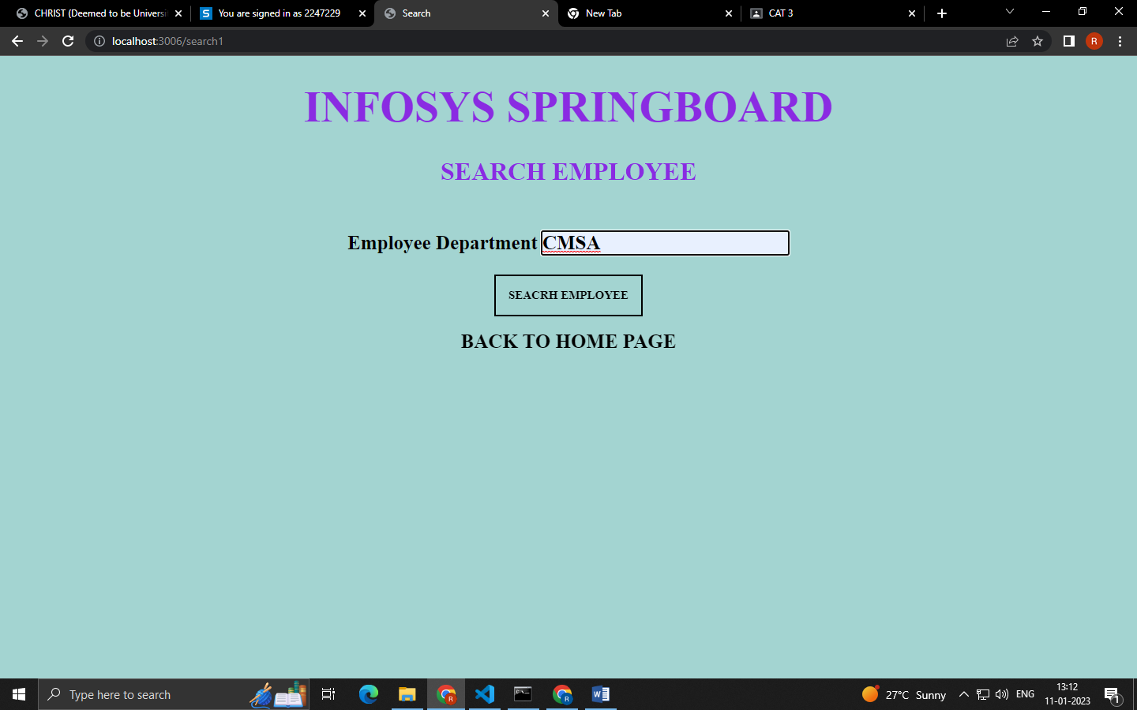

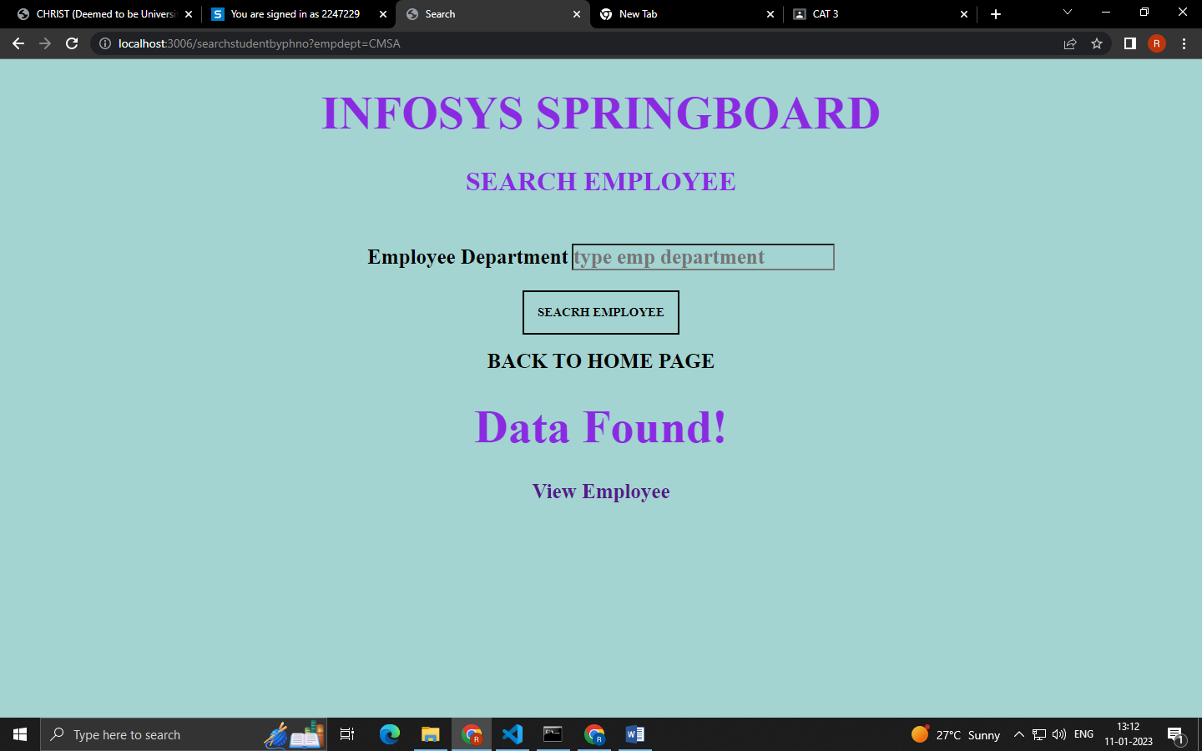

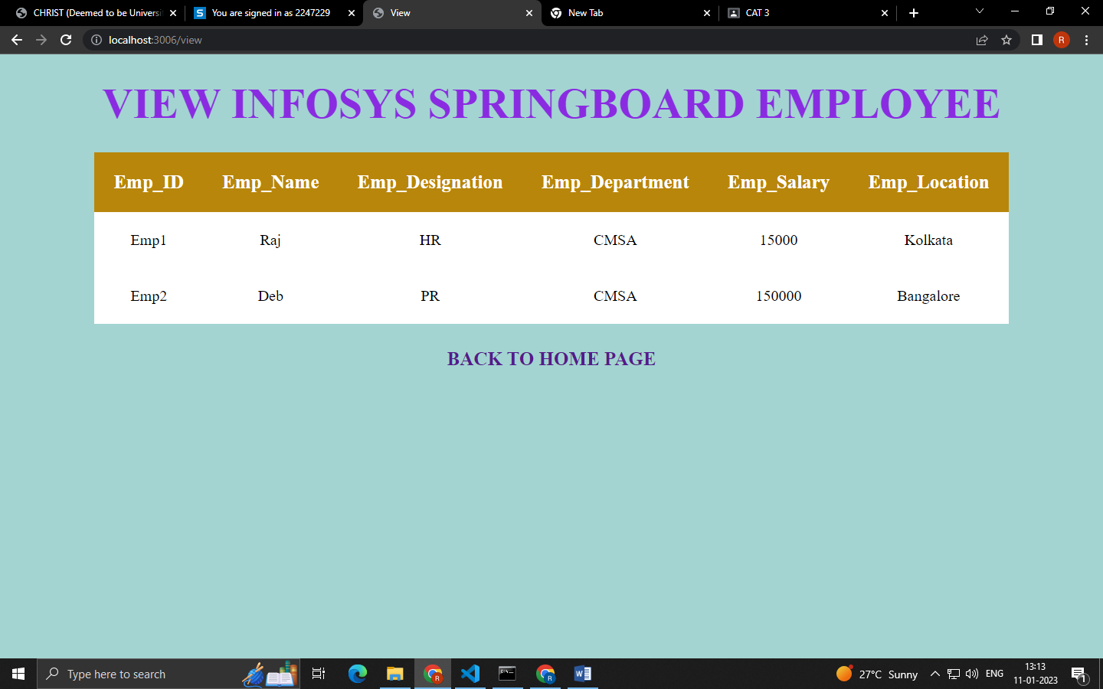

Update.hbs

<!DOCTYPE html>

<html lang="en">

<head>

    <meta charset="UTF-8">

    <meta http-equiv="X-UA-Compatible" content="IE=edge">

    <meta name="viewport" content="width=device-width, initial-scale=1.0">

    <title>Update</title>

    <style>

      *{

        padding: 0;

        margin: 0;

        box-sizing: border-box;

        font-family: 'Poppins';

        background-color: #A3D4D1;

      }

      h1{

        margin: 2rem;

        text-align: center;

        font-family: 'Times New Roman', Times, serif;

        font-weight: 600;

        font-size: 3.5rem;

        color: blueviolet;

      }

      h2{

      margin: 1rem;

      text-align: center;

      font-family: 'Times New Roman', Times, serif;

      font-weight: 600;

      font-size: 2rem;

      color: blueviolet;

        }

      .container{

        padding: 1.5rem;

        margin: 2rem;

        text-align: center;

        font-family: 'Times New Roman', Times, serif;

      }

      label,input{

        margin-bottom: 1.5rem;

        font-family: 'Times New Roman', Times, serif;

        font-weight: 600;

        font-size: 25px;

      }

      .registerbtn{

        padding: 1rem;

        font-size: 15px;

        font-weight: 600;

        cursor: pointer;

      }

      .registerbtn:hover{

        padding: 1.5rem;

        background-color: aliceblue;

        transition: 3ms ease-in-out;

      }

      a{

        text-decoration: none;

        font-weight: 600;

        font-size: 25px;

      }

      a:hover{

        font-size: 30px;

        transition: 3ms ease-in-out;

      }

    </style>

</head>

<body>

    <h1>INFOSYS SPRINGBOARD</h1>

  <h2>UPDATE EMPLOYEE</h2>

    <div class="container">

      <form action="/updatesearch">

    <label for="eid"><b>Employee ID</b></label>

    <input type="text" placeholder="type employee id" name="eid" id="eid" required>

    <br>

    <button type="submit" class="registerbtn">SEACRH EMPLOYEE</button>

    <br><br>

    {{#if umesg}}

    <h1>Data Updated</h1>

    {{/if}}

     {{#if mesg2}}

     <h1>Data Not Found!</h1>

     {{/if}}

     <br>

    <a href="./" style="color:black">BACK TO HOME PAGE</a>

    <br>

    </form>

  </div>

  {{#if mesg1}}

  <h2>UPDATE SEARCHED EMPLOYEE</h2>

     <div class="container">

       <form action="/updatestudent">

    {{#data}}

    <label for="eid"><b>Employee ID</b></label>

    <input type="text" placeholder="Enter EmpID" name="eid" value={{eid}} id="eid" required readonly>

    <br>

    <label for="ename"><b>Employee name</b></label>

    <input type="text" placeholder="Enter EmpName" name="ename" value={{ename}} id="ename" required readonly>

    <br>

    <label for="empdesig"><b>Employee Designation</b></label>

    <input type="text" placeholder="Enter EmpDesignation" name="empdesig" value={{empdesig}} id="empdesig" required readonly>

    <br>

    <label for="empdept"><b>Employee Department</b></label>

    <input type="text" placeholder="Enter EmpDepartment" name="empdept" id="empdept" value={{empdept}} required readonly>

    <br>

    <label for="empsal"><b>Employee Salary</b></label>

    <input type="number" placeholder="Enter EmpSalary" name="empsal" id="empsal" value={{empsal}} required readonly>

    <br>

    <label for="emploc"><b>Employee Location</b></label>

    <input type="text" placeholder="Enter EmpLocation" name="emploc" id="emploc"  required>

    <br>

    <button type="submit" class="registerbtn">UPDATE EMPLOYEE</button>

  <br>

  <br>

    <a href="./" style="color:black">BACK TO HOME PAGE</a> <br>

    {{/data}}

</form>

</div>

     {{/if}}

</body>

</html>

