**Pariksha, A Quiz Web Application**

**Project report in partial fulfillment of the requirement for the award of the degree of**

**Bachelor of Technology**

**In**

**Computer Science**

**Submitted By**

Rajarshi Das Enrollment No. 12021002023013

Subham Garain Enrollment No. 12021002022079

Diya Sri Enrollment No. 12021002022065

Isha Jha Enrollment No. 12021002023079

Ayan Ghosh Enrollment No. 12021002023067

Pratik Srivastav Enrollment No. 12021002022031

**Under the guidance of**

Prof. Dr. Subhalaxmi Chakraborty

Department of Computer Science and Technology & Computer Science and Information Technology (CST & CSIT)



UNIVERSITY OF ENGINEERING & MANAGEMENT, KOLKATA

University Area, Plot No. III – B/5, New Town, Action Area – III, Kolkata – 700160.

**CERTIFICATE**

This is to certify that the project titled **Pariksha, A Quiz Web Application** submitted by **Rajarshi Das (University Roll No. 12021002023013),** **Subham Garain (University Roll No. 12021002022079)**, **Diya Sri (University Roll No. 12021002022065), Isha Jha (University Roll No. 12021002023079)**, **Ayan Ghosh (University Roll No. 12021002023067) and Pratik Srivastav (University Roll No. 12021002022031)** students of UNIVERSITY OF ENGINEERING and MANAGEMENT, KOLKATA, in partial fulfillment of requirement for the degree of Bachelor of Computer Science, is a bonafide work carried out by them under the supervision and guidance of Prof. Dr. Subhalaxmi Chakraborty during 5th Semester of academic session of 2023 - 2024. The content of this report has not been submitted to any other university or institute. I am glad to inform that the work is entirely original and its performance is found to be quite satisfactory.

_________________________________

Signature of Guide

___________________________________

Signature of Head of the Department

**ACKNOWLEDGEMENT**

We would like to take this opportunity to thank everyone whose cooperation and encouragement throughout the ongoing course of this project remains invaluable to us.

We are sincerely grateful to our guide Prof. Dr. Subhalaxmi Chakraborty of the Department of CST & CSIT, UEM, Kolkata, for her wisdom, guidance and inspiration that helped us to go through with this project and take it to where it stands now.

Last but not the least, we would like to extend our warm regards to our families and peers who have kept supporting us and always had faith in our work.

Rajarshi Das

Subham Garain

Diya Sri

Isha Jha

Ayan Ghosh

Pratik Srivastav

**TABLE OF CONTENTS**

**ABSTRACT..................................................................................1**

**CHAPTER – 1: INTRODUCTION...........................................................2**

**CHAPTER – 2: LITERATURE SURVEY**

**2.1 Web Application Architecture ..................................................3**

**2.2 Tools and technologies Used .............................................4**

**CHAPTER – 3: PROBLEM STATEMENT**

**3.1 Objective……………….....................................................5**

**CHAPTER – 4: PROPOSED IMPLEMENTATION**

**4.1 Enhanced – Entity Relationship Diagram ..................6**

**4.2 Use Case Diagram...........................................................7**

**CHAPTER – 5: EXPERIMENTAL IMPLEMENTATION**

**5.1 Implementation.............................................................8 - 10**

**CHAPTER – 6: CONCLUSION & FUTURE SCOPE**

**6.1 Conclusion .....................................................................11**

**6.2 Limitations of the work and Future scope .................12**

**BIBLIOGRAPHY ..........................................................................16**

**ABSTRACT**

Currently, every Educational institute be it school or university, is focusing on online education where they are starting to take classes in online mode. Also, providing a way of online Education. Here we are introducing an online quiz application where student can attempt a quiz and enhance there skills.

The Pariksha (A Quiz Web Application) is a web application for taking an online quiz in an efficient manner and no time wasting checking the paper. The main objective of Pariksha is to efficiently evaluate the candidate thoroughly through a fully automated system which not only saves lot of time but also gives fast results. students can attend Quiz according to their convenience and time and there is no need of using extra thing like paper, pen etc.

This can be used in educational institutions as well as in corporate world. It’s also use-full for student they can give those quiz for practice or we can use anywhere any time as it is a web-based Application (user location doesn’t matter). No restriction that examiner has to be present when the candidate takes the test.

This Web Application provides facility to conduct online quiz from worldwide. It saves time as it allows a number of students to give the exam at a time and displays the results as the test gets over, so no need to wait for the result. It is automatically generated by the server. The administrator has the privilege to create, modify and delete the Quiz, questions of the quiz, Categories of the Quiz, and also evaluate different contexts. Students can see their results and other activity where a student not only judges their knowledge/skill but they can improve their knowledge/skill at the same time.

Pariksha is quite light weight and the UI is also user friendly, which makes it the best online quiz application for organizing quizzes for the class by the proffessors.

**INTRODUCTION**

Pariksha is a web application which can run on the browser be it desktop or a smartphone.

This web application is made using Angular in the frontend and the server is made using the Java Framework, Spring Boot. The schema is made using hibernate in the MySQL.

Pariksha is capable of taking huge traffic at once, as the architecture is a Three – Tire Architecture.

Admins can create quizzes and schedule the exam as per their choice.

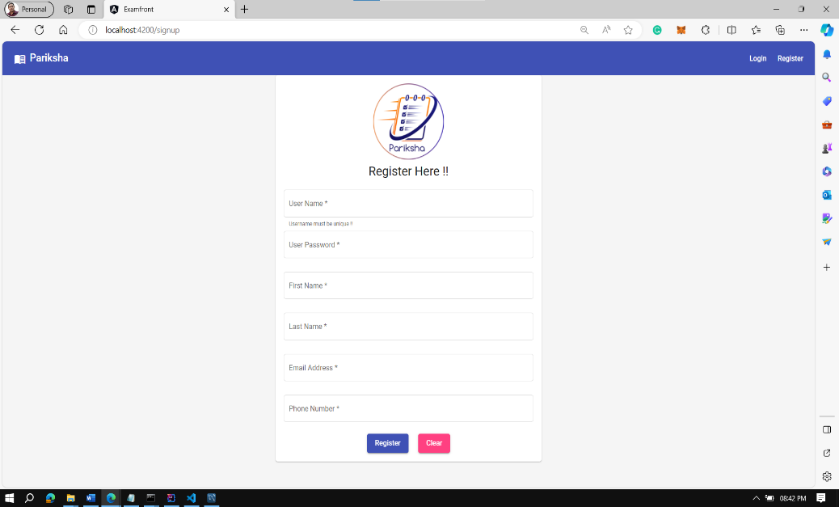

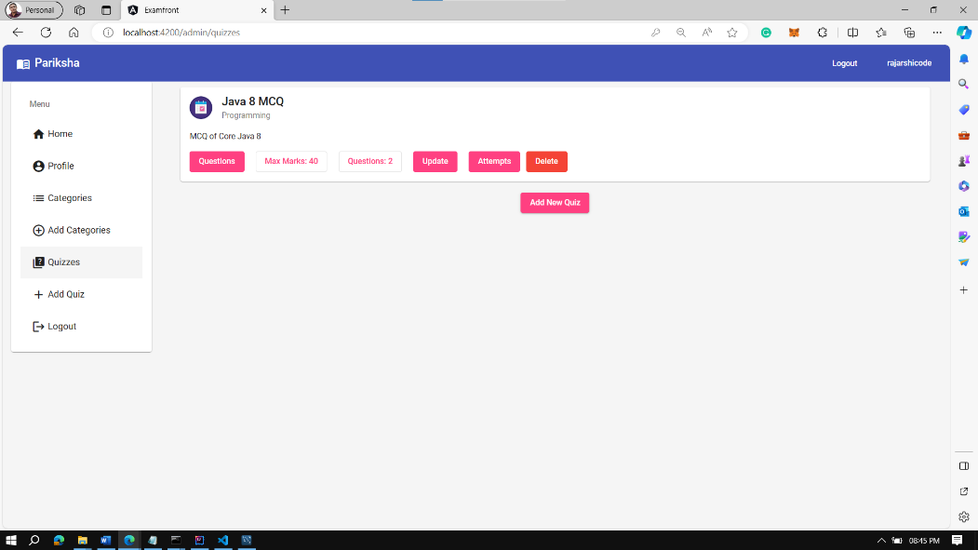

**Web Application Architecture**

**Three – Tier Architecture**

Three-tier architecture, which separates applications into three tiers:-

* Presentation Tier
* Logical Tier
* Data Tier

It is the predominant software architecture for traditional client-server applications.

Three-tier architecture is a well-established software application architecture that organizes applications into three logical and physical computing tiers: the presentation tier, or user interface; the application tier, where data is processed; and the data tier, where the data associated with the application is stored and managed.

Presentation Tier :- Frontend layer of the web application

Application Tier :- Also know as the logic tier.

Data Tier :- Backend application and Database

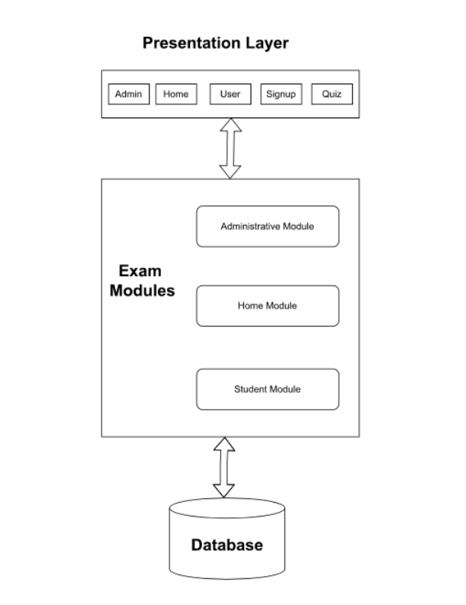

Three Tier Architecture

**Tools and Technologies Used**

* **Angular :-** Angular is a platform and framework for building single-page client applications using HTML CSS JS and TypeScript. It implements core and optional functionality as a set of TypeScript libraries that you import into your applications.
* **Component :-** Angular components are a subset of directives, always associated with a template. Unlike other directives, only one component can be instantiated for a given element in a template. A component must belong to an Ng Module in order for it to be available to another component or application. It’s a function that handles HTML tag creation as well as an example of Virtual-DOM processing capability. Any changes of data at any time will be processed and updated immediately by Virtual-DOM.
* **Java :-** Java is an object-oriented programming language with a high level of abstraction and as few implementation dependencies as possible. Most firms believe it to be one of the fastest, most secure, and most trustworthy programming languages for developing their projects.
* **Spring Boot** :- Spring Boot makes it simple to construct self-contained, production-ready Spring-based applications that can be” simply run.” We offer an unbiased perspective on the Spring platform and third-party libraries so you can get started quickly. The majority of Spring Boot apps only require a minimal amount of Spring configuration.
* **MySQL :-** MySql One of the reasons MySQL is the world’s most popular open source database is that it provides comprehensive support for every application development need. Within the database, support can be found for stored procedures, triggers, functions, views, cursors, ANSI-standard SQL, and more. A unique storage-engine architecture allows database professionals to configure the MySQL database server specifically for particular applications, with the end result being amazing performance results.

**Objective**

Today many organizations conduct online exams worldwide successfully and issue results online. There are some advantages and disadvantages to the online examination. The advantage is that, “It can be conducted remote candidates’ evaluations for answers can be conducted can be fully automated for multiple choice”. The question can be evaluated manually or through an automated system depending on the nature of the question and requirements. The disadvantage is there is no method to identify whether the exact student takes the exam.

**Enhanced Entity Relationship Diagram**

An enhanced entity relationship diagram (EERD), also known as an entity relationship model, is a graphical representation that depicts relationships among people, objects, places, concepts or events within an information technology (IT) system. An ERD uses data modeling techniques that can help define business processes and serve as the foundation for a relational database.

**Importance of EERDs** Enhanced Entity relationship diagrams provide a Visual starting point for database design that can also be used to help determine information system requirements throughout an organization. After a relational database is rolled out, an EERD can still serve as a reference point, should any debugging or business process re-engineering be needed later.

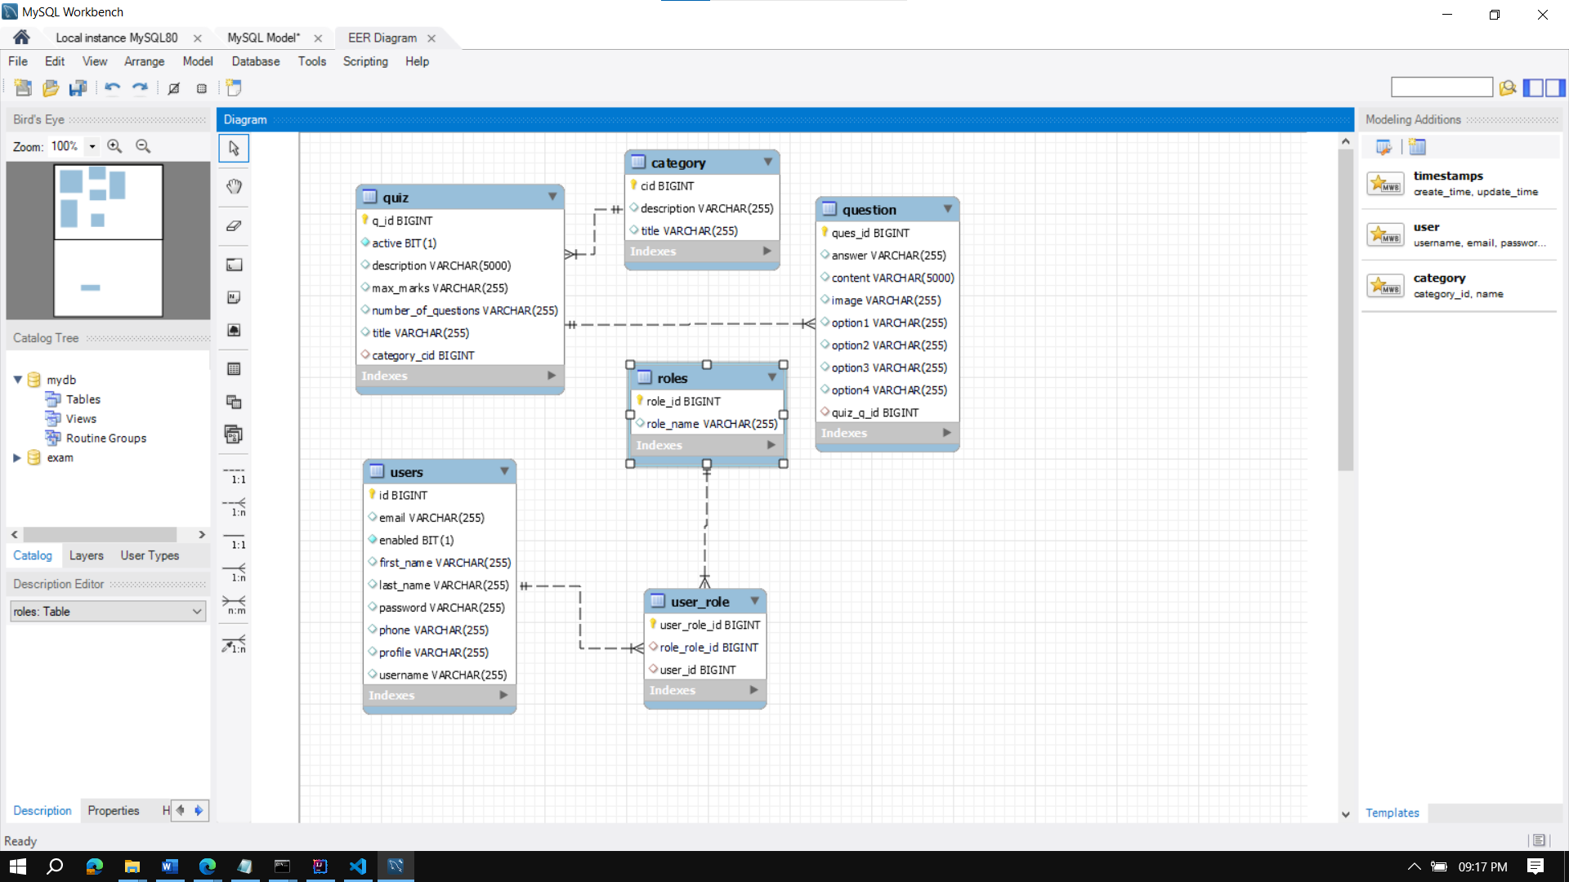

Enhanced Entity Relationship Diagram of Pariksha

**Use Case Diagram**

The unified modeling language used is use case diagram. A use case is a set of scenarios that describes an interaction between a user and a system. A use case diagram displays the relationship among actors and use cases. The two main components of a use case diagram are use cases and actors.

Admins has the authority to build the quiz.

Users can opt for quiz.

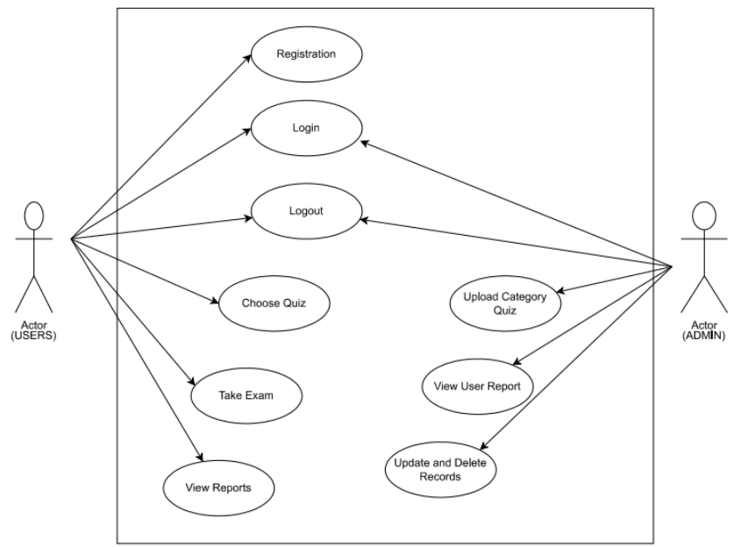

Use Case Diagram of Pariksha

**Components**

Home Page :- The very first Page of our Web Application

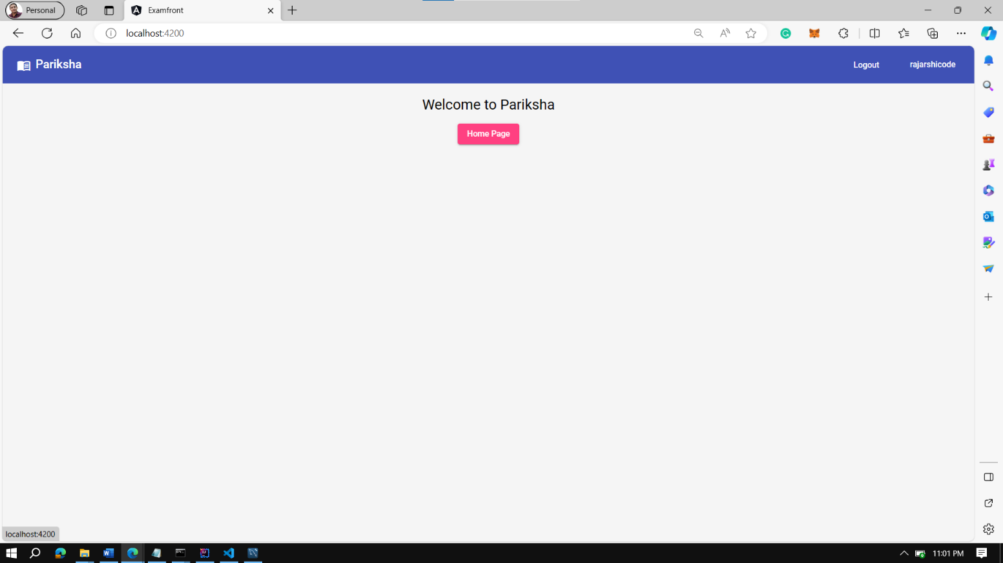User or Admin can login or register themselves.

Registration Page

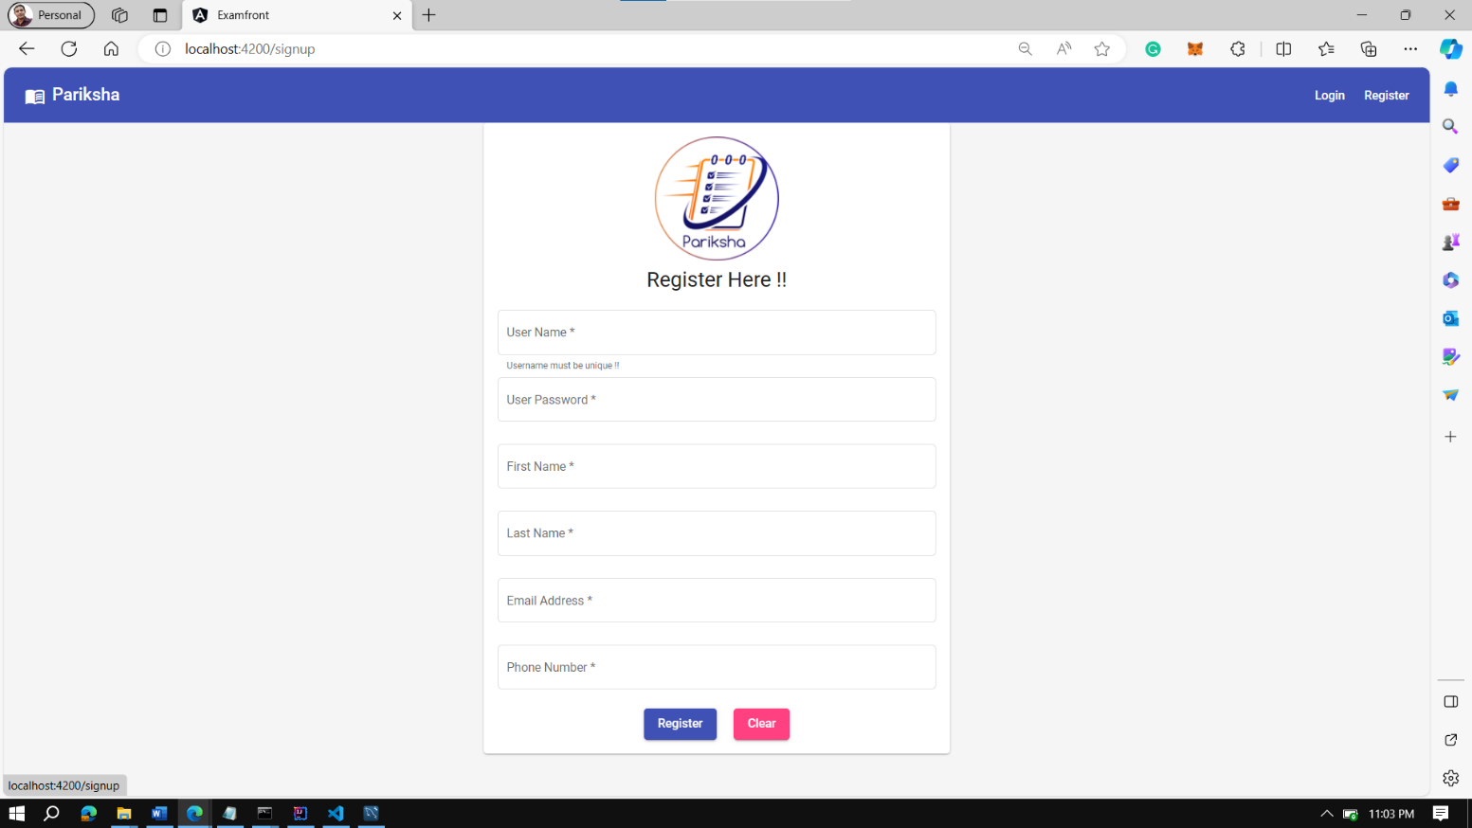A new user can Register to avail the online quiz facility.

Admin Profile

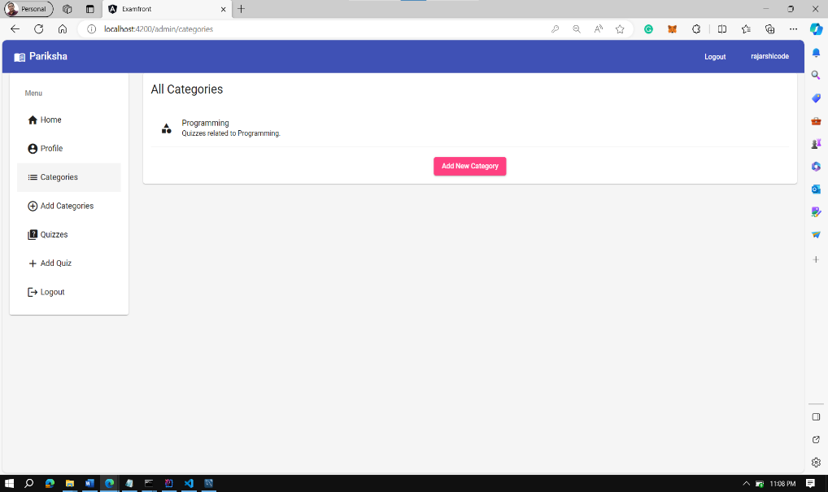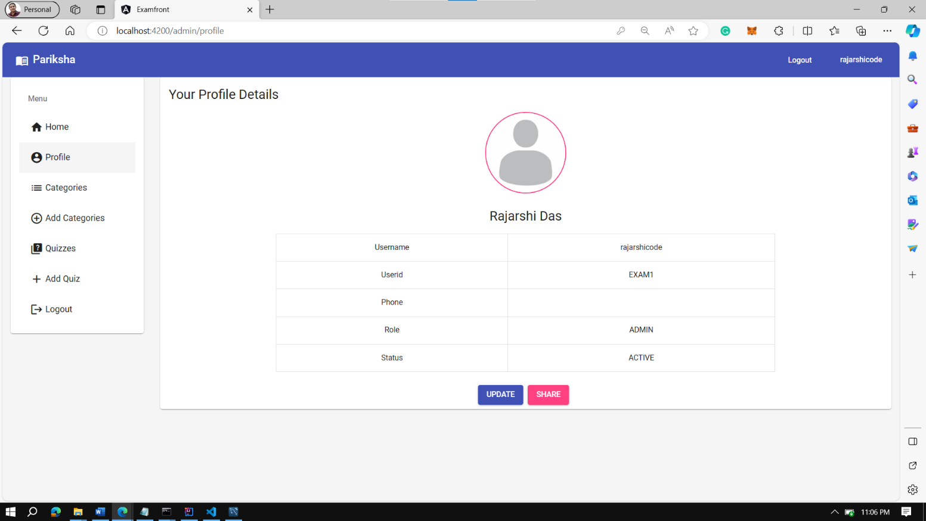

Quiz Categories and the Quizzes

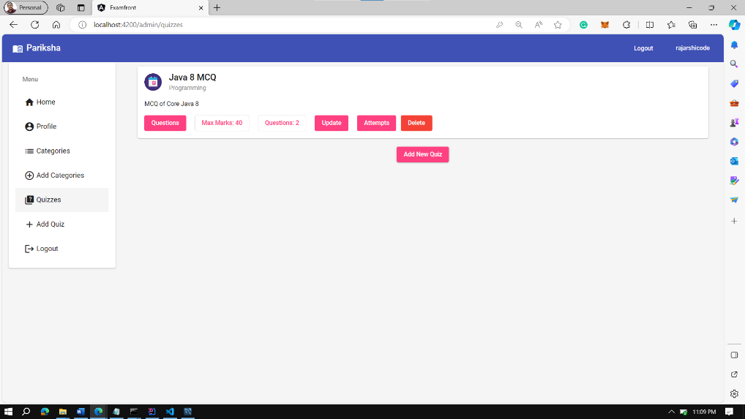

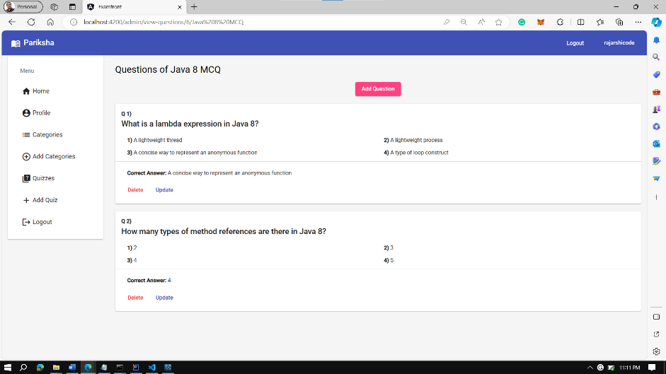Adding, Updating, and Deleting questions

Questions which has been added earlier.

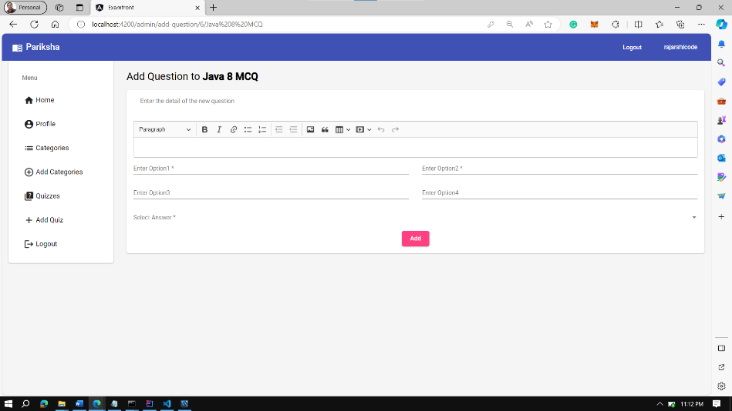

Adding Questions

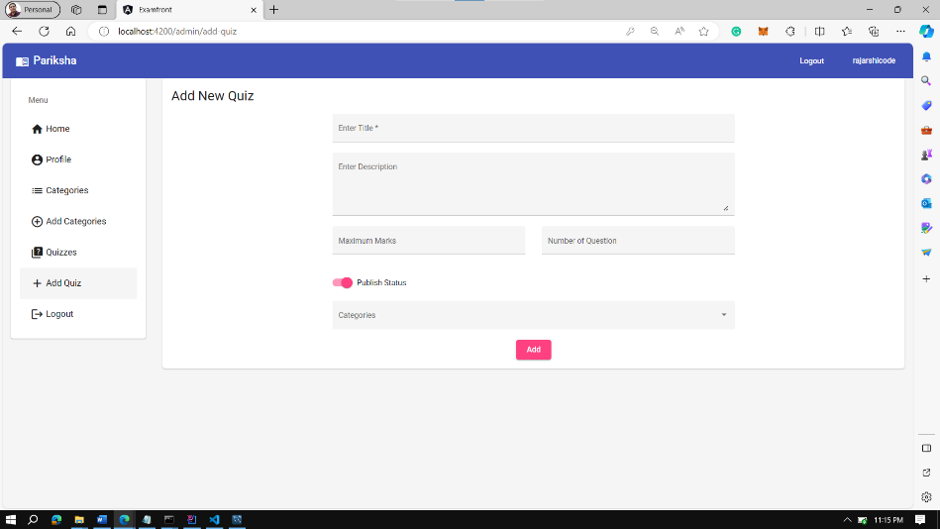

Adding a new Quiz

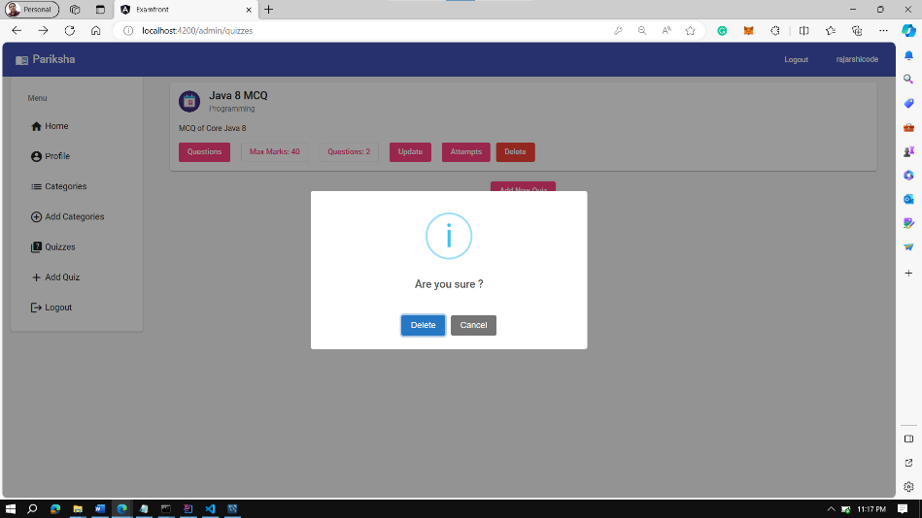

Deleting the quiz

**Conclusion**

Pariksha is Online Quiz Web Application which helps the teachers as well as the Students. This application serves a key role in Educational Institute to upgrade skills and foster a unique way to take assessment.

**Limitation of the Work**

Let us look at the disadvantages of an online examination system:

* Challenges in Technology Adoption..
* Infrastructural Barriers.
* Maintenance also Require..
* Susceptible to Cheating .
* Transitioning to Open-Book Exams.

**Future scope**

* In future we want to add online Compilers. So that Universities will be able to take online coding praticals(DSA, DBMS).
* Login and Registration through university roll number, not via username and password.
* Will be shifting the database from mysql to nosql format.
* Will be creating a Result component to store all the results and score of a particular student.

**Bibliography**

We reffered to the following article to carry on our research work:-

* [Spring | Quickstart](https://spring.io/quickstart)
* [Learn Hibernate Tutorial - javatpoint](https://www.javatpoint.com/hibernate-tutorial)