

**PONDICHERRY UNIVERISTY**

**Department of  
Computer Science**

M.Sc. 1st Year

**CSSC 536 Big Data Tools RECORD**

**SUBMITTED BY:**

**Rajarsi Saha**

19370037

**INDEX**

|  |  |  |  |
| --- | --- | --- | --- |
| **SL NO** | **TOPIC** | **REMARKS** | **PAGE NO** |
| 1 | Learn all the basic commands |  |  |
| 2 | To take some census data, using census data compute the number of records for each state using Pig |  |  |
| 3 | Appy Natural Join between two tables using MapReduce |  |  |
| 4 | Integrate two text files and count the number of words available in the resultant file and also find the length of the word |  |  |
| 5 | Write a MapReduce Job that read any text input and find the average length of all words that starts with each character |  |  |
| 6 | Analyse the log file from a web server to count the no. of hits made from each unique IP address. |  |  |
| 7 | Write a MapReduce program that counts the no. of times words appear next to each other |  |  |
| 8 | Import data from a relational database using sqoop |  |  |
| 9 | Manipulate the data imported data using Hive |  |  |

**EXPERIMENT 1**

**AIM:** Learn all the basic commands.

**COMMANDS:**

1. **start-all.sh –** This command is used for starting Hadoop services.
2. **jps –** This command is used to check if Hadoop services are up and running successfully.
3. **hdfs dfs -ls <path> -** This command is used to list all the files under hdfs filesystem.
4. **hdfs dfs -mkdir <folder name> -** This command is used to create a directory under hdfs filesystem.
5. **hdfs dfs -copyFromLocal <local file path> <dest (present on hdfs) > -** This command is used to copy files/folders from local file system to hdfs filesystem.
6. **hdfs dfs -cat <path> -** This command is used to print file contents onto the CLI window.
7. **hdfs dfs -copyToLocal <srcfile (on hdfs) > <local file dest> -** This command is used to copy files/folders from hdfs filesystem store to local file system.
8. **hdfs dfs -moveFromLocal <local src> <dest (on hdfs) > -** This command is used to move files from local to hdfs filesystem.
9. **hdfs dfs -cp <src (on hdfs) > <dest (on hdfs) > -** This command is used to copy files within hdfs filesystem.
10. **hdfs dfs -mv <src (on hdfs) > <src (on hdfs) > -** This command is used to move files within hdfs filesystem.
11. **hdfs dfs -rmr <filename/directoryName> -** This command is used to deletesa file from HDFS recursively.

**EXPERIMENT 2**

**AIM:** To take some census data, using census data compute the number of records for each state using Pig.

**PROCEDURE:**

1. Load data into Pig Storage format from hdfs (Hadoop Distributed File System)
2. Group data by state
3. For each grouped data generate count of population from data
4. Store the count data into output.txt in hdfs

**PROGRAM:**

data = LOAD 'hdfs://localhost:9000/pig_data/Pop_data.csv' USING PigStorage(',') AS (sl:int, district:chararray, state:chararray, pop:chararray, growth:chararray, sex_ratio:chararray, literacy:chararray);

data_group = GROUP data BY state;

data_group_count = FOREACH data_group GENERATE COUNT(data.pop);

STORE data_group_count INTO 'output.txt';

**OUTPUT:**

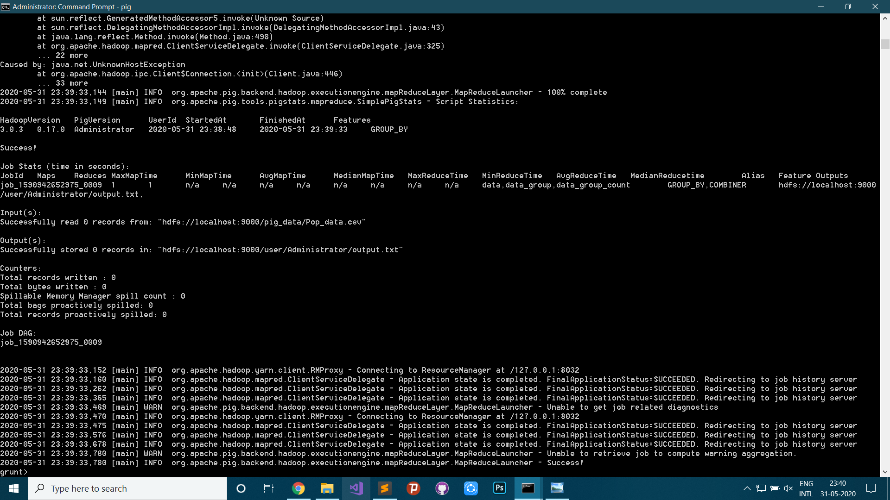

2

27

38

9

14

30

20

4

.

.

.

2

71

23

50

12

16

22

1

3

**EXPERIMENT 3**

**AIM:** Appy Natural Join between two tables using MapReduce.

**PROCEDURE:**

1. Load data in hdfs filesystem
2. Map cell number and customer name as key-value pair
3. Map cell number and delivery code as key-value pair
4. Reduce key-value pair as customer name and delivery status applying natural join
5. Store output to hdfs filesystem

**PROGRAM:**

UserFileMapper.java

package joinmapreduce;

import java.io.IOException;

import org.apache.hadoop.io.LongWritable;

import org.apache.hadoop.io.Text;

import org.apache.hadoop.mapred.MapReduceBase;

import org.apache.hadoop.mapred.Mapper;

import org.apache.hadoop.mapred.OutputCollector;

import org.apache.hadoop.mapred.Reporter;

public class UserFileMapper extends MapReduceBase implements Mapper<LongWritable, Text, Text, Text>

{

private String cellNumber, customerName, fileTag = "CD~";

public void map(LongWritable key, Text value, OutputCollector<Text, Text> output, Reporter reporter) throws IOException

{

String line = value.toString();

String splitarray[] = line.split(",");

cellNumber = splitarray[0].trim();

customerName = splitarray[1].trim();

output.collect(new Text(cellNumber), new Text(fileTag + customerName));

}

}

DeliveryFileMapper.java

package joinmapreduce;

import java.io.IOException;

import org.apache.hadoop.io.LongWritable;

import org.apache.hadoop.io.Text;

import org.apache.hadoop.mapred.MapReduceBase;

import org.apache.hadoop.mapred.Mapper;

import org.apache.hadoop.mapred.OutputCollector;

import org.apache.hadoop.mapred.Reporter;

public class DeliveryFileMapper extends MapReduceBase implements Mapper<LongWritable, Text, Text, Text>

{

private String cellNumber, deliveryCode, fileTag = "DR~";

public void map(LongWritable key, Text value, OutputCollector<Text, Text> output, Reporter reporter) throws IOException

{

String line = value.toString();

String splitarray[] = line.split(",");

cellNumber = splitarray[0].trim();

deliveryCode = splitarray[1].trim();

output.collect(new Text(cellNumber), new Text(fileTag + deliveryCode));

}

}

SmsReducer.java

package joinmapreduce;

import java.io.BufferedReader;

import java.io.FileNotFoundException;

import java.io.FileReader;

import java.io.IOException;

import java.util.HashMap;

import java.util.Iterator;

import java.util.Map;

import org.apache.hadoop.io.Text;

import org.apache.hadoop.mapred.JobConf;

import org.apache.hadoop.mapred.MapReduceBase;

import org.apache.hadoop.mapred.OutputCollector;

import org.apache.hadoop.mapred.Reducer;

import org.apache.hadoop.mapred.Reporter;

public class SmsReducer extends MapReduceBase implements Reducer<Text, Text, Text, Text> {

private String customerName, deliveryReport;

private static Map<String, String> DeliveryCodesMap = new HashMap<String, String>();

public void configure(JobConf job) {

loadDeliveryStatusCodes();

}

public void reduce(Text key, Iterator<Text> values, OutputCollector<Text, Text> output, Reporter reporter) throws IOException {

while (values.hasNext()) {

String currValue = values.next().toString();

String valueSplitted[] = currValue.split("~");

if(valueSplitted[0].equals("CD")) {

customerName = valueSplitted[1].trim();

}

else if(valueSplitted[0].equals("DR")) {

deliveryReport = DeliveryCodesMap.get(valueSplitted[1].trim());

}

}

if(customerName != null && deliveryReport != null)

output.collect(new Text(customerName), new Text(deliveryReport));

else if(customerName == null)

output.collect(new Text("customerName"), new Text(deliveryReport));

else if(deliveryReport == null)

output.collect(new Text(customerName), new Text("deliveryReport"));

}

private void loadDeliveryStatusCodes() {

String strRead;

try {

BufferedReader reader = new BufferedReader(new FileReader("C:\\Users\\Administrator\\eclipse-workspace\\JoinMapReduce\\DeliveryStatusCodes.txt"));

while ((strRead = reader.readLine() ) != null) {

String splitarray[] = strRead.split(",");

DeliveryCodesMap.put(splitarray[0].trim(), splitarray[1].trim());

}

reader.close();

}

catch (FileNotFoundException e) {

e.printStackTrace();

}

catch( IOException e ) {

e.printStackTrace();

}

}

}

SmsDriver.java

package joinmapreduce;

import java.io.IOException;

import org.apache.hadoop.conf.Configuration;

import org.apache.hadoop.conf.Configured;

import org.apache.hadoop.fs.FileSystem;

import org.apache.hadoop.fs.Path;

import org.apache.hadoop.io.Text;

import org.apache.hadoop.mapred.FileOutputFormat;

import org.apache.hadoop.mapred.JobClient;

import org.apache.hadoop.mapred.JobConf;

import org.apache.hadoop.mapred.TextInputFormat;

import org.apache.hadoop.mapred.lib.MultipleInputs;

import org.apache.hadoop.util.Tool;

import org.apache.hadoop.util.ToolRunner;

public class SmsDriver extends Configured implements Tool {

public int run(String[] args) throws Exception {

JobConf conf = new JobConf(getConf(), SmsDriver.class);

conf.setJobName("SMS Reports");

conf.setOutputKeyClass(Text.class);

conf.setOutputValueClass(Text.class);

conf.setReducerClass(SmsReducer.class);

MultipleInputs.addInputPath(conf, new Path(args[0]), TextInputFormat.class, UserFileMapper.class);

MultipleInputs.addInputPath(conf, new Path(args[1]), TextInputFormat.class, DeliveryFileMapper.class);

deleteDirectory(args[2], conf);

FileOutputFormat.setOutputPath(conf, new Path(args[2]));

JobClient.runJob(conf);

return 0;

}

private static void deleteDirectory(String args, Configuration conf) throws IOException {

Path p = new Path(args);

FileSystem fs = FileSystem.get(conf);

fs.exists(p);

fs.delete(p, true);

}

public static void main(String[] args) throws Exception {

int res = ToolRunner.run(new Configuration(), new SmsDriver(), args);

System.exit(res);

}

}

**OUTPUT:**

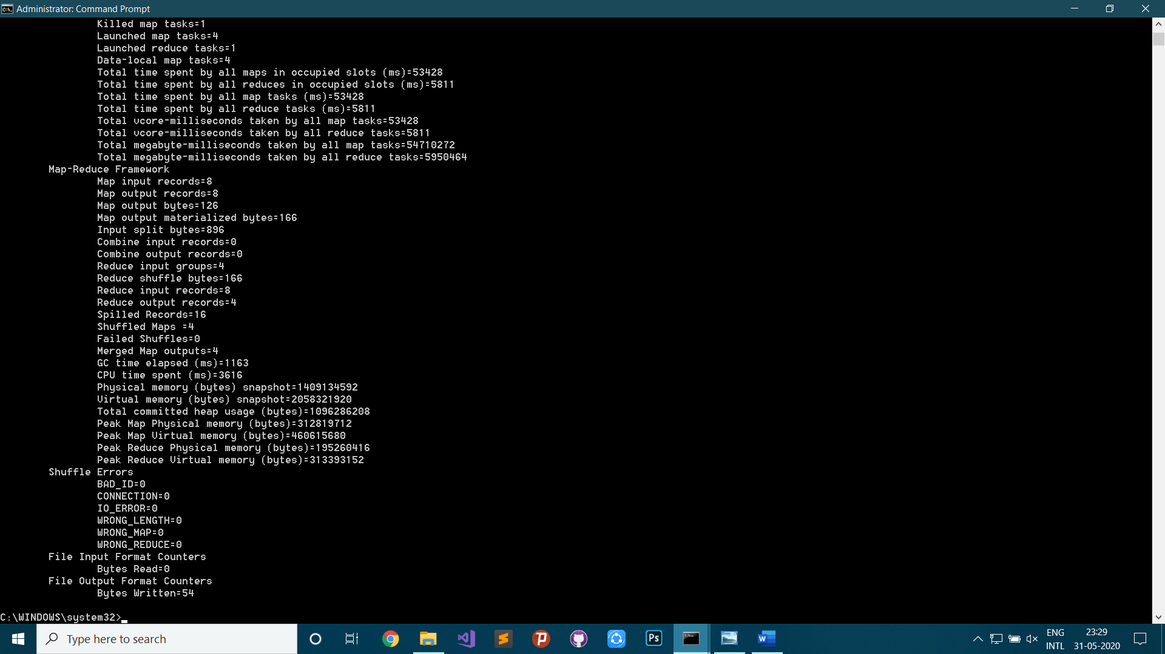

**part-00000**

Jim Delivered

Tom Pending

Harry Failed

Richard Resend

**EXPERIMENT 4**

**AIM:** Integrate two text files and count the number of words available in the resultant file and also find the length of the word.

**PROCEDURE:**

1. Load data in hdfs filesystem
2. Start Job 1
3. Map “Total” and “1” as key-value pair
4. Reduce “Total” and sum of “1” s as key-value pair
5. Store output to hdfs filesystem
6. Start Job 2
7. Map token(word) and “1” as key-value pair
8. Reduce token(word) and length of tokens as key-value pair
9. Store output to hdfs filesystem

**PROGRAM:**

WCJMapper.java

package wordcountjob;

import java.io.IOException;

import java.util.StringTokenizer;

import org.apache.hadoop.io.IntWritable;

import org.apache.hadoop.io.LongWritable;

import org.apache.hadoop.io.Text;

import org.apache.hadoop.mapred.*;

public class WCJMapper extends MapReduceBase implements Mapper<LongWritable, Text, Text, IntWritable> {

private final static IntWritable one = new IntWritable(1);

public void map(LongWritable key, Text value, OutputCollector<Text, IntWritable> output, Reporter reporter) throws IOException {

StringTokenizer itr = new StringTokenizer(value.toString());

while (itr.hasMoreTokens()) {

output.collect(new Text("Total"), one);

itr.nextToken();

}

}

}

WCJMapper1.java

package wordcountjob;

import java.io.IOException;

import java.util.StringTokenizer;

import org.apache.hadoop.io.IntWritable;

import org.apache.hadoop.io.LongWritable;

import org.apache.hadoop.io.Text;

import org.apache.hadoop.mapred.*;

public class WCJMapper1 extends MapReduceBase implements Mapper<LongWritable, Text, Text, IntWritable> {

private final static IntWritable one = new IntWritable(1);

public void map(LongWritable key, Text value, OutputCollector<Text, IntWritable> output, Reporter reporter) throws IOException {

StringTokenizer itr = new StringTokenizer(value.toString());

while (itr.hasMoreTokens()) {

output.collect(new Text(itr.nextToken()), one);

}

}

}

WCJReducer.java

package wordcountjob;

import java.io.IOException;

import java.util.*;

import org.apache.hadoop.io.IntWritable;

import org.apache.hadoop.io.Text;

import org.apache.hadoop.mapred.*;

public class WCJReducer extends MapReduceBase implements Reducer<Text, IntWritable, Text, IntWritable> {

public void reduce(Text t_key, Iterator<IntWritable> values, OutputCollector<Text,IntWritable> output, Reporter reporter) throws IOException {

Text key = t_key;

int sum = 0;

while (values.hasNext()) {

IntWritable value = (IntWritable) values.next();

sum += value.get();

}

output.collect(key, new IntWritable(sum));

}

}

WCJReducer1.java

package wordcountjob;

import java.io.IOException;

import java.util.*;

import org.apache.hadoop.io.IntWritable;

import org.apache.hadoop.io.Text;

import org.apache.hadoop.mapred.*;

public class WCJReducer1 extends MapReduceBase implements Reducer<Text, IntWritable, Text, IntWritable> {

public void reduce(Text t_key, Iterator<IntWritable> values, OutputCollector<Text,IntWritable> output, Reporter reporter) throws IOException {

Text key = t_key;

output.collect(key, new IntWritable(t_key.getLength()));

}

}

WCJDriver.java

package wordcountjob;

import java.io.IOException;

import org.apache.hadoop.conf.*;

import org.apache.hadoop.fs.FileSystem;

import org.apache.hadoop.fs.Path;

import org.apache.hadoop.io.*;

import org.apache.hadoop.mapred.*;

import org.apache.hadoop.mapreduce.Job;

import org.apache.hadoop.util.*;

public class WCJDriver extends Configured implements Tool {

public int run(String[] args) {

JobConf job_conf = new JobConf(WCJDriver.class);

job_conf.setJobName("Total Length");

job_conf.setOutputKeyClass(Text.class);

job_conf.setOutputValueClass(IntWritable.class);

job_conf.setMapperClass(wordcountjob.WCJMapper.class);

job_conf.setReducerClass(wordcountjob.WCJReducer.class);

job_conf.setInputFormat(TextInputFormat.class);

job_conf.setOutputFormat(TextOutputFormat.class);

FileInputFormat.setInputPaths(job_conf, new Path(args[0]));

FileOutputFormat.setOutputPath(job_conf, new Path(args[1]));

JobConf job_conf1 = new JobConf(WCJDriver.class);

job_conf1.setJobName("Word Count");

job_conf1.setOutputKeyClass(Text.class);

job_conf1.setOutputValueClass(IntWritable.class);

job_conf1.setMapperClass(wordcountjob.WCJMapper1.class);

job_conf1.setReducerClass(wordcountjob.WCJReducer1.class);

job_conf1.setInputFormat(TextInputFormat.class);

job_conf1.setOutputFormat(TextOutputFormat.class);

FileInputFormat.setInputPaths(job_conf1, new Path(args[0]));

FileOutputFormat.setOutputPath(job_conf1, new Path(args[2]));

int result = -1;

try {

deleteDirectory(args[1], job_conf);

Job job1 = Job.getInstance(job_conf);

result = job1.waitForCompletion(true) ? 0 : 1;

} catch (Exception e) {

e.printStackTrace();

}

System.out.println("\nFirst Job Finished=============\n");

if(result == 0) {

try {

deleteDirectory(args[2], job_conf1);

Job job2 = Job.getInstance(job_conf1);

result = job2.waitForCompletion(true) ? 0 : 1;

} catch (Exception e) {

e.printStackTrace();

}

System.out.println("\nSecond Job Finished=============\n");

}

return result;

}

private static void deleteDirectory(String args, Configuration conf) throws IOException {

Path p = new Path(args);

FileSystem fs = FileSystem.get(conf);

fs.exists(p);

fs.delete(p, true);

}

public static void main(String[] args) throws Exception {

int res = ToolRunner.run(new Configuration(), new WCJDriver(), args);

System.exit(res);

}

}

**OUTPUT:**

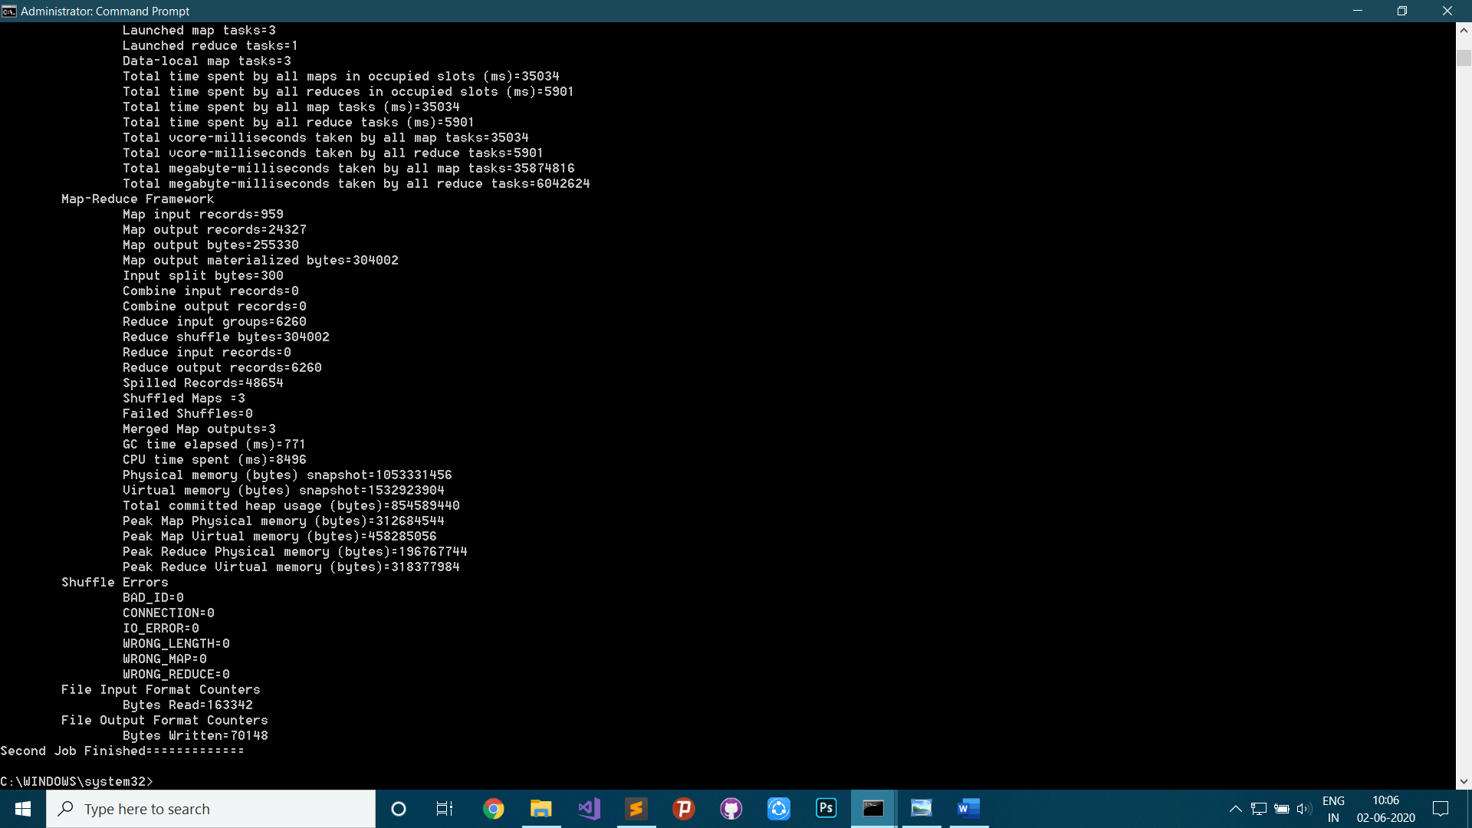

**output_dir_1_WCL/part-00000**

Total 24327

**output_dir_2_WCL/part-00000**

"30% 4

"A 2

"Acorn 6

"Carrie 7

"DST 4

"Do 3

"Enter 6

"Error 6

"Fingerprint 12

"Five 5

"Fujianese" 11

.

.

.

youngsters,[493][52] 20

youth 5

youths 6

youths" 7

zone.[619][620] 15

~9000 5

┬º 2

ΓÇîα░╛) 7

ΓÇô 3

ΓÇó 3

σÅìΘÇüΣ╕¡ΘüèΦíî 15

σÆîτÉåΘ¥₧) 10

σ╗óΘ¥Æ; 7

**EXPERIMENT 5**

**AIM:** Write a MapReduce Job that read any text input and find the average length of all words that starts with each character.

**PROCEDURE:**

1. Load data in hdfs filesystem
2. Map first character of each token (word) and the length of that token
3. Reduce the character and average length of the words beginning with that character
4. Store output to hdfs filesystem

**PROGRAM:**

WordCountAverage.java

package org.apache.hadoop.examples;

import java.io.IOException;

import java.util.StringTokenizer;

import org.apache.hadoop.conf.Configuration;

import org.apache.hadoop.fs.FileSystem;

import org.apache.hadoop.fs.Path;

import org.apache.hadoop.io.IntWritable;

import org.apache.hadoop.io.DoubleWritable;

import org.apache.hadoop.io.Text;

import org.apache.hadoop.mapreduce.Job;

import org.apache.hadoop.mapreduce.Mapper;

import org.apache.hadoop.mapreduce.Reducer;

import org.apache.hadoop.mapreduce.lib.input.FileInputFormat;

import org.apache.hadoop.mapreduce.lib.output.FileOutputFormat;

public class WordCountAverage {

public static class WCAMapper extends Mapper<Object, Text, Text, IntWritable>{

private Text firstCharacter = new Text();

private final static IntWritable length = new IntWritable(1);

public void map(Object key, Text value, Context context) throws IOException, InterruptedException {

StringTokenizer itr = new StringTokenizer(value.toString());

while (itr.hasMoreTokens()) {

String token = itr.nextToken();

firstCharacter.set(token.substring(0, 1));

length.set(token.length());

context.write(firstCharacter, length);

}

}

}

public static class WCAReducer extends Reducer<Text, IntWritable, Text, DoubleWritable> {

private DoubleWritable result = new DoubleWritable();

public void reduce(Text key, Iterable<IntWritable> values, Context context) throws IOException, InterruptedException {

double sum = 0;

int total = 0;

for (IntWritable val : values) {

total ++;

sum += val.get();

}

double average = sum / total;

result.set(average);

context.write(key, result);

}

}

private static void deleteDirectory(String args, Configuration conf) throws IOException {

Path p = new Path(args);

FileSystem fs = FileSystem.get(conf);

fs.exists(p);

fs.delete(p, true);

}

public static void main(String[] args) throws Exception {

Configuration conf = new Configuration();

Job job = new Job(conf, "Word Count Average");

job.setJarByClass(WordCountAverage.class);

job.setMapperClass(WCAMapper.class);

job.setReducerClass(WCAReducer.class);

job.setOutputKeyClass(Text.class);

job.setOutputValueClass(IntWritable.class);

FileInputFormat.addInputPath(job, new Path(args[0]));

FileOutputFormat.setOutputPath(job, new Path(args[1]));

deleteDirectory(args[1], conf);

System.exit(job.waitForCompletion(true) ? 0 : 1);

}

}

**OUTPUT:**

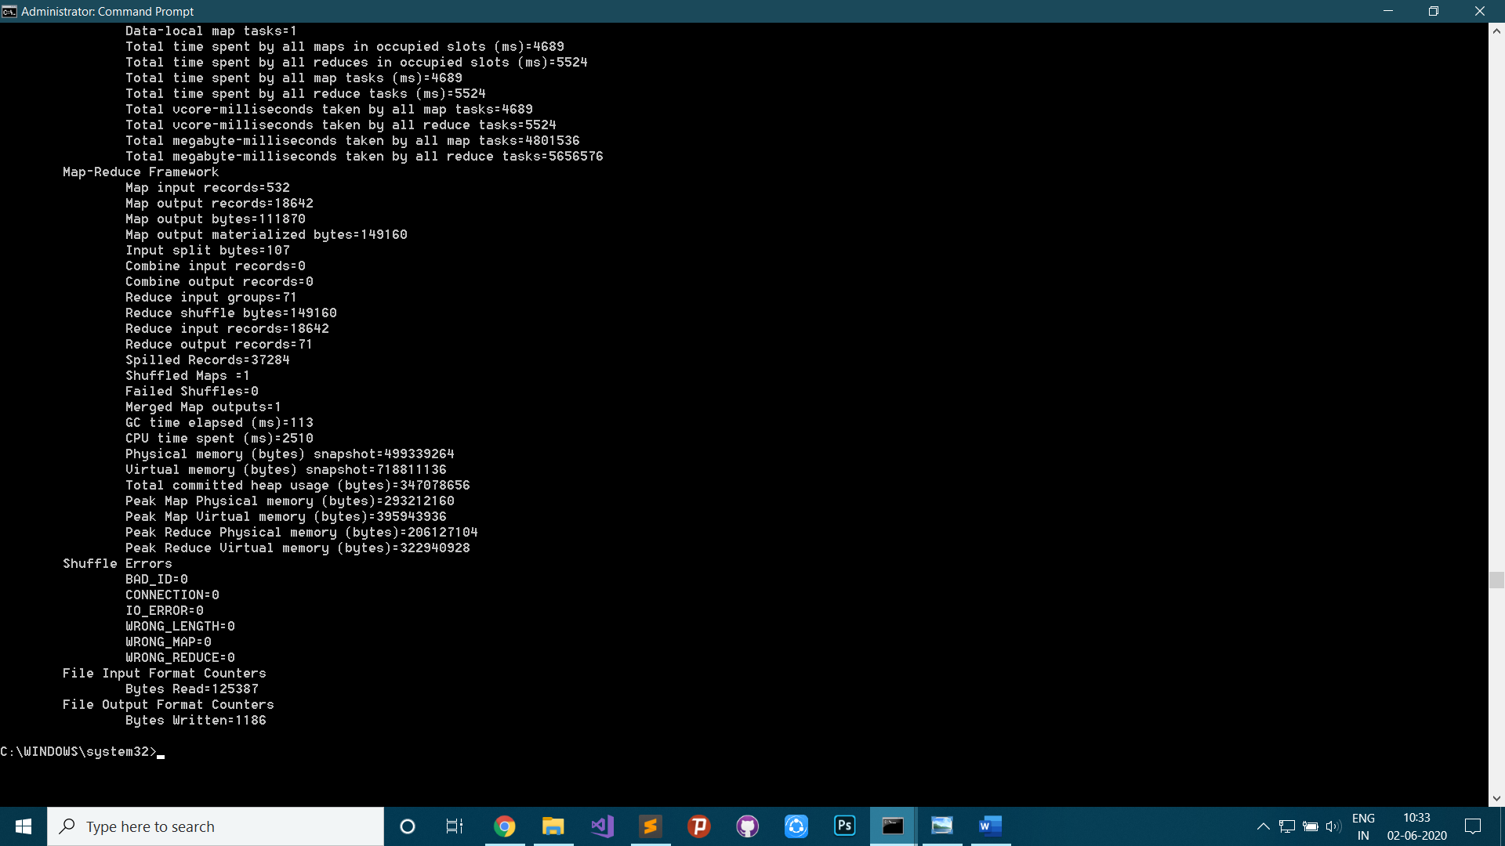

**Part-r-00000**

" 7.810457516339869

# 7.0

( 7.1891891891891895

- 1.0

0 5.6

1 2.910179640718563

2 4.852739726027397

3 3.0

4 1.6666666666666667

.

.

.

v 7.762962962962963

w 4.491048593350383

y 5.636363636363637

z 15.0

ΓÇó 1.0

σÅì 5.0

σÆî 4.0

σ╗ó 3.0

**EXPERIMENT 6**

**AIM:** Analyse the log file from a web server to count the no. of hits made from each unique IP address.

**PROCEDURE:**

1. Load the sample data in hdfs filesystem
2. Map ip address as key and one (1) as value
3. Reduce the IP address as key and the sum of similar IP addresses as value
4. Store output to hdfs filesystem

**PROGRAM:**

IPHits.java

package iphits;

import java.io.IOException;

import java.util.StringTokenizer;

import org.apache.hadoop.conf.Configuration;

import iphits.IPHits;

import org.apache.hadoop.fs.FileSystem;

import org.apache.hadoop.fs.Path;

import org.apache.hadoop.io.IntWritable;

import org.apache.hadoop.io.Text;

import org.apache.hadoop.mapreduce.Job;

import org.apache.hadoop.mapreduce.Mapper;

import org.apache.hadoop.mapreduce.Reducer;

import org.apache.hadoop.mapreduce.lib.input.FileInputFormat;

import org.apache.hadoop.mapreduce.lib.output.FileOutputFormat;

public class IPHits {

public static class IPHitsMapper extends Mapper<Object, Text, Text, IntWritable>{

private Text ip = new Text();

private final static IntWritable one = new IntWritable(1);

public void map(Object key, Text value, Context context) throws IOException, InterruptedException {

StringTokenizer itr = new StringTokenizer(value.toString(), "\n");

//String token = itr.nextToken();

while (itr.hasMoreTokens()) {

String token = itr.nextToken();

if(token.substring(0, token.indexOf(',')).equalsIgnoreCase("ip") == true)

continue;

ip.set(token.substring(0, token.indexOf(',')));

context.write(ip, one);

}

}

}

public static class IPHitsReducer extends Reducer<Text, IntWritable, Text, IntWritable> {

private IntWritable result = new IntWritable();

public void reduce(Text key, Iterable<IntWritable> values, Context context) throws IOException, InterruptedException {

int sum = 0;

for (IntWritable val : values) {

sum += val.get();

}

result.set(sum);

context.write(key, result);

}

}

private static void deleteDirectory(String args, Configuration conf) throws IOException {

Path p = new Path(args);

FileSystem fs = FileSystem.get(conf);

fs.exists(p);

fs.delete(p, true);

}

public static void main(String[] args) throws Exception {

Configuration conf = new Configuration();

Job job = new Job(conf, "Word Count Average");

job.setJarByClass(IPHits.class);

job.setMapperClass(IPHitsMapper.class);

job.setReducerClass(IPHitsReducer.class);

job.setOutputKeyClass(Text.class);

job.setOutputValueClass(IntWritable.class);

FileInputFormat.addInputPath(job, new Path(args[0]));

FileOutputFormat.setOutputPath(job, new Path(args[1]));

deleteDirectory(args[1], conf);

System.exit(job.waitForCompletion(true) ? 0 : 1);

}

}

**OUTPUT:**

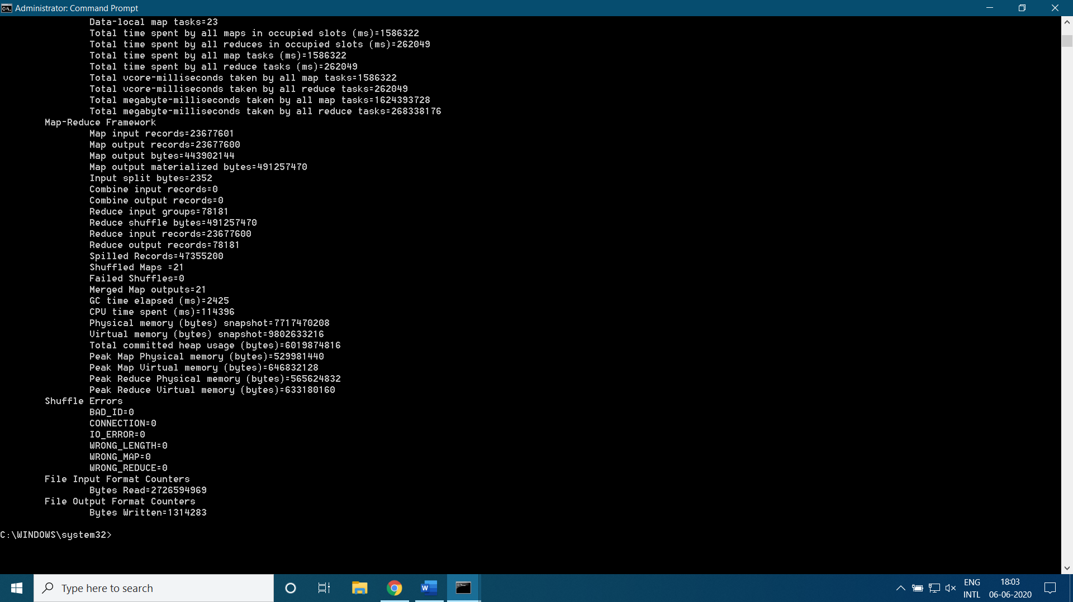

**Part-r-00000**

1.0.139.ceb 1

1.10.175.bch 1

1.10.205.fjb 1

1.119.129.eag 1

1.120.134.aca 1

1.124.48.acc 1

1.124.48.icd 2

1.127.48.fbb 8

.

.

.

99.96.207.bdf 1

99.97.29.ihf 2

99.98.103.cca 3

99.99.223.jda 4

99.99.56.def 2

**EXPERIMENT 7**

**AIM:** Write a MapReduce program that counts the no. of times words appear next to each other.

**PROCEDURE:**

1. Load the sample data in hdfs filesystem
2. Map a pair of words separated by a single space as key and one (1) as value
3. Reduce the pair of words as key and the total similar pairs as value
4. Store output to hdfs filesystem

**PROGRAM:**

IPHits.java

package wordpair;

import java.io.IOException;

import java.util.StringTokenizer;

import org.apache.hadoop.conf.Configuration;

import org.apache.hadoop.fs.FileSystem;

import org.apache.hadoop.fs.Path;

import org.apache.hadoop.io.IntWritable;

import org.apache.hadoop.io.Text;

import org.apache.hadoop.mapreduce.Job;

import org.apache.hadoop.mapreduce.Mapper;

import org.apache.hadoop.mapreduce.Reducer;

import org.apache.hadoop.mapreduce.lib.input.FileInputFormat;

import org.apache.hadoop.mapreduce.lib.output.FileOutputFormat;

public class WordPair {

public static class WPMapper extends Mapper<Object, Text, Text, IntWritable> {

private final static IntWritable one = new IntWritable(1);

private Text word = new Text();

public void map(Object key, Text value, Context context) throws IOException, InterruptedException {

StringTokenizer itr = new StringTokenizer(value.toString(), " ");

if(itr.hasMoreTokens()) {

String str1 = itr.nextToken(), str2 = "";

while (itr.hasMoreTokens()) {

str2 = itr.nextToken();

word.set(str1.trim() + " " + str2.trim());

context.write(word, one);

str1 = str2;

}

}

}

}

public static class WPReducer extends Reducer<Text,IntWritable,Text,IntWritable> {

private IntWritable result = new IntWritable();

public void reduce(Text key, Iterable<IntWritable> values, Context context) throws IOException, InterruptedException {

int sum = 0;

for (IntWritable val : values) {

sum += val.get();

}

result.set(sum);

context.write(key, result);

}

}

private static void deleteDirectory(String args, Configuration conf) throws IOException {

Path p = new Path(args);

FileSystem fs = FileSystem.get(conf);

fs.exists(p);

fs.delete(p, true);

}

public static void main(String[] args) throws Exception {

Configuration conf = new Configuration();

Job job = Job.getInstance(conf, "Total words next to each other");

job.setJarByClass(WordPair.class);

job.setMapperClass(WPMapper.class);

job.setCombinerClass(WPReducer.class);

job.setReducerClass(WPReducer.class);

job.setOutputKeyClass(Text.class);

job.setOutputValueClass(IntWritable.class);

deleteDirectory(args[1], conf);

FileInputFormat.addInputPath(job, new Path(args[0]));

FileOutputFormat.setOutputPath(job, new Path(args[1]));

System.exit(job.waitForCompletion(true) ? 0 : 1);

}

}

**OUTPUT:**

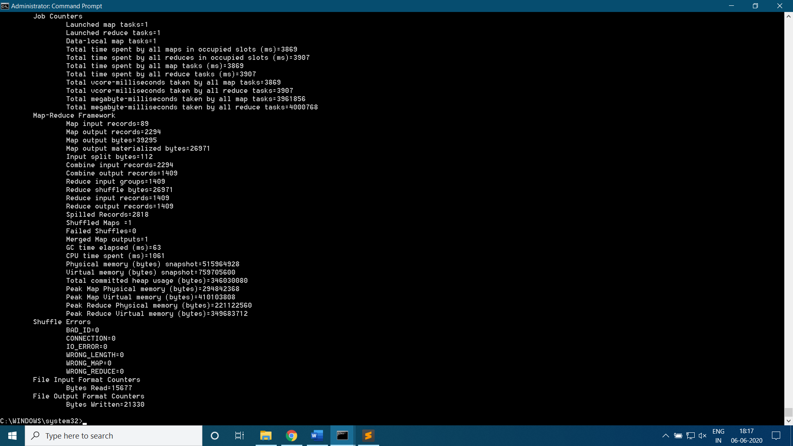

**Part-r-00000**

(Try it 1

1 In eleifend 1

1, 2020 1

2 Cras fringilla 1

2006 review 1

2011, researchers 1

3 Aliquam erat 1

4 Fusce vitae 1

5 Etiam vehicula 1

.

.

.

ΓÇó Maecenas tincidunt 1

ΓÇó Mauris id 1

ΓÇó Morbi viverra 1

ΓÇó Nulla facilisi. 1

**EXPERIMENT 8**

**AIM:** Import data from a relational database using sqoop.

**PROCEDURE:**

1. Connect to mysql database using username and password
2. Create table and input data
3. Use sqoop import command to import data from mysql database to hdfs system

**PROGRAM:**

Commands in MYSQL Shell:

\connect –-mysql root@localhost:3306

Please provide the password for 'root@localhost:3306': toor

\sql

create database sqoop_db;

use sqoop_db;

create table Persons(

PersonID int,

LastName varchar(255),

FirstName varchar(255),

Address varchar(255),

City varchar(255)

);

insert into Persons values(1, 'SAHA', 'RAJARSI', 'BARANAGAR', 'KOLKATA');

insert into Persons values(2, 'BHATTACHARYA', 'SAWON', 'BELGHORIA', 'KOLKATA');

insert into Persons values(3, 'MUKHERJEE', 'AYAN', 'BAGHAJATIN', 'KOLKATA');

insert into Persons values(4, 'GHOSH', 'SOUVIK', 'BADYABATI', 'KOLKATA');

commit;

Commands in command prompt:

sqoop import --connect jdbc:mysql://localhost:3306/sqoop_db --username root --password toor --table Persons --target-dir /sqoop_data --m 1

hdfs dfs -cat /sqoop_data/part-m-00000

**OUTPUT:**

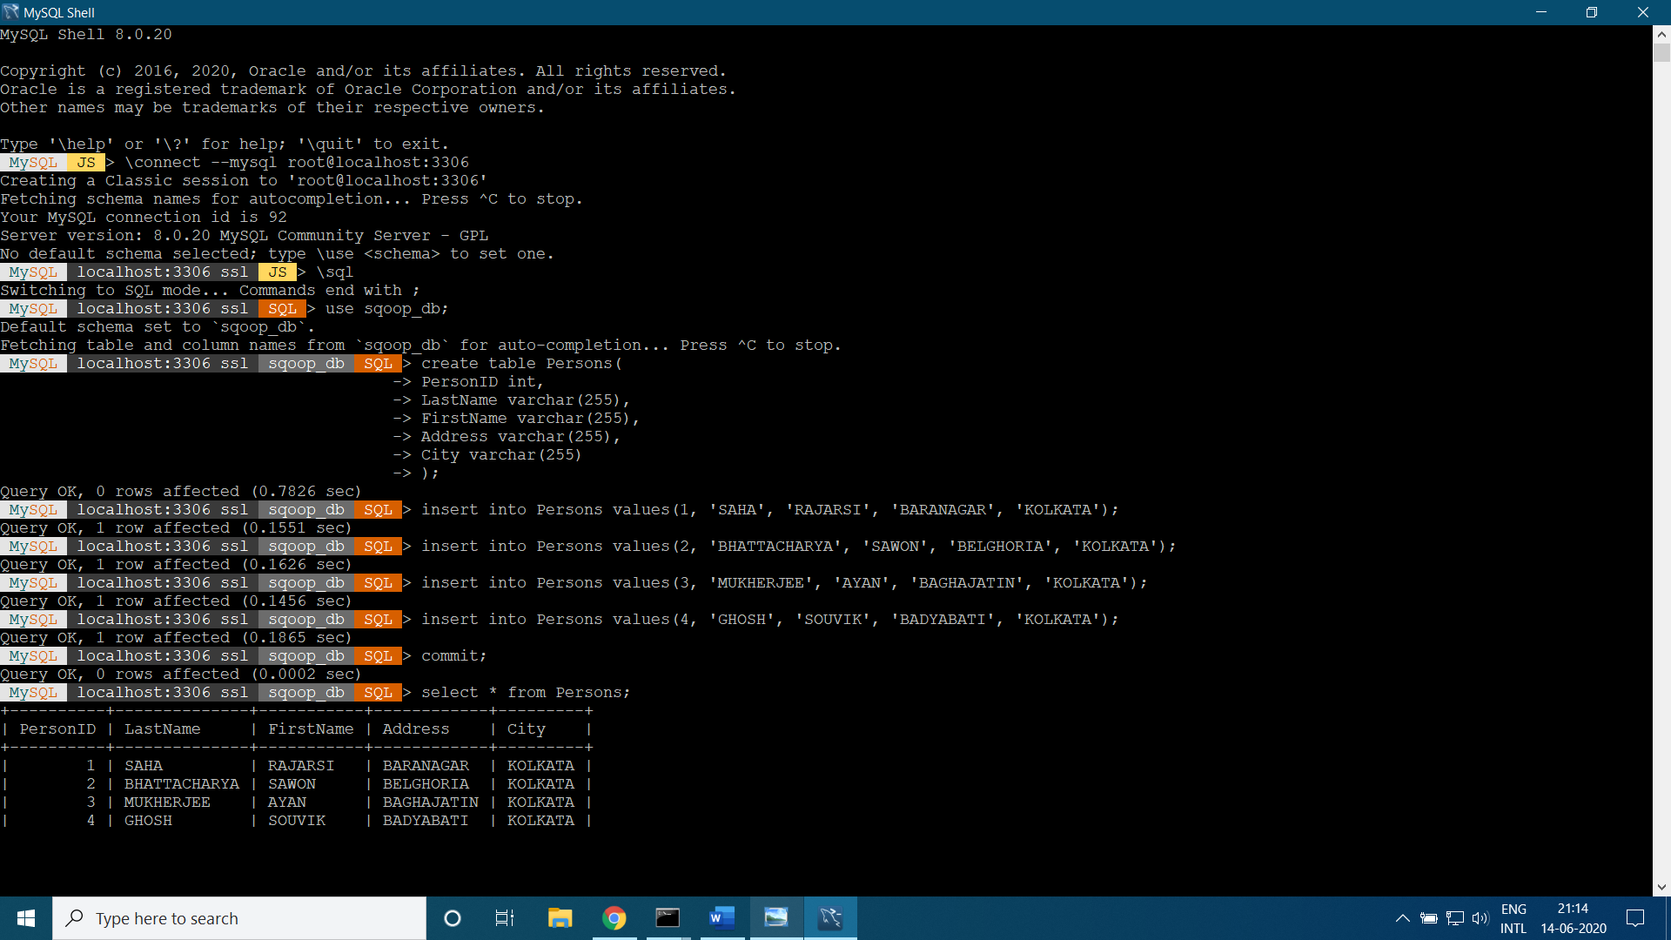

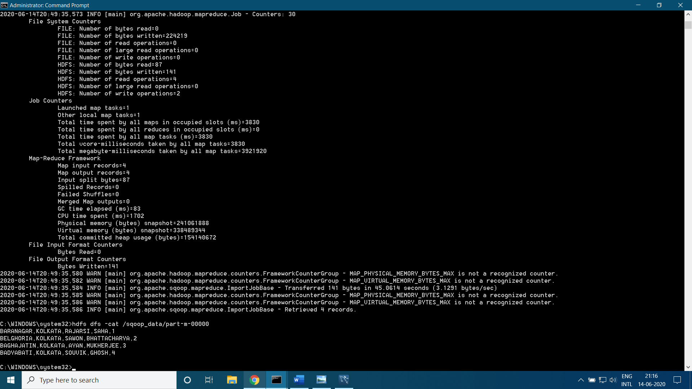

**part-m-00000**

BARANAGAR,KOLKATA,RAJARSI,SAHA,1

BELGHORIA,KOLKATA,SAWON,BHATTACHARYA,2

BAGHAJATIN,KOLKATA,AYAN,MUKHERJEE,3

BADYABATI,KOLKATA,SOUVIK,GHOSH,4

**EXPERIMENT 9**

**AIM:** Manipulate the data imported data using Hive.

**PROCEDURE:**

1. Create table schemas in Hive
2. Load data tables from hdfs system to Hive tables
3. Manipulate tables using HQL commands

**PROGRAM:**

Commands in Hive Shell:

CREATE TABLE flight_data(

year INT,

month INT,

day INT,

day_of_week INT,

dep_time INT,

crs_dep_time INT,

arr_time INT,

crs_arr_time INT,

unique_carrier STRING,

flight_num INT,

tail_num STRING,

actual_elapsed_time INT,

crs_elapsed_time INT,

air_time INT,

arr_delay INT,

dep_delay INT,

origin STRING,

dest STRING,

distance INT,

taxi_in INT,

taxi_out INT,

cancelled INT,

cancellation_code STRING,

diverted INT,

carrier_delay STRING,

weather_delay STRING,

nas_delay STRING,

security_delay STRING,

late_aircraft_delay STRING

)

ROW FORMAT DELIMITED

FIELDS TERMINATED BY ',';

LOAD DATA INPATH 'hive_data/2008.csv' OVERWRITE INTO TABLE flight_data;

CREATE TABLE airports(

name STRING,

country STRING,

area_code INT,

code STRING)

ROW FORMAT DELIMITED

FIELDS TERMINATED BY ',';

LOAD DATA INPATH 'hive_data/airports.csv' OVERWRITE INTO TABLE airports;

Manipulating Commands in Hive Shell:

1. To ensure the table got created and loaded fine

SHOW TABLES;

SELECT * FROM flight_data LIMIT 10;

SELECT * FROM airports LIMIT 10

1. To Find average arrival delay for all flights departing SFO in January

SELECT avg(arr_delay) FROM flight_data WHERE month=1 AND origin='SFO';

1. To run a join query to find the average delay in January 2008 for each airport and to print out the airport's name

SELECT name, AVG(arr_delay) FROM flight_data f INNER JOIN airports a ON (f.origin=a.code) WHERE month=1 GROUP BY name;

**OUTPUT:**

