**COST BASED QUERY OPTIMIZER**

**AIM: Implementation of Cost Based Query Optimizer.**

INTRODUCTION: Cost of query is the time taken by the query to hit the database and return the result. It involves query processing time i.e. time taken to parse and translate the query, optimize it, evaluate, execute and return the result to the user is called cost of the query. Though it is in fraction of seconds, it includes multiple sub tasks and time taken by each of them. Executing the optimized query involves hitting the primary and secondary memory based on the file organization method. Depending on file organization and the indexes used, time taken to retrieve the data may vary.

Majority of time is spent by the query in accessing the data from the memory. It too has several factors determining the cost of access time – disk I/O time, CPU time, network access time etc. Disk access time is the time taken by the processor to search and find the record in the secondary memory and return the result. This takes the majority of time while processing a query. Other times can be ignored compared to disk I/O time.

While calculating the disk I/O time, usually only two factors are considered – seek time and transfer time. The **seek time** is the time taken the processor to find a single record in the disk memory and is represented by tS. For example, in order to find the student ID of a student ‘John’, the processor will fetch in the memory based on the index and the file organization method. The time taken by the processor to hit the disk block and search for his ID is called the seek time. The time taken by the disk to return fetched result back to the processor / user is called transfer time and is represented by tT. Suppose a query need to seek S times to fetch a record and there is B blocks needs to be returned to the user. Then the disk I/O cost is calculated as below

**(S* tS) + (B* tT)**

That is, it is the sum of the total time taken for seek S times and the total time taken to transfer B blocks. Here other costs like CPU cost, RAM cost etc are ignored as they are comparatively small. Disk I/O alone is considered as cost of a query. But we have to calculate the worst-case cost – the maximum time taken by the query when there is a worst case like buffer is full or no buffers etc. because the memory space / buffers depend on the number of queries executing in parallel. All queries would be using the buffers and determining the number of buffers / blocks available for our query is unpredictable. The processor might have to wait till it gets all the memory blocks.

**SOFTWARE AND TOOLS USED:**

1. **Visual Studio 2017 with .NET framework 4.6.1**  
   - used to create Windows forms
2. **Oracle Database Desktop class 12c**  
   - used to create an Oracle database
3. **ODP.NET Managed Driver**  
   - used to create a database connection to the windows forms

**SYSTEM REQUIREMENTS:**

1. **Visual Studio 2017 with .NET framework 4.6.1**

**Supported Operating Systems:** Visual Studio 2017 will install and run on the following operating systems:

* Windows 10 version 1507 or higher: Home, Professional, Education, and Enterprise (LTSC and S are not supported)
* Windows Server 2016: Standard and Datacentre
* Windows 8.1 (with Update 2919355): Core, Professional, and Enterprise
* Windows Server 2012 R2 (with Update 2919355): Essentials, Standard, Datacentre
* Windows 7 SP1 (with latest Windows Updates): Home Premium, Professional, Enterprise, Ultimate

**Hardware:**

* 1.8 GHz or faster processor. Dual-core or better recommended
* 2 GB of RAM; 4 GB of RAM recommended (2.5 GB minimum if running on a virtual machine)
* Hard disk space: up to 130 GB of available space, depending on features installed; typical installations require 20-50 GB of free space.
* Hard disk speed: to improve performance, install Windows and Visual Studio on a solid-state drive (SSD).
* Video card that supports a minimum display resolution of 720p (1280 by 720); Visual Studio will work best at a resolution of WXGA (1366 by 768) or higher.

**Additional Requirements:**

* .NET Framework 4.5.2 or above is required to **install** Visual Studio. Visual Studio requires .NET Framework 4.7.2 to run, but this will be installed during setup.

1. **Oracle Database Desktop class 12c**

**Operating system general requirements:** Oracle Database for Windows x64 is supported on the following operating system versions:

* Windows 7 x64 - Professional, Enterprise, and Ultimate editions
* Windows 8 x64 and Windows 8.1 x64 - Pro and Enterprise editions
* Windows 8.1 x64 - Pro and Enterprise editions
* Windows 10 x64 - Pro, Enterprise, and Education editions
* Windows Server 2012 x64 - Standard, Datacentre, Essentials, and Foundation editions
* Windows Server 2012 R2 x64 - Standard, Datacentre, Essentials, and Foundation editions
* Windows Server 2016 x64 - Standard, Datacentre, and Essentials editions

**System Architecture: Processor:** AMD64 and Intel EM64T

**Physical memory (RAM):** 2 GB minimum

**Virtual memory (swap):**

* If physical memory is between 2 GB and 16 GB, then set virtual memory to 1 time the size of the RAM
* If physical memory is more than 16 GB, then set virtual memory to 16 GB

**Disk space:**

* Typical Install Type total: **10 GB**
* Advanced Install Types total: **10 GB**

**Video adapter:** 256 colours

**Screen Resolution:** 1024 X 768 minimum

**PROCEDURE:**

Backend:

1. Open SQL Plus for Oracle and login with credentials
2. **Create table:**

**create table cost_parameter(**

**PlanId int primary key,**

**SeekTime int,**

**SeekCount int,**

**TransferTime int,**

**BlockCount int,**

**IoCost int,**

**Cpucost int,**

**NetworkCost int,**

**TotalCost int);**

1. Schema: A database schema is the skeleton structure that represents the logical view of the entire database. It defines how the data is organized and how the relations among them are associated. It formulates all the constraints that are to be applied on the data.

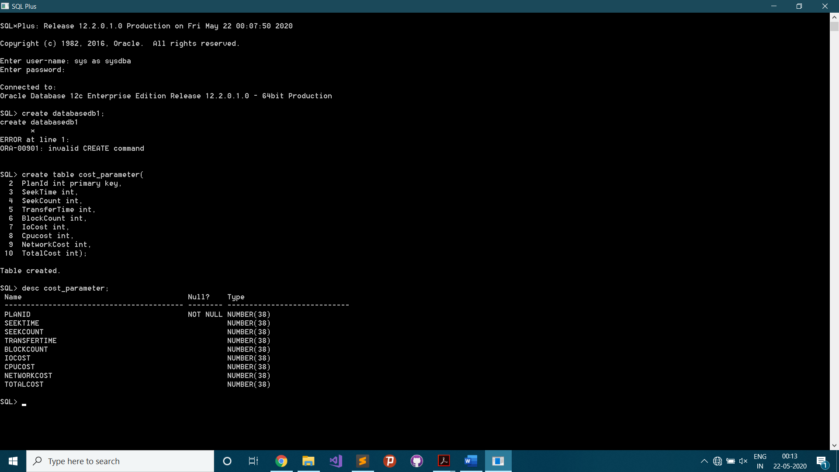

Frontend:

1. Create new Windows Forms App (.NET Framework) in VB Project

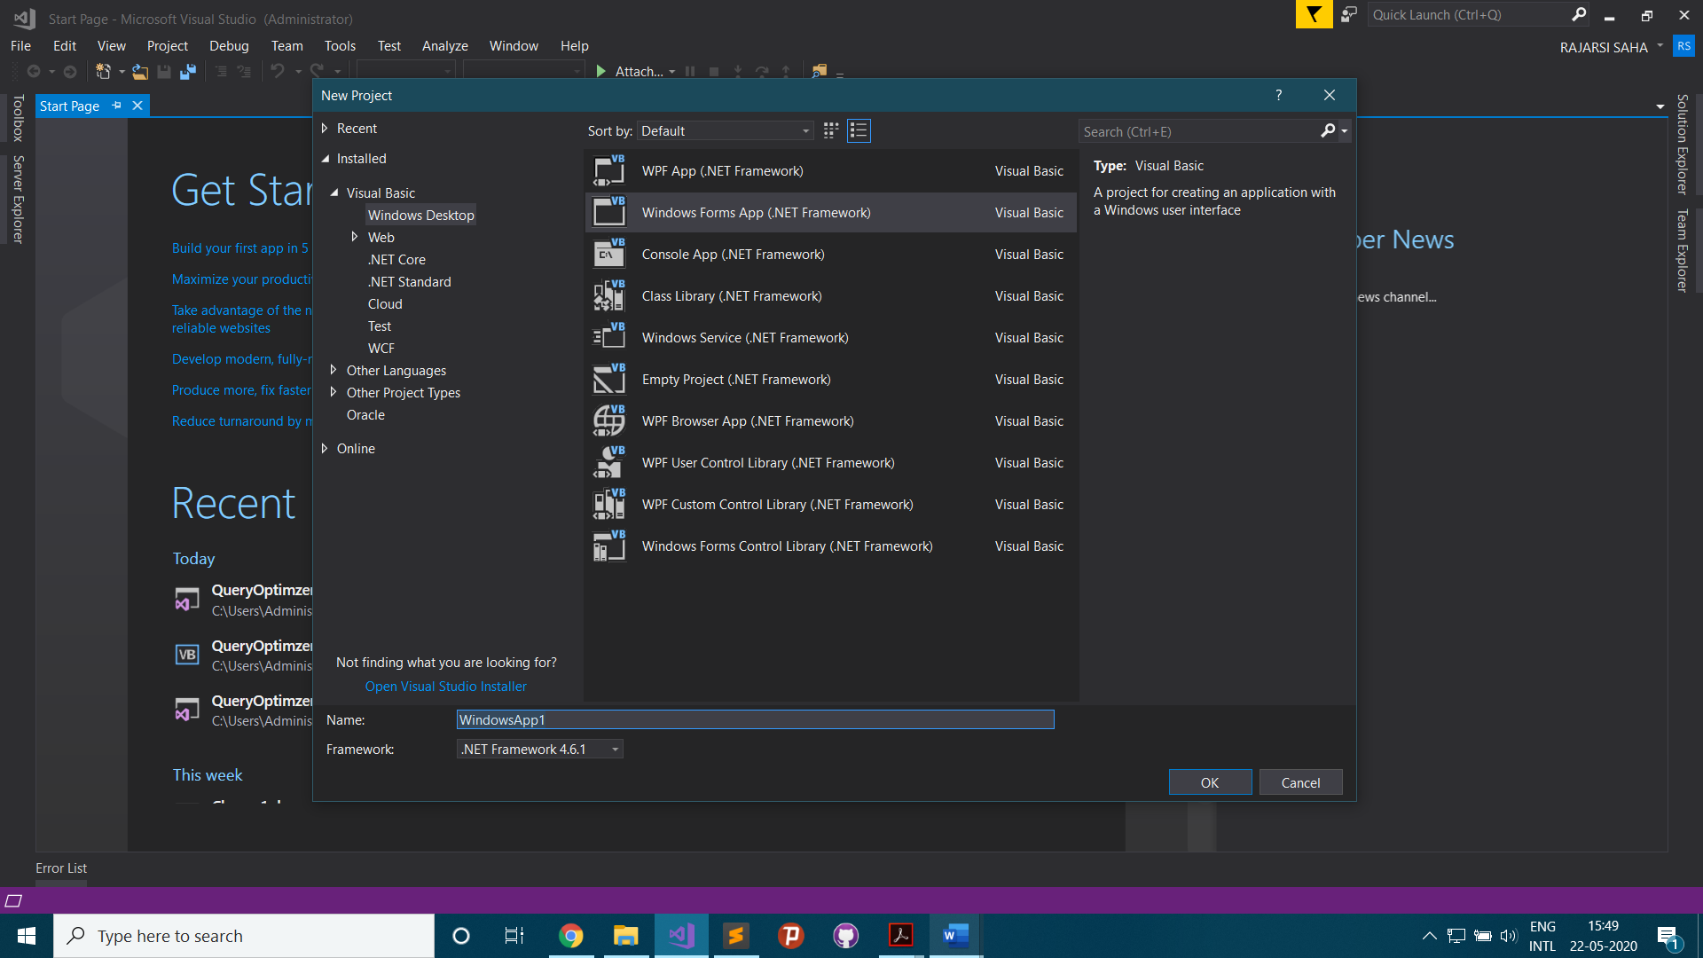

1. Create Database Connection

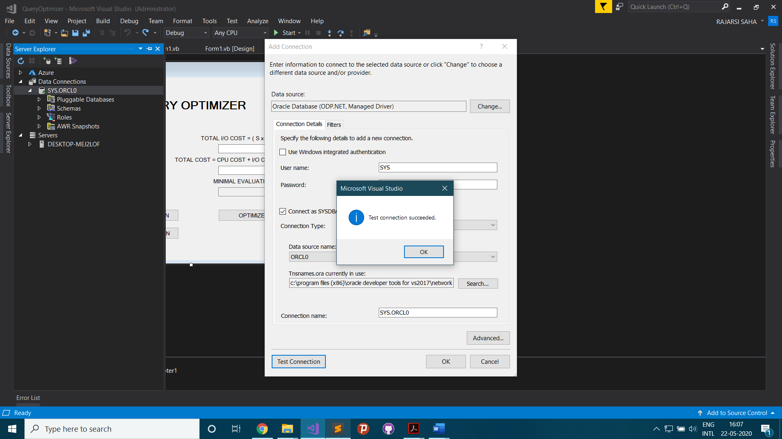

1. Add Dataset

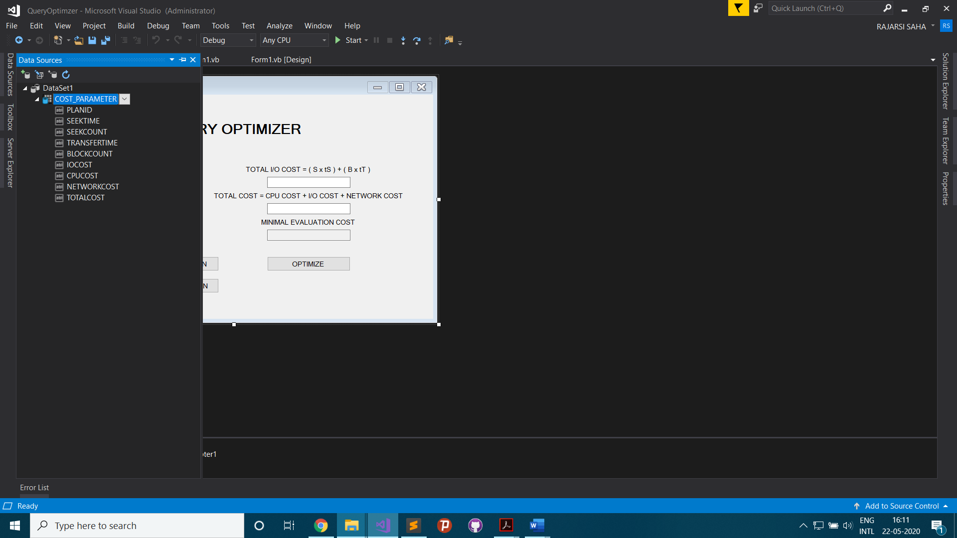

1. Front-end Design

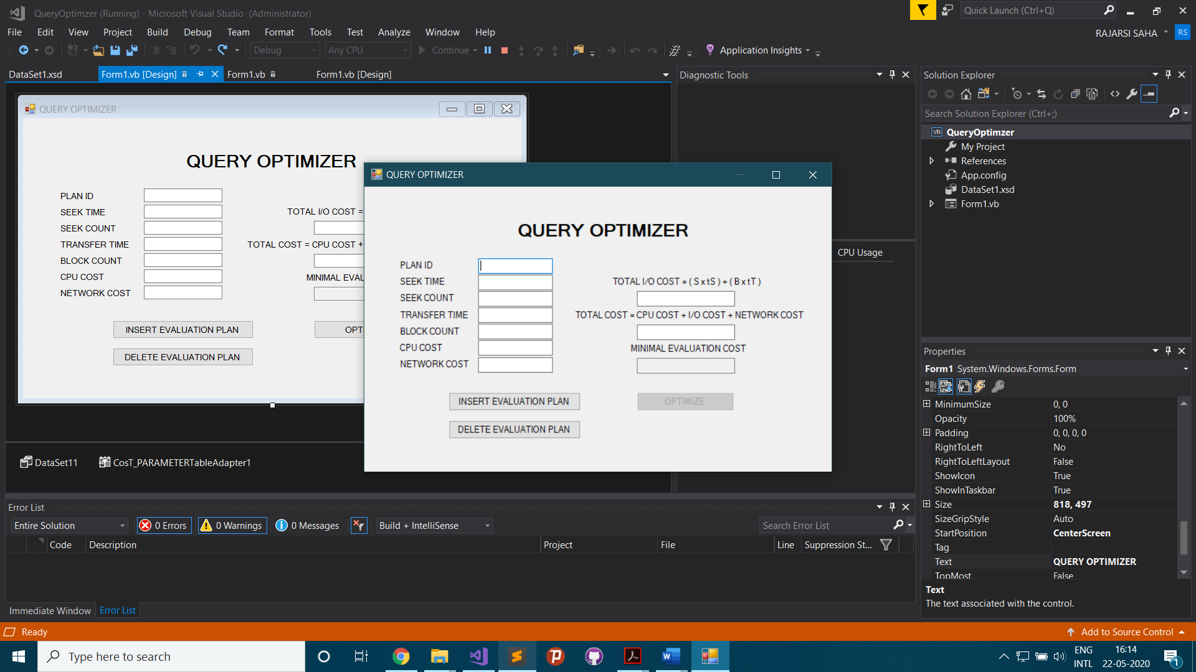

1. Insert Evaluation Plan

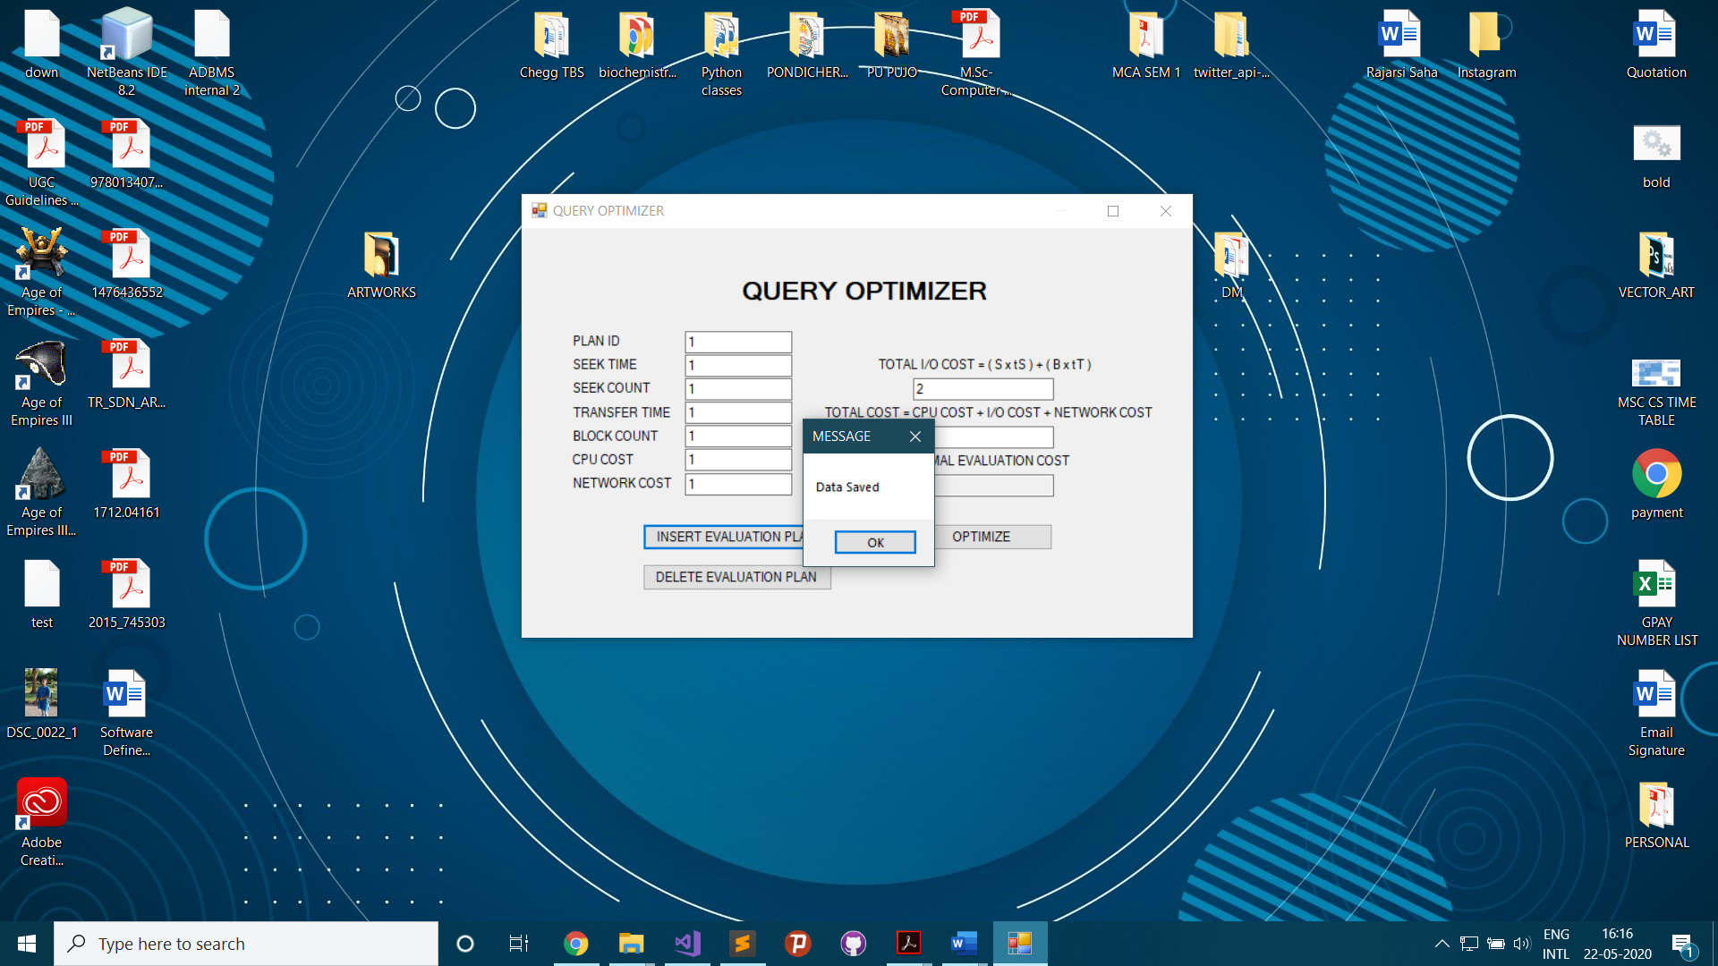

1. Delete Evaluation Plan

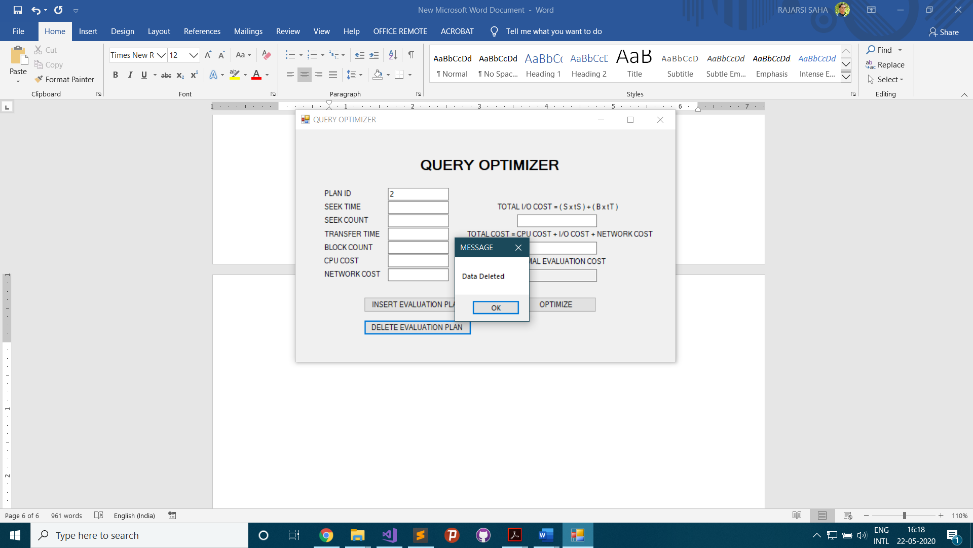

1. Optimize result

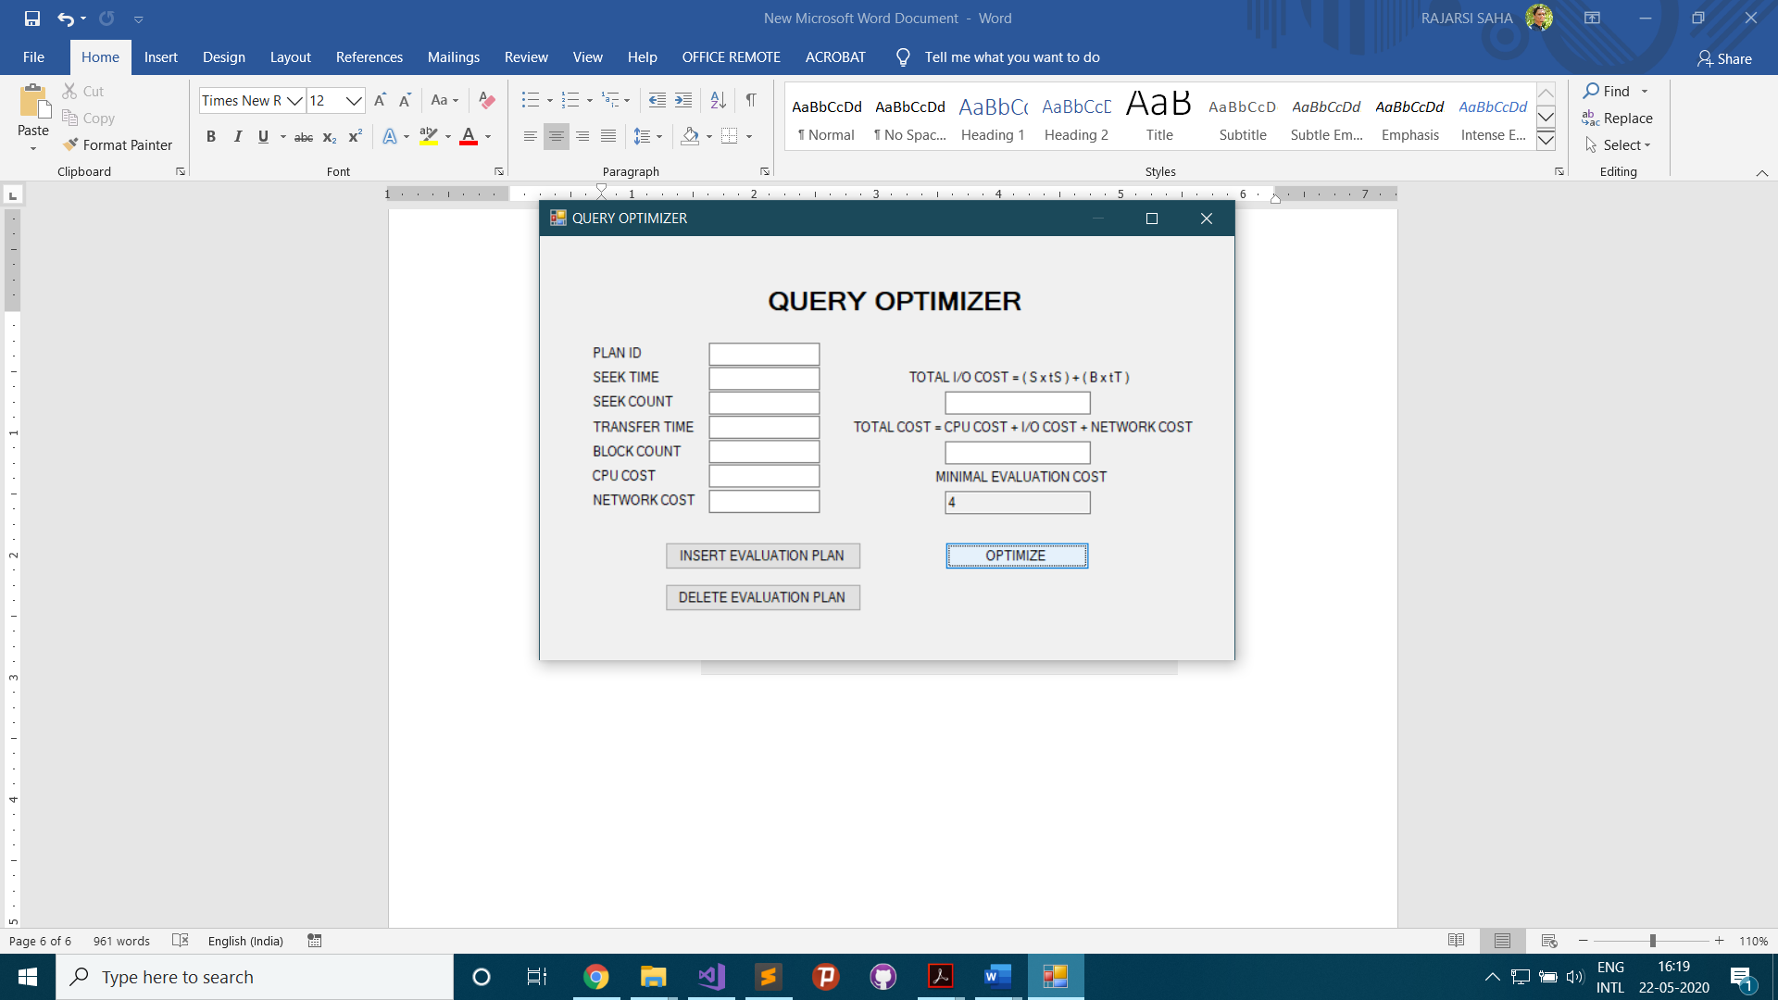

**VISUAL BASIC CODE:**

Public Class Form1

Dim TotalPlans = 0

Private Sub Button1_Click(sender As Object, e As EventArgs) Handles Button1.Click

Dim IoCost, TotalCost As Decimal

IoCost = (TextBox2.Text * TextBox3.Text) + (TextBox4.Text * TextBox5.Text)

TotalCost = IoCost + TextBox6.Text + TextBox7.Text

TextBox8.Text = IoCost

TextBox9.Text = TotalCost

CosT_PARAMETERTableAdapter1.Insert(TextBox1.Text, TextBox2.Text, TextBox3.Text, TextBox4.Text, TextBox5.Text, TextBox8.Text, TextBox6.Text, TextBox7.Text, TextBox9.Text)

Me.DataSet11.AcceptChanges()

TotalPlans += 1

Button3.Enabled = True

MessageBox.Show("Data Saved", "MESSAGE")

TextBox1.Clear()

TextBox2.Clear()

TextBox3.Clear()

TextBox4.Clear()

TextBox5.Clear()

TextBox6.Clear()

TextBox7.Clear()

TextBox8.Clear()

TextBox9.Clear()

TextBox10.Clear()

End Sub

Private Sub Button2_Click(sender As Object, e As EventArgs) Handles Button2.Click

CosT_PARAMETERTableAdapter1.DeleteQuery(Val(TextBox1.Text))

Me.DataSet11.AcceptChanges()

TotalPlans -= 1

If TotalPlans = 0 Then

Button3.Enabled = False

End If

MessageBox.Show("Data Deleted", "MESSAGE")

TextBox1.Clear()

TextBox10.Clear()

End Sub

Private Sub Button3_Click(sender As Object, e As EventArgs) Handles Button3.Click

Dim TotalCost

TotalCost = CosT_PARAMETERTableAdapter1.ScalarQuery()

TextBox10.Text = TotalCost

End Sub

End Class

**FEW RELATED DEFINITIONS:**

**Database:** A **database** is an organized collection of data, generally stored and accessed electronically from a computer system. Where databases are more complex, they are often developed using formal design and modelling techniques.

**Database Management System (DBMS):**

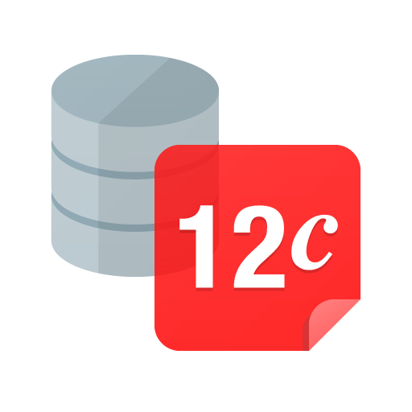**The database management system (DBMS)** is the software that interacts with end users, applications, and the database itself to capture and analyse the data. The DBMS software additionally encompasses the core facilities provided to administer the database.

**Oracle 12c database**

The sum total of the database, the DBMS and the associated applications can be referred to as a "database system". Often the term "database" is also used to loosely refer to any of the DBMS, the database system or an application associated with the database.

**Windows Forms:**

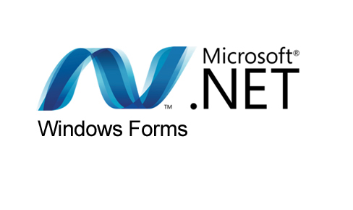**Windows Forms (WinForms)** is a graphical (GUI) class library included as a part of Microsoft .NET Framework or Mono Framework, providing a platform to write rich client applications for desktop, laptop, and tablet PCs. While it is seen as a replacement for the earlier and more complex C++ based Microsoft Foundation Class Library, it does not offer a comparable paradigm and only acts as a platform for the user interface tier in a multi-tier solution.

**Microsoft .NET Windows form**

At the Microsoft Connect event on December 4, 2018, Microsoft announced releasing Windows Forms as an open source project on GitHub. It is released under the MIT License. With this release, Windows Forms has become available for projects targeting the .NET Core framework. However, the framework is still available only on the Windows platform, and Mono's incomplete implementation of WinForms remains the only cross-platform implementation.