**NAME: RAJARSI SAHA  
REG: 19370037  
PAPER CODE: CSSC512  
DATE: 22-12-2020**

CODE:

**index.html**

<!DOCTYPE html>

<html>

<head>

<meta charset="utf-8">

<title>Job Application Form</title>

<meta name="viewport" content="width=device-width, initial-scale=1.0, maximum-scale=2.0, user-scalable=1" />

<!-- MATERIAL DESIGN ICONIC FONT -->

<link rel="stylesheet" href="fonts/material-design-iconic-font/css/material-design-iconic-font.css">

<!-- STYLE CSS -->

<link rel="stylesheet" href="css/style.css">

<!-- CSS only -->

<link href="https://cdn.jsdelivr.net/npm/bootstrap@5.0.0-beta1/dist/css/bootstrap.min.css" rel="stylesheet" integrity="sha384-giJF6kkoqNQ00vy+HMDP7azOuL0xtbfIcaT9wjKHr8RbDVddVHyTfAAsrekwKmP1" crossorigin="anonymous">

<script src="js/jquery-3.3.1.min.js"></script>

<!-- JQUERY STEP -->

<script src="js/jquery.steps.js"></script>

<script src="js/main.js"></script>

</head>

<body>

<div class="wrapper container" style="margin: 0px; padding: 0px;">

<div class="row">

<div class="col-md-6 position-fixed" style="padding: 0px;">

<div class="image-holder"></div>

</div>

<div class="col-md-6" style="position: absolute; left: 50%; padding: 0px;">

<form action="">

<div id="wizard">

<h1 class="text-center" style="padding: 1em;">Job Application Form</h1>

<!-- SECTION 1 -->

<h4></h4>

<section>

<div class="form-row form-group">

<div class="form-holder">

<label for="">

First Name *

</label>

<input type="text" class="form-control" placeholder="Your first name" required>

</div>

<div class="form-holder">

<label for="">

Last Name *

</label>

<input type="text" class="form-control" placeholder="Your last name" required>

</div>

</div>

<div class="form-row">

<label for="">

Phone Number *

</label>

<input type="text" class="form-control" placeholder="Your phone" required>

</div>

<div class="form-row">

<label for="">

Email *

</label>

<input type="email" class="form-control" placeholder="Your email" required>

</div>

<div class="form-row">

<label for="">

Address *

</label>

<input type="text" class="form-control" placeholder="Street address" style="margin-bottom: 0.5em" required>

<input type="text" class="form-control" placeholder="Street address line 2">

</div>

<div class="form-row">

<label for="">

Town / City *

</label>

<input type="text" class="form-control" placeholder="Your town / city" required>

</div>

<div class="form-row">

<label for="">

Country *

</label>

<div class="form-holder">

<select name="" id="" class="form-control" required>

<option value=""></option>

<option value="Afganistan" class="option">Afghanistan</option>

<option value="Albania" class="option">Albania</option>

<option value="Algeria" class="option">Algeria</option>

<option value="American Samoa" class="option">American Samoa</option>

<option value="Andorra" class="option">Andorra</option>

<option value="Angola" class="option">Angola</option>

<option value="Anguilla" class="option">Anguilla</option>

<option value="Antigua & Barbuda" class="option">Antigua & Barbuda</option>

<option value="Argentina" class="option">Argentina</option>

<option value="Armenia" class="option">Armenia</option>

<option value="Aruba" class="option">Aruba</option>

<option value="Australia" class="option">Australia</option>

<option value="Austria" class="option">Austria</option>

<option value="Azerbaijan" class="option">Azerbaijan</option>

<option value="Bahamas" class="option">Bahamas</option>

<option value="Bahrain" class="option">Bahrain</option>

<option value="Bangladesh" class="option">Bangladesh</option>

<option value="Barbados" class="option">Barbados</option>

<option value="Belarus" class="option">Belarus</option>

<option value="Belgium" class="option">Belgium</option>

<option value="Belize" class="option">Belize</option>

<option value="Benin" class="option">Benin</option>

<option value="Bermuda" class="option">Bermuda</option>

<option value="Bhutan" class="option">Bhutan</option>

<option value="Bolivia" class="option">Bolivia</option>

<option value="Bonaire" class="option">Bonaire</option>

<option value="Bosnia & Herzegovina" class="option">Bosnia & Herzegovina</option>

<option value="Botswana" class="option">Botswana</option>

<option value="Brazil" class="option">Brazil</option>

<option value="British Indian Ocean Ter" class="option">British Indian Ocean Ter</option>

<option value="Brunei" class="option">Brunei</option>

<option value="Bulgaria" class="option">Bulgaria</option>

<option value="Burkina Faso" class="option">Burkina Faso</option>

<option value="Burundi" class="option">Burundi</option>

<option value="Cambodia" class="option">Cambodia</option>

<option value="Cameroon" class="option">Cameroon</option>

<option value="Canada" class="option">Canada</option>

<option value="Canary Islands" class="option">Canary Islands</option>

<option value="Cape Verde" class="option">Cape Verde</option>

<option value="Cayman Islands" class="option">Cayman Islands</option>

<option value="Central African Republic" class="option">Central African Republic</option>

<option value="Chad" class="option">Chad</option>

<option value="Channel Islands" class="option">Channel Islands</option>

<option value="Chile" class="option">Chile</option>

<option value="China" class="option">China</option>

<option value="Christmas Island" class="option">Christmas Island</option>

<option value="Cocos Island" class="option">Cocos Island</option>

<option value="Colombia" class="option">Colombia</option>

<option value="Comoros" class="option">Comoros</option>

<option value="Congo" class="option">Congo</option>

<option value="Cook Islands" class="option">Cook Islands</option>

<option value="Costa Rica" class="option">Costa Rica</option>

<option value="Cote DIvoire" class="option">Cote DIvoire</option>

<option value="Croatia" class="option">Croatia</option>

<option value="Cuba" class="option">Cuba</option>

<option value="Curaco" class="option">Curacao</option>

<option value="Cyprus" class="option">Cyprus</option>

<option value="Czech Republic" class="option">Czech Republic</option>

<option value="Denmark" class="option">Denmark</option>

<option value="Djibouti" class="option">Djibouti</option>

<option value="Dominica" class="option">Dominica</option>

<option value="Dominican Republic" class="option">Dominican Republic</option>

<option value="East Timor" class="option">East Timor</option>

<option value="Ecuador" class="option">Ecuador</option>

<option value="Egypt" class="option">Egypt</option>

<option value="El Salvador" class="option">El Salvador</option>

<option value="Equatorial Guinea" class="option">Equatorial Guinea</option>

<option value="Eritrea" class="option">Eritrea</option>

<option value="Estonia" class="option">Estonia</option>

<option value="Ethiopia" class="option">Ethiopia</option>

<option value="Falkland Islands" class="option">Falkland Islands</option>

<option value="Faroe Islands" class="option">Faroe Islands</option>

<option value="Fiji" class="option">Fiji</option>

<option value="Finland" class="option">Finland</option>

<option value="France" class="option">France</option>

<option value="French Guiana" class="option">French Guiana</option>

<option value="French Polynesia" class="option">French Polynesia</option>

<option value="French Southern Ter" class="option">French Southern Ter</option>

<option value="Gabon" class="option">Gabon</option>

<option value="Gambia" class="option">Gambia</option>

<option value="Georgia" class="option">Georgia</option>

<option value="Germany" class="option">Germany</option>

<option value="Ghana" class="option">Ghana</option>

<option value="Gibraltar" class="option">Gibraltar</option>

<option value="Great Britain" class="option">Great Britain</option>

<option value="Greece" class="option">Greece</option>

<option value="Greenland" class="option">Greenland</option>

<option value="Grenada" class="option">Grenada</option>

<option value="Guadeloupe" class="option">Guadeloupe</option>

<option value="Guam" class="option">Guam</option>

<option value="Guatemala" class="option">Guatemala</option>

<option value="Guinea" class="option">Guinea</option>

<option value="Guyana" class="option">Guyana</option>

<option value="Haiti" class="option">Haiti</option>

<option value="Hawaii" class="option">Hawaii</option>

<option value="Honduras" class="option">Honduras</option>

<option value="Hong Kong" class="option">Hong Kong</option>

<option value="Hungary" class="option">Hungary</option>

<option value="Iceland" class="option">Iceland</option>

<option value="Indonesia" class="option">Indonesia</option>

<option value="India" class="option">India</option>

<option value="Iran" class="option">Iran</option>

<option value="Iraq" class="option">Iraq</option>

<option value="Ireland" class="option">Ireland</option>

<option value="Isle of Man" class="option">Isle of Man</option>

<option value="Israel" class="option">Israel</option>

<option value="Italy" class="option">Italy</option>

<option value="Jamaica" class="option">Jamaica</option>

<option value="Japan" class="option">Japan</option>

<option value="Jordan" class="option">Jordan</option>

<option value="Kazakhstan" class="option">Kazakhstan</option>

<option value="Kenya" class="option">Kenya</option>

<option value="Kiribati" class="option">Kiribati</option>

<option value="Korea North" class="option">Korea North</option>

<option value="Korea Sout" class="option">Korea South</option>

<option value="Kuwait" class="option">Kuwait</option>

<option value="Kyrgyzstan" class="option">Kyrgyzstan</option>

<option value="Laos" class="option">Laos</option>

<option value="Latvia" class="option">Latvia</option>

<option value="Lebanon" class="option">Lebanon</option>

<option value="Lesotho" class="option">Lesotho</option>

<option value="Liberia" class="option">Liberia</option>

<option value="Libya" class="option">Libya</option>

<option value="Liechtenstein" class="option">Liechtenstein</option>

<option value="Lithuania" class="option">Lithuania</option>

<option value="Luxembourg" class="option">Luxembourg</option>

<option value="Macau" class="option">Macau</option>

<option value="Macedonia" class="option">Macedonia</option>

<option value="Madagascar" class="option">Madagascar</option>

<option value="Malaysia" class="option">Malaysia</option>

<option value="Malawi" class="option">Malawi</option>

<option value="Maldives" class="option">Maldives</option>

<option value="Mali" class="option">Mali</option>

<option value="Malta" class="option">Malta</option>

<option value="Marshall Islands" class="option">Marshall Islands</option>

<option value="Martinique" class="option">Martinique</option>

<option value="Mauritania" class="option">Mauritania</option>

<option value="Mauritius" class="option">Mauritius</option>

<option value="Mayotte" class="option">Mayotte</option>

<option value="Mexico" class="option">Mexico</option>

<option value="Midway Islands" class="option">Midway Islands</option>

<option value="Moldova" class="option">Moldova</option>

<option value="Monaco" class="option">Monaco</option>

<option value="Mongolia" class="option">Mongolia</option>

<option value="Montserrat" class="option">Montserrat</option>

<option value="Morocco" class="option">Morocco</option>

<option value="Mozambique" class="option">Mozambique</option>

<option value="Myanmar" class="option">Myanmar</option>

<option value="Nambia" class="option">Nambia</option>

<option value="Nauru" class="option">Nauru</option>

<option value="Nepal" class="option">Nepal</option>

<option value="Netherland Antilles" class="option">Netherland Antilles</option>

<option value="Netherlands" class="option">Netherlands (Holland, Europe)</option>

<option value="Nevis" class="option">Nevis</option>

<option value="New Caledonia" class="option">New Caledonia</option>

<option value="New Zealand" class="option">New Zealand</option>

<option value="Nicaragua" class="option">Nicaragua</option>

<option value="Niger" class="option">Niger</option>

<option value="Nigeria" class="option">Nigeria</option>

<option value="Niue" class="option">Niue</option>

<option value="Norfolk Island" class="option">Norfolk Island</option>

<option value="Norway" class="option">Norway</option>

<option value="Oman" class="option">Oman</option>

<option value="Pakistan" class="option">Pakistan</option>

<option value="Palau Island" class="option">Palau Island</option>

<option value="Palestine" class="option">Palestine</option>

<option value="Panama" class="option">Panama</option>

<option value="Papua New Guinea" class="option">Papua New Guinea</option>

<option value="Paraguay" class="option">Paraguay</option>

<option value="Peru" class="option">Peru</option>

<option value="Phillipines" class="option">Philippines</option>

<option value="Pitcairn Island" class="option">Pitcairn Island</option>

<option value="Poland" class="option">Poland</option>

<option value="Portugal" class="option">Portugal</option>

<option value="Puerto Rico" class="option">Puerto Rico</option>

<option value="Qatar" class="option">Qatar</option>

<option value="Republic of Montenegro" class="option">Republic of Montenegro</option>

<option value="Republic of Serbia" class="option">Republic of Serbia</option>

<option value="Reunion" class="option">Reunion</option>

<option value="Romania" class="option">Romania</option>

<option value="Russia" class="option">Russia</option>

<option value="Rwanda" class="option">Rwanda</option>

<option value="St Barthelemy" class="option">St Barthelemy</option>

<option value="St Eustatius" class="option">St Eustatius</option>

<option value="St Helena" class="option">St Helena</option>

<option value="St Kitts-Nevis" class="option">St Kitts-Nevis</option>

<option value="St Lucia" class="option">St Lucia</option>

<option value="St Maarten" class="option">St Maarten</option>

<option value="St Pierre & Miquelon" class="option">St Pierre & Miquelon</option>

<option value="St Vincent & Grenadines" class="option">St Vincent & Grenadines</option>

<option value="Saipan" class="option">Saipan</option>

<option value="Samoa" class="option">Samoa</option>

<option value="Samoa American" class="option">Samoa American</option>

<option value="San Marino" class="option">San Marino</option>

<option value="Sao Tome & Principe" class="option">Sao Tome & Principe</option>

<option value="Saudi Arabia" class="option">Saudi Arabia</option>

<option value="Senegal" class="option">Senegal</option>

<option value="Seychelles" class="option">Seychelles</option>

<option value="Sierra Leone" class="option">Sierra Leone</option>

<option value="Singapore" class="option">Singapore</option>

<option value="Slovakia" class="option">Slovakia</option>

<option value="Slovenia" class="option">Slovenia</option>

<option value="Solomon Islands" class="option">Solomon Islands</option>

<option value="Somalia" class="option">Somalia</option>

<option value="South Africa" class="option">South Africa</option>

<option value="Spain" class="option">Spain</option>

<option value="Sri Lanka" class="option">Sri Lanka</option>

<option value="Sudan" class="option">Sudan</option>

<option value="Suriname" class="option">Suriname</option>

<option value="Swaziland" class="option">Swaziland</option>

<option value="Sweden" class="option">Sweden</option>

<option value="Switzerland" class="option">Switzerland</option>

<option value="Syria" class="option">Syria</option>

<option value="Tahiti" class="option">Tahiti</option>

<option value="Taiwan" class="option">Taiwan</option>

<option value="Tajikistan" class="option">Tajikistan</option>

<option value="Tanzania" class="option">Tanzania</option>

<option value="Thailand" class="option">Thailand</option>

<option value="Togo" class="option">Togo</option>

<option value="Tokelau" class="option">Tokelau</option>

<option value="Tonga" class="option">Tonga</option>

<option value="Trinidad & Tobago" class="option">Trinidad & Tobago</option>

<option value="Tunisia" class="option">Tunisia</option>

<option value="Turkey" class="option">Turkey</option>

<option value="Turkmenistan" class="option">Turkmenistan</option>

<option value="Turks & Caicos Is" class="option">Turks & Caicos Is</option>

<option value="Tuvalu" class="option">Tuvalu</option>

<option value="Uganda" class="option">Uganda</option>

<option value="United Kingdom" class="option">United Kingdom</option>

<option value="Ukraine" class="option">Ukraine</option>

<option value="United Arab Erimates" class="option">United Arab Emirates</option>

<option value="United States of America" class="option">United States of America</option>

<option value="Uraguay" class="option">Uruguay</option>

<option value="Uzbekistan" class="option">Uzbekistan</option>

<option value="Vanuatu" class="option">Vanuatu</option>

<option value="Vatican City State" class="option">Vatican City State</option>

<option value="Venezuela" class="option">Venezuela</option>

<option value="Vietnam" class="option">Vietnam</option>

<option value="Virgin Islands (Brit)" class="option">Virgin Islands (Brit)</option>

<option value="Virgin Islands (USA)" class="option">Virgin Islands (USA)</option>

<option value="Wake Island" class="option">Wake Island</option>

<option value="Wallis & Futana Is" class="option">Wallis & Futana Is</option>

<option value="Yemen" class="option">Yemen</option>

<option value="Zaire" class="option">Zaire</option>

<option value="Zambia" class="option">Zambia</option>

<option value="Zimbabwe" class="option">Zimbabwe</option>

</select>

<i class="zmdi zmdi-caret-down"></i>

</div>

</div>

<div class="form-row">

<label for="">

What is the best time to contact you? *

</label>

<div class="form-holder">

<select name="" id="" class="form-control" required>

<option value=""></option>

<option value="Morning" class="option">Morning</option>

<option value="Lunch Time" class="option">Lunch Time</option>

<option value="Afternoon" class="option">Afternoon</option>

<option value="Doesn't Matter" class="option">Doesn't Matter</option>

</select>

<i class="zmdi zmdi-caret-down"></i>

</div>

</div>

<div class="form-row">

<label for="">

What is the best time to contact you? *

</label>

<div class="form-holder">

<select name="" id="" class="form-control" required>

<option value=""></option>

<option value="Morning" class="option">Morning</option>

<option value="Lunch Time" class="option">Lunch Time</option>

<option value="Afternoon" class="option">Afternoon</option>

<option value="Doesn't Matter" class="option">Doesn't Matter</option>

</select>

<i class="zmdi zmdi-caret-down"></i>

</div>

</div>

<div class="form-row">

<label for="">

What is your social security number? *

</label>

<input type="test" class="form-control" placeholder="Your PAN number" required>

</div>

<div class="form-row">

<label for="">

Are you currently legally entitled to work in the country where the job is based? *

</label>

<div class="checkbox-circle">

<label class="active">

<input type="radio" name="legally" value="yes" checked>Yes

<span class="checkmark"></span>

</label>

<label>

<input type="radio" name="legally" value="no">No

<span class="checkmark"></span>

</label>

</div>

</div>

<div class="form-row">

<label for="">

If applicable, please detail any restrictions:

</label>

<textarea class="form-control" style="height: 100px;"></textarea>

</div>

<div class="form-row">

<label for="">

If selected for employment are you willing to submit a background check? *

</label>

<div class="checkbox-circle">

<label class="active">

<input type="radio" name="background" value="yes" checked>Yes

<span class="checkmark"></span>

</label>

<label>

<input type="radio" name="background" value="no">No

<span class="checkmark"></span>

</label>

</div>

</div>

</section>

<!-- SECTION 2 -->

<h4></h4>

<section>

<div class="form-row">

<label for="">

What position are you applying for? *

</label>

<div class="form-holder">

<select name="" id="" class="form-control" required>

<option value=""></option>

<option value="Sales" class="option">Sales</option>

<option value="Marketing" class="option">Marketing</option>

<option value="Human Resources" class="option">Human Resources</option>

<option value="Customer Service" class="option">Customer Service</option>

</select>

<i class="zmdi zmdi-caret-down"></i>

</div>

</div>

<div class="form-row">

<label for="">

What is your desired employment? *

</label>

<div class="form-holder">

<select name="" id="" class="form-control" required>

<option value=""></option>

<option value="Full Time" class="option">Full Time</option>

<option value="Part Time" class="option">Part Time</option>

<option value="Internship" class="option">Internship</option>

</select>

<i class="zmdi zmdi-caret-down"></i>

</div>

</div>

<div class="form-row">

<div class="form-holder">

<label for="">

What is your desired pay? *

</label>

<input type="text" class="form-control" required>

</div>

</div>

<div class="form-row">

<div class="form-holder">

<label for="">

What is your available start date? *

</label>

<input type="date" class="form-control" required>

</div>

</div>

<div class="form-row">

<label for="">

Have you worked for Company before? *

</label>

<div class="checkbox-circle">

<label class="active">

<input type="radio" name="worked" value="yes" checked>Yes

<span class="checkmark"></span>

</label>

<label>

<input type="radio" name="worked" value="no">No

<span class="checkmark"></span>

</label>

</div>

</div>

<div class="form-row">

<label for="">

Education details *

</label>

<input type="text" class="form-control" placeholder="10th" style="margin-bottom: 0.5em" required>

<input type="text" class="form-control" placeholder="12th" style="margin-bottom: 0.5em" required>

<input type="text" class="form-control" placeholder="UG / Diploma" style="margin-bottom: 0.5em" required>

<input type="text" class="form-control" placeholder="PG">

</div>

</section>

<!-- SECTION 3 -->

<h4></h4>

<section>

<div class="form-row">

<label for="">

Work details

</label>

<input type="text" class="form-control" placeholder="FIll out as applicable" style="margin-bottom: 0.5em">

<input type="text" class="form-control" placeholder="FIll out as applicable" style="margin-bottom: 0.5em">

<input type="text" class="form-control" placeholder="FIll out as applicable">

</div>

<div class="form-row">

<label for="">

Other achievements & details

</label>

<input type="text" class="form-control" placeholder="FIll out as applicable" style="margin-bottom: 0.5em">

<input type="text" class="form-control" placeholder="FIll out as applicable" style="margin-bottom: 0.5em">

<input type="text" class="form-control" placeholder="FIll out as applicable">

</div>

<div class="form-row">

<label for="">

Skills

</label>

<label>

MS Office<input type="range" name="ms-word" min="0" max="50" value="10" step="10" style="float: right; width: 50%; top: 3px; margin: 0 2em; position: relative;">

</label>

<label>

Communication Skills<input type="range" name="com-skill" min="0" max="50" value="10" step="10" style="float: right; width: 50%; top: 3px; margin: 0 2em; position: relative;">

</label>

<label>

SEO<input type="range" name="seo" min="0" max="50" value="10" step="10" style="float: right; width: 50%; top: 3px; margin: 0 2em; position: relative;">

</label>

</div>

</section>

<!-- SECTION 4 -->

<h4></h4>

<section>

<div class="form-row">

<label for="">

References

</label>

<input type="text" class="form-control" placeholder="FIll out as applicable" style="margin-bottom: 0.5em">

<input type="text" class="form-control" placeholder="FIll out as applicable" style="margin-bottom: 0.5em">

<input type="text" class="form-control" placeholder="FIll out as applicable">

</div>

<div class="form-row">

<label for="">

Please upload your CV here *

</label>

<input type="file" class="form-control">

</div>

<div class="form-row">

<label for="">

Please upload your Cover Letter here *

</label>

<input type="file" class="form-control">

</div>

<div class="form-row">

<div class="form-holder">

<label for="">

Date *

</label>

<input type="date" class="form-control" required>

</div>

</div>

<div class="checkbox">

<label>

<input type="checkbox" name="billing method" value="Check payments">I agree to terms & conditions. *

<span class="checkmark"></span>

</label>

</div>

</section>

</div>

</form>

</div>

</div>

</div>

</body>

</html>

**style.css**

@font-face {

font-family: "Poppins-Regular";

src: url("../fonts/poppins/Poppins-Regular.ttf"); }

@font-face {

font-family: "Poppins-SemiBold";

src: url("../fonts/poppins/Poppins-SemiBold.ttf"); }

@font-face {

font-family: "Poppins-Medium";

src: url("../fonts/poppins/Poppins-Medium.ttf"); }

@font-face {

font-family: "Muli-Bold";

src: url("../fonts/muli/Muli-Bold.ttf"); }

* {

-webkit-box-sizing: border-box;

-moz-box-sizing: border-box;

box-sizing: border-box; }

body {

font-family: "Poppins-Regular";

font-size: 15px;

color: #666;

margin: 0; }

:focus {

outline: none; }

textarea {

resize: none; }

input, textarea, select, button {

font-family: "Poppins-Regular";

font-size: 15px;

color: #666; }

p, h1, h2, h3, h4, h5, h6, ul {

margin: 0; }

ul {

padding: 0;

margin: 0;

list-style: none; }

a {

text-decoration: none; }

textarea {

resize: none; }

select {

-moz-appearance: none;

-webkit-appearance: none;

cursor: pointer;

border: none; }

select option[value=""][disabled] {

display: none; }

img {

max-width: 100%;

vertical-align: middle; }

body {

background: url("../images/form-wizard-bg.jpg");

background-size: cover;

scrollbar-width: none;

-ms-overflow-style: none;

-webkit-font-smoothing: antialiased; }

body::-webkit-scrollbar {

display: none;

}

.wrapper {

height: 100vh;

margin: auto;

display: block; }

.wrapper .image-holder {

background: url('../images/form-wizard.jpg') center center fixed;

background-size: cover;

height: 100vh;

}

.wizard > .steps .current-info, .wizard > .steps .number {

display: none; }

#wizard {

min-height: 834px;

background: #fff;

margin:auto;

padding: 107px 75px 65px; }

.steps {

margin-bottom: 30px; }

.steps ul {

display: flex;

position: relative; }

.steps ul li {

width: 20.16%;

margin-right: 10px; }

.steps ul li a {

display: inline-block;

width: 100%;

height: 7px;

background: #e6e6e6;

border-radius: 3.5px; }

.steps ul li.first a, .steps ul li.checked a {

background: #000000;

transition: all 0.5s ease; }

.steps ul:before {

content: "Personal Information";

font-size: 22px;

font-family: "Poppins-SemiBold";

color: #333;

top: -38px;

position: absolute; }

.steps ul.step-2:before {

content: "Position Information"; }

.steps ul.step-3:before {

content: "Work Experience"; }

.steps ul.step-4:before {

content: "References"; }

h3 {

font-family: "Poppins-SemiBold"; }

.form-row {

margin-bottom: 24px; }

.form-row label {

margin-bottom: 8px;

display: block; }

.form-row.form-group {

display: flex; }

.form-row.form-group .form-holder {

width: 50%;

margin-right: 21px; }

.form-row.form-group .form-holder:last-child {

margin-right: 0; }

.form-holder {

position: relative; }

.form-holder i {

position: absolute;

top: 11px;

right: 19px;

font-size: 17px;

color: #999; }

.form-control {

height: 42px;

border: 1px solid #e6e6e6;

background: none;

width: 100%;

padding: 0 18px; }

.form-control:focus {

border-color: #000000; }

.form-control::-webkit-input-placeholder {

color: #999;

font-size: 13px; }

.form-control::-moz-placeholder {

color: #999;

font-size: 13px; }

.form-control:-ms-input-placeholder {

color: #999;

font-size: 13px; }

.form-control:-moz-placeholder {

color: #999;

font-size: 13px; }

textarea.form-control {

padding-top: 11px;

padding-bottom: 11px; }

.option {

color: #999; }

.actions ul {

display: flex;

margin-top: 30px;

justify-content: space-between; }

.actions ul.step-last {

justify-content: flex-end; }

.actions ul.step-last li:first-child {

display: none; }

.actions li a {

color: #fff !important;

padding: 0;

border: none;

display: inline-flex;

text-decoration: none;

height: 51px;

width: 135px;

align-items: center;

background: #000000;

cursor: pointer;

position: relative;

padding-left: 41px;

color: #333;

-webkit-transform: perspective(1px) translateZ(0);

transform: perspective(1px) translateZ(0);

-webkit-transition-duration: 0.3s;

transition-duration: 0.3s;

font-weight: 400; }

.actions li a:before {

content: '\f2ee';

position: absolute;

top: 15px;

right: 40px;

font-family: Material-Design-Iconic-Font;

-webkit-transform: translateZ(0);

transform: translateZ(0); }

.actions li a:hover {

color: #000 !important;

background: #ffffff; }

.actions li a:hover:before {

-webkit-animation-name: hvr-icon-wobble-horizontal;

animation-name: hvr-icon-wobble-horizontal;

-webkit-animation-duration: 1s;

animation-duration: 1s;

-webkit-animation-timing-function: ease-in-out;

animation-timing-function: ease-in-out;

-webkit-animation-iteration-count: 1;

animation-iteration-count: 1; }

.actions li[aria-disabled="true"] a {

display: none; }

.actions li:first-child a {

background: #e6e6e6;

padding-left: 48px; }

.actions li:first-child a:before {

content: '\f2ea';

left: 26px; }

.actions li:first-child a:hover {

background: #ccc; }

.actions li:last-child a {

padding-left: 29px;

width: 167px;

font-weight: 400; }

.actions li:last-child a:before {

right: 30px; }

.checkbox {

position: relative; }

.checkbox label {

padding-left: 21px;

cursor: pointer;

color: #999; }

.checkbox input {

position: absolute;

opacity: 0;

cursor: pointer; }

.checkbox input:checked ~ .checkmark:after {

display: block; }

.checkmark {

position: absolute;

top: 50%;

left: 0;

transform: translateY(-50%);

height: 15px;

width: 15px;

border-radius: 2px;

background-color: #ebebeb;

border: 1px solid #ccc;

font-family: Material-Design-Iconic-Font;

color: #000;

font-size: 10px;

font-weight: bolder; }

.checkmark:after {

position: absolute;

top: 50%;

left: 50%;

transform: translate(-50%, -50%);

display: none;

content: '\f26b'; }

.checkbox-circle {

margin-top: 41px;

margin-bottom: 46px; }

.checkbox-circle label {

cursor: pointer;

padding-left: 26px;

color: #999;

display: block;

margin-bottom: 15px;

position: relative; }

.checkbox-circle label.active .tooltip {

display: block; }

.checkbox-circle input {

position: absolute;

opacity: 0;

cursor: pointer; }

.checkbox-circle input:checked ~ .checkmark:after {

display: block; }

.checkbox-circle .checkmark {

position: absolute;

top: 11px;

left: 0;

height: 14px;

width: 14px;

border-radius: 50%;

background: #ebebeb;

border: 1px solid #cdcdcd; }

.checkbox-circle .checkmark:after {

content: "";

top: 6px;

left: 6px;

width: 6px;

height: 6px;

border-radius: 50%;

background: #666666;

position: absolute;

display: none; }

.checkbox-circle .tooltip {

padding: 9px 22px;

background: #f2f2f2;

line-height: 1.8;

position: relative;

margin-top: 16px;

margin-bottom: 28px;

display: none; }

.checkbox-circle .tooltip:before {

content: "";

border-bottom: 10px solid #f2f2f2;

border-right: 9px solid transparent;

border-left: 9px solid transparent;

position: absolute;

bottom: 100%; }

.product {

margin-bottom: 33px; }

.item {

display: flex;

justify-content: space-between;

align-items: center;

padding-bottom: 30px;

border-bottom: 1px solid #e6e6e6;

margin-bottom: 30px; }

.item:last-child {

margin-bottom: 0;

padding-bottom: 0;

border: none; }

.item .left {

display: flex;

align-items: center; }

.item .thumb {

display: inline-flex;

width: 100px;

height: 90px;

justify-content: center;

align-items: center;

border: 1px solid #f2f2f2; }

.item .purchase {

display: inline-block;

margin-left: 21px; }

.item .purchase h6 {

font-family: "Poppins-Medium";

font-size: 16px;

margin-bottom: 4px;

font-weight: 500; }

.item .purchase h6 a {

color: #333; }

.item .price {

font-size: 16px; }

.checkout {

margin-bottom: 44px; }

.checkout span.heading {

font-family: "Poppins-Medium";

font-weight: 500;

margin-right: 5px; }

.checkout .subtotal {

margin-bottom: 18px; }

.checkout .shipping {

margin-bottom: 19px; }

.checkout .shipping span.heading {

margin-right: 4px; }

.checkout .total-price {

font-family: "Muli-Bold";

color: #333;

font-weight: 700; }

@-webkit-keyframes hvr-icon-wobble-horizontal {

16.65% {

-webkit-transform: translateX(6px);

transform: translateX(6px); }

33.3% {

-webkit-transform: translateX(-5px);

transform: translateX(-5px); }

49.95% {

-webkit-transform: translateX(4px);

transform: translateX(4px); }

66.6% {

-webkit-transform: translateX(-2px);

transform: translateX(-2px); }

83.25% {

-webkit-transform: translateX(1px);

transform: translateX(1px); }

100% {

-webkit-transform: translateX(0);

transform: translateX(0); } }

@keyframes hvr-icon-wobble-horizontal {

16.65% {

-webkit-transform: translateX(6px);

transform: translateX(6px); }

33.3% {

-webkit-transform: translateX(-5px);

transform: translateX(-5px); }

49.95% {

-webkit-transform: translateX(4px);

transform: translateX(4px); }

66.6% {

-webkit-transform: translateX(-2px);

transform: translateX(-2px); }

83.25% {

-webkit-transform: translateX(1px);

transform: translateX(1px); }

100% {

-webkit-transform: translateX(0);

transform: translateX(0); } }

@media (max-width: 1500px) {

.wrapper {

height: 100vh; } }

@media (max-width: 1199px) {

.wrapper {

height: 100vh; }

#wizard {

margin-right: 40px;

min-height: 829px;

padding-left: 60px;

padding-right: 60px; } }

@media (max-width: 991px) {

.wrapper {

justify-content: center; }

.wrapper .image-holder {

display: none; }

.wrapper form {

width: 60%; }

#wizard {

margin-right: 0;

padding-left: 40px;

padding-right: 40px; } }

@media (max-width: 767px) {

.wrapper {

height: auto;

display: block; }

.wrapper .image-holder {

width: 100%;

display: block; }

.wrapper form {

width: 100%; }

#wizard {

min-height: unset;

padding: 70px 20px 40px; }

.form-row.form-group {

display: block; }

.form-row.form-group .form-holder {

width: 100%;

margin-right: 0;

margin-bottom: 24px; }

.item .purchase {

margin-left: 11px; } }

**main.js**

$(function(){

$("#wizard").steps({

headerTag: "h4",

bodyTag: "section",

transitionEffect: "fade",

enableAllSteps: true,

transitionEffectSpeed: 500,

onStepChanging: function (event, currentIndex, newIndex) {

if ( newIndex === 1 ) {

$('.steps ul').addClass('step-2');

} else {

$('.steps ul').removeClass('step-2');

}

if ( newIndex === 2 ) {

$('.steps ul').addClass('step-3');

} else {

$('.steps ul').removeClass('step-3');

}

if ( newIndex === 3 ) {

$('.steps ul').addClass('step-4');

$('.actions ul').addClass('step-last');

} else {

$('.steps ul').removeClass('step-4');

$('.actions ul').removeClass('step-last');

}

return true;

},

labels: {

finish: "Submit",

next: "Next",

previous: "Previous"

}

});

// Custom Steps Jquery Steps

$('.wizard > .steps li a').click(function(){

$(this).parent().addClass('checked');

$(this).parent().prevAll().addClass('checked');

$(this).parent().nextAll().removeClass('checked');

});

// Custom Button Jquery Steps

$('.forward').click(function(){

$("#wizard").steps('next');

})

$('.backward').click(function(){

$("#wizard").steps('previous');

})

// Checkbox

$('.checkbox-circle label').click(function(){

$('.checkbox-circle label').removeClass('active');

$(this).addClass('active');

})

})

SCREENSHOTS:

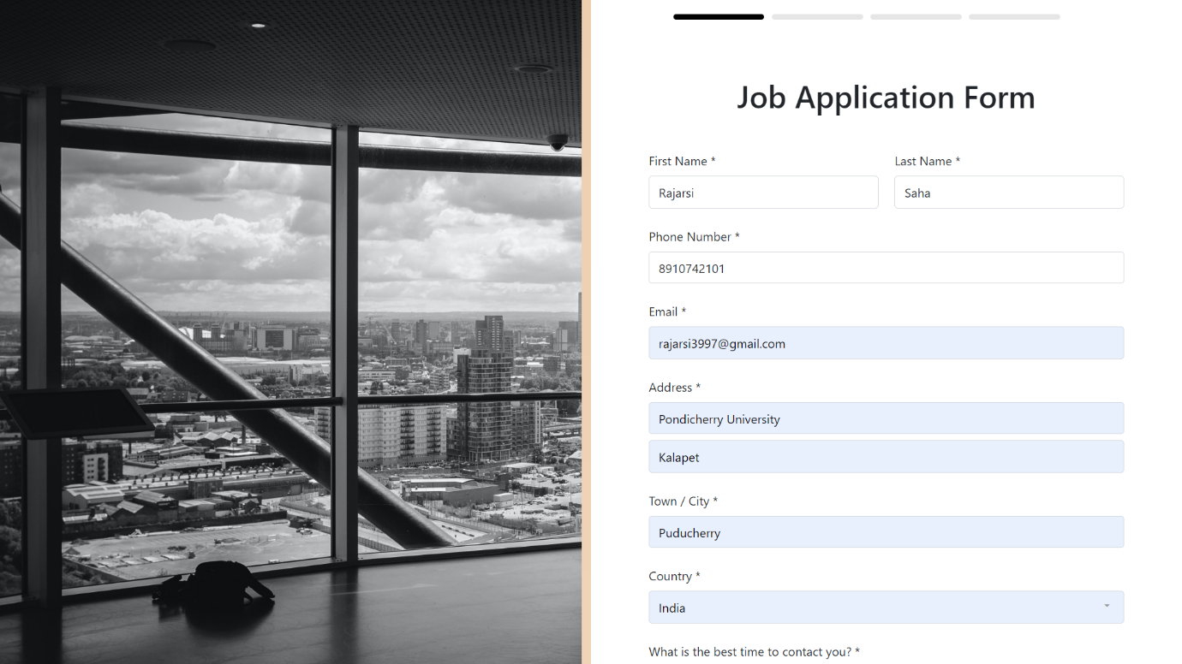

First page

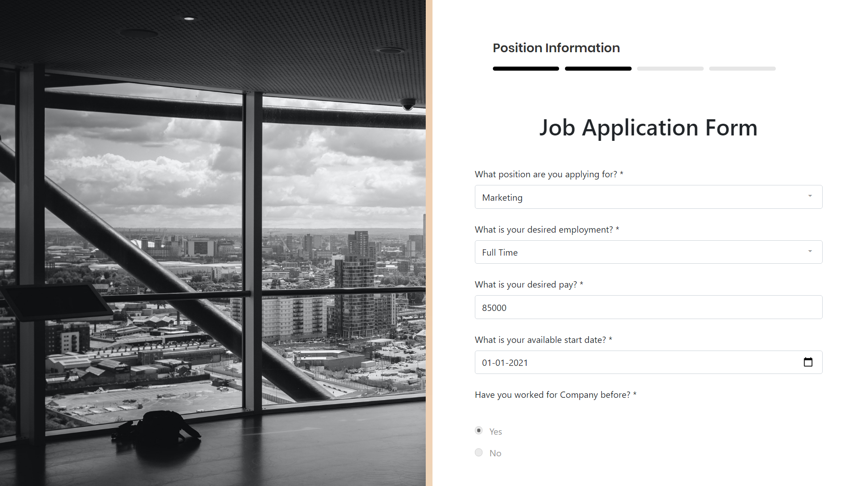

Second Page

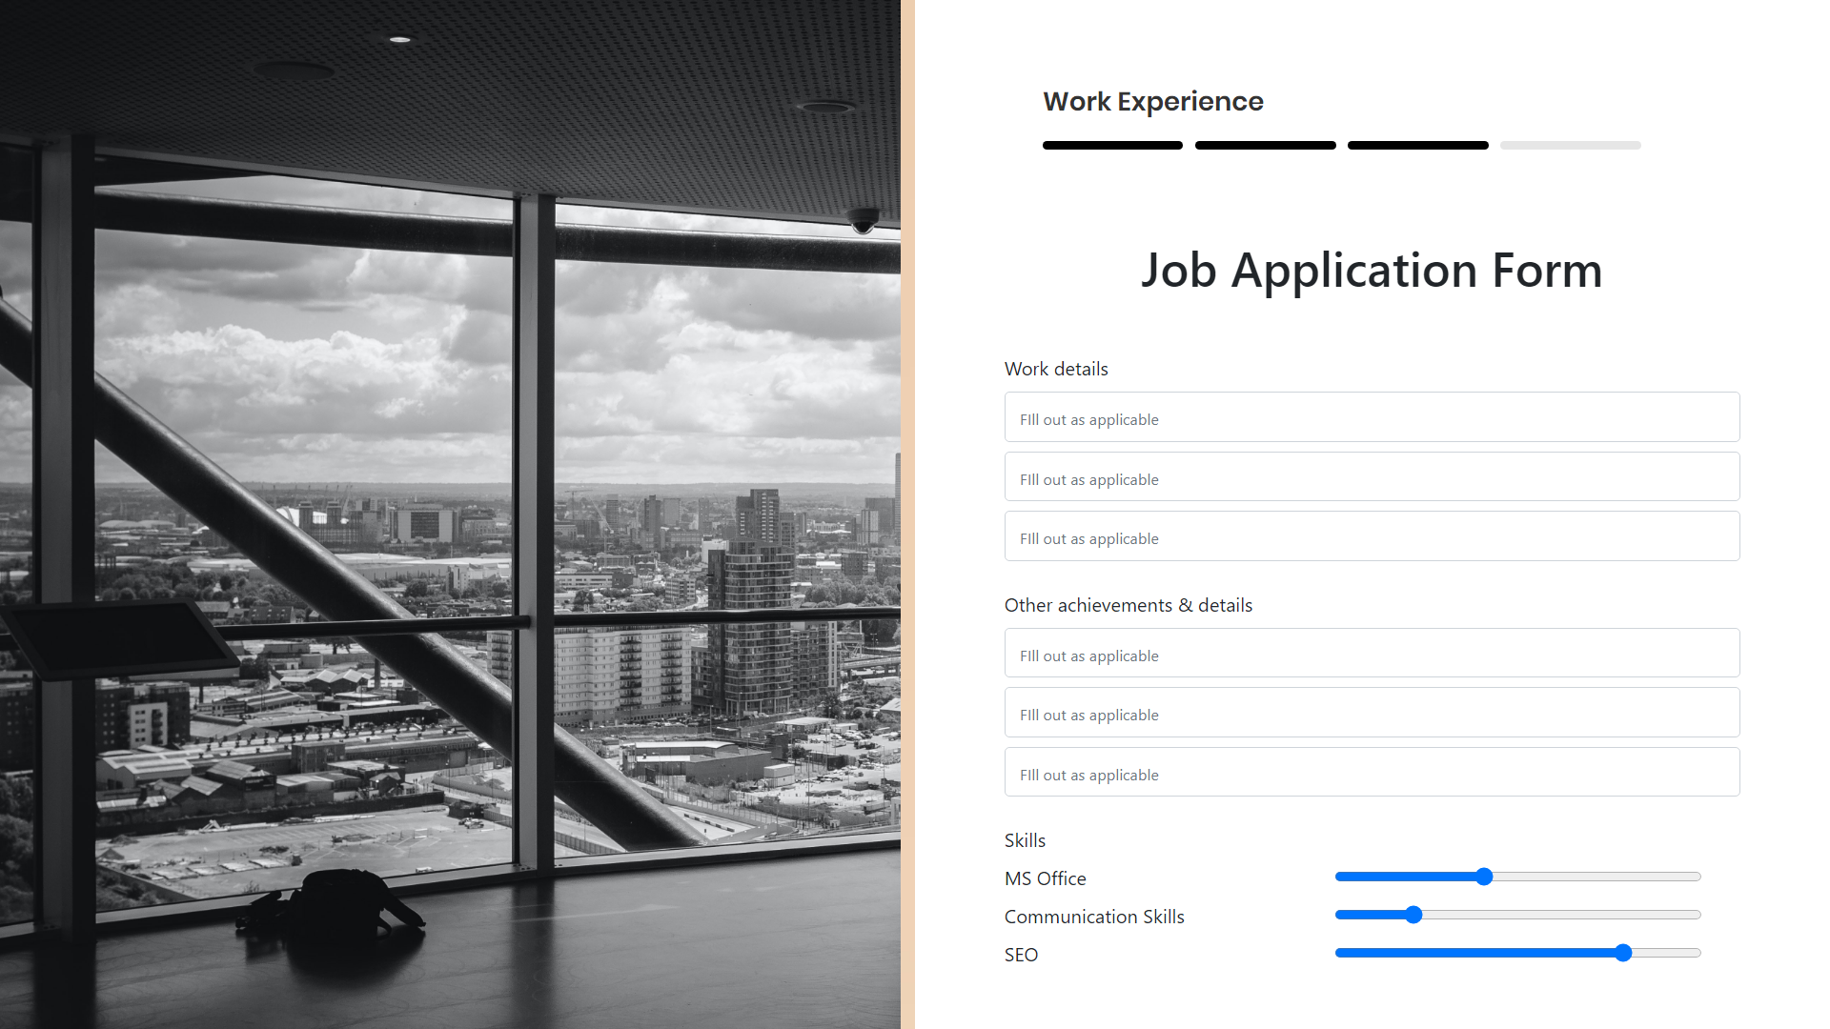

Third Page

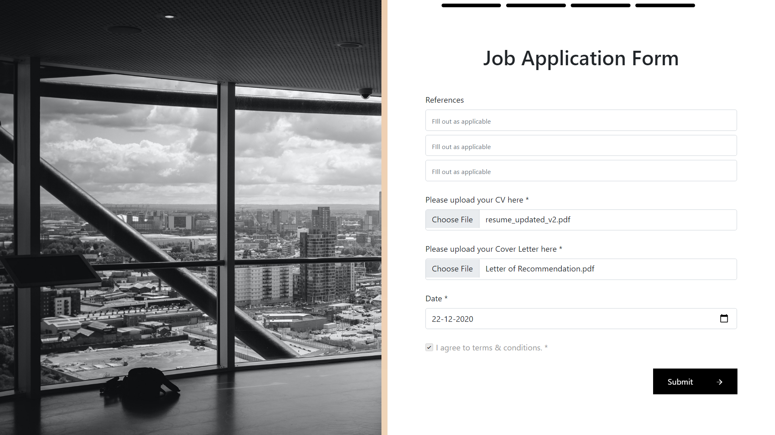

Fourth Page