Hospital Operations & Patient Risk Intelligence Dashboard
Power BI Build Guide
Logic + Data Model + Power Query + DAX + Visual Layout + Formatting Instructions
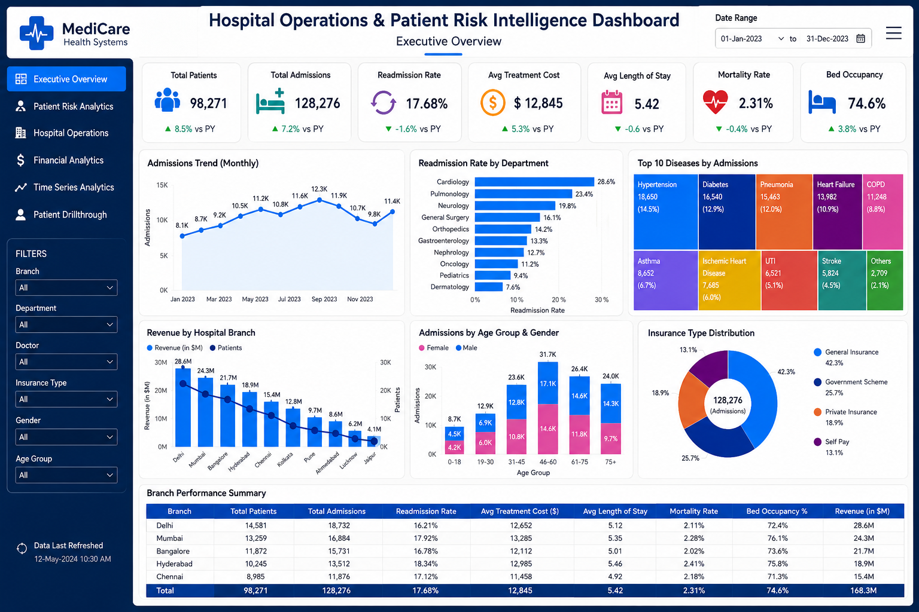
Purpose: This document guides to recreate a professional healthcare Power BI dashboard similar to the reference image. The goal is not only to place charts, but to understand business logic, KPIs, data cleaning, data modeling, DAX, storytelling and UI design.

Table of Contents
1. Dashboard Objective and Business Story
2. Required Data Tables
3. Data Model and Relationships
4. Power Query Transformation Guide
5. Date Table and DAX Measures
6. Executive Overview Dashboard Layout
7. Visual-by-Visual Build Instructions
8. Design Theme, Icons and Formatting
9. Interactions: Slicers, Drillthrough, Tooltips and Navigation
10. Page Expansion Plan
11. Student Submission Checklist

1. Dashboard Objective and Business Story
This dashboard is designed as a hospital leadership command center. It should help hospital management monitor patient volume, readmissions, treatment cost, branch performance, insurance mix, department pressure and operational efficiency.
Business Question | Dashboard Answer
How many patients and admissions are handled? | KPI cards: Total Patients and Total Admissions
Are readmissions under control? | Readmission Rate KPI and Readmission by Department chart
Which branches generate revenue and patient load? | Revenue by Hospital Branch combo chart and Branch Summary table
Which diseases create high admission burden? | Top Diseases treemap
Which age groups and genders dominate admissions? | Age Group and Gender stacked column chart
How is payment distributed? | Insurance Type donut chart

2. Required Data Tables
Table | Purpose | Important Columns
patients | Patient demographics and chronic disease profile | patient_id, age, gender, city, chronic_condition, insurance_type, income_group
admissions | Hospital visit/admission event data | admission_id, patient_id, doctor_id, department_id, branch_id, admission_date, discharge_date, readmitted, discharge_status
billing | Financial data for each admission | billing_id, admission_id, total_bill, insurance_covered_amount, patient_payable_amount
doctors | Doctor master data | doctor_id, doctor_name, specialization, experience_years
departments | Department master data | department_id, department_name
hospital_branches | Hospital branch master and capacity data | branch_id, branch_name, city, available_beds
treatments | Treatment/procedure details | treatment_id, admission_id, treatment_type, treatment_cost
date_table | Calendar table for time intelligence | Date, Year, Month Number, Month Name, Month Year, Quarter

3. Data Model and Relationships
Use a star-schema style model. Keep master tables as dimensions and admission/billing/treatment tables as fact/detail tables. This improves filtering and performance.
Relationship | Cardinality | Cross-filter Direction
patients[patient_id] → admissions[patient_id] | 1 to Many | Single
doctors[doctor_id] → admissions[doctor_id] | 1 to Many | Single
departments[department_id] → admissions[department_id] | 1 to Many | Single
hospital_branches[branch_id] → admissions[branch_id] | 1 to Many | Single
admissions[admission_id] → billing[admission_id] | 1 to Many or 1 to 1 | Single
admissions[admission_id] → treatments[admission_id] | 1 to Many | Single
date_table[Date] → admissions[admission_date] | 1 to Many | Single

Avoid many-to-many relationships unless absolutely necessary. If there are duplicate IDs in master tables, clean them in Power Query before creating relationships.

4. Power Query Transformation Guide
Power Query is used to clean data before building DAX and visuals. Students must complete transformations table by table.

4.1 Patients Table
Issue | Transformation | Expected Result
Gender values are inconsistent | Trim, lower, replace m/male/f/female | Male/Female only
City contains blanks | Trim and replace blank/null with Unknown | Clean city slicer
Chronic condition contains disease names | Proper case and create chronic flag | Disease name + numeric flag
Age contains wrong/missing values | Change type, replace extreme/blank values | Valid age column

Power Query example: Gender clean column
Gender Clean =
let
g = Text.Lower(Text.Trim([gender]))
in
if g = "m" or g = "male" then "Male"
else if g = "f" or g = "female" then "Female"
else "Unknown"
Power Query example: Chronic condition clean and flag
Chronic Condition Clean =
let
c = Text.Proper(Text.Trim(Text.From([chronic_condition])))
in
if c = "" or c = "Nan" or c = "Null" or c = "None" then "Unknown" else c
Chronic Flag =
if [Chronic Condition Clean] = "Unknown" then 0 else 1

4.2 Admissions Table
Column | Transformation
admission_date | Change data type to Date
discharge_date | Change data type to Date
readmitted | Standardize yes/y/true/1 as Yes and no/n/false/0 as No
length_of_stay | Create as discharge_date - admission_date
invalid length_of_stay | If LOS is negative, make it null or review the row

Power Query example: Length of stay
length_of_stay =
Duration.Days([discharge_date] - [admission_date])
length_of_stay_clean =
if [length_of_stay] < 0 then null else [length_of_stay]
Power Query example: Readmitted clean
Readmitted Clean =
let
r = Text.Lower(Text.Trim(Text.From([readmitted])))
in
if r = "yes" or r = "y" or r = "true" or r = "1" then "Yes"
else if r = "no" or r = "n" or r = "false" or r = "0" then "No"
else "Unknown"

4.3 Billing Table
Issue | Transformation
Negative bills | Replace with null and investigate
Text amount columns | Change data type to Decimal Number
Missing patient payable amount | Create rule-based imputation only after discussion
Need business grouping | Create payment category

Power Query example: Payment category
Payment Category =
if [patient_payable_amount] = 0 then "Fully Covered"
else if [patient_payable_amount] < 5000 then "Low Payable"
else if [patient_payable_amount] < 20000 then "Medium Payable"
else "High Payable"

5. Date Table and DAX Measures
Create a proper date table first. Mark it as Date Table using date_table[Date]. This is required for time intelligence calculations like previous year comparison.
Date Table DAX
date_table =
ADDCOLUMNS(
CALENDAR(
MIN(admissions[admission_date]),
MAX(admissions[admission_date])
),
"Year", YEAR([Date]),
"Month Number", MONTH([Date]),
"Month Name", FORMAT([Date], "MMM"),
"Month Year", FORMAT([Date], "MMM YYYY"),
"Quarter", "Q" & FORMAT([Date], "Q")
)
Measure | DAX
Total Patients | DISTINCTCOUNT(patients[patient_id])
Total Admissions | DISTINCTCOUNT(admissions[admission_id])
Total Revenue | SUM(billing[total_bill])
Revenue in M | DIVIDE([Total Revenue], 1000000)
Avg Treatment Cost | AVERAGE(billing[total_bill])
Avg Length of Stay | AVERAGE(admissions[length_of_stay])

Readmission Measures
Readmission Count =
CALCULATE(
DISTINCTCOUNT(admissions[admission_id]),
admissions[readmitted] = "Yes"
)
Readmission Rate =
DIVIDE(
[Readmission Count],
[Total Admissions],
0
)
Mortality Measures
Mortality Count =
CALCULATE(
DISTINCTCOUNT(admissions[admission_id]),
admissions[discharge_status] = "Expired"
)
Mortality Rate =
DIVIDE(
[Mortality Count],
[Total Admissions],
0
)
Bed Occupancy Measure
Bed Occupancy % =
DIVIDE(
SUM(admissions[length_of_stay]),
SUM(hospital_branches[available_beds]) * DISTINCTCOUNT(date_table[Date]),
0
)
Previous Year Comparison Measures
Revenue PY =
CALCULATE(
[Total Revenue],
SAMEPERIODLASTYEAR(date_table[Date])
)
Revenue Growth % =
DIVIDE(
[Total Revenue] - [Revenue PY],
[Revenue PY],
0
)
Readmission Rate PY =
CALCULATE(
[Readmission Rate],
SAMEPERIODLASTYEAR(date_table[Date])
)
Readmission Change % =
[Readmission Rate] - [Readmission Rate PY]
Age Group Column
Age Group =
SWITCH(
TRUE(),
patients[age] <= 18, "0-18",
patients[age] <= 30, "19-30",
patients[age] <= 45, "31-45",
patients[age] <= 60, "46-60",
patients[age] <= 75, "61-75",
"75+"
)

6. Executive Overview Dashboard Layout
Use a 16:9 report canvas. The page should be divided into four zones: left navigation, top header, KPI strip, and main visual grid.
Zone | Position / Size | Content
Left Navigation | Approx. 180 px wide, full height | Logo, page buttons, filters, refresh note
Top Header | Top horizontal band | Dashboard title, subtitle, date range slicer, menu icon
KPI Strip | Below header | 7 KPI cards
Main Grid | Middle and bottom | Charts arranged in 3-column grid plus bottom summary table

Page Setting | Recommended Value
Canvas | 16:9
Background | #F7FAFC
Font | Segoe UI
Visual card fill | #FFFFFF
Left panel fill | #062B55
Primary accent | #006BFF
Rounded corners | 8 to 12 px
Spacing | 12 to 16 px between objects

7. Visual-by-Visual Build Instructions
Visual | Power BI Visual | Fields / Logic
KPI Cards | Card / New Card | Use measures: Total Patients, Total Admissions, Readmission Rate, Avg Treatment Cost, Avg LOS, Mortality Rate, Bed Occupancy %. Add icons and growth text.
Admissions Trend (Monthly) | Line Chart | X-axis: date_table[Month Year]. Y-axis: Total Admissions. Sort Month Year by Date/Month Number.
Readmission Rate by Department | Clustered Bar Chart | Y-axis: departments[department_name]. X-axis: Readmission Rate. Sort descending by Readmission Rate.
Top 10 Diseases by Admissions | Treemap | Group: patients[chronic_condition_clean]. Values: Total Admissions. Apply Top N filter = 10.
Revenue by Hospital Branch | Line and Clustered Column Chart | X-axis: hospital_branches[branch_name]. Column: Revenue in M. Line: Patients by Branch.
Admissions by Age Group & Gender | Stacked Column Chart | X-axis: patients[Age Group]. Y-axis: Total Admissions. Legend: gender_clean.
Insurance Type Distribution | Donut Chart | Legend: patients[insurance_type]. Values: Total Admissions.
Branch Performance Summary | Table or Matrix | Rows: branch. Values: Total Patients, Total Admissions, Readmission Rate, Avg Treatment Cost, Avg LOS, Mortality Rate, Bed Occupancy, Revenue in M.

8. Design Theme, Icons and Formatting
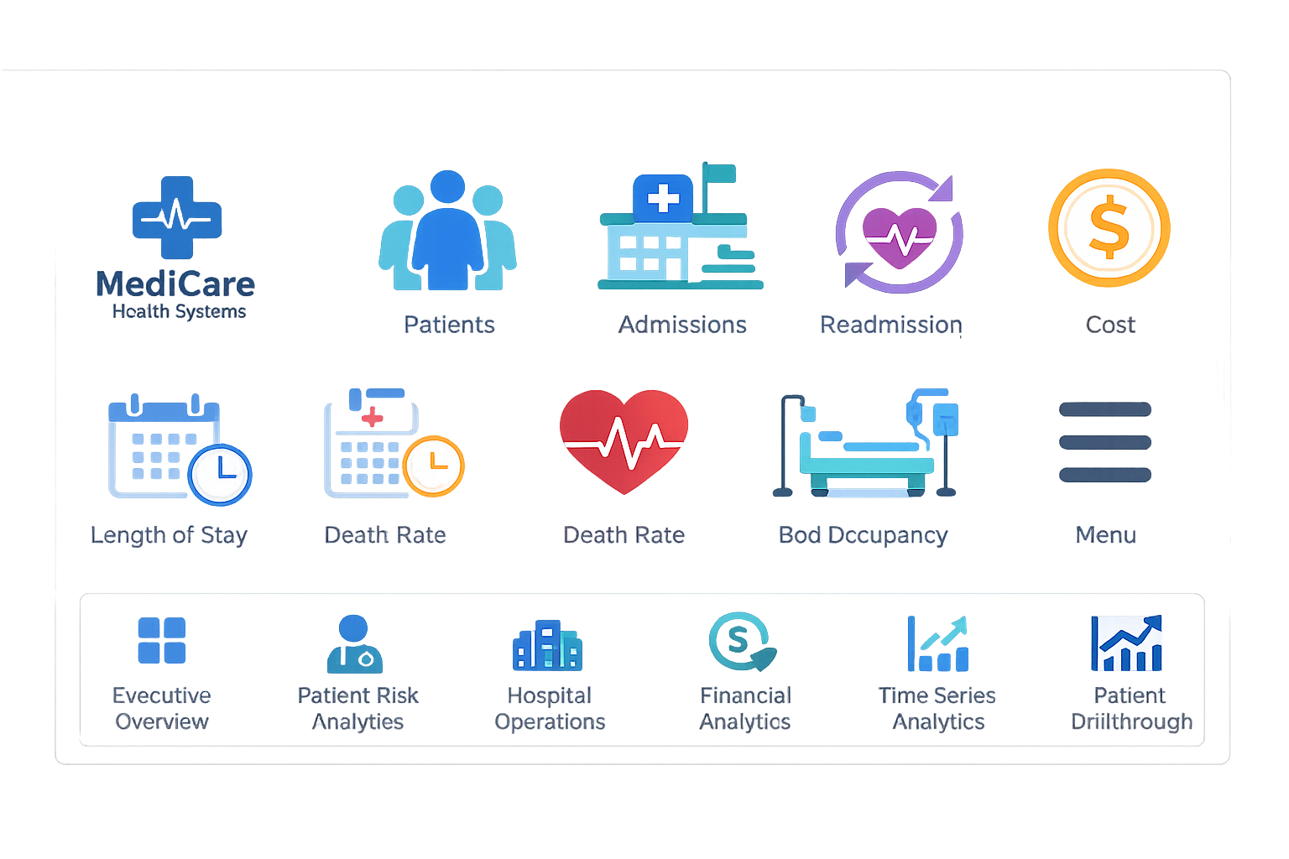
Item | Instruction
Icons required | Hospital logo, patients, admissions, readmission, cost, length of stay, mortality, bed occupancy, menu, page navigation icons
Icon size | 64x64 for KPI cards, 20x20 to 28x28 for navigation menu
Format | Prefer SVG or transparent PNG
Where to place | Inside each KPI card at left; navigation icons in left panel
Color discipline | Use same palette throughout. Avoid random colors.

Color Name | Hex Code | Use
Dark Navy | #062B55 | Left navigation and table headers
Primary Blue | #006BFF | Main highlights, selected navigation item, line charts
Light Blue | #EAF4FF | Soft highlight backgrounds
Teal | #00A6A6 | Operational metrics
Green | #00A651 | Positive growth indicators
Red | #D7263D | Mortality or negative indicators
Orange | #FF8A00 | Cost and warning indicators
White | #FFFFFF | Visual card backgrounds

Most premium look comes from alignment, whitespace, consistent colors, grouping, and card backgrounds. Do not rely only on default Power BI visuals.

9. Interactions: Slicers, Drillthrough, Tooltips and Navigation
Feature | How to Implement | Why It Matters
Slicers | Add Branch, Department, Doctor, Insurance Type, Gender, Age Group, Date Range | Allows management to filter the dashboard
Sync Slicers | View → Sync slicers | Keeps filters consistent across pages
Navigation buttons | Insert → Buttons → Blank → Action → Page navigation | Makes dashboard feel like an app
Drillthrough | Create Patient Detail page and add patient_id in drillthrough field | Allows patient-level investigation
Tooltips | Create custom tooltip pages for KPI/charts | Adds detailed explanation without crowding visuals
Bookmarks | Use for show/hide filter panel or menu expansion | Adds professional interactivity

10. Page Expansion Plan
Page | Purpose | Recommended Visuals
Executive Overview | CEO-level summary | KPIs, trends, branch comparison, disease burden, summary table
Patient Risk Analytics | Identify high-risk patients | Risk score distribution, age vs readmission, chronic disease analysis, high-risk patient table
Hospital Operations | Evaluate doctors and departments | Doctor matrix, department workload, bed occupancy trend, emergency vs scheduled admissions
Financial Analytics | Cost and revenue analysis | Revenue by department, payer mix, high-cost procedures, cost trend
Time Series Analytics | Forecast hospital load | Monthly admissions, seasonal disease heatmap, Power BI forecast
Patient Drillthrough | Patient-level profile | Patient history, admissions timeline, cost summary, readmission history

12. Student Submission Checklist
All required tables loaded into Power BI.
Power Query transformations completed and documented.
Relationships created correctly with single-direction filtering.
Date table created and marked as date table.
All DAX measures created and formatted correctly.
Executive Overview page matches the reference structure.
KPI cards are aligned and formatted consistently.
All charts have meaningful titles and correct fields.
Slicers are placed in the filter panel and tested.
Navigation buttons work correctly.
Dashboard uses consistent colors, spacing and fonts.
Student can explain every KPI and visual from a business perspective.
Final expectation: Students should not only submit a Power BI file. They should be able to explain the logic, transformations, measures, visual choices and recommendations like a real data analyst.

