**CSC 238 – Human Computer Interface Design**

California State University, Sacramento (CSUS)

Computer Science Department

Spring – 2024.

By Rajasekhar Reddy Kolagotla

**Assignment: Five Similar Apps**

**Application – 1: Trello**

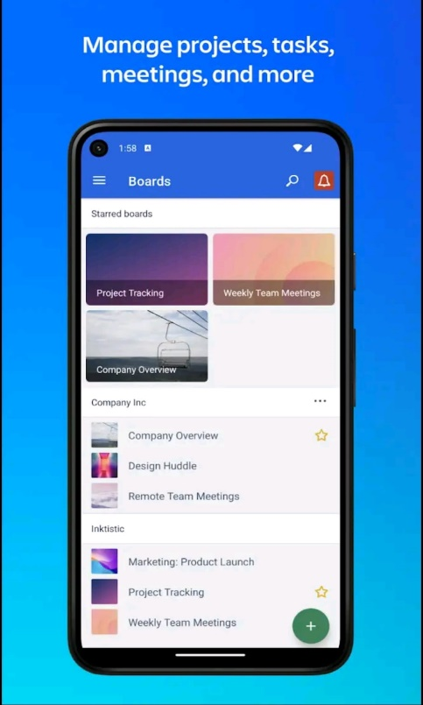 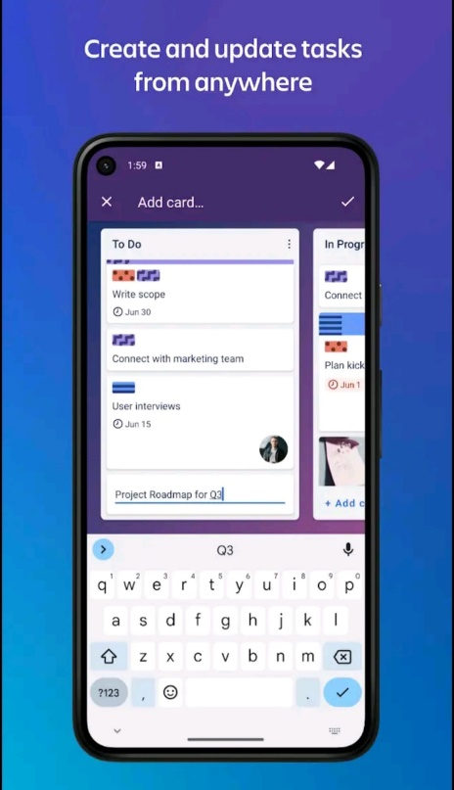 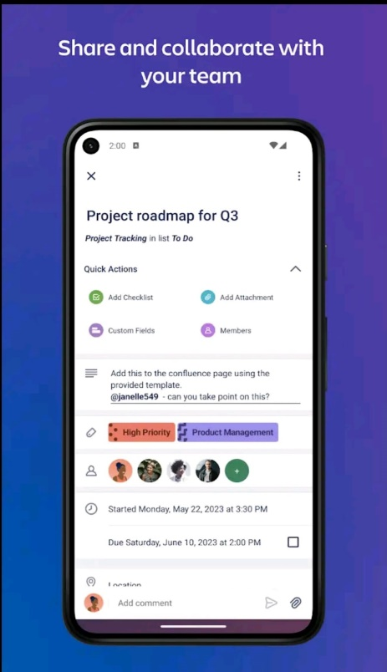

**Similarities and Differences:** Trello's visually intuitive board system allows for flexible organization of tasks and projects, which could be particularly useful for managing individual aspects of a Master's project. Trello is more versatile in its application, not specifically tailored for academic projects.

**Limitations:** It might lack the depth in features required for managing the nuances of academic research projects, such as detailed progress tracking or academic resource management.

**Takeaways:** Utilizing a visual board system could help students and professors visually track project progress and task completion.

**Application – 2: Asana**

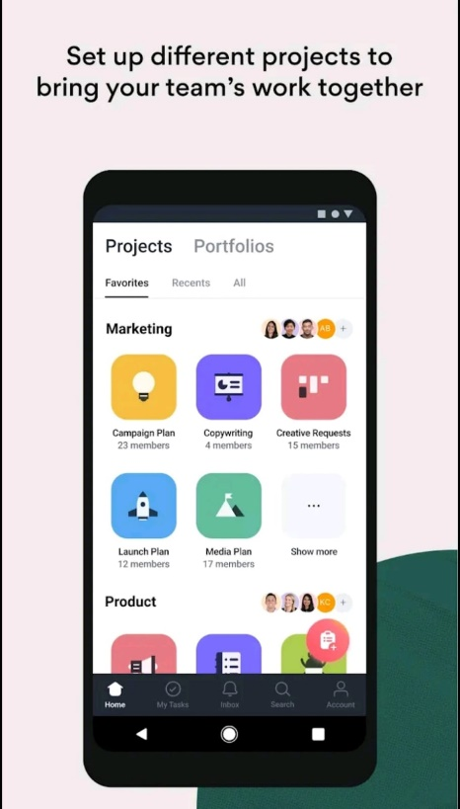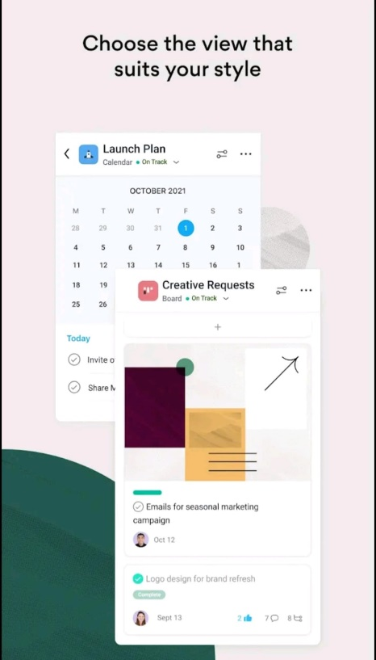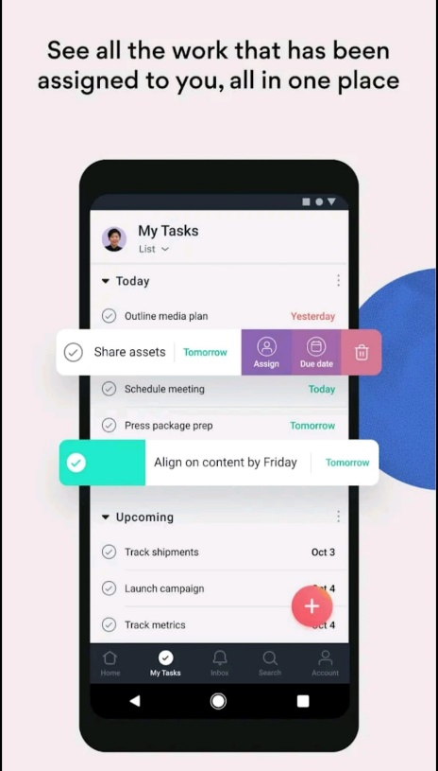

**Similarities and Differences:** Asana functions as a comprehensive work management solution, offering a blend of project management and goal alignment across teams and projects. Unlike a specific academic focus, Asana is designed for a broad range of enterprise applications.

**Limitations:** It can become overwhelming for individual academic projects due to its broad business orientation. The basic free version may be limiting for larger academic groups or projects with complex needs.

**Takeaways:** Incorporating goal alignment and extensive integrations could enhance the utility of your project management system for academic purposes.

**Application – 3: Airtable**

**Similarities and Differences:** Airtable combines database functionality with project management, offering a high degree of customization for managing diverse project types, which could be beneficial for handling the varied nature of Master's projects. It differs in its database-centric approach, which may not be initially designed with academic project management in mind.

**Limitations:** The open-ended nature of its customization might require a steeper learning curve for users unfamiliar with database concepts or those looking for a more straightforward project management tool.

**Takeaways:** Incorporating customizable database features could allow your system to adapt to a wide range of academic project types and requirements.

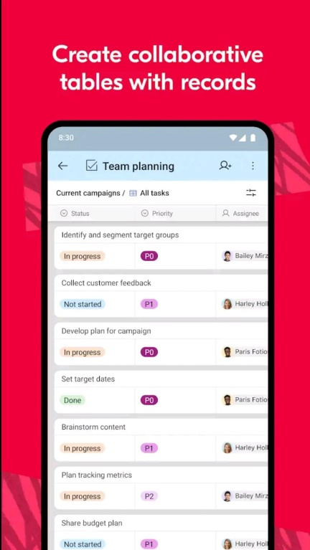 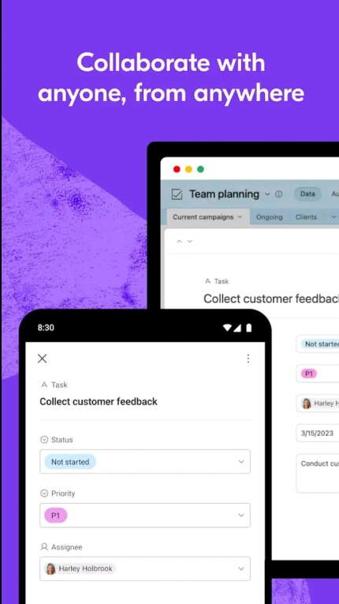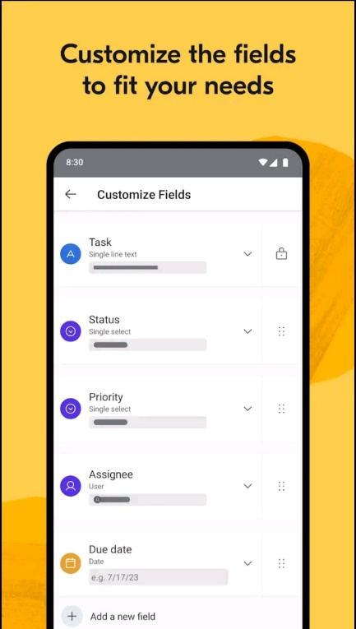

**Application – 4: ClickUp**

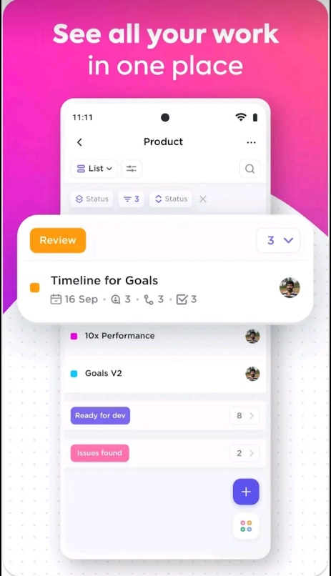 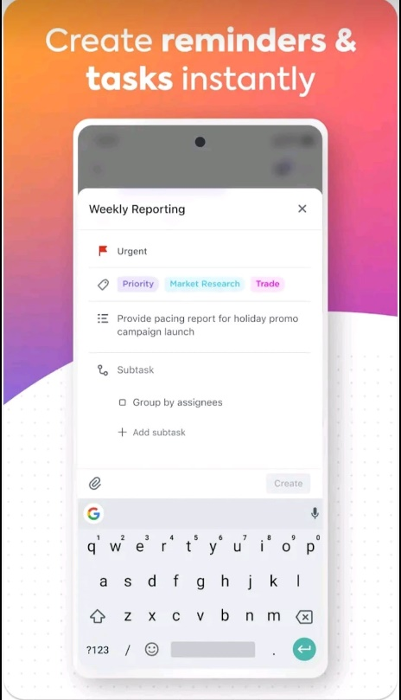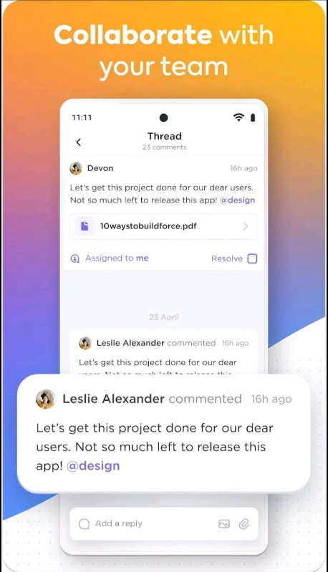

**Similarities and Differences:** ClickUp offers customized task views and project management features tailored for small teams or startups, making it adaptable for academic project management. Its interface and functionality balance between simplicity and feature richness might differ from an academic-focused project management tool designed specifically for Master's projects.

**Limitations:** It may not be specifically optimized for the academic workflow, such as integrating with academic databases or supporting specific academic collaboration protocols.

**Takeaways:** The balance between simplicity and customization in ClickUp could inform the development of a user-friendly yet feature-rich interface for your system.

**Application – 5: Monday.com**

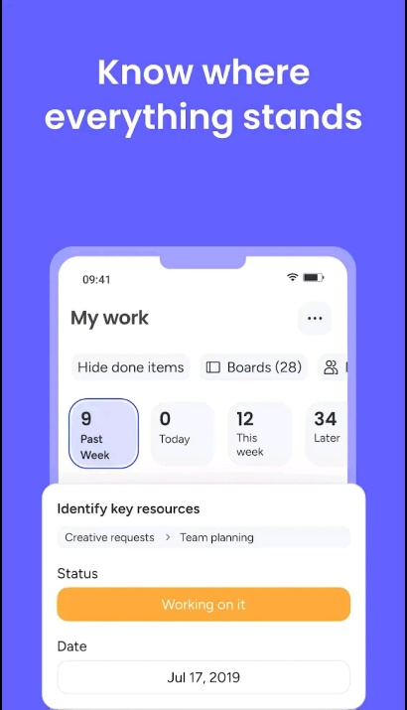 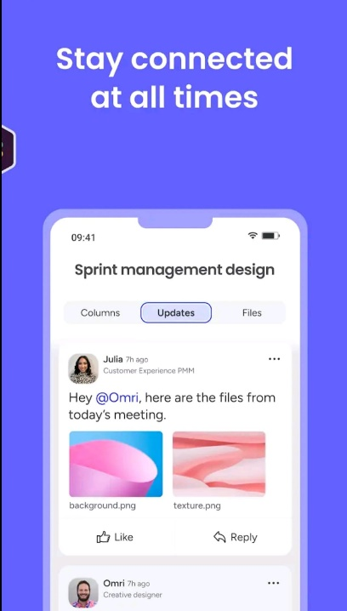 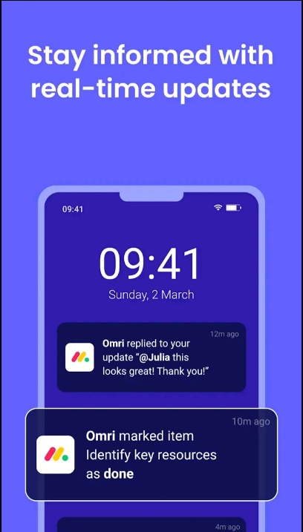

**Similarities and Differences:** Monday.com is designed for a broad range of project management activities, focusing on visual project tracking and customization. Unlike platforms with a strong academic orientation, Monday.com offers general project management features, making it versatile but not specifically tailored for academic needs.

**Limitations:** The primary limitation of Monday.com for academic use is its lack of features directly supporting academic research, such as integration with scholarly databases or tools for academic publishing.

**Takeaways:** The key takeaway from Monday.com is the importance of flexible, visual project tracking and the value of a user-friendly interface to facilitate collaboration among project participants, which can be adapted to improve academic project management systems.