**CSC 238 – Human Computer Interface Design**

California State University, Sacramento (CSUS)

Computer Science Department

Spring – 2024.

**Name – Rajasekhar Reddy K**

**Instructor Name – Anna Baynes**

Heuristic Evaluation done for the Application – **What’s In that?**

1. **No “Back” or “Scan another Item” button in Scanner Page**

**Heuristic Violation - User Control and Freedom.**

Description – There are no “Back” and “Scan another Item” buttons in the Scanner design page, if the user wants to scan another item, they have to go back to home page and need to scan another item.

Severity – 3, Major Usability Problem.

Suggested Fix – Add the buttons “Back” and “Scan another item” buttons in the Scanner Page.

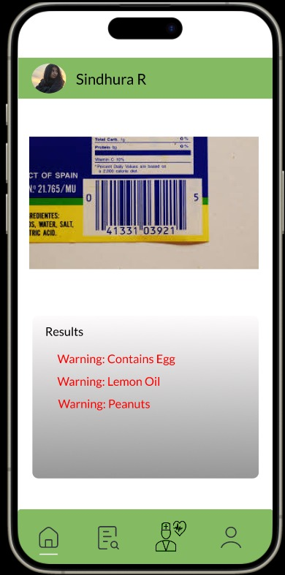

1. **Inconsistent “Back” Navigation.**

**Heuristic Violation – Consistency and Standards.**

Description – The “Sign Up” and “Login” pages have different styles of “back” navigation, potentially confusing users about how to return to the previous page.

Severity – 2, Minor Usability Problem

Suggested Fix – Standardize the “Back” navigation across all screens to offer a consistent user experience.

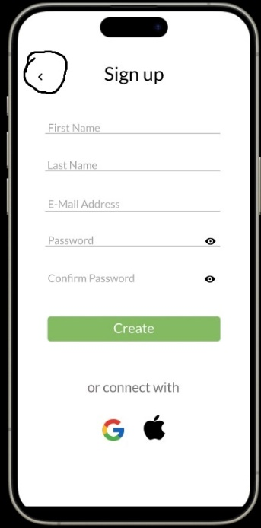

1. **Unlabeled Status Toggles**

**Heuristic Violation – Recognition rather than recall.**

Description – The “Remember Password” toggle on the “Login” page does not clearly indicate whether it’s active or inactive.

Severity – 2, Minor Usability Problem

Suggested Fix – Visually differentiate the toggle’s on/off state to make it clear to users without requiring memory of the selection.

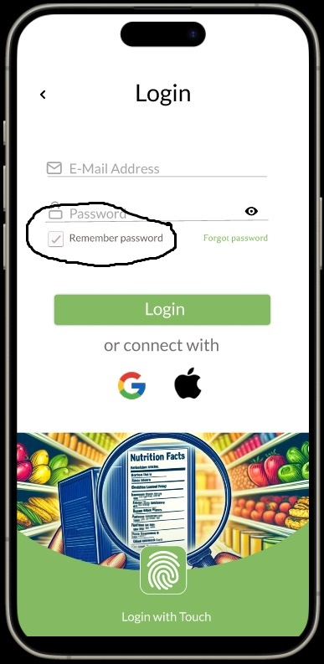

1. **No Feedback for Successful or Unsuccessful Login**

**Heuristic Violation – Visibility of System Status.**

Description – There is no clear indication of a successful or unsuccessful login before transitioning to the main application screen.

Severity – 2, Minor Usability Problem.

Suggested Fix – Provide immediate Feedback upon successful login, or provide an error message upon unsuccessful login, such as message or transition animation.

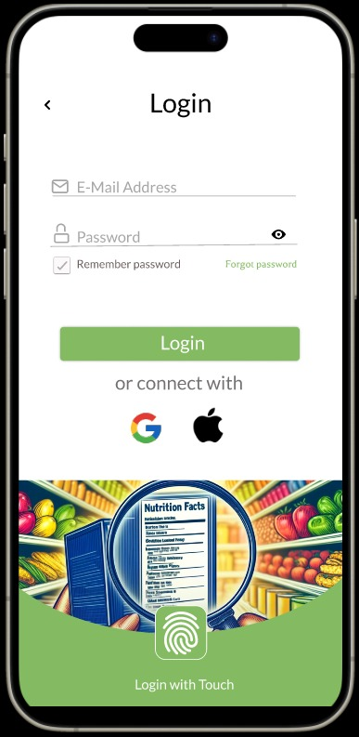

1. **Inadequate Error Messaging**

**Heuristic Violation – Help Users Recognize, Diagnose, and Recover from Errors.**

Description – When a scan identifies potential allergens, the app does not offer guidance or next steps for users.

Severity – 3, Major Usability Problem.

Suggested Fix – Include Suggestions or remedial actions for users when an allergen or harmful ingredient is detected.

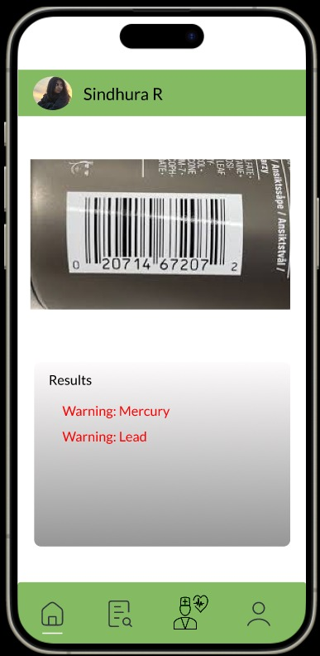

1. **No option for Advanced Search**

**Heuristic Violation – Flexibility and Efficient Use.**

Description – For Suppose, if the user identifies allergens or chemicals in the product and need to do a quick search about that chemical, there is no search option in the application and the application is not suggesting any related articles to it. This makes difficult for users to find specific content.

Severity – 2, Minor Usability Problem.

Suggested Fix – Introduce a search page/bar to allow users to quickly search the chemicals online or related articles.

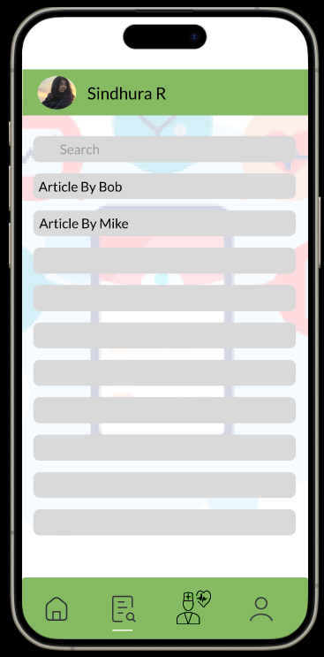

1. **Lack of Editable Account Settings**

**Heuristic Violation – User Control and Freedom.**

Description – The user profile page does not provide clear options for users to edit or manage their account settings.

Severity – 2, Minor Usability Problem.

Suggested Fix – Add a clear “Edit Profile” or “Account Settings” button to allow users to modify their personal information and preferences.

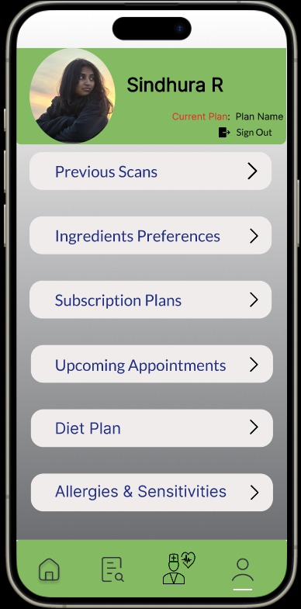

1. **Confusing Navigation in Profile Page.**

**Heuristic Violation – Consistency and Standards.**

Description – The design and navigation of the profile page differ from the rest of the app, potentially leading to user confusion.

Severity – 2, Minor Usability Problem.

Suggested Fix – Align the profile page’s navigation and design with the conventions established in the rest of the app.

