**GraduGate**

**Paper Prototype**

**By**

**Team** –

Aravind Yuvraj

Rajasekhar Reddy K

Kundana Lingala

Nithin Gogineni

GraduGate - Welcome Page:

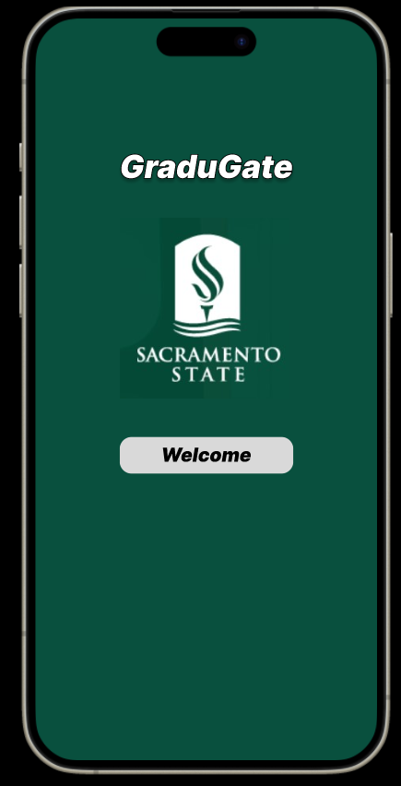

Task – 1: Logging into the application using user Credentials.

Once we click on Welcome, we navigate to login screen where student can login into the application using their sac state credentials and view their Dashboard.

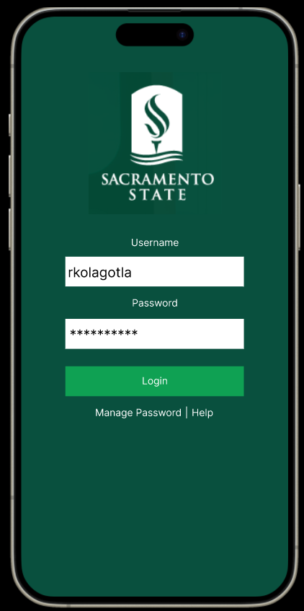

GraduGate Student Dashboard Page:

Once Student logins, they reach to the Dashboard Page, where the student information and List of available Professors options are displayed.

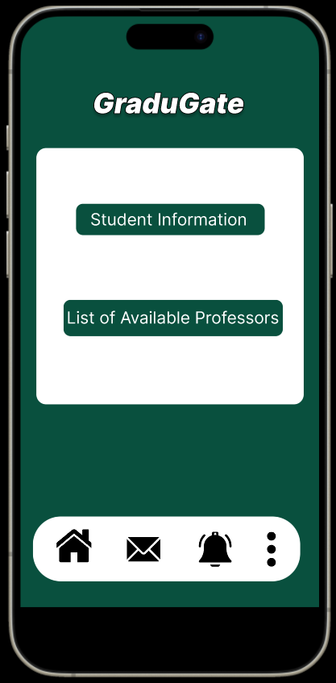

GraduGate List of Available Professors Page:

Once the user clicks on List of available professors’ button, it displays all the available professors present in their department.

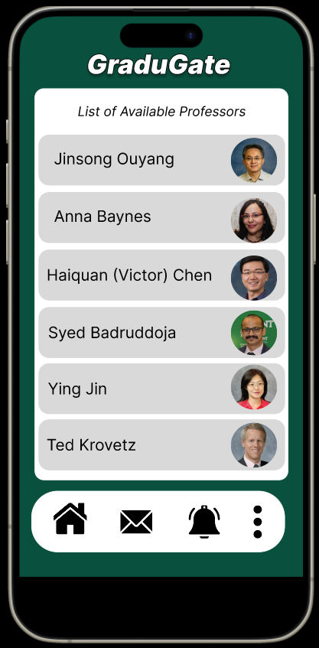

Selection of Professor:

Once the user taps on Professor name or image, it displays their Page with all their work. If the user wants to work this professor, they can click on apply, where it leads to submit proposal page.

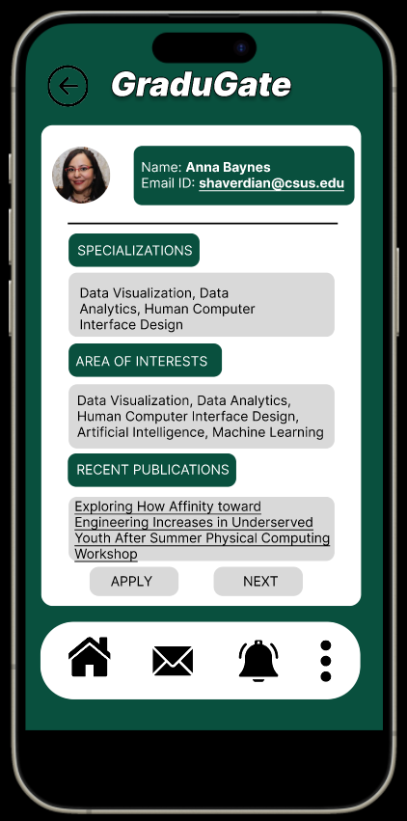

Submit Proposal Page:

Once the user clicks on apply and upload their proposal document and click on Submit. It displays a pop-up message as shown below.

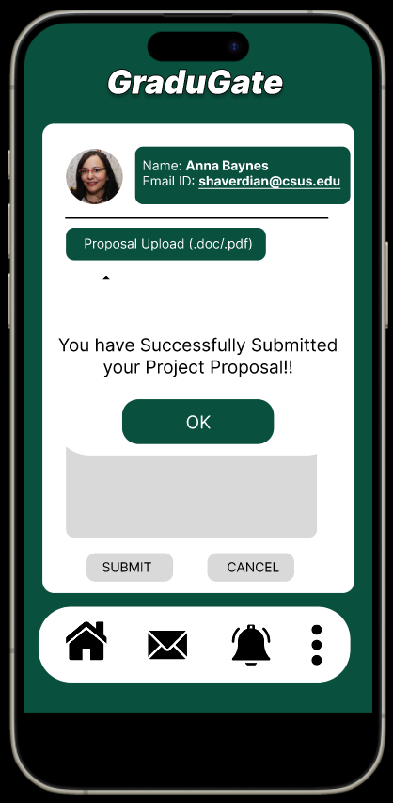

Task – 2: Project Proposal Approval

Professor’s Dashboard Page:

Once the student submits their project Proposal, professor login to the application with their user credentials and checks them. Below is the dashboard screen that appears once they login into the application.

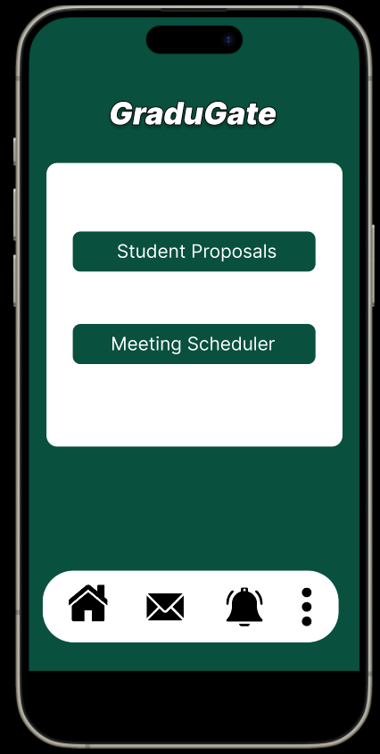

List of Student Proposals Page:

Once the advisor clicks on Student Proposals button, it redirects to the below screen, where it displays the student’s name and their area of interest along with their proposal document ready to download.

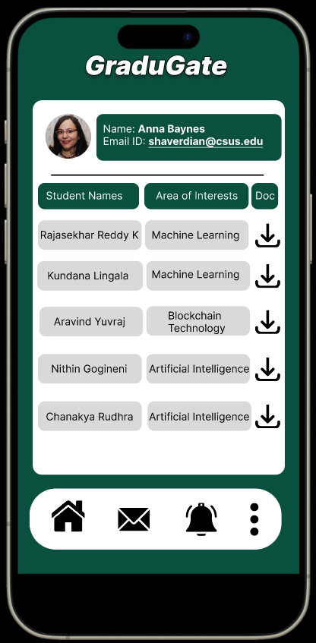

Proposal Review and Decision:

Once professor downloads the student’s proposal and review them, they can now decide whether to approve/reject or keep in pending status based on their project proposal. If they approve a pop-up screen will appear with the message as shown below.

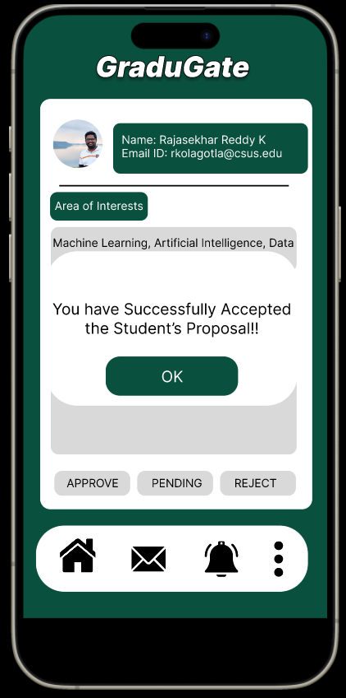

Student Project Forms Upload Page:

Student now submits the Project approval forms to provide their signatures as needed by the department for course enrollment.

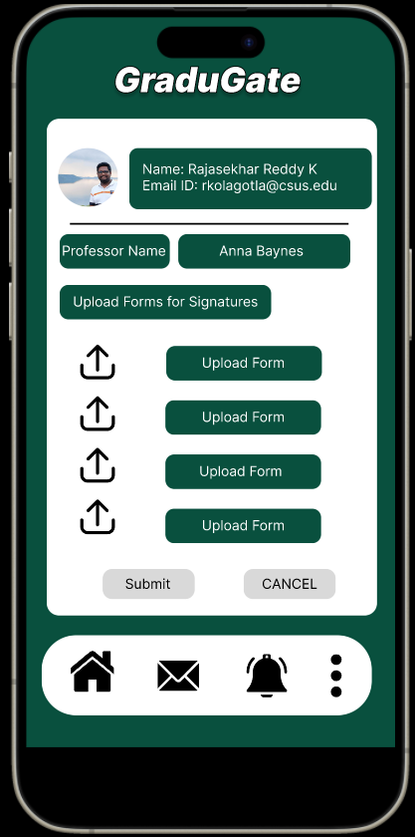

Professor Project Forms Download Page:

Professors download the documents from their login, download them and sign the documents and re-upload them into the application for further process.

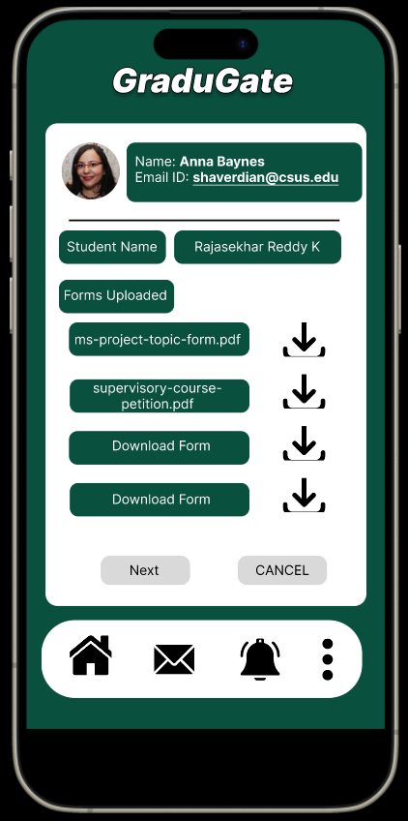

Task – 3: Graduate Co-ordination Approval Forms

If both the student and professor complete their signatures, now the project proposal documents have to be signed by Graduate Co-Ordinator. Below is the dashboard screen.

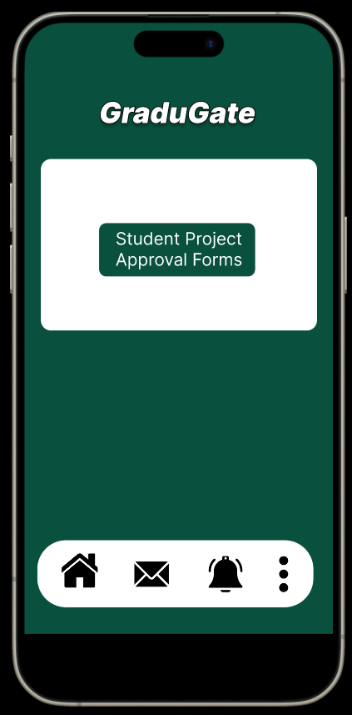

Graduate Co-Ordinator Student’s List Page:

Once, the grad. Co-Ordinator clicks on student project approvals forms button; the below screen appears. They can click on student name to view their forms.

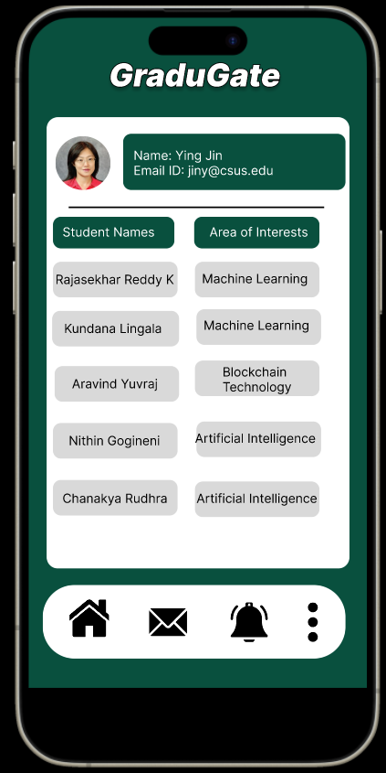

Graduate Co-Ordinator Decision Page:

Grad. Co-Ordinator Clicks on students name and can view their documents and sign them. If everything looks good, the approval will be provided, otherwise Grad. Co-Ordinator will reject the application and provide some comments.

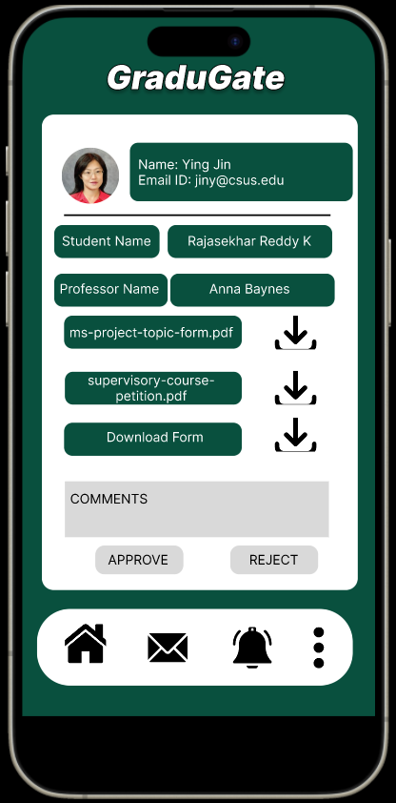

Overview of GraduGate Prototype:

