**GraduGate**

**Team** –

Aravind Yuvraj

Rajasekhar Reddy K

Kundana Lingala

Nithin Gogineni

Problem:

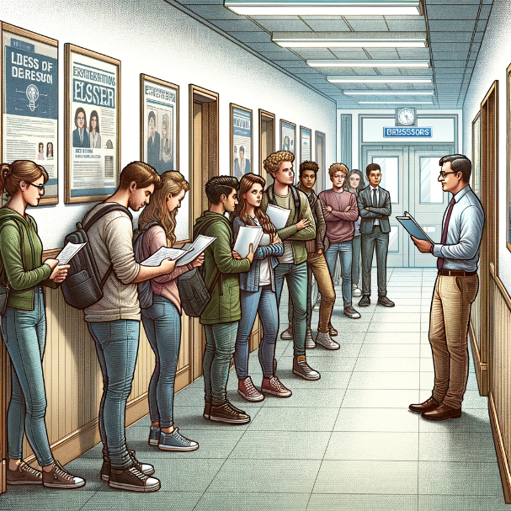The main issue arises from the time-consuming nature of the proposal review process. Students must approach professors via email with their project proposals. Professors, in turn, review these proposals on a case-by-case basis, providing feedback, suggesting modifications, or outright rejecting proposals that do not align with their research interests or expectations. This iterative process, while thorough, often results in substantial delays. Consequently, students face the risk of not being able to register for the Master's project course in a timely manner, potentially delaying their graduation. Due to this prolonged process, there is not enough time for students to reach out to other professors with different project proposals within the given time frame for registration. This bottleneck exacerbates the challenge of meeting registration deadlines, further complicating students' academic timelines and contributing to potential delays in their educational progress.

Figure 1: Students waiting in-front of Professor's Office room.

Source: Image generated using Chat GPT AI

Solution:

To address these challenges, we propose the development and implementation of a centralized digital platform designed to streamline the Master's project proposal process. It involves in detailed profiles of professors showcasing research interests, availability, and capacity to take on new students. The Proposal Submission and Tracking interface for students to submit and track the status of their proposals in real time. A structured system for professors to provide feedback, request modifications, or approve proposals directly within the platform. The notification system interface for real-time alerts to keep students and professors updated on proposal status changes and required actions. This will Significantly cut down the time required for proposal reviews and approvals, enabling students to register for the Master's project course promptly. By achieving this, the proposal submission and review process becomes more efficient for both students and faculty. Therefore, the students get graduated as per their academic timeline without any delays.

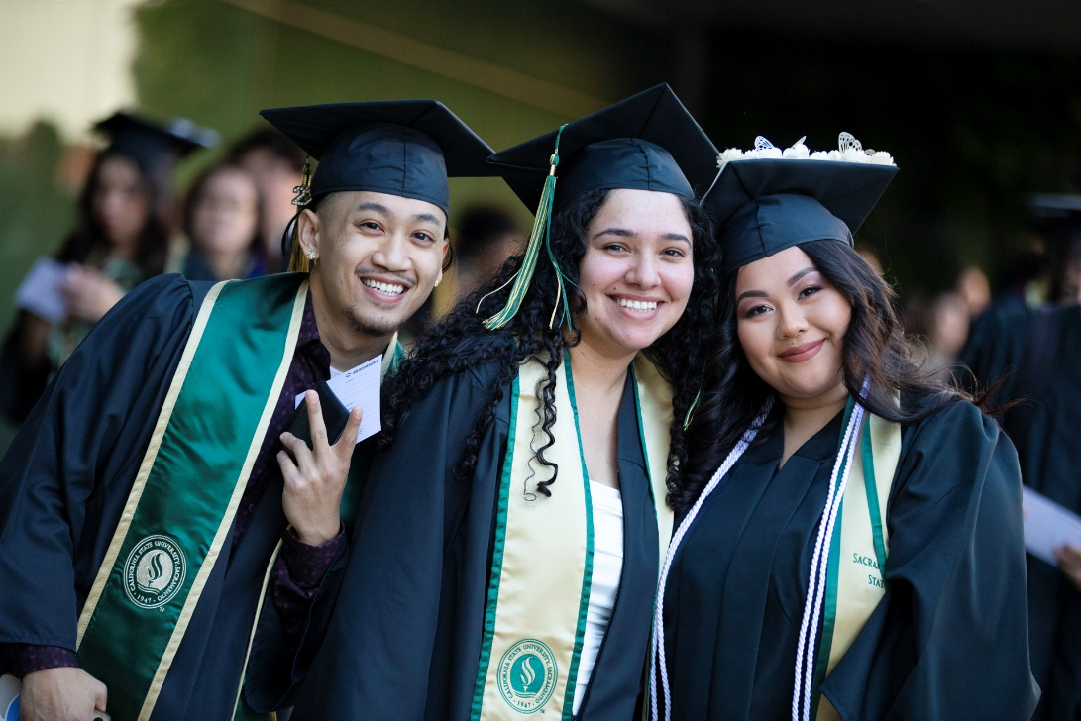

Figure 2: Sac State Students Graduating happily.

Source: <https://www.csus.edu/news/newsroom/stories/2022/5/commencement.html>

Design Research Goals:

* Understand the challenges and pain points experienced by both professors and master’s students in the process of initiating and executing master’s projects.
* Identify opportunities to streamline the project proposal process, enhance communication between students and professors, and improve project management for master’s students.
* Explore potential features and functionalities for an app aimed at facilitating project planning, proposal submission, and progress tracking for master’s students and professors.
* Determine the criteria and expectations for quality project proposals from both the student and professor perspectives.
* Investigate methods to enhance the alignment between student project proposals and professor interests, reducing the need for extensive revisions.
* Examine the availability and scheduling challenges faced by students in finding suitable professors for their master’s projects.
* Explore the potential for integrating features such as progress tracking and bookmarking of research materials into the app to enhance collaboration between students and professors.

Stakeholders:

Professors: These are academic professionals responsible for guiding master’s students through their projects. They play a crucial role in evaluating project proposals, providing guidance, and monitoring progress.

Master’s Students: These are individuals pursuing advanced degrees who require guidance and support from professors to successfully complete their master’s projects.

App Developers: The team responsible for designing and developing the app aimed at facilitating project planning and management for master’s students and professors.

Academic Institutions: Universities and colleges offering master’s programs, which have a vested interest in ensuring the success and efficiency of the master’s project process.

Participants:

Professor Jagannath Chidella: Assistant Professor at Sac State with expertise in project proposal evaluation and departmental procedures.

Nagarjuna Reddy Gujjula: Sac State master’s student who has experienced challenges in finding suitable professors and aligning project proposals with professor interests.

Chanakya Rudhra Baluguri: Sac State master’s student who has insights into the difficulties faced by students in navigating the master’s project process.

App Developers: Professionals involved in the design and development of the app aimed at addressing the identified challenges and needs of both professors and master’s students.

Reasoning for Participant Selection:

Professor Chidella brings expertise in project evaluation and departmental procedures, providing valuable insights into the expectations and requirements for quality project proposals.

Master’s students Nagarjuna and Chanakya offer firsthand experiences and perspectives on the challenges encountered during the master’s project process, including difficulties in finding professors and aligning project proposals with professor interests.

Involving app developers ensures that the design research considers technical feasibility and practical implementation of proposed solutions, aligning with the overarching goal of developing an effective project management app for master’s students and professors.

The selection of participants represents key stakeholders involved in the master’s project process, ensuring a comprehensive understanding of the challenges and requirements from both the academic and student perspectives.

Quality of Proposals:

Both professors and students highlighted the challenge of ensuring quality proposals. Students often lack clarity on the expectations, assuming master's projects are similar to undergraduate assignments. Professors seek innovative and relevant proposals aligned with their research interests.

Updated Theme: The need for clear guidelines and examples of successful proposals emerged as essential to addressing this challenge.

Finding Professor Availability:

Students struggle to find available professors due to busy schedules, limited project offerings, and professors already working with other students. This results in difficulties in securing project approvals and guidance.

Updated Theme: Implementing a system to alert students when professors are unavailable due to prior commitments emerged as a crucial feature to address this challenge.

Interaction with User Portfolio:

Both students and professors must understand each other's portfolios to ensure compatibility and alignment in working styles. Misalignments can lead to inefficiencies and dissatisfaction.

Updated Theme: Integrating detailed professor profiles within the app to showcase research interests, previous projects, and working preferences emerged as a key solution to facilitate better matching between students and professors.

Inefficiency and Delays:

The current process of proposal submission, review, and approval is time-consuming, leading to delays in project commencement and completion.

Updated Theme: Developing a streamlined proposal submission and tracking system within the app emerged as a critical solution to address inefficiencies and reduce delays.

Lack of Transparency:

There is a lack of transparency in the project proposal process, with students often left unaware of the status of their proposals or the feedback provided by professors.

Updated Theme: Implementing a real-time notification system for proposal status updates and feedback emerged as a crucial feature to enhance transparency and communication between students and professors.

Communication Gaps:

Current communication methods, primarily relying on email, are inefficient for managing project proposals and feedback, leading to miscommunications and delays.

Updated Theme: Developing an integrated communication platform within the app, allowing for seamless interaction between students and professors, emerged as a key solution to bridge communication gaps and improve collaboration.

By organizing the data collected from task analysis slides into concept maps, models, and flow sequence models, insights were gained into the interconnected nature of the identified themes and problems. These insights guided the design process towards developing a comprehensive solution that addresses the core challenges faced by both students and professors in the master's project process.

Task Analysis Questions:

1. **Who is going to use the design?**

**Answer:** The primary users will be Master's students who are undertaking academic projects or thesis work across various departments. Secondary users include faculty advisors who guide, support, and evaluate these projects, as well as university administrative staff involved in overseeing academic programs and project evaluations.

1. **What tasks do they now perform?**

**Answer**: Students draft project proposals based on their interests. Students seek approval by reaching out to professors via email. Professors review proposals, provide feedback, request modifications, or approve. Administrative staff oversee program compliance and academic standards and register the appropriate courses for their academics.

1. **What tasks are desired?**

**Answer**: Submitting and tracking project proposals in real time. Receiving immediate feedback, modifications requests, or approval from professors. Managing project documentation digitally. Facilitating communication between students and faculty advisors efficiently. Monitoring student progress and outcomes by faculty advisors.

1. **How are the tasks learned?**

**Answer**: Tasks are primarily learned through academic guidelines provided by the university, direct instructions from faculty advisors, and the use of the proposed digital platform, which would include tutorials or guidance on its functionalities.

1. **Where are the tasks performed?**

**Answer**: Tasks are performed in a combination of physical and digital environments: at university facilities, in digital workspaces like the application we develop, and in any location where students and faculty advisors access the platform remotely.

1. **What is the relationship between the person and data?**

**Answer**: Students and faculty advisors are both data creators and consumers. Students submit project proposals and updates, while faculty advisors provide feedback and evaluations. Administrative staff use data for oversight and ensuring compliance with academic standards.

1. **What other tools does the person have?**

**Answer**: Currently, they rely on email for communication, word processors for drafting proposals, and various digital tools for project management and data analysis, depending on the nature of the project.

1. **How do people communicate with each other?**

**Answer**: Communication currently happens via email, face-to-face meetings, and potentially through existing digital platforms that are not specifically designed for managing Master's projects.

1. **How often are the tasks performed?**

**Answer**: These tasks are performed throughout the academic year, with peak times aligning with project proposal deadlines, mid-term evaluations, and final project submissions.

1. **What are the time constraints on the tasks?**

**Answer**: The main constraint is the academic calendar, with specific deadlines for proposal submission, project course registration, and final project submission to meet graduation requirements.

1. **What happens when things go wrong?**

**Answer**: When things go wrong, such as missed deadlines or rejected proposals, it can delay a student's academic progress, potentially affecting their graduation timeline. The proposed platform aims to minimize these risks by improving the efficiency and transparency of the process.

From our design research for the proposed platform aimed at addressing the challenges encountered by master’s students, faculty advisors, and administrative staff involved in academic project management. The primary users identified were master’s students engaged in thesis work or academic projects across various departments, while faculty advisors and administrative staff served as secondary users overseeing program the compliance and evaluations.

The master’s students draft project the proposals and seek approval from the professors through email communication or in person meet, then professors review those proposals, provide feedback, and approve projects based on their interests and availability. And administrative staff play a crucial role in ensuring program compliance and registering courses for students. However, the process is marred by inefficiencies, including time-consuming communication methods and a lack of transparency.

Desired tasks that are identified through the research include the real-time submission and tracking of project proposals, immediate feedback from professors, digital management of project documentation, efficient communication channels between students and faculty advisors, and the monitoring of student progress. These tasks are crucial for streamlining the project management process and enhancing collaboration between stakeholders.

Tasks are primarily learned through university guidelines, direct instructions from faculty advisors, and tutorials or guidance provided within the proposed digital platform. The platform is envisioned to serve as a centralized hub for project management, offering features such as proposal submission, feedback tracking, document management, and communication tools.

Right now, communication currently relies mostly on emails, face-to-face meetings, and potentially existing digital platforms not specifically designed for managing Master's projects. However, these methods often result in communication gaps and delays in the project approval process. By integrating efficient communication channels within the platform, stakeholders can collaborate seamlessly and stay updated on project progress.

The proposed App addresses the time constraints imposed by academic deadlines for proposal submission, course registration, and project completion. These deadlines are critical for meeting the graduation requirements and ensuring timely academic progress. However, missed deadlines or rejected proposals can significantly impact a student's graduation timeline and finding other professors.

To tackle these risks, our app will incorporate features such as real-time notifications for proposal status updates and feedback, streamlined submission and tracking processes, and digital document management capabilities. These features will enhance transparency, efficiency, and accountability throughout the project management lifecycle.

Additionally, the app will provide detailed profiles for faculty advisors, allowing students to identify relevant mentors based on their research interests and expertise. This will facilitate the better matching between students and advisors, reducing the likelihood of misalignments in working styles and expectations.

Overall, the design research highlights the need for a comprehensive platform tailored to the specific requirements of Master's project management. By addressing inefficiencies, enhancing transparency, and fostering better communication and collaboration between stakeholders, the proposed platform aims to streamline the project management process and improve the overall experience for master’s students, faculty advisors, and administrative staff alike.

Proposed Design Sketches:

Proposed Design sketch – 1:

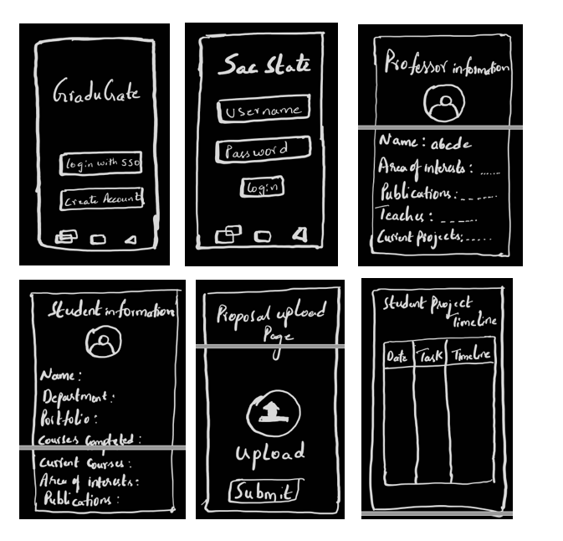

The first design sketch covers how a user would approach an advisor/professor to complete their Master’s project under their guidance. When a user opens the application, login with SSO and Create Account buttons are presented. Once the Sac State student clicks on Login with SSO button, it redirects to Sac State login page where the student has to enter their university login credentials to sign in. Once the student is logged into the application, it displays the available list of professors and their details. Similarly, student information is also presented. If a student likes the professor interests, they reach out to them in the application by contacting them through the inbuilt messaging system. Once the professor had a discussion, the student submits his proposals through the upload page in the application. Afterward, the professor accepts his/her proposal and get back with reviews or suggestion for the students work. Further, there are some more screens where students access them and use for their Master’s project approvals.

Proposed Design Sketch – 2:

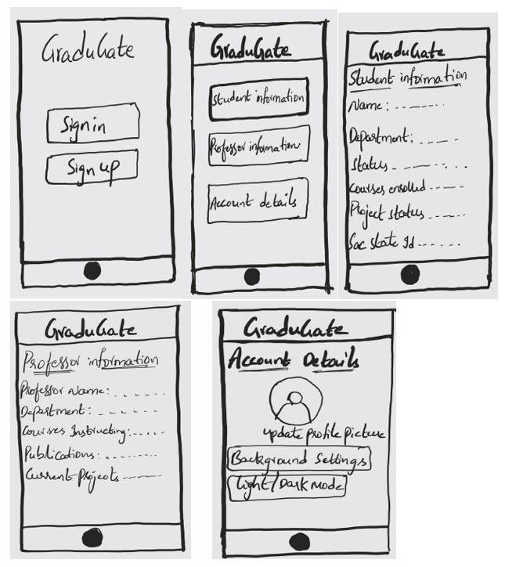

The second design sketch covers how a student can change his/her account details, interests and application settings based on their preferences. When a user opens the application sign in and signup buttons are presented. Once the student logins with their credentials, it displays the student information, professors’ information and account details of the student who logged into the application. The user can click on Account details button, where it displays to change/update their profile picture, their interests, their current project, application background settings, they can even their theme to dark/light mode. Similarly, there are some more features where the student can explore and change their details in the application.

Proposed Design Sketch – 3:

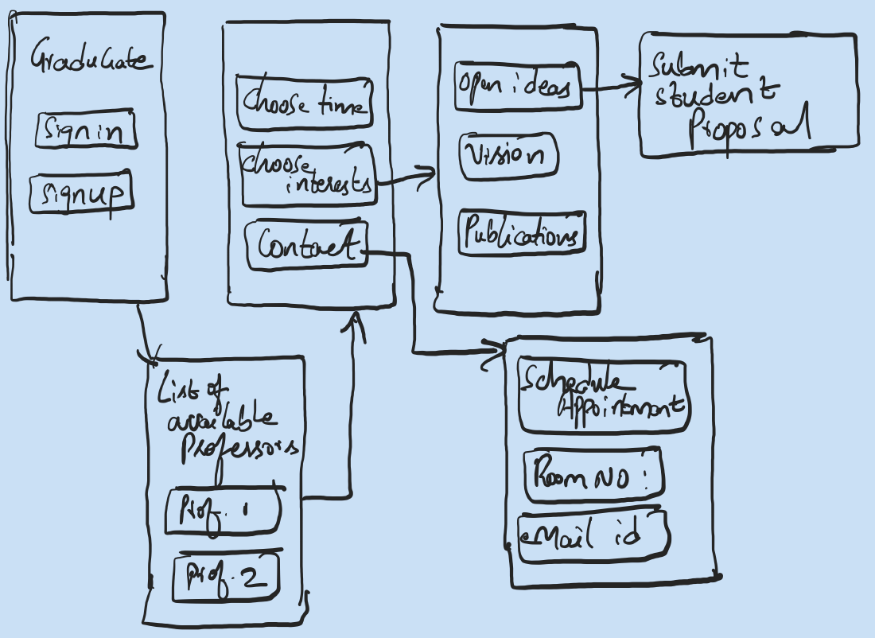

The random sketch above provides a user-friendly interface, when a user opens application, sign in and signup screens are presented. When the user signs it displays choose time, choose interests buttons. Further when the user explores the application, they can access the list of available professors in that semester to accept the students for master’s project guidance based on their bandwidth. Students can reach out to the professors based on their interests and submit their open ideas/project proposals to professors. Students can even schedule a meeting with professors by clicking on contact button on the screen. It displays the advisors’ details like email id, Room number on the campus, zoom meeting scheduler, advisors open timings.

Written Scenarios and Storyboards:

Scenario and Storyboard – 1:

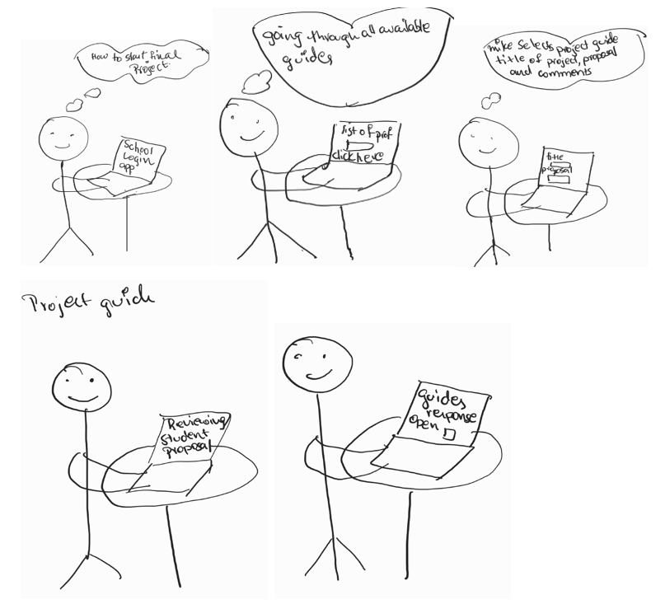

Scene 1 – Student Logs In

The student logs into the application using the school credentials and navigates to the desired pages designed for the Grad2gate. Once the student is inside, the dashboard welcomes them with the available guides for the current semester, their area of expertise and status of the active projects.

Scene 2 – The search for Guide

The students can filter and search functionality to navigate the list of accessible project guides, where they can see each guide’s profile, which includes their area of expertise, research interests.

Scene 3 – Student requests a Project Guide

The student selects a project guide they would like to work with and files a request, the application notifies the selected project guide about the student’s request. The application would have the Title of the project, proposal, and empty space for any comments or remarks for correction or upgradation.

Scene 4 – Project Guide Review Request

The project guide receives the student’s request and evaluates their profile and project specifics. The project guide might accept or deny the request based on their availability and suitability for the student’s project.

Scene 5 – Student receiving a response

The student is informed of the guide’s decision, if the request is approved, the student and guide can start the project paper work needed for the department, if denied then the student might look for and seek another project guide, or can work on the professor’s mentioned changes to go ahead with decision.

Scenario and Storyboard – 2:

Scene 1:

Aravind wants to start his project for his final semester. He recently gets to know about GraduGate, and starts using the application.

Scene 2:

In the home screen, he found available professors’ menu, in that he finds professor Pitha. He looked at the professor portfolio. The professor is interested in doing cryptography, but Aravind wants to do AI projects.

Scene 3:

He goes back to the Available professor’s menu, and selects professor goopuram, and the professor I interested in AI projects, clicks on contact now.

Scene 4:

After messaging the professor in the app and finds the Aravind portfolio interesting and asks him to meet in person rather than app conversation.

Scene 5:

Professor goopuram approves the project and told Aravind to update his real time work in the app.

Scene 6:

After reviewing all the Aravind work and submission documents, he sends approval to department.

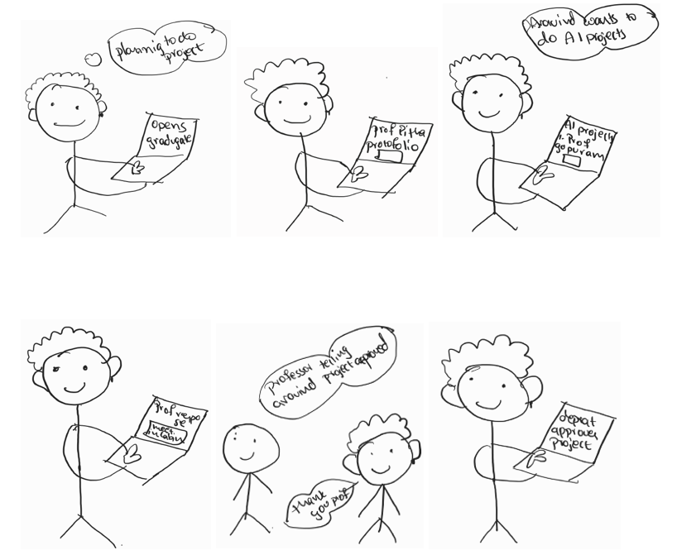

Scenario and Storyboard – 3:

Scene 1 – Mike is a student

Mike is a student in the university who has no knowledge how to start the search for the project guide.

Scene 2 – Appointment with the advisor

Mike schedules an appointment with the advisor and checks about how to go ahead with his project guide search, and the guide tells Mike about the GraduGate application. The application is all about how the student and current active professors interact to start the project.

Scene 3 - Mike Logs In

Mike uses his school credentials to log into the application and know more about the application and its dashboard.

Scene 4 – The search for Guide

Mike now is into the application and goes through the all the available guides for the current semester and their profile, which includes their area of expertise, research interests. Mike chooses a particular professor who he wishes to start his project.

Scene 5 – Mike requests for a Project Guide

Mike selects a project guide that he like to work with and files a request, the application notifies the selected project guide about his request. The dashboard of the application would have the Title of the project, proposal, and empty space for any comments or remarks for correction or upgradation.

Scene 6 – Project Guide Review Request

The project guide receives the Mike’s request and evaluates his profile and project specifications. The project guide denies the request, as Mike had not taken a course under the professor he wants to start.

Scene 7 – Mike receiving a response

Mike is informed of the guide’s decision; he then decides to start the process all over again and how he shortlists all the professor’s he has taken course and approaches them through app again.

Scene 8 – Meet with Professor

Mike is now able to find 2 new professors that align with his ideas and want to schedule a zoom meet before going ahead with the process.

Scene 9 – Updating

Once the meet is completed, the app is updated with the discussed information and it is taken ahead for the department process.

