**CSC 238 – Human Computer Interface Design**

California State University, Sacramento (CSUS)

Computer Science Department

Spring – 2024.

**Master’s Project Management System**

**Team - 10**

**Introduction:**

The current process for Final project proposal acceptance and submissions at our university poses significant challenges for both Bachelor’s and Master’s students aspiring to obtain their degrees. This critical phase requires students to independently develop a project or thesis proposal aligned with their interests and seek approval from professors engaged in relevant research areas.

**Problem Proposal:**

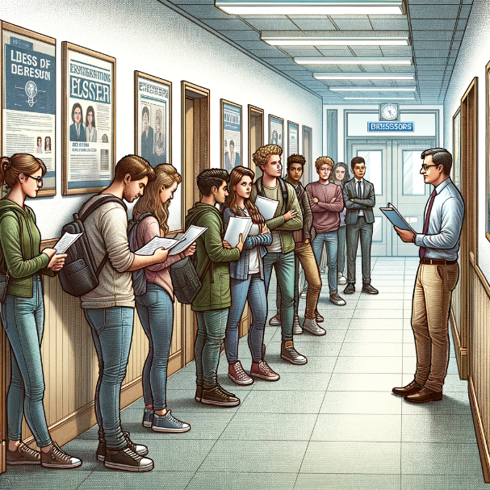The main issue arises from the time-consuming nature of the proposal review process. Students must approach professors via email with their project proposals. Professors, in turn, review these proposals on a case-by-case basis, providing feedback, suggesting modifications, or outright rejecting proposals that do not align with their research interests or expectations. This iterative process, while thorough, often results in substantial delays. Consequently, students face the risk of not being able to register for the Master's project course in a timely manner, potentially delaying their graduation. Due to this prolonged process, there is not enough time for students to reach out to other professors with different project proposals within the given time frame for registration. This bottleneck exacerbates the challenge of meeting registration deadlines, further complicating students' academic timelines and contributing to potential delays in their educational progress.

Figure 1: Students waiting in-front of Professor's Office room.

Source: Image generated using Chat GPT AI

**Proposed Solution:**

To address these challenges, we propose the development and implementation of a centralized digital platform designed to streamline the Master's project proposal process. It involves in detailed profiles of professors showcasing research interests, availability, and capacity to take on new students. The Proposal Submission and Tracking interface for students to submit and track the status of their proposals in real time. A structured system for professors to provide feedback, request modifications, or approve proposals directly within the platform. The notification system interface for real-time alerts to keep students and professors updated on proposal status changes and required actions. This will Significantly cut down the time required for proposal reviews and approvals, enabling students to register for the Master's project course promptly. By achieving this, the proposal submission and review process becomes more efficient for both students and faculty. Therefore, the students get graduated as per their academic timeline without any delays.

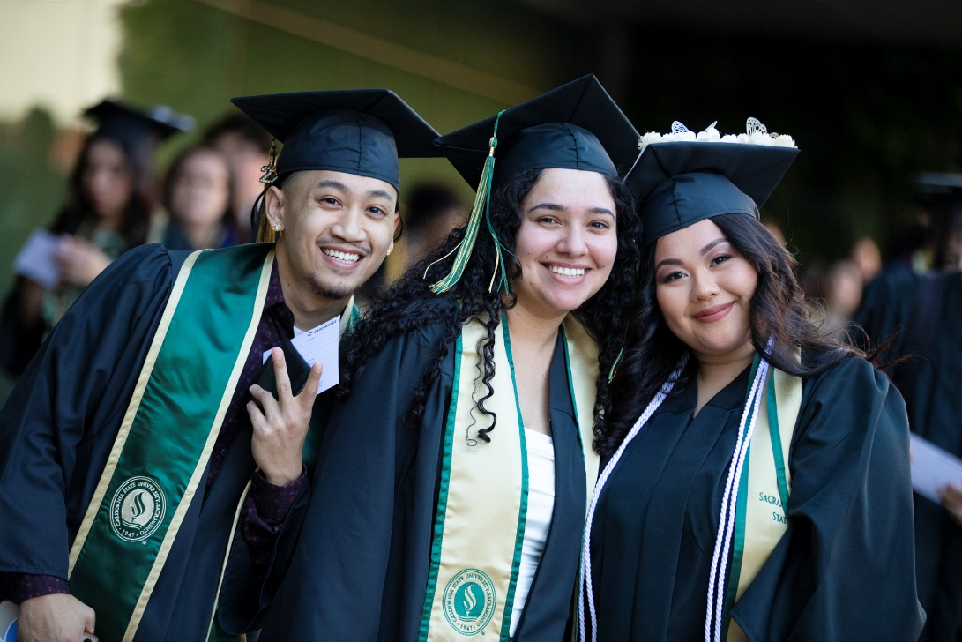

Figure 2: Sac State Students Graduating happily.

Source: https://www.csus.edu/news/newsroom/stories/2022/5/commencement.html